CS4249 Assignment 1 Experiment Instructions

This experiment will require you to test out the copy and paste techniques AutoComPaste and the traditional copy-paste technique.

The traditional copy-paste technique refers to ctrl-C (win)/cmd-C(mac) to copy a selected chunk of text and ctrl-V (win)/cmd-V(mac) to paste it.

For both methods, you are required to look for the stated phrase (green circle) and paste it into the Text Editor.

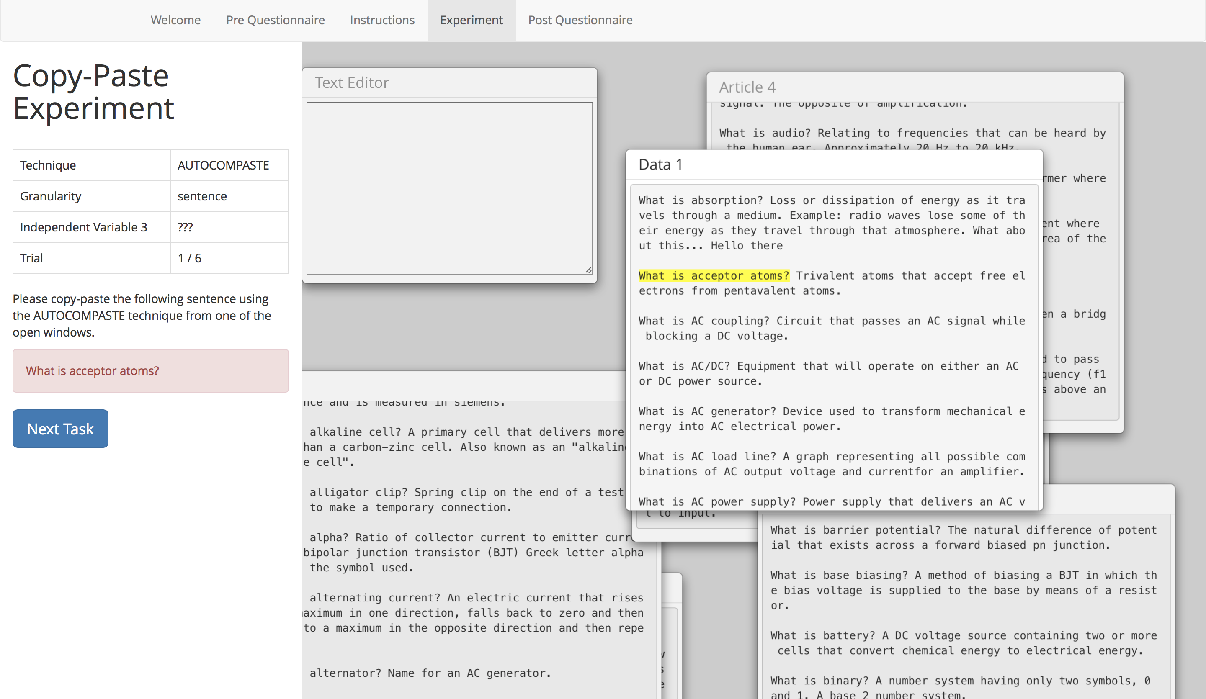

When the technique stated on the left is “autocompaste”, you are required to execute the copy-paste using the autocompaste method.

How to:

1. Type the first few words of the phrase, until a selection of texts appear.   
     
   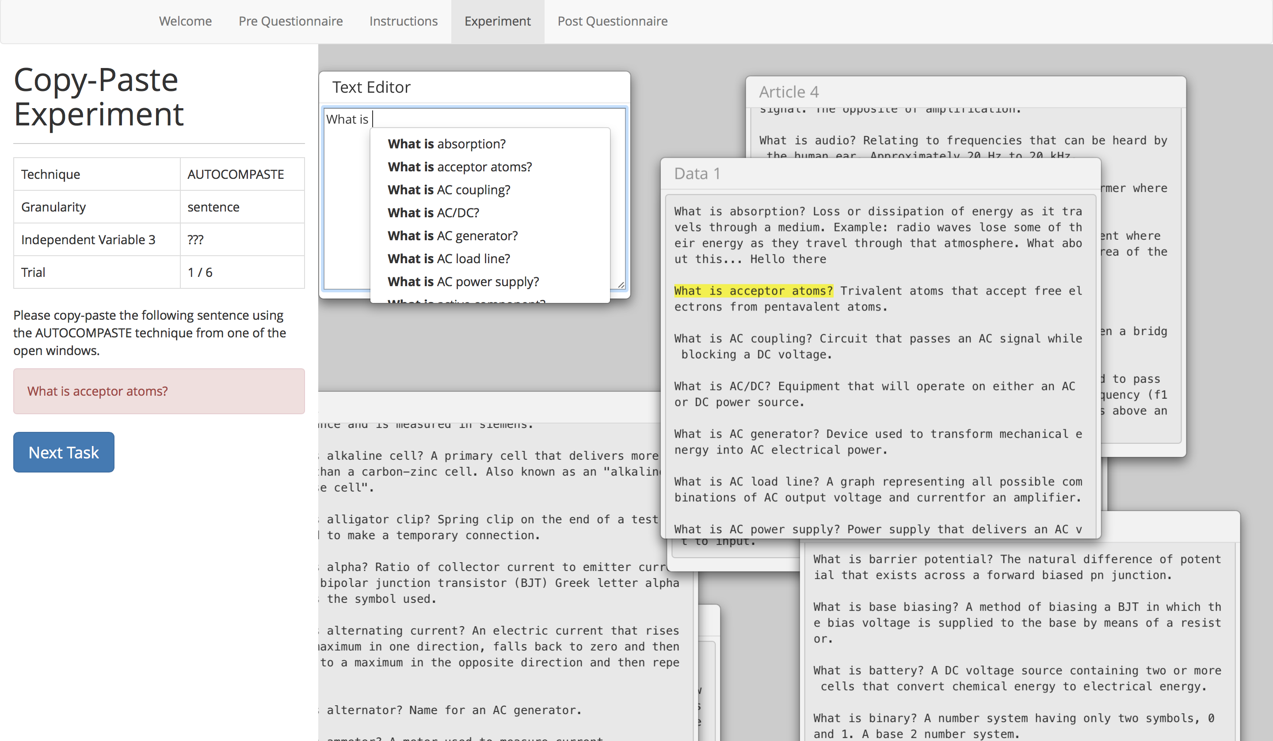
2. Use the mouse to click on, or use the arrow keys and click enter to select the desired phrase.
3. Use the left and right arrow keys after selecting the phrase to decide whether to add the subsequent sentence or delete it.