ANGELWINGS COMPREHENSIVE COLLEGE,MAROKO, PW, KUBWA, ABUJA.
3rd TERM EXAMINATION 2025/2026 ACADEMIC SESSION
SUBJECT: LITERACY/PHONICS
CLASS: NURSERY ONE
INSTRUCTION: ANSWER ALL QUESTIONS
1. Fill in the missing letters
- N _ se
- H _ nd
- S _ oe
- F _sh
- B _ok

2.colour and write the names of this pictures


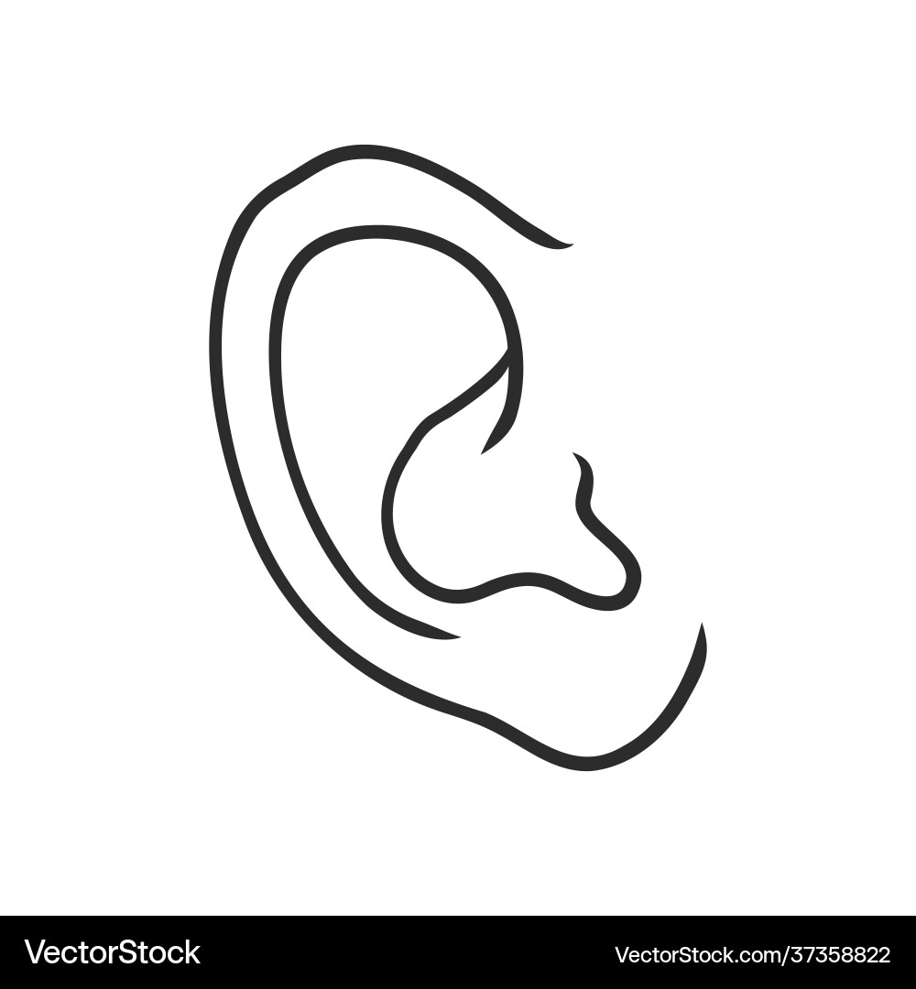

3. Match the sounds to where they are present
- Sing. th
- Chips. Sh
- this. ch
- Shoe. ng

4. Fill in the missing vowel sounds
a. i. u

5. spell your name in the space below.
My name is
I am a
6. Circle the vowel sound i in the following words
- big
- tip
- blink
- him

