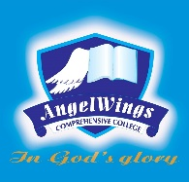

|  |  |
| --- | --- |
| **ANGELWINGS COMPREHENSIVE COLLEGE, MAROKO, PW, KUBWA, ABUJA** | |
| **THIRD TERM EXAMINATION 2024/2025 ACADEMIC SESSION** | |
| **SUBJECT: GENERAL PAPER** | **CLASS: FOUNDATION** |

1.identify and colour

 

2. Identify and colour the parts of the body

   

3.identify and colour the fruit

  

4.identify and colour the things we use to keep our environment clean

  

5. Pencil is used for