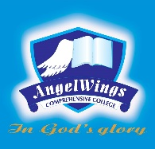

|  |  |
| --- | --- |
| **ANGELWINGS COMPREHENSIVE COLLEGE, MAROKO, PW, KUBWA, ABUJA** | |
| **THIRD TERM EXAMINATION 2024/2025 ACADEMIC SESSION** | |
| **SUBJECT: LITERACY** | **CLASS: FOUNDATION** |

1. Colour the letters a and b

A B C D

2. Name the fruit and colour

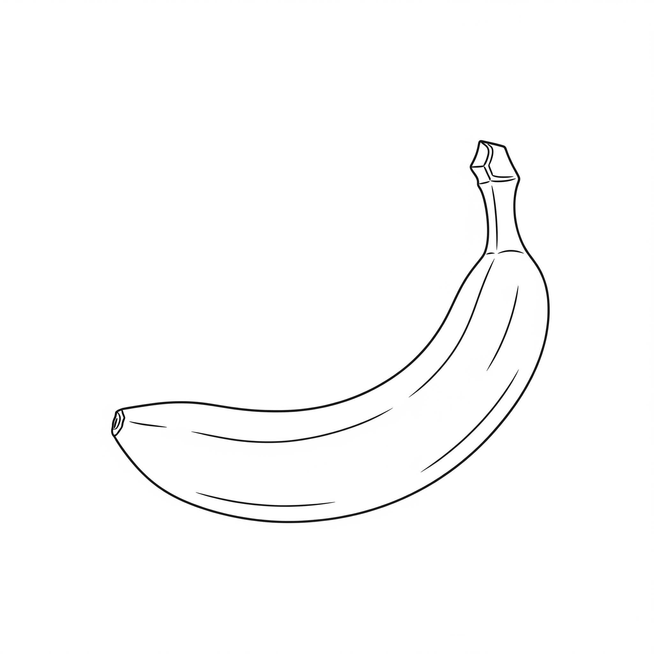

3.a as in

b as in

4.identify the following letters

A B C D