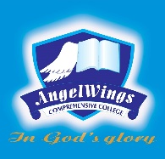

|  |  |
| --- | --- |
| **ANGELWINGS COMPREHENSIVE COLLEGE, MAROKO, PW, KUBWA, ABUJA** | |
| **THIRD TERM MIDTERM EXAMINATION 2024/2025 ACADEMIC SESSION** | |
| **SUBJECT: PHONICS** | **CLASS: NURSERY ONE** |

1. Identify and colour

2.the five magic words are

3. Identify and colour the following means of transportation



4. Identify and colour the following living things