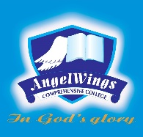

|  |  |
| --- | --- |
| **ANGELWINGS COMPREHENSIVE COLLEGE, MAROKO, PW, KUBWA, ABUJA** | |
| **THIRD TERM EXAMINATION 2024/2025 ACADEMIC SESSION** | |
| **SUBJECT: RHYMES** | **CLASS: FOUNDATION** |

1. Tick says the clock
2. Rain rain go away
3. Baa baa black sheep
4. Roll roll roll your boat
5. Doe a deer a female deer