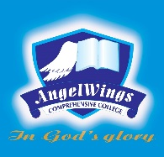

|  |  |
| --- | --- |
| **ANGELWINGS COMPREHENSIVE COLLEGE, MAROKO, PW, KUBWA, ABUJA** | |
| **THIRD TERM EXAMINATION 2024/2025 ACADEMIC SESSION** | |
| **SUBJECT: Cultural and Creative Arts** | **CLASS: YEAR TWO** |

1. Draw five kitchen utensils

2. What is the full meaning of CCA?

3. Write three things you use for drawing?

4. Highlight five types of colors

5. Draw and Color two items in your classroom.