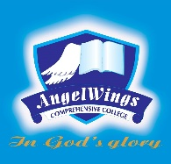

|  |  |
| --- | --- |
| **ANGELWINGS COMPREHENSIVE COLLEGE, MAROKO, PW, KUBWA, ABUJA** | |
| **THIRD TERM EXAMINATION 2024/2025 ACADEMIC SESSION** | |
| **SUBJECT: Cultural and Creative Arts** | **CLASS: YEAR THREE** |

C.C.A exam questions for grade 3

1. Draw and label the human body and it's part

2. What is color

3. List the types of color that we have

4. Give three examples of each of the colors we have

5. What were the materials you used in making the paper mache