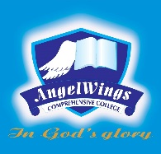

|  |  |
| --- | --- |
| **ANGELWINGS COMPREHENSIVE COLLEGE, MAROKO, PW, KUBWA, ABUJA** | |
| **THIRD TERM EXAMINATION 2024/2025 ACADEMIC SESSION** | |
| **SUBJECT: DICTATION** | **CLASS: NURSERY ONE** |

1. Bag
2. Cat
3. Hand
4. Cap
5. Moon
6. Book
7. Brown
8. Fish
9. Nose
10. Shoe
11. Black
12. Ball
13. Boy
14. Dad
15. Cup
16. Egg
17. Pot
18. Man
19. Nigeria
20. Bat