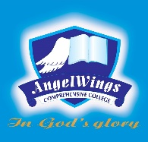

|  |  |
| --- | --- |
| **ANGELWINGS COMPREHENSIVE COLLEGE, MAROKO, PW, KUBWA, ABUJA** | |
| **THIRD TERM EXAMINATION 2024/2025 ACADEMIC SESSION** | |
| **SUBJECT: EAD** | **CLASS: NURSERY ONE** |

1. Draw and colour a ball

2. Draw and colour a square.

3. Name and colour the given image

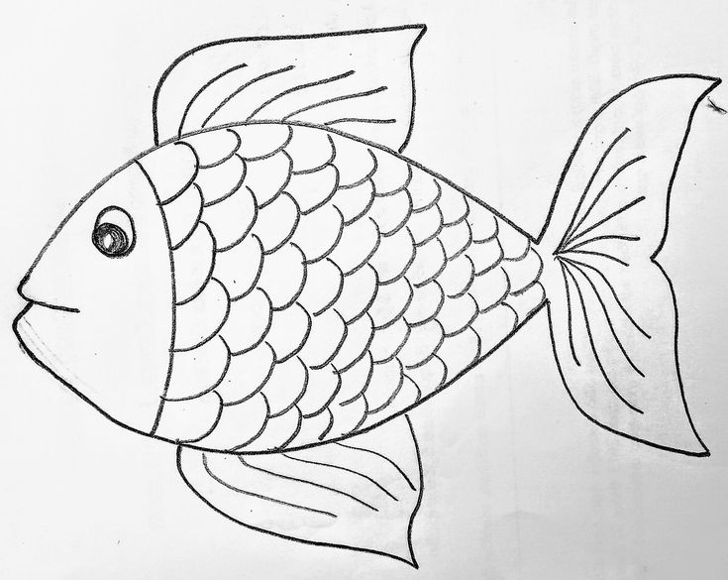

___________________________

5. Mention 3 things that float in water

___________________________

___________________________

___________________________