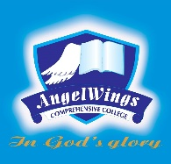

|  |  |
| --- | --- |
| **ANGELWINGS COMPREHENSIVE COLLEGE, MAROKO, PW, KUBWA, ABUJA** | |
| **THIRD TERM EXAMINATION 2024/2025 ACADEMIC SESSION** | |
| **SUBJECT: LITERACY** | **CLASS: NURSERY ONE** |

1. Complete the following words

B___g

C___p

C___t

P___t

2. Match the vowel sounds with the right pictures

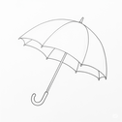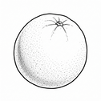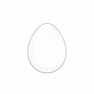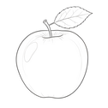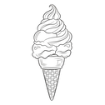

a e i o u

3. Colour and name the following objects

  

  