

|  |  |
| --- | --- |
| **ANGELWINGS COMPREHENSIVE COLLEGE, MAROKO, PW, KUBWA, ABUJA** | |
| **THIRD TERM MIDTERM EXAMINATION 2024/2025 ACADEMIC SESSION** | |
| **SUBJECT: PHONICS** | **CLASS: NURSERY ONE** |

.

1. 1. Fill in the missing letters
2. N _ se
3. H _ nd
4. S _ oe
5. F _sh
6. B _ok
8. 2.colour and write the names of this pictures
9. 
10. 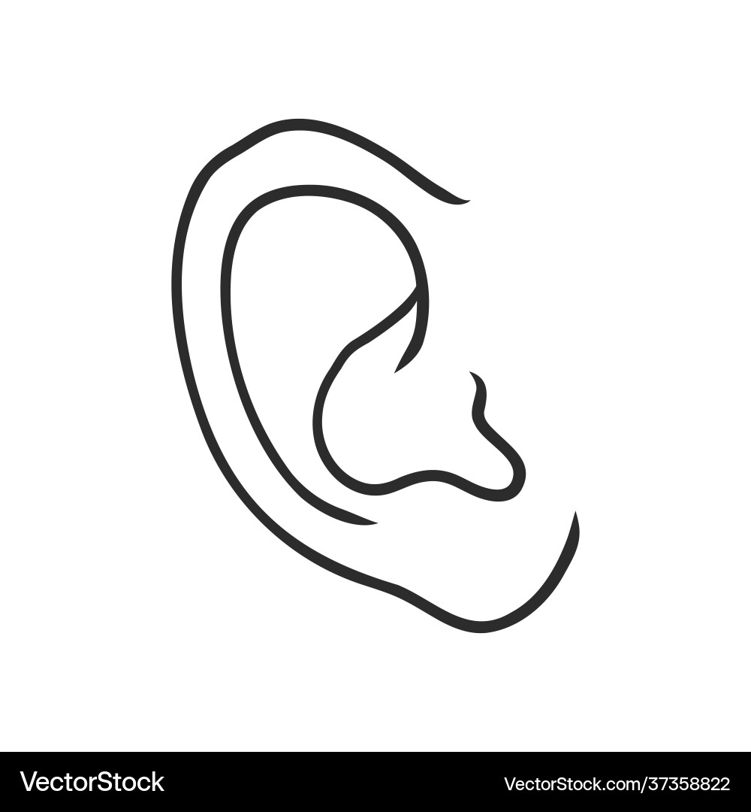
11. 3. Match the sounds to where they are present
12. Sing. th
13. Chips. Sh
14. this. ch
15. Shoe. ng
16. 4. Fill in the missing vowel sounds
17. a. i. u
19. 5. spell your name in the space below.
20. My name is
21. I am a
22. 6. Circle the vowel sound i in the following words
23. big
24. tip
25. blink
26. him