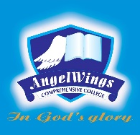

|  |  |
| --- | --- |
| **ANGELWINGS COMPREHENSIVE COLLEGE, MAROKO, PW, KUBWA, ABUJA** | |
| **THIRD TERM EXAMINATION 2024/2025 ACADEMIC SESSION** | |
| **SUBJECT: RHYMES** | **CLASS: NURSERY ONE** |

1. Doe a deer
2. Shoo fly, don't bother me
3. Aeroplane × 2 all in a roll
4. Tick says the clock
5. Rain on the house top
6. Yankee doodle