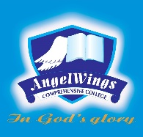

|  |  |
| --- | --- |
| **ANGELWINGS COMPREHENSIVE COLLEGE, MAROKO, PW, KUBWA, ABUJA** | |
| **THIRD TERM EXAMINATION 2024/2025 ACADEMIC SESSION** | |
| **SUBJECT: DICTATION** | **CLASS: NURSERY TWO** |

1. Cash
2. Tail
3. Clean
4. Tree
5. Room
6. Clay
7. Boat
8. Will
9. Cross
10. Cuff
11. Heat
12. Light
13. Plant
14. King
15. Read
16. Bath
17. Soil
18. Fresh
19. Some
20. Stain