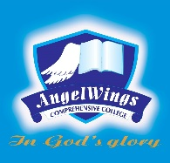

|  |  |
| --- | --- |
| **ANGELWINGS COMPREHENSIVE COLLEGE, MAROKO, PW, KUBWA, ABUJA** | |
| **THIRD TERM EXAMINATION 2024/2025 ACADEMIC SESSION** | |
| **SUBJECT: PSED** | **CLASS: NURSERY TWO** |

(1) A place where christians worship is called ____________.

(2)Draw one important need.

(3). Tick ✓ for needs and cross out wants.

 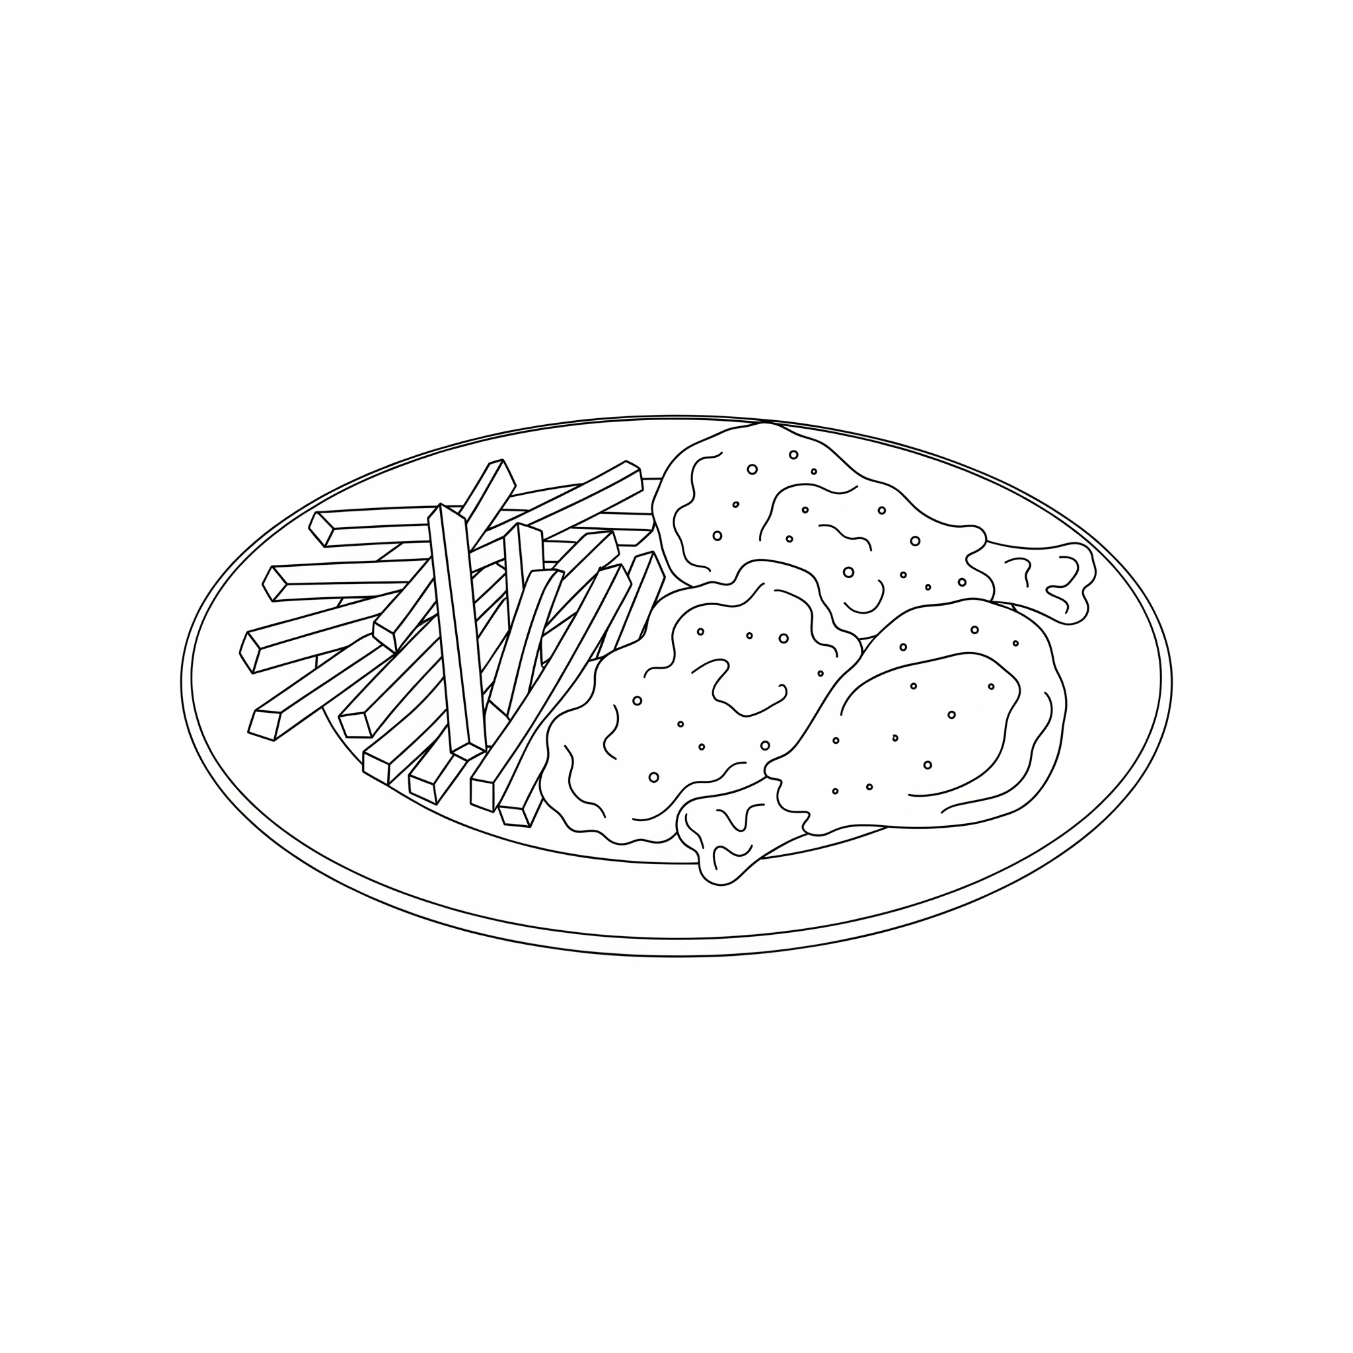 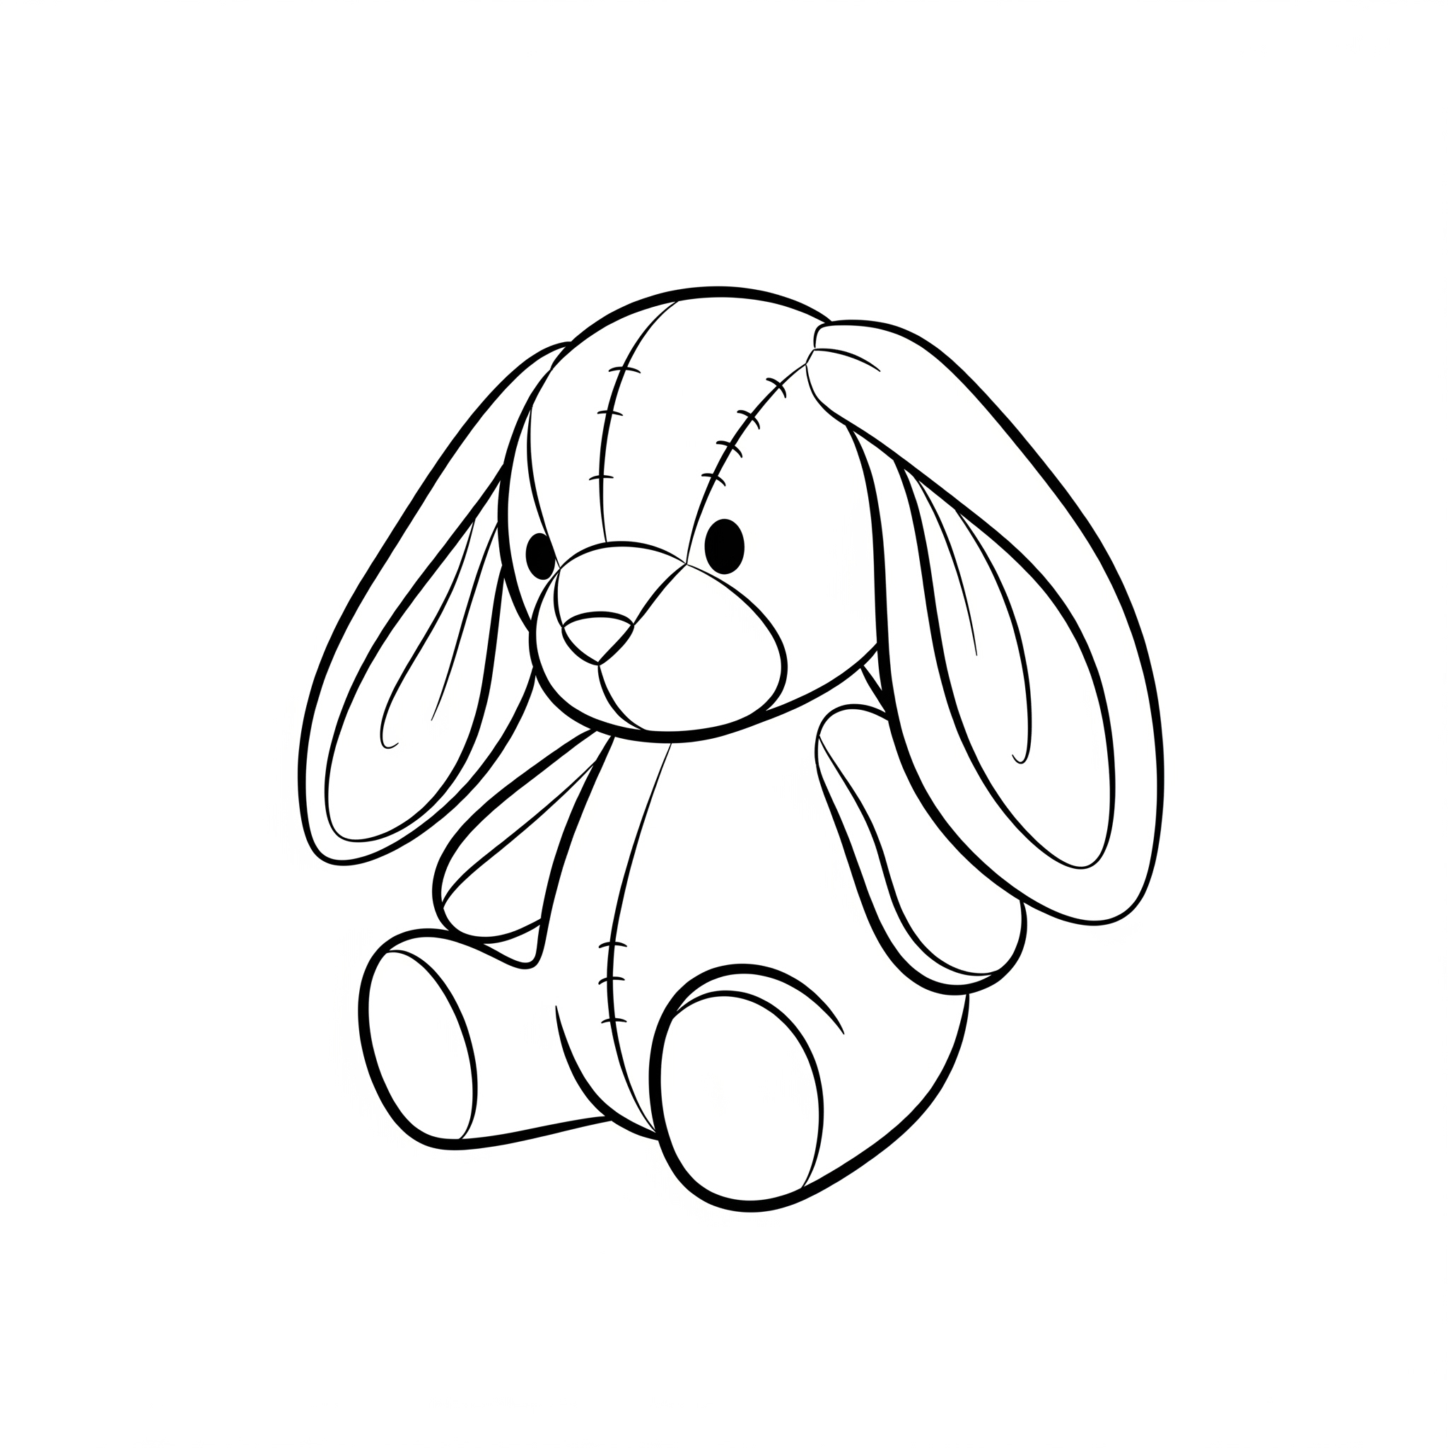

Fill in the gaps from the underlined words: Strength dignity

(4) In national coat of arm the two white horses stand for __________

(5) The eagle stands for __________________

(6) Draw one national symbol you know.

(7) food gives us __________________

(8) Mention the food you like best __________________

(9). Draw one gift you can give to your best friend on his or her birthday.