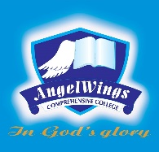

|  |  |
| --- | --- |
| **ANGELWINGS COMPREHENSIVE COLLEGE, MAROKO, PW, KUBWA, ABUJA** | |
| **THIRD TERM EXAMINATION 2024/2025 ACADEMIC SESSION** | |
| **SUBJECT: RHYMES** | **CLASS: NURSERY TWO** |

(1). Little Peter rabbit.

(2). Old mac donald.

(3). Five little soldiers

(4). Do you know the muffin man.

(5). Use the underlined words to fill in the blank spaces.

black yes three one dame

Baa baa __________. sheep

Have you any wool,

____________ sir, yes sir

___________ bags full,

_________ for the master ,

One for the _______,

And one for the little boy who lives down the lane.