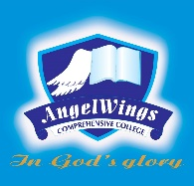

|  |  |
| --- | --- |
| **ANGELWINGS COMPREHENSIVE COLLEGE, MAROKO, PW, KUBWA, ABUJA** | |
| **THIRD TERM EXAMINATION 2024/2025 ACADEMIC SESSION** | |
| **SUBJECT: DICTATION** | **CLASS: PRENURSERY** |

1. at
2. an
3. as
4. am
5. if
6. is
7. in
8. it
9. up
10. us