

|  |  |
| --- | --- |
| **ANGELWINGS COMPREHENSIVE COLLEGE, MAROKO, PW, KUBWA, ABUJA** | |
| **THIRD TERM EXAMINATION 2024/2025 ACADEMIC SESSION** | |
| **SUBJECT: ICT** | **CLASS: PRENURSERY** |

1. What is a computer

__________________**____________________________________________**

2. Identify and color

 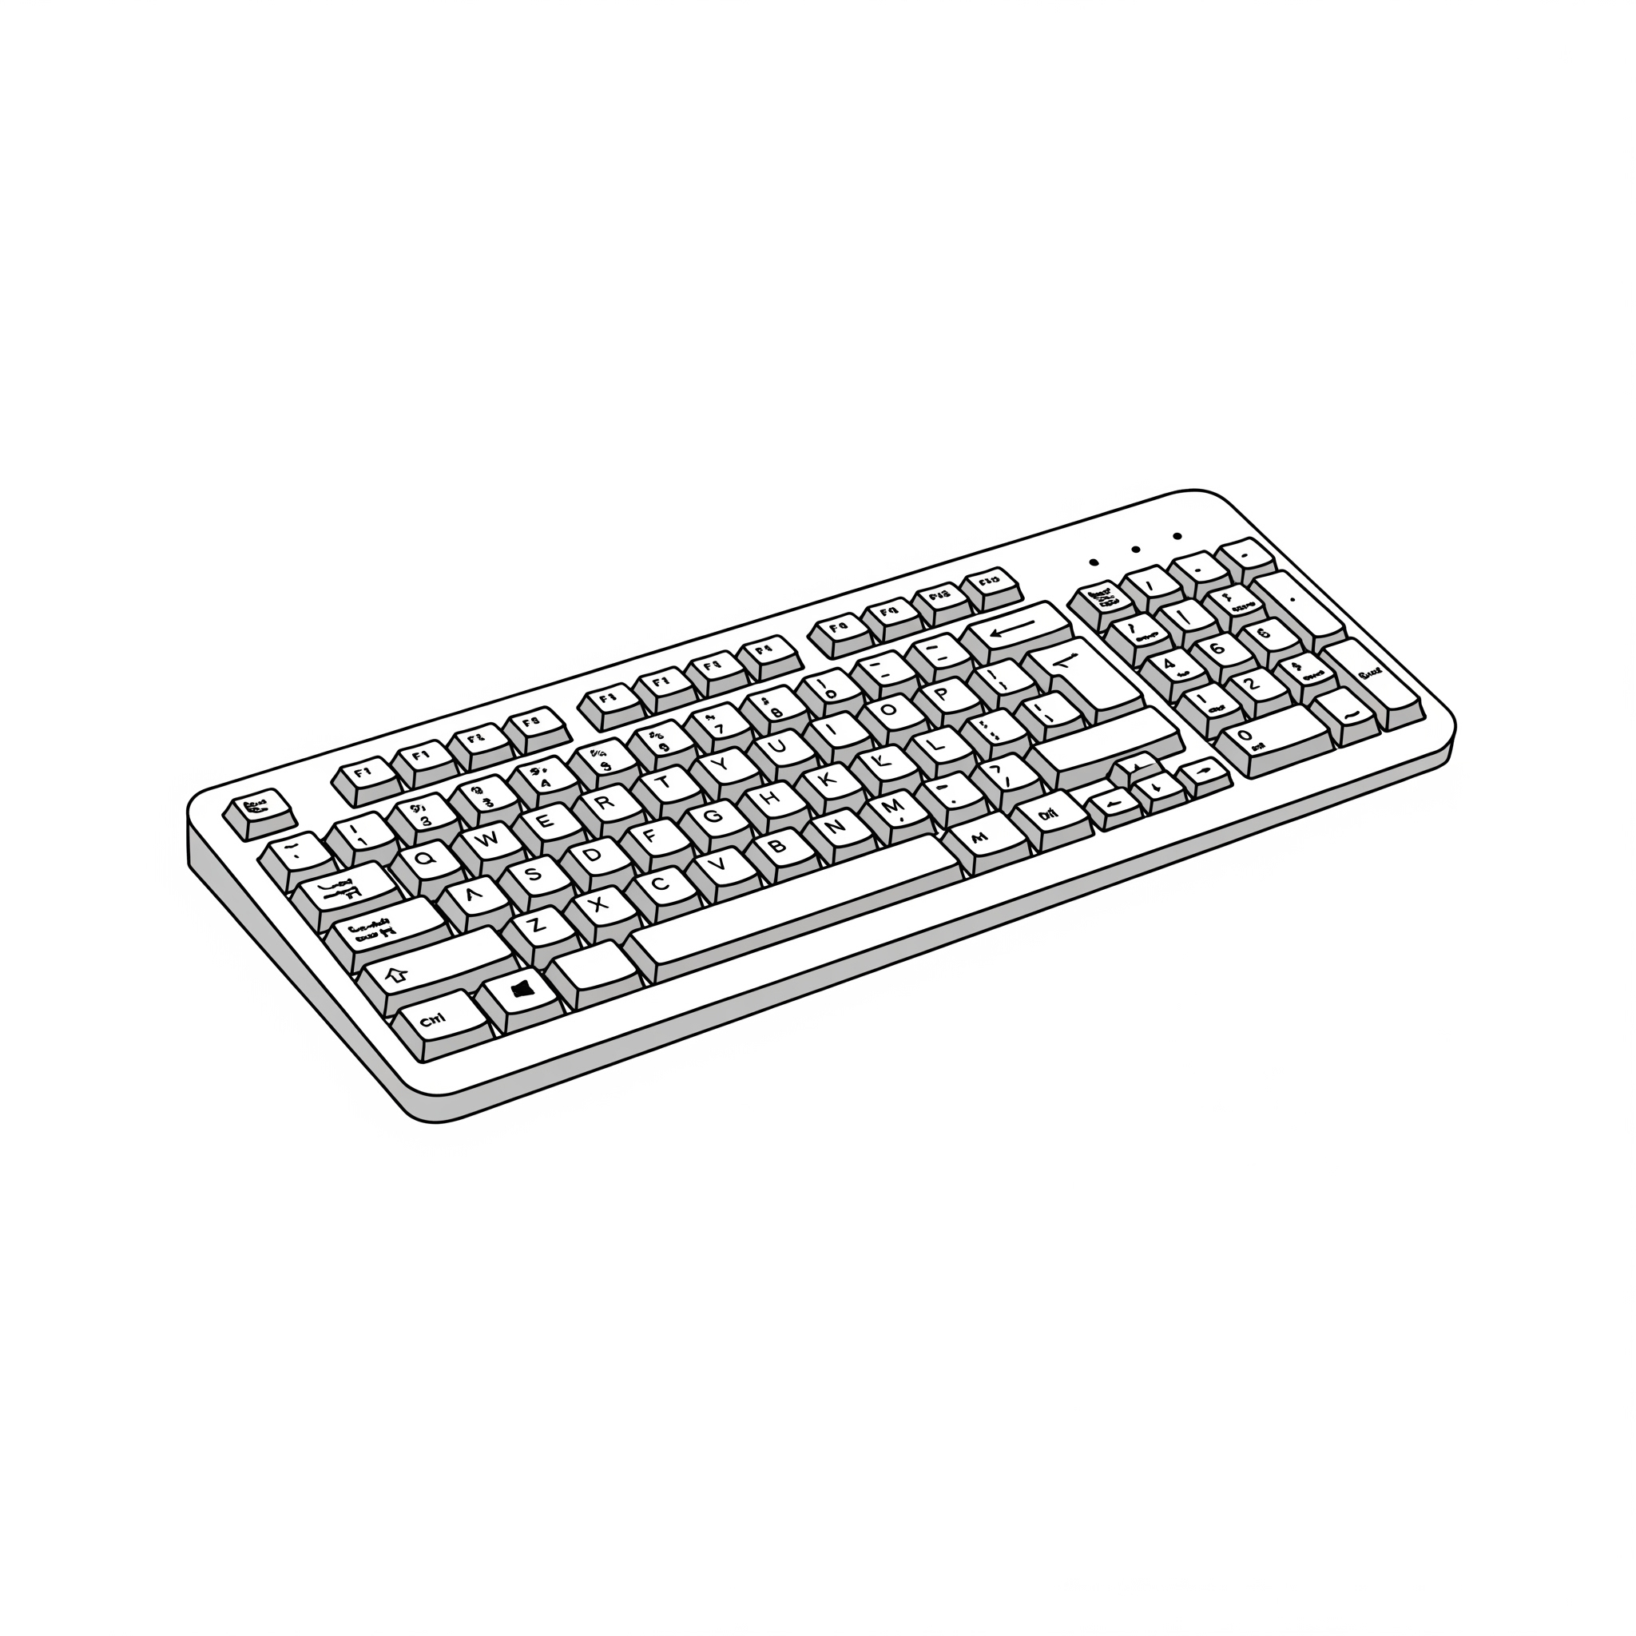

____________ ____________

3. Parts of computer are

______________________________________________________________

4. Draw and color a mouse

5. match the parts of computer to its name

 mouse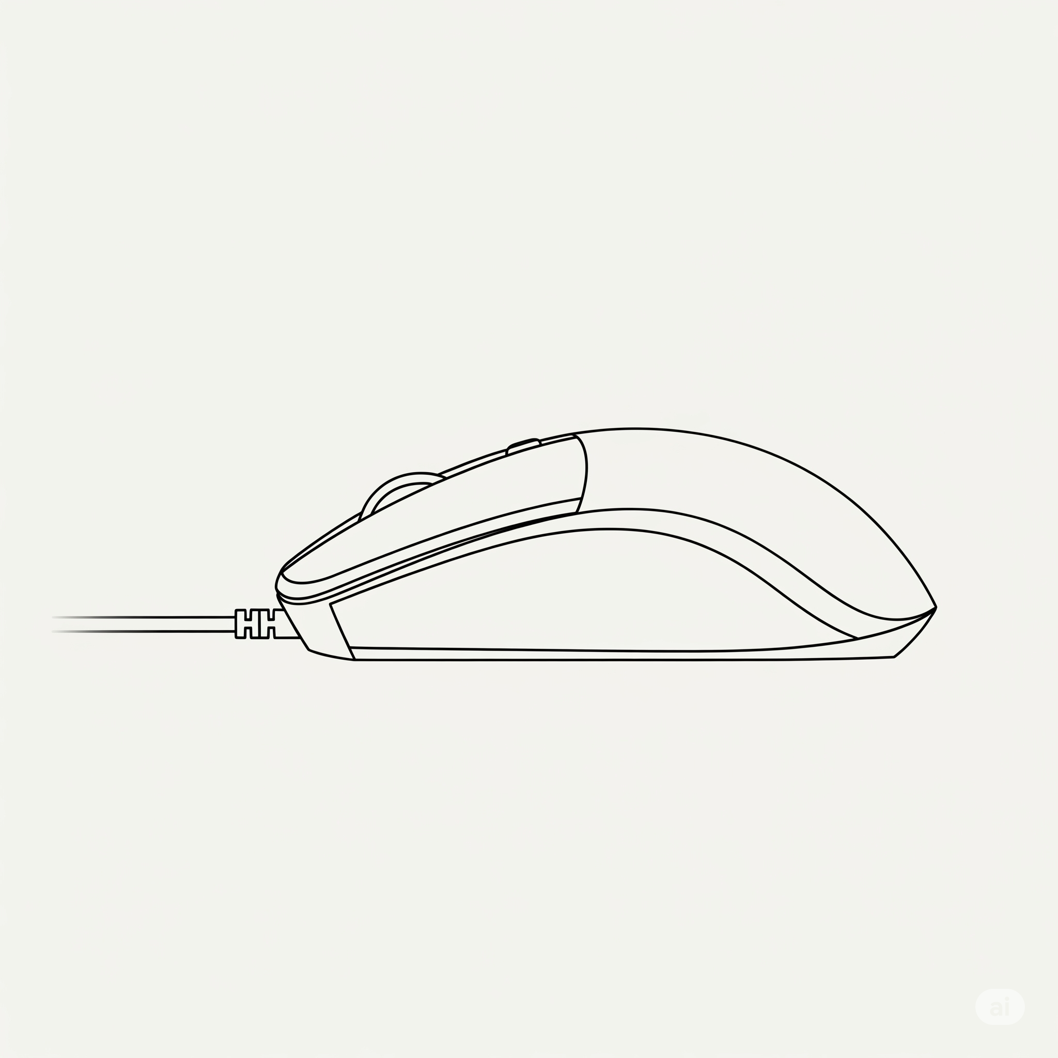 keyboard monitor