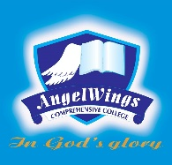

|  |  |
| --- | --- |
| **ANGELWINGS COMPREHENSIVE COLLEGE, MAROKO, PW, KUBWA, ABUJA** | |
| **THIRD TERM MIDTERM EXAMINATION 2024/2025 ACADEMIC SESSION** | |
| **SUBJECT: KUW** | **CLASS: PRENURSERY** |

1. What are water animals

2. Circle the of water animals

3. Identify and colour

4. What is food ?

5. Identify and color a food