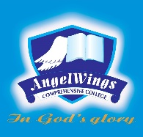

|  |  |
| --- | --- |
| **ANGELWINGS COMPREHENSIVE COLLEGE, MAROKO, PW, KUBWA, ABUJA** | |
| **THIRD TERM MIDTERM EXAMINATION 2024/2025 ACADEMIC SESSION** | |
| **SUBJECT: LITERACY** | **CLASS: PRENURSERY** |

1. Sound letters a-h

2. Complete the following

'c' as in ........................

'd' as in .........................

3.color the letter

D 3 2

4. Colour and identify

  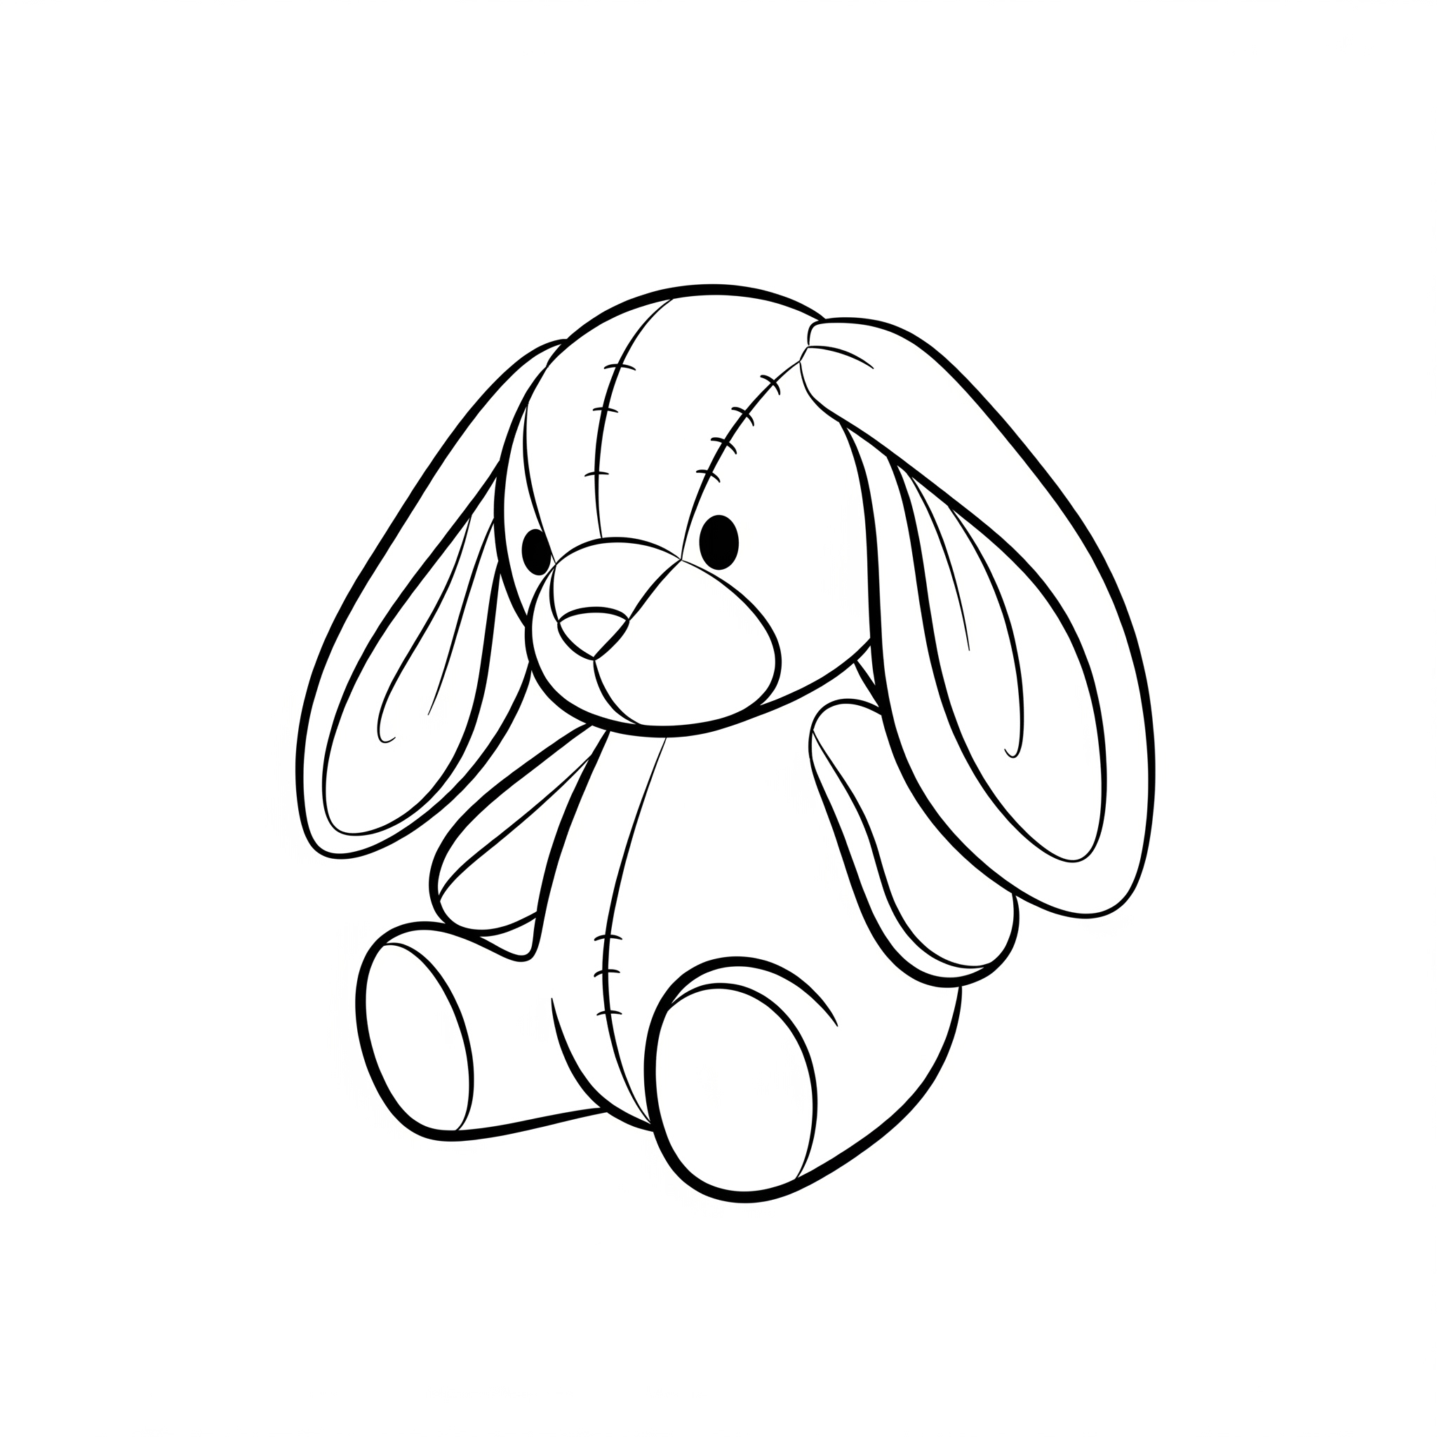

5. Identify and sound

|  |  |  |
| --- | --- | --- |
| c | d | e |