

|  |  |
| --- | --- |
| **ANGELWINGS COMPREHENSIVE COLLEGE, MAROKO, PW, KUBWA, ABUJA** | |
| **THIRD TERM EXAMINATION 2024/2025 ACADEMIC SESSION** | |
| **SUBJECT: PSED** | **CLASS: PRENURSERY** |

1. Mention three (3) things u can see in your environment

___________________________

___________________________

___________________________

2. Identify and colour

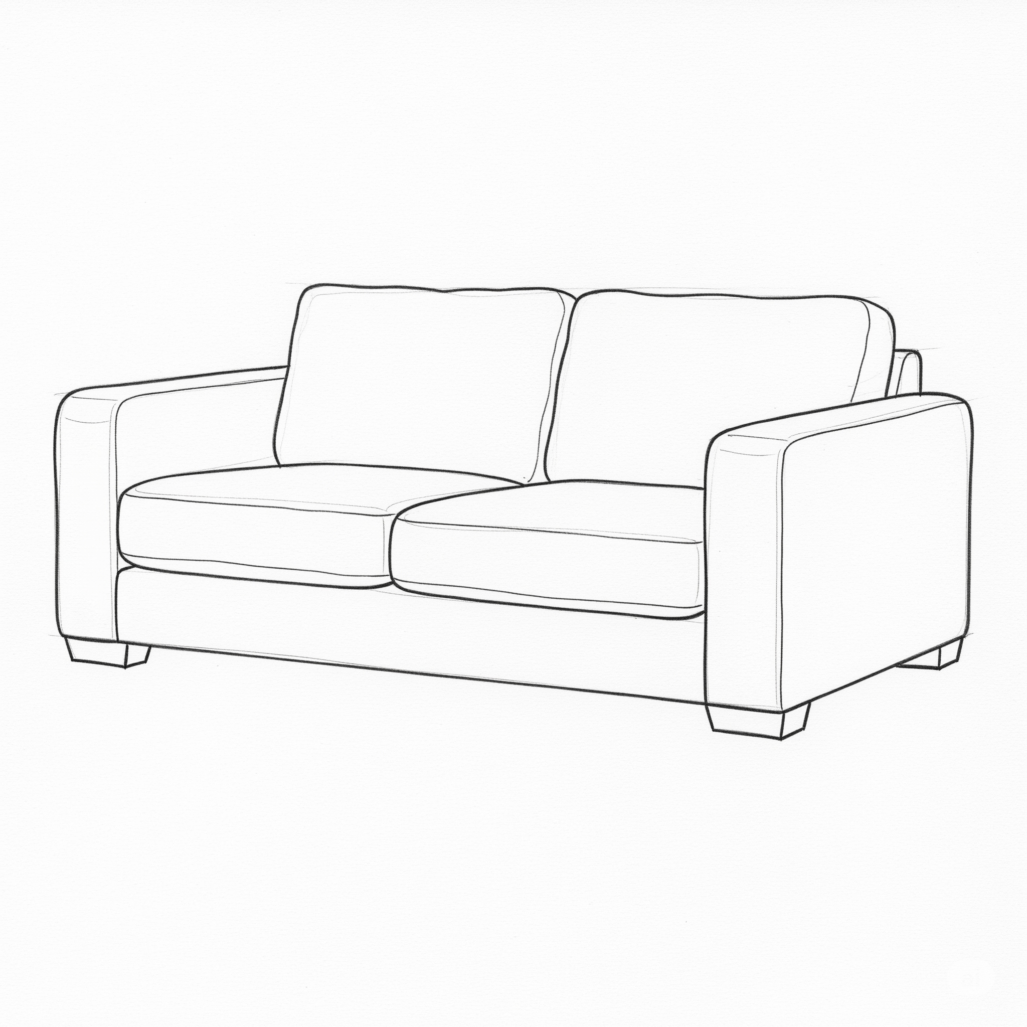  

__________________ __________________ __________________

3. What is the name of your country

___________________________