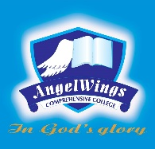

|  |  |
| --- | --- |
| **ANGELWINGS COMPREHENSIVE COLLEGE, MAROKO, PW, KUBWA, ABUJA** | |
| **THIRD TERM EXAMINATION 2024/2025 ACADEMIC SESSION** | |
| **SUBJECT: RHYMES** | **CLASS: PRENURSERY** |

1. Twinkle twinkle little star

2. 12345 Once i caught a fish alive

3. Itsy bitsy spider

4. Row row row your boat

5. Tick says the clock