**Fields that must appear in all claims**

1. 1. In the type of service contracted field, it must be auto-completed with the possible options are: Telefonía fija, Servicio móvil postpago, Servicio móvil prepago, Internet de acceso fijo, Internet móvil, Arrendamiento de circuitos, LDI – Fija, LDI – Servicio móvil, LDN.

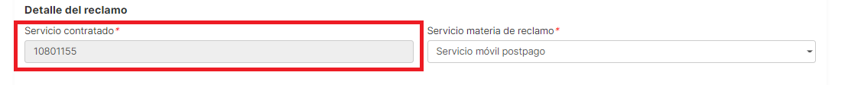

1. The button does not allow to register a claim

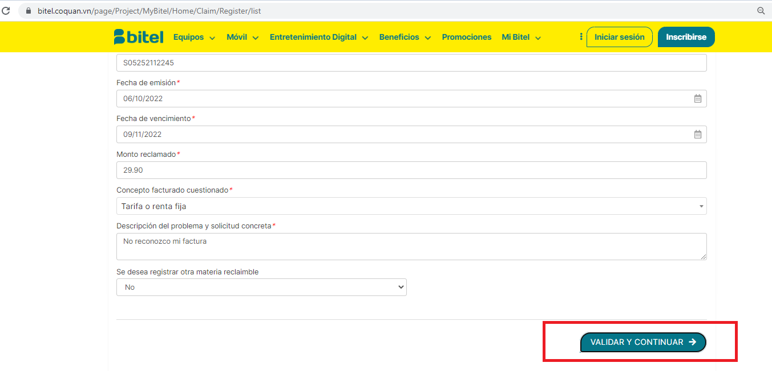

1. The page should not allow the registration of a claim with two equal claimable matters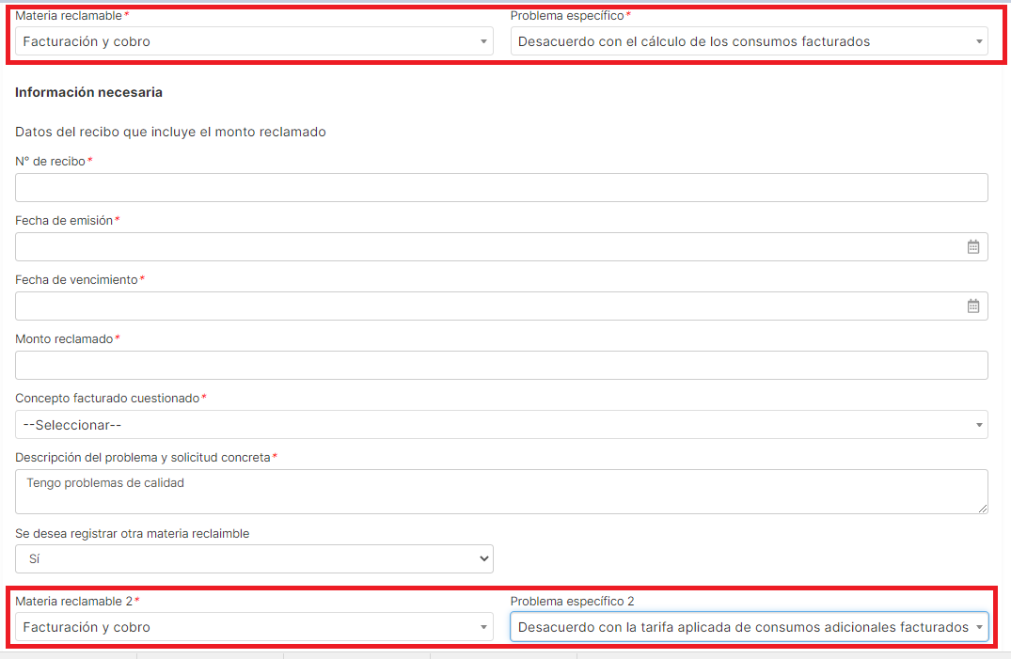
2. When the Claim group Quality and suitability in the provision of the service is selected as claimable matter 2, some fields appear in the Vietnamese language

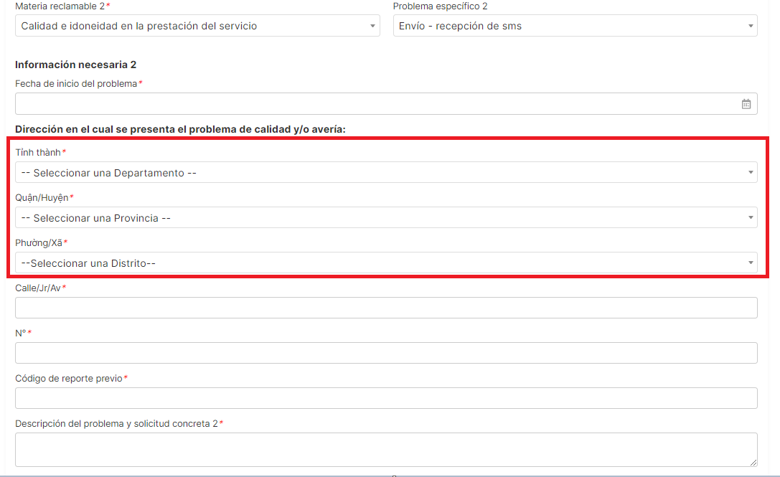

1. For all the specific problems of the claimable matter "Failure to execute the cancellation or suspension of the service", the order code field is missing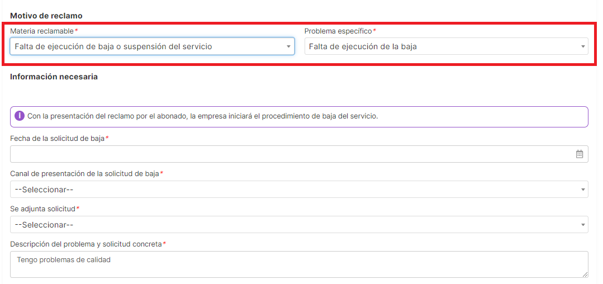
2. It is identified that there are options where the word “No” is in Vietnamese.

