Web Design Basics

Class 6 Assignment

Nino Mendolia

mendolin@newschool.edu

*PSAM 1028-D CRN: 3787 10/03/2017*

*PSAM 1028-C CRN: 2805 10/04/2017*

This week please continue refining your portfolio site in progress. We’ll be reviewing the finished versions in next week, week 7. This version will be the basis for the mid-term evaluation so please take the time to make it as polished as you can.

In suggesting that you refine the site there are a few things I’d like you to think about:

1. If appropriate for your site, add drop down menu items using styled nested lists as discussed in class and on pages 402-403 of the *HTML and CSS* textbook.

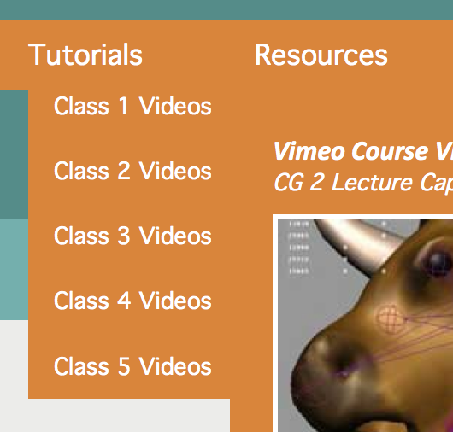

1. Give your links more impact and improve usability by having the text change color when the user’s cursor hovers over it. Use the *hover* pseudo-class as described in class and on page 248 of *HTML and CSS*. Read more about pseudo classes on pages 219-220.

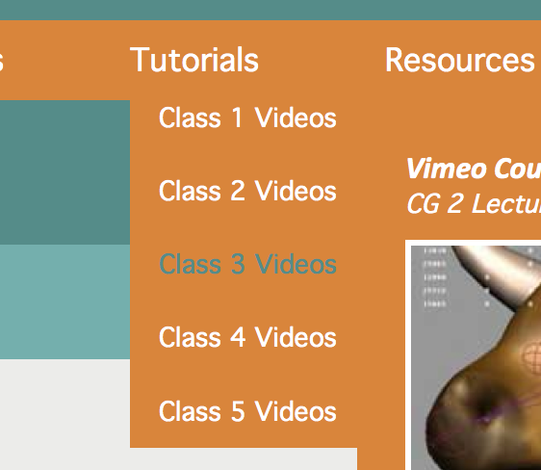

1. To apply a similar effect to thumbnail images try using the CSS 3 *opacity* property as described in class and on pages 382-383 of *HTML and CSS*.

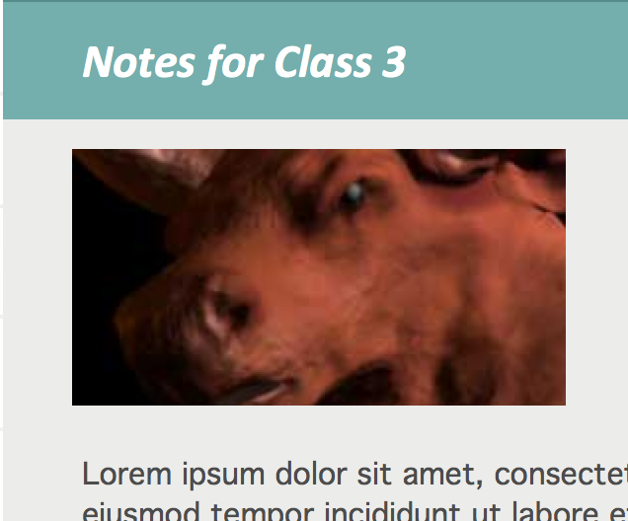 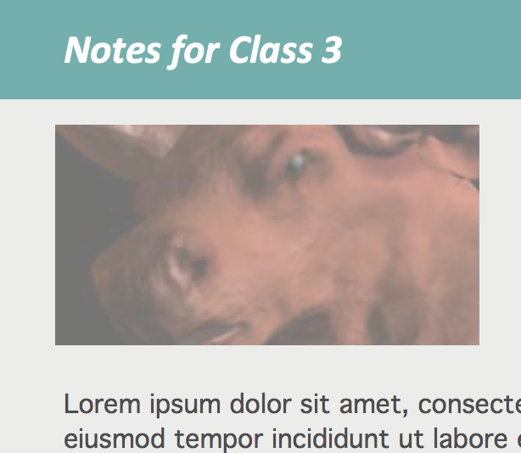

Please upload your site files in progress to the week-06 folder of your web site and send me the link via Canvas or email.

As always, please send me note if you have any questions.

For CRN 3787, Section D, Assignment 6 is due 10/10/17 by 12 Noon.

For CRN 2805, Section C, Assignment 6 is due 10/11/17 by 9 AM.

Readings for next Class:

*HTML and CSS: Visual QuickStart Guide (8th Edition)*

*Chapter 13: Working with Web Fonts*

*Chapter 15: Lists*

*Chapter 18: Tables*