CSPMS: A Centralized School Performance and Monitoring System for Department of Education Division Office in Santiago City.

A Capstone Project Submitted to the College of Computer Studies AMA Computer College Santiago Campus Santiago City

In Partial Fulfillment of the Academic Requirements for the Degree Bachelor of Science in Information Technology

Niel Patrick G. Batarao
Angellie D. Marcos
Lhord Czedrick T. Pascua
Kian Carlo T. Catu

CHAPTER I
PROJECT AND ITS BACKGROUND
Teachers and DepEd Division Office staff in Santiago City still spend too much time filling out forms and typing data into spreadsheets. This old way of working often leads to mistakes, lost papers, and delays in helping students who are falling behind. Since the pandemic, schools have faced even bigger challenges in tracking student attendance, enrollment, and performance. The Department of Education (DepEd) saw a noticeable drop in enrollment numbers, with millions of students leaving school or struggling to keep up with their studies. To fix these problems, the Schools Division Office Santiago City uses special projects like Project I-META and Project TARGETS-MET to monitor schools, but the data collection still relies on slow manual methods and physical site visits.
The proposed Centralized School Performance and Monitoring System (CSPMS) is a web-based system designed to help the SMM&E unit and school heads track student records more easily. Instead of using paper forms and spreadsheets, this system allows authorized users to manage student information using the Learner Reference Number (LRN), update enrollment changes, and submit required DepEd forms digitally. The system provides real-time dashboard data synchronization. It also automatically calculates important numbers like student-to-teacher ratios and total enrollment counts, saving staff from doing manual math and reducing human errors.
The frontend of the system is built using React with typescript, HTML and CSS to create a clean and simple interface, it adds interactive features like live updates and clickable buttons. The backend is powered by PHP, which handles all the server-side tasks such as user login, role-based access control, and automatic report generation. For data storage, local storage is used to securely keep all student records, school forms, and user activity logs.
Since all school heads and monitors are already familiar with using computers for their daily work, it makes sense to provide them with a web-based system that simplifies their tasks. CSPMS focuses only on the needs of DepEd Santiago City, helping the SMM&E unit do its job without unnecessary technical steps. By moving away from manual tracking, the division can focus more on helping students rather than just finishing paperwork. The system ensures that data is organized and consistent across all schools, allowing leaders to make faster and smarter decisions to support every learner. This project aims to protect the educational journey of each child and ensure that no student is left behind.
Project Context
The School Management Monitoring and Evaluation (SMM&E) unit of School Division Office in Santiago City acts as the main guardian of educational quality and standards. Its primary job is to make sure that every school and learning center follows the rules set by the Department of Education while providing constant support to teachers and staff. By offering technical assistance and checking for regulatory compliance, the unit helps schools improve their daily operations and long-term goals. They are responsible for assessing whether students are truly learning and if the schools are meeting their specific targets. Without this oversight, it would be difficult to track how well the division is performing as a whole. Ultimately, the unit ensures that every educational institution stays on the right path toward success.
To gather detailed information, the division uses specialized local projects like Project I-META and Project TARGETS-MET to track various school data. Project I-META is a broad tool that covers everything from small private kindergartens to large public senior high schools. Meanwhile, Project TARGETS-MET looks at four main areas like school resources, student access, learning results, and child protection rights. This includes checking if schools have enough chairs, clean water, working internet, and safe fences for the students. They also keep a close eye on important numbers like how many students enroll, how many stay in school, and how many actually graduate each year. These detailed indicators give the DepEd division a very clear picture of what each school needs to improve.
Despite having these great programs, the current way of collecting data is very slow because it relies on manual paper forms and physical site visits. Staff members have to spend a lot of time filling out reports like SF-1 and SF-5, which often leads to delays and a heavy workload for everyone involved. This is where the CSPMS capstone project comes in, as it is designed specifically to fix these local problems by making the data flow much faster and easier. Unlike other big systems, CSPMS focuses only on the needs of SDO Santiago City to help the SMM&E unit do its job without unnecessary technical steps. By moving away from manual tracking, the DepEd division can focus more on helping students rather than just finishing paperwork.
Purpose and Description
The main goal of the CSPMS capstone project is to make school management much easier by reducing the heavy amount of paperwork for teachers and staff. Instead of waiting for problems to happen, this new system allows school leaders to be proactive by catching issues before they become too big to handle. It gathers all the important school information into one central digital platform that is very easy for authorized users to access and navigate. By having everything in one place, the system ensures that the data is organized and stays consistent across the entire school division. This shift from manual tracking to a digital setup helps everyone stay on the same page regarding student needs and school goals. It transforms the way schools handle their daily tasks by making the entire administrative process much smoother and more professional.
For school administrators and monitors, the system offers powerful tools that simplify the tracking of every single student using their unique Learner Reference Number (LRN). Administrators can easily manage student sections, update enrollment changes, and submit required forms digitally without ever needing to print a single piece of paper. Meanwhile, school monitors have access to live dashboards that show exactly how many students are enrolled and highlight any alerts for those at risk of dropping out. The platform also tracks important school indicators to ensure that every institution is following the required national standards and local guidelines. These digital tools provide a clear and instant picture of what is happening in the classroom without the need for long meetings. Having this real-time data allows school head to make faster and smarter decisions to help their students succeed.
One of the best features of CSPMS is that it automatically calculates difficult numbers like student-to-teacher ratios and total enrollment counts for the staff. In the past, DepEd employees had to spend hours or even days manually adding up these totals, which often led to stressful mistakes and delays. Now, the system handles all the math and report preparation instantly, which significantly speeds up the entire monitoring and evaluation process for the office. Because these routine tasks are now digitized, the SMM&E unit can spend their valuable time on more important things like coaching teachers and supporting student welfare. This means that instead of being stuck behind a desk doing math, experts can actually go out and help improve the quality of education. By focusing on people rather than just paperwork, the project creates a much better environment for both the educators and the learners.
Statement of the Problem
The current process of tracking student performance and school compliance at DepEd Division Office Santiago City relies on slow manual methods using paper forms and spreadsheets. This study aims to address the following problems:
- What are the main problems experienced by the SMM&E unit and school heads when using manual paper forms and spreadsheets for tracking school performance and student records?
- How can the proposed CSPMS project improve the current manual process of collecting, storing, and monitoring student data in the division?
- How will the CSPMS project be designed, developed, and implemented to meet the needs of DepEd Santiago City?
- How does the proposed system work in helping school heads manage student records and monitors track school performance?
- How effective is the performance of the CSPMS in monitoring student records when in terms of Accuracy, Efficiency, Usability, Reliability, and Security?
Objectives of the Study
The primary goal of this study is to design and develop a web-based system called CSPMS to simplify school monitoring for DepEd Division Office Santiago City.
Specifically, the proponents would like to present the following objectives:
- To create a user-friendly web-based application that allows school head to manage school statuses and submit required digital forms easily.
- To develop a web-based system that allows school heads to manage forms and submit reports digitally.
- To develop a real-time dashboard for DepEd monitors to instantly see enrollment trends, dropout alerts, and whether schools are following DepEd standards.
- To calculate the school reports and student totals to save time and provide accurate information for better decision-making.
- To reduce human errors and delays caused by using paper forms and spreadsheets through a database.
- To provide a secure and accessible system that authorized users can use on computers or laptops to monitor schools without needing constant travel.
Significance of the Study
The development of the Centralized School Performance and Monitoring System (CSPMS) holds significant value for various individuals and groups involved in the educational process within DepEd Division Office Santiago City. The following are the direct and indirect beneficiaries of the proposed system.
The following are the beneficiaries of the proposed system:
School Head – The system provides a convenient way to manage student records and submit reports digitally. It reduces the stress of manual paperwork and ensures that enrollment data is always accurate and organized.
DepEd SMM&E unit – By providing live dashboards and automatic alerts, the system allows monitors to see school progress instantly. This helps them identify issues, like high dropout rates, much faster without needing to travel for frequent site visits.
Learners – As monitoring becomes more efficient, at-risk students can be identified and helped earlier. This ensures that every child receives the support they need to stay in school and finish their education.
Researchers and IT Students – This project serves as a reference for how digital tools can be customized to solve specific problems in the government sector, especially in local education offices.
Community – By modernizing how schools are managed, the project contributes to a more responsive and effective educational system. It demonstrates how technology can be used to ensure that no student in the community is left behind.
Scope and Limitations
The system scope focuses on managing student records and monitoring school compliance for all public and private schools under DepEd Division Office Santiago City. It allows School Head to update student statuses using their Learners Reference Number (LRN), manage class sections, and submit required digital documents. For DepEd SMM&E, the system provides live dashboards that show enrollment trends and alerts for missing requirements. Key features include the automatic calculation of school reports and a secure login system to ensure that only authorized people can see specific data. The study also includes building a working system and testing it to make sure it is fast, accurate, and easy to use.
The system Limitations it is designed only for DepEd Division Office Santiago City and will not be used by other DepEd divisions or at a national level. It does not connect directly to national systems like the LIS or EBEIS; instead, it uses the LRN only as a reference for identifying students. The system does not include advanced features like artificial intelligence, and mobile apps. Additionally, it does not provide physical hardware like computers, it is software only, and the study will not cover long-term training programs or large-scale deployment beyond the initial testing phase.

CHAPTER II
REVIEW OF RELATED LITERATURE AND STUDIES
Review of Related Literature #change
It consists of various related literature and studies about the CSPMS project. It included articles, books as well and internet sources.
Foreign Literature
According to Anfal Al Yousufi, Vikas Rao Naidu, Karan Jesrani, and Vishal Dattana (2023) schools are moving from old tracking methods to using Big Data to help students find better jobs. This Big Data Analytics (BDA) lets leaders compare their progress against other top schools to see where they can improve. By looking at digital trails like study times and exam speeds, teachers can predict which students need more help. This data also helps instructors guide learners toward the best career paths and fix performance issues quickly. Some advanced tools even use smartwatches to check if students are paying attention during their lessons. However, experts say schools must work hard to keep this private student information safe and follow strict ethical rules.
In addition, Shivani Karpe (2025) she examines a new web-based centralized tracking system designed to modernize how schools track student records and grades. This centralized platform replaces old manual methods with a single digital space for all academic information. By using this unified database, the system helps teachers find and fix learning gaps more quickly than before. It also reduces common human errors and prevents the same information from being recorded twice. Her study highlights how real-time data allows school leaders to make better decisions to help their students succeed. She concludes that these digital tools are essential for keeping education quality high and secure for everyone.
Mahia Saracostti, Ximenade Toro, Andrea Rossi, Laura Lara, María Belen Sotomayor (2022) they examine a System for Evaluation, Monitoring, and Strategies for the Promotion of Student Engagement and Contextual Factors (SIESE) in Chile designed to stop students from dropping out of school. This system uses scientific tests to measure how students feel and behave toward their education. It follows a clear six-step process that helps school leaders make smart decisions based on real data. Their study shows that teachers find the tool simple to use for tracking both group and individual progress. While the technology works well, the authors note that good internet and school organization are the most important factors for success. Their study suggests that this helpful early warning system could soon be used in many other countries.
According to Linus J. Mmole, Shima D. Banele (2024) they study a digital platform called Primary Record Management (PReM) that manages student records and grades in one place. This system helps schools organize information across many different regions and local areas more easily. Their findings show that using this tool saves a lot of time and reduces the daily workload for teachers. Their study states that having accurate and secure data helps leaders make better choices to improve student learning. By using one main database, schools can quickly see how many students are enrolled and how they are performing. They conclude that this system replaces old, messy methods and helps create fair policies for everyone.
In addition, Madhuri P. Bhaisare, Prof. Gurudeo Sawarkar (2021) they describe a Student Activities Monitoring System (SAMS) that tracks both school grades and after-school activities in one place. This digital tool gathers data from attendance records, exam results, and club participation to show how students are doing. By using smart technology like AI, the system gives teachers clear information to help every student perform better. Their study also mentions that tools like facial recognition make taking attendance much faster and remove human errors. These cloud-based systems allow parents and teachers to communicate easily and see reports in real-time. They conclude that these automated tools are necessary to find and help students who are struggling.
Local Literature
Department of Education (2021) discusses a new National Quality Management System (NQMS) to improve how basic education is delivered across the country. This system follows international quality standards to make sure schools keep getting better every single year. The findings show that these new rules connect all levels of school management into one smooth process. By using a single manual, the department can better manage risks and check its own work through regular audits. The study highlights how these changes lead to more honesty and better service for students and their families. Finally, the authors conclude that this organized environment helps everyone work together to improve learning results.
Department of Education NCR (2024) discusses the updated guidelines for the School-Based Management (SBM) in the Philippines that give schools more power to make their own decisions. This updated system helps schools create a culture where they are always trying to get better. The findings suggest that these new rules fix old problems by reducing the heavy amount of boring paperwork. Instead of doing extra tasks, school heads can now spend more time working closely with their local communities. They highlight that this practice prepares schools to reach for excellence and take their duties more seriously. They conclude that these plans must fit the unique culture and needs of each individual school.
According to Ms. Cecille E. Cruz, Ms. Tiffany Joy P. Gonzales (2025) they describe a School Management Monitoring and Evaluation (SMM&E) that is in charge of following educational rules and standards. This team is responsible for checking how well schools are managed and helping teachers assess student learning. Their findings show that this group builds systems to monitor progress and find areas that need improvement. By looking at data and reports, they act as a quality control center to keep schools accountable. The study highlights that this department helps schools stay focused on what students and their communities truly need. Finally, the authors conclude that this team ensures resources are used correctly to keep the quality of education high.
Department of Education (2022) discusses a Basic Education Monitoring and Evaluation Framework (BEMEF) that sets a standard way to track all school programs and activities. This system moves away from old monitoring styles to focus on how well programs are actually working. Their findings show that leaders meet every three months to share their progress and how they spent their budget. These meetings help the team find specific problems or delays that are stopping their plans from succeeding. When a project falls behind, the staff must create a quick plan to catch up and reach their goals. They conclude that this method helps teachers and leaders focus on real learning results instead of just following rules.
In addition, Department of Education (2023) shares its mission to protect the right of every child to receive a good education. They describe school leaders as keepers of the institution who must make sure students feel safe and happy. Their findings suggest that families and communities must work together to help children keep learning throughout their lives. They are committed to using fair rules and smart leadership to make schools better for everyone. Their study concludes that sharing power and being honest about school data helps the public get involved. They emphasize that clear and open management is the key to improving how all students learn.
Review of Related Studies
The researchers gathered related research and studies which served as a guide to their study. All this information was used in the development of the new system which is the CSPMS project.
Foreign Studies
According to Vindhiya R, Hajira Ahmed, Syeda Aliyah Bakshi (2024) they describe a Student Performance Analysis and Intervention System that uses machine learning programs to help students do better in school. This tool collects and shows data so teachers can easily understand how students are performing in different subjects. By looking at old test scores, the system can predict which students might need extra help in the future. Their findings show that these advanced formulas are very good at guessing how successful a student will be. A central dashboard allows teachers to see important details like attendance and grades all in one clear view. They conclude that while this technology is very powerful, schools must be careful to keep student data private.
Similarities:
- Centralized dashboard displaying student data (attendance, grades)
- Identifies at-risk students needing intervention
Differences:
- Uses machine learning algorithms for predictive analysis
- Focuses on intervention based on predictive modeling
In addition, Organization for Economic Co-operation and Development (2022) they explain the results of a Programme for International Student Assessment (PISA) that measures how well 15-year-old students can read and do math. Their study shows that scores in many countries dropped recently because of major disruptions to regular learning. The study indicates that while some students have less money than others, the best school systems help everyone succeed. These successful schools focus on teaching students how to learn on their own and stay healthy and happy. They highlight that keeping parents involved in their child's education is a key way to improve results. They conclude that giving extra help to struggling students works much better than making them repeat a grade.
Similarities:
- Monitors student performance using collected data
- Identifies struggling students to provide support
Differences:
- Large-scale international assessment across countries
- Cross-sectional assessment at a single point in time
According to Erverson B.G. de Sousa, Bruno Alexandre, Rafael Ferreira Mello, Taciana Pontual Falcao, Boban Vesin, Dragan Gasevic (2021) they look at how high schools use Learning Analytics (LA) to track and help their students learn better. Their study shows that using online records helps teachers find ways to keep students from quitting school. While these tools work well in colleges, many high school teachers still worry about how they might change their lessons. The findings suggest that digital footprints, like online logs, can help schools see where students are struggling. They state that these tools could even help students learn how to think more like computer scientists. Their study concludes that school leaders must understand this data better to meet the needs of every learner.
Similarities:
- Uses digital records to track student progress
- Identifies students at risk of dropping out
Differences:
- Analyzes digital footprints (online logs, learning behaviors)
- Directly influences teaching methods and instructional practices
In addition, Eileen du Plooy , Daleen Casteleijn , Denise Franzsen (2025) they reviewed sixty-nine studies to see how special personalized adaptive learning platforms help students learn at their own speed. These systems change the lessons to fit what each student needs to improve their school grades. Their findings show that over half of the students who used these tools did much better in their classes. Many students and teachers also feel that these platforms make learning more fun and interesting. Although these tools can be hard to set up and take a lot of time, they help students understand their work deeply. They suggest that more schools should try to use these systems to help every child succeed.
Similarities:
- Uses digital platform to enhance educational experience
- Provides tools to support student learning journey

Differences:
- Adapts lessons based on individual student needs
- Delivers instructional content directly to students
Balqis Albreiki, Nazar Zaki, Hany, Alashwal (2021) discussed how Educational Data Mining (EDM) and machine learning tools can find students who are at risk of failing their classes. These schools use big sets of data to see patterns in how students learn and where they struggle. Their study show that these methods are very good at predicting who might quit school early. By looking at how often students log in and how they answer questions, the tools turn raw data into helpful tips. They state that these systems help schools overcome the problem of not having a standard way to test everyone. Their study concludes that using these intelligent tools makes online learning easier and more helpful for all students.
Similarities:
- Uses data-driven approach to identify at-risk students
- Transforms raw student data into actionable insights
Differences:
- Employs Educational Data Mining (EDM) and machine learning algorithms
- Analyzes login frequency and question response patterns

Local Studies
According to Ali A. Naim (2025) he created a machine learning model to predict how students perform at a university in the Philippines. His study looked at nearly five hundred students and sorted them into groups based on their school grades. By testing five different methods, he found that one specific model was the most accurate. The study shows that tracking how often students log in and their test scores helps identify those who might fail. He used special data cleaning steps to make sure the results were fair and correct for everyone. His study concludes that these tools are necessary to give students the extra help they need to succeed.
Similarities:
- Identifies students who need extra academic help
- Uses student data (login activity, test scores) for decision-making
Differences:
- Employs machine learning models for performance prediction
- Focused on university students rather than K-12
Jason V. Ang, Marlon F. Adlit, Vercelle A. Docdoc, Jihan Sesican Comeros, Lycel LagnasonPacheco (2025) they conducted an inquiry into the implementation of School-Based Management (SBM) and its influence on educational outcomes in Philippine public schools. This study looked at five hundred different schools to see if making their own decisions improved test scores. Their findings show that schools with more local control have much higher scores and fewer students quitting. Community programs that help find and bring children back to class were a big reason for this success. They state that letting local leaders manage their own resources makes the school more responsive to student needs. Their study concludes that schools would do even better if the government reduced the amount of confusing paperwork.
Similarities:
- Emphasizes local control and data-driven decision-making
- Aims to reduce paperwork and administrative burden
Differences:
- Focuses on School-Based Management (SBM) policies and governance
- Examines correlation between local autonomy and test scores
According to Janna M. Navarra*, Elbren O. Antonio (2025) they built and tested an online student monitoring and data tracking system to track students at a high school in the Philippines. This online student monitoring and data tracking system was created quickly in small steps to focus on recording attendance and keeping data safe. Their findings show that teachers, parents, and students gave the system a very high score for being easy to use. Almost everyone involved agreed that the technology made monitoring student progress much more effective than before. By showing information in real time, the system helps teachers spot learning patterns and give students help exactly when they need it. Their study concludes that these modern tools are essential for keeping students safe and helping them succeed in school.
Similarities:
- Web-based system for monitoring student progress and attendance
- Provides real-time data to users
Differences:
- Developed using agile methodology (small iterative steps)
- Includes parents and students as end users
In addition, Leo H. Grefaldo, Jr. Milan E. Bausa, MIT (2024) they describe an Attendance Monitoring and Records Management System that uses face recognition to track attendance in a high school. This tool uses smart cameras and a central database to record when students arrive automatically. Their findings show that this technology stops mistakes and prevents students from checking in for others. By seeing who is in class instantly, school leaders can quickly help students who are often absent. Their study notes that the system follows privacy laws by only letting the right people see sensitive data. They conclude that these digital tools make school management much faster and more honest for everyone.
Similarities:
- Digitizes school management processes to reduce errors
- Prioritizes data security and authorized access
Differences:
- Uses facial recognition technology and smart cameras
- Focuses specifically on attendance tracking only
JOE REMY LOY P. SUGOT; BENCH CARYL B. LADIA (2024) They analyzed how Classroom Observation Tool (COT) and the Results-Based Performance Management System (RPMS) are used to check and improve the work of teachers in the Philippines. These systems provide a clear way to see if teachers are meeting professional standards during their lessons. The findings show that using these tools leads to better grades for students and higher happiness for teachers. By finding areas where they can grow, teachers become better at helping students with different learning needs. The study mentions that a lack of supplies or a fear of change can sometimes slow down these improvements. They conclude that these regular checks are necessary to keep the quality of teaching high across the whole country.
Similarities:
- Aligned with DepEd standards and frameworks
- Provides data to support decision-making
Differences:
- Focuses on teacher performance evaluation
- Addresses professional development of teachers

Synthesis
The complete review of related literatures and studies underscores a global and local consensus centralized student performance monitoring is essential for modern educational accountability. The international landscape emphasizes the technical feasibility of using big data and machine learning to predict outcomes and personalize the learning experience. These technologies, while sophisticated, are best utilized when integrated into a unified institutional dashboard that provides real-time accessibility to all stakeholders.
In the Philippine context, the push for centralization is driven by the mandates of DepEd Order 009, s. 2021 (NQMS) and the Revised SBM Framework. Local studies validate that high levels of SBM practice are significantly correlated with better student outcomes, and that machine learning algorithms can be successfully applied within local universities to identify at-risk students with high accuracy. However, the challenges of internet connectivity, management training for school heads, and documentation overload remain significant barriers to full-scale adoption.
The proposed CSPMS addresses these challenges by serving as an all-in-one platform that automates administrative tasks while providing the analytical depth needed for effective SMM&E. By integrating attendance, grades, behavior, and engagement into a single secure database, the system fosters a culture of transparency and proactive intervention. The ultimate goal of such a system is not just to track performance, but to protect the educational journey of every learner, ensuring that the school environment is supportive, equitable, and focused on long-term success.
The synthesis of these sources confirms that the development of a Centralized Student Performance Analytics and Monitoring System is a scientifically grounded and administratively necessary reform. It provides the SMM&E section with the tools needed to navigate the complexities of 21st-century education, transforming the school’s division into a data-driven, quality-assured, and learner-centered institution.
Technical Background
The development of the Centralized Student Performance Analytics and Monitoring System (CSPMS) requires the use of various tools, software, and programming languages to ensure that the system functions properly and meets the needs of the end users. The researchers carefully selected these technologies based on their reliability, ease of use, and compatibility with the project requirements.
The following are the list of tools and software that the researcher will be using in the project:
- The researchers used Visual Studio Code as the primary code editor for writing and editing the source code of the system. This tool provides a clean and user-friendly interface that makes it easier to write HTML, CSS, React with typescript, and PHP codes. It also offers features like syntax highlighting and error detection, which help the developers spot mistakes quickly and maintain organized code throughout the development process.
- Hypertext Markup Language, or HTML, is the foundation of all web pages. The researchers used HTML to build the structure and layout of the CSPMS interface. It defines the different parts of the system, such as forms for entering student data, buttons for submitting reports, tables for displaying enrollment lists, and links for navigating between pages. HTML ensures that all content is properly organized and displayed in the web browser.
- Cascading Style Sheets, or CSS, is used to control the appearance and design of the system. The researchers used CSS to set the colors, fonts, spacing, and overall look of the user interface. By using CSS, the developers can make the system visually clean and easy to read, which helps users navigate the platform without confusion. It also ensures that the system looks consistent across different computers and screen sizes.
- React is a JavaScript library used for building user interfaces, and TypeScript is a programming language that adds type checking to JavaScript. The researchers used React with TypeScript to create interactive and dynamic features in the system, such as real-time updates on the dashboards showing enrollment trends and dropout alerts without needing to refresh the page. TypeScript helps catch errors early during development by checking the code for mistakes, making the system more reliable and easier to maintain. It also handles user interactions like clicking buttons, filling out forms, and receiving instant feedback, which makes the system more responsive and user-friendly for school heads and monitors.
- For storing all the information used in the system, the researchers chose to use local storage. Local storage is a feature of web browsers that allows data to be saved directly on the user's computer. This is where all student records, Learner Reference Numbers, school forms, user accounts, and activity logs are kept. Local storage organizes the data in a way that makes it easy to retrieve and update quickly. Since the data is stored locally, it can be accessed even without an internet connection, and it includes basic security features to protect sensitive learner information from unauthorized access on the same device.
Frontend
CSS | For the look and style of html elements, the developers will use CSS.
React with typescript | For the interactive and dynamic features of the system.

Backend
PHP | This back-end language was used by the developers to modify database records
Local Storage | For storing all the information used in the system, it allows data to be saved directly on the user's computer.

CHAPTER III
METHODOLOGY, RESULT, AND DISCUSSION
This chapter describes the methodology used in programming the Centralized Student Performance Analytics and Monitoring System (CSPMS), they include the context of research design, the setting, the respondents of the study, how the data is collected and its analysis methods. The system development and evaluation methods, conceptual framework, software design products and processes, system architecture, requirements analysis, prototype description, and implementation plan are also discussed.
Research Design
The development adopted an applied research approach with a software development that should be linear, which is the ‘Waterfall Model' as a software development approach since it followed a structured and sequential development approach. These phases included requirements analysis, system design, implementation, testing, deployment preparation, and documentation.
Research Setting #change
The research was conducted at Department of Education (DEPED) Division Office Santiago City. The research was intended to satisfy the needs and requirements of the employees in charge of School Management Monitoring and Evaluation (SMM&E) in Department of Education (DEPED) Division Office Santiago City. It was designed, developed and improved at AMA Computer College.
Figure 3.1. Waterfall Model Used in the Development of CSPMS
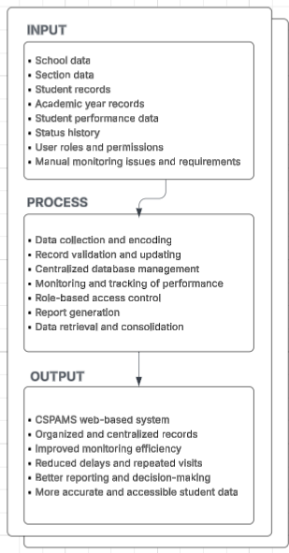
Conceptual Framework
The IPO (Input-Process-Output) model defines how the required data and operational prerequisites are fed into the system as it processes through the program's logical processes as shown in the figure 3.2, and its processes and output.
Figure 3. 2. Input-Process-Output
Another figure illustrates the CSPMS workflow where the School Admin inputs, or updates the student performance metrics and lifecycle status, which then instantly synchronized via a secure, encrypted database:
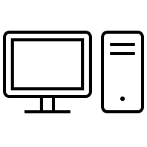
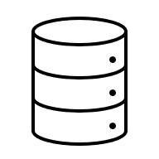
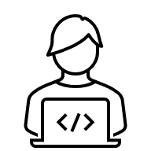
Computer
Database
School Admin

Figure 3.3
The figure below shows CSPMS automatically retrieves the stored data to calculate and generate Key Performance Indicators (KPIs), such as enrollment, dropout, and cohort survival rates which are then visualized through real-time dashboards to support the Division's monitoring and intervention efforts.
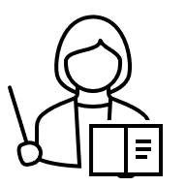
School Admin

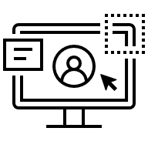

CSPAMS’ User Interface
Database

Division Monitor

Figure 3.4. The illustrated interaction

System Architecture
The system architecture of CSPMS serves as the formal blueprint and structural representation of the platform, designed to facilitate a comprehensive understanding of its centralized data management and real-time analytical behavior. It describes the specific roles and data access levels of its primary users like the School Admin and the Division Monitor, ensuring that the system effectively tracks the student lifecycle.
The system uses a web-based client-server architecture. For the presentation tier, CSPMS uses a React frontend created using TypeScript, React Router, Recharts, and Vite, along with Tailwind CSS for styling. For the application tier, CSPMS uses Laravel 11 with additional components from Filament for administration interfaces, Sanctum for authentication, Reverb for real-time functionality, Spatie Permission for role and permission management, and DomPDF for generating documents. For the data tier, CSPMS uses a relational database with Laravel's migration and seeding capabilities. During development, the Vite configuration forwards requests to the APIs, sanctum, and broadcasting to the Laravel backend. The architecture is designed to separate interface concerns from business logic and data storage. This separation supports maintainability, scalability, and clearer control over authentication, authorization, record handling, and reporting functions.
A. Use Case Diagram
A visual blueprint to describe and validate the specific interactions between the system’s two primary roles the School Head and Division Monitor and the platform's core functionalities. It illustrates how data flows from individual school-level updates into centralized platform, evolving from a functional representation of student lifecycle tracking into a detailed technical realization of real-time data synchronization.

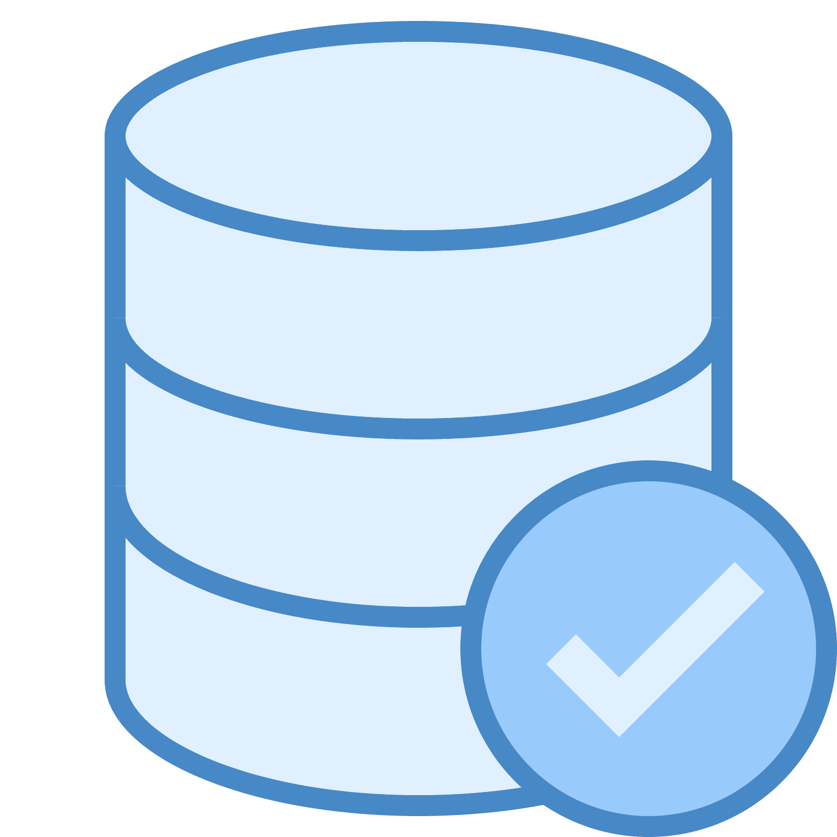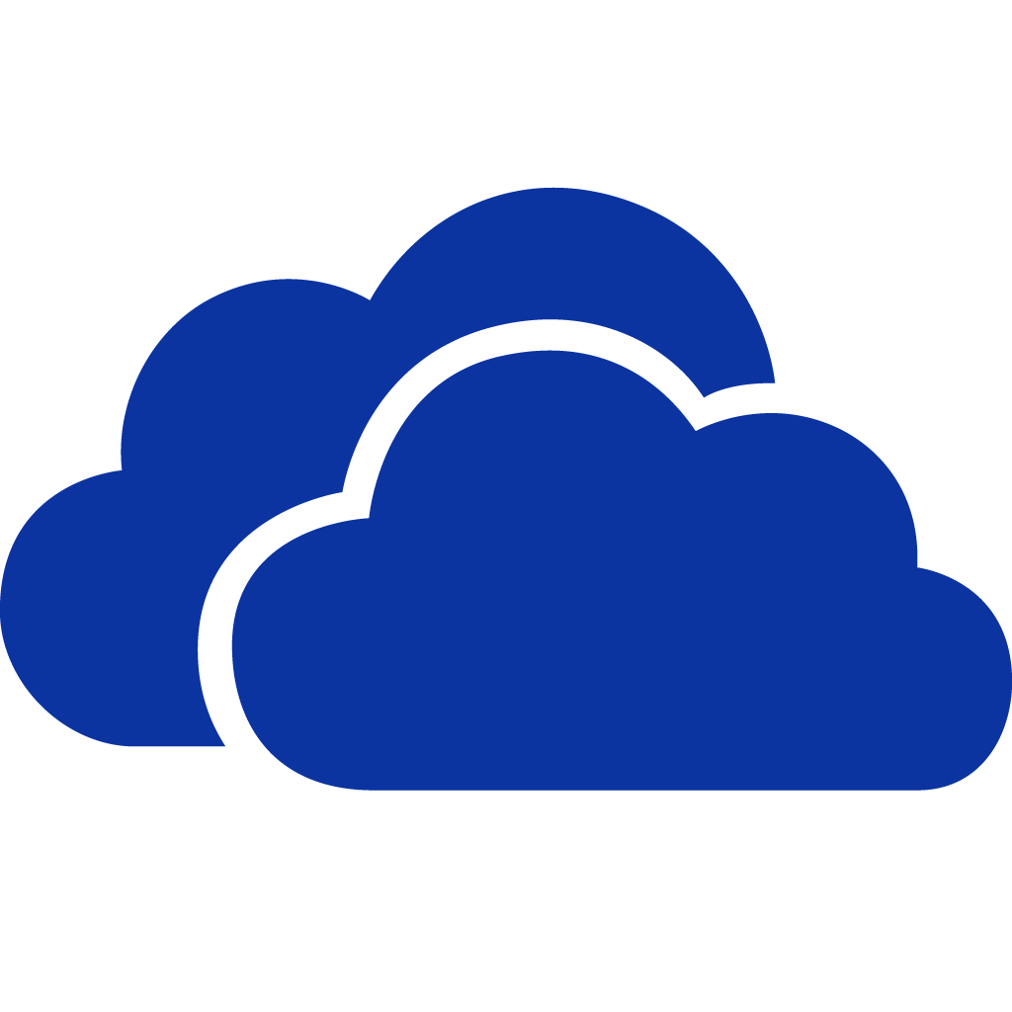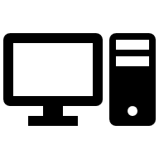
- Manage Student records within assigned school
- Update learner status & related information
- Create and update indicator packages
- Submit compliance packages for monitor reviews
- View history or feedbacks
- Access division-wide data
- Review history or feedback
- Review data
- Validate data
Verify
Response
School Admin
School Monitor
Figure 3.5
Conceptual Design
The conceptual design phase focuses on creating a system that will integrate various interrelated inputs at the school level within its data environment to facilitate real-time communication with the division level. This phase of the design considers the various ways of synchronizing scattered data into a single database, taking into account that the system will facilitate the extraction of value through automated KPIs and smart insights to address problems of delayed reporting and scattered student tracking.
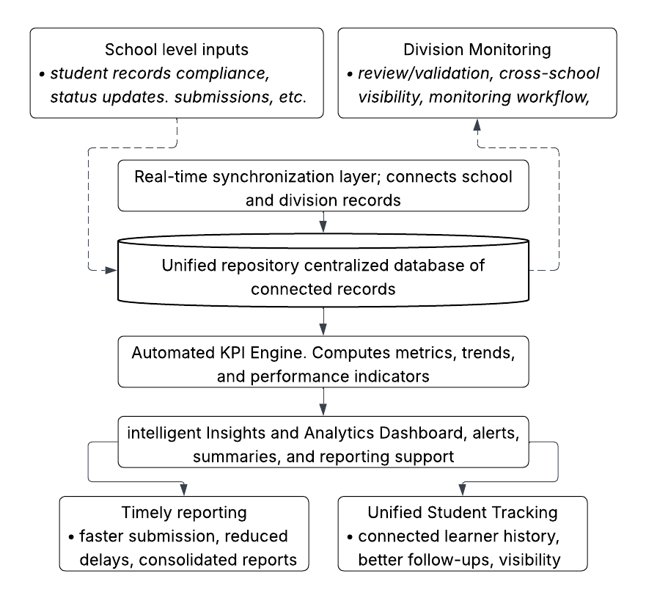
Figure 3.6. CSPMS’ Unified Data Environment
System control and data access are governed by a multi-tiered hierarchy designed to track the student lifecycle and academic performance. The process is initiated by the School Head who serves as the primary data source by managing individual learner records and entering critical metrics such as Learner Reference Numbers, attendance rates, and Mean Percentage Scores for various subjects. Once a record is saved, the system utilizes real-time listeners to instantly synchronize the information with a centralized database which eliminates the traditional need for manual and delayed documents reporting.
This data flow allows the Division Monitor to log in and access aggregated district-level data to oversee school performance and ensure alignment with the Basic Education Monitoring and Evaluation Framework as they could access the city-wide analytics through live dashboards that provide intelligent summarization and alerts regarding dropout rate increases to facilitate immediate educational interventions.
Every update is secured via encryption and stored in a unified database to maintain a longitudinal timeline that prevents lost student records during school-to-school transitions.
Cost Benefit Analysis
- System Implementation
Table 3.1. System Implementation focuses on the Initial Setup and Development Costs. It compares what you need to build the system for the first time. Shows the difference between the present and the proposed system with regards to the accumulated expenses in Philippine peso.
PRESENT SYSTEM |  |  | PROPOSED SYSTEM |  |  | VARIANCE
Description | Qty | Amount | Description | Qty | Amount | Qty | Amount | Remarks
HARDWARE |  |  | HARDWARE
a, Computer Unit | 4 | ₱80,000 | A. Computer | 1 | ₱20,000 |  | 60,000
b. Internet/Router | 1 | ₱1,213 | B. Router | 1 | ₱1,213 |  | 0
MANPOWER |  |  | MANPOWER
c. System Admin | - | - | C. System Admin | 1 | 0
Differences / Total | 5 | ₱81,213 | diff./total | 3 | ₱21,213 |  | 60,000 | Favorable

- System and Procedure
Table 3.2. System Procedure focuses on the Operational and Maintenance Costs. It compares what it costs to run the system on a daily, monthly, or per-transaction basis. Shows the difference between the present and the proposed system with regards to the accumulated expenses in Philippine peso.

PRESENT SYSTEM |  |  | PROPOSED SYSTEM |  |  | VARIANCE
Description | Qty | Amount | Description | Qty | Amount | Qty | Amount | Remarks
HARDWARE |  |  | HARDWARE
A. Computer | 4 | ₱80,000 | A. Computer | 1 | ₱20,000 |  | 60,000
B. Router | 1 | ₱1,213 | B. Router | 1 | ₱1,213 |  | 0
MANPOWER |  |  | MANPOWER
C. System Admin | - | - | C. System Admin | 0 | 0
diff./total | 5 | ₱81,213 | Differences / Total | 2 | ₱21,213 |  | 60,000 | Favorable

- System Development
Table 3.3: System Development shows the expenses of the researchers during the development of the proposed system.
PRESENT SYSTEM |  |  | PROPOSED SYSTEM |  |  | VARIANCE
Description | Qty | Amount | Description | Qty | Amount | Qty | Amount | Remarks
MANPOWER |  |  | MANPOWER
 | - | - | I. System Developer | 2 | 0 | (2) | (0)
 | - | - | II. System Researcher | 2 | 0 | (2) | (0)
 |  |  | Legend for System Developer:
 |  |  | 1 year = 0
 |  |  | 1 month = 0
 |  |  | 1 week = 0
 |  |  | 1 day = 0
 |  |  | Legend for System Researcher:
 |  |  | 0 min = 1 day
 |  |  | 0 hr = 1 day
 |  |  | 0 week = 6 days
 |  |  | 0 month = 24 days
diff./total | - | - | Differences / Total | 4 | 0 | (4) | (0) | Favorable

Table 3.4: Summary shows the comparison between the present and the proposed system with regards to financial assets.
Description | Present System | Proposed System | Variance | Remarks
I. System Implementation | ₱80,000 | ₱20,000 | ₱60,000 | Favorable
II. System Procedure | ₱80,000 | ₱20,000 | ₱60,000 | Favorable
III. System Development |  | 0 | 0 | Favorable
TOTAL | ₱160,000 | ₱40,000 | ₱120,000 | Favorable
Ratio and Cost Reduction
Cost Ratio (Present ÷ Proposed) | 4x
Cost Reduction Rate ((Present - Proposed)/Proposed) | 300%

$Ratio=\frac{Present System}{Proposed System}$ $Ratio\frac{Present System - Proposed System}{Proposed System} x100$
$Ratio=\frac{160,000}{40,000}$ $Ratio\frac{160,000 - 40,000}{40,000} x100$
=0.91 =300%
For every 0.91(peso) invested from the present system 300% will be cost less from original investment
Requirements Analysis
To ensure functionality, the system requires the following:
Hardware Requirements
Authorized computers or laptops for school heads and SDO monitors. (Note: The project does not provide physical hardware)
Hardware Requirements
Category | Minimum | Recommended
Processor | Dual-core 1.5 GHz | Quad-core 2.0 GHz or higher
RAM | 2 GB | 4 GB or higher
Internet Connection | 1 MB/s | 5 MB/s or higher
Display Resolution | 1080 x 720 | 1920 x 1080 or higher
Peripherals | Monitor, Mouse, and Keyboard | Monitor, Mouse, and Keyboard

Software Requirements
The following minimum requirements and the recommended version were
Software Requirements
Category | Minimum | Recommended
Operating System | Windows 7 / Ubuntu / macOS | Windows 10 / Ubuntu / macOS
Web Browser | A working Web Browser | Latest version of Google Chrome or Firefox
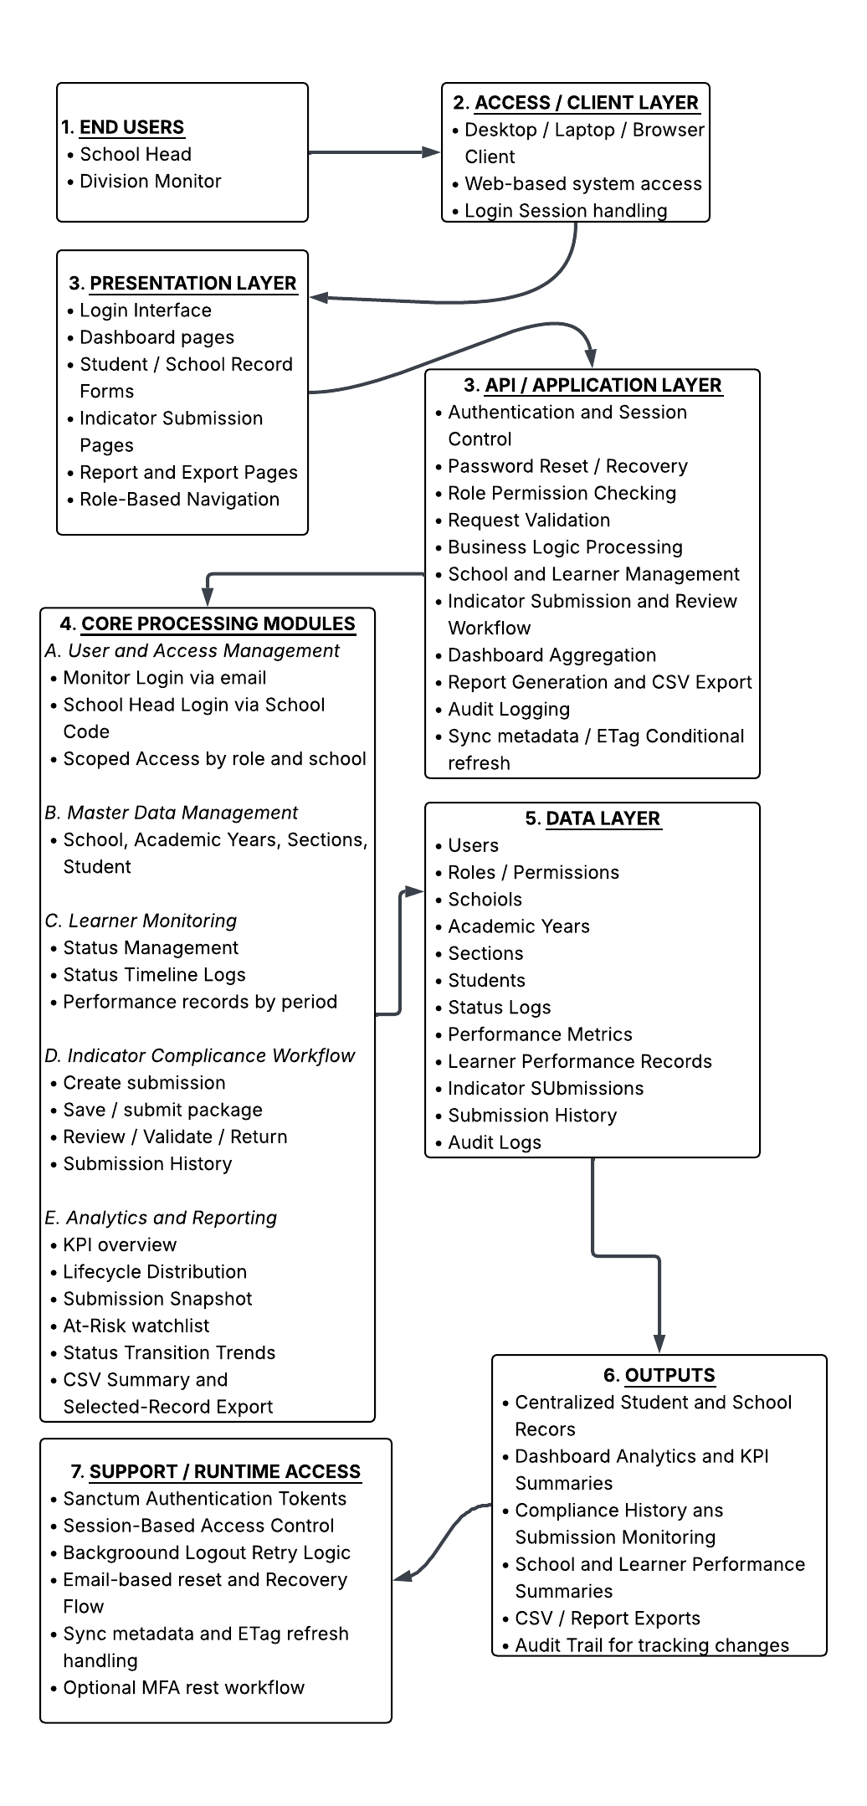
Requirement Analysis

The expanded Requirement Analysis diagram of CSPMS shows the complete flow of information and processing within the system. At the top level, the primary users are the School Head and the Division Monitor. These users access the system through a web browser using a desktop or laptop client. The browser serves as the entry point to the system and allows the users to interact with the application interface. The repository documents these two principal roles and their different authentication flows: monitors sign in using email, while school heads sign in using a 6-digit school code.
The next layer is the presentation layer, which is built using React, TypeScript, and Vite. This layer is responsible for rendering the user interface, including the login page, dashboard, forms for school and student records, indicator submission pages, and report views. It also controls role-based navigation so that each user sees only the pages and functions appropriate to their assigned role. The project’s documented frontend behavior includes dashboard views, record pages, reporting pages, and SPA login/session handling.
Beneath the presentation layer is the API and application layer, which is powered by Laravel. This layer handles the main system logic, including authentication, request validation, business rules, school and learner management, indicator submission workflow, reporting, audit logging, and synchronization behavior. The repository specifically documents an API sync layer using Sanctum authentication, dashboard record endpoints, and ETag-based conditional refresh, as well as compliance submission endpoints for create, submit, review, and history operations.
Within the application layer are the system’s core processing modules. These include user and access management, master data management, learner monitoring, indicator compliance workflow, and analytics/reporting. The implemented scope includes schools, academic years, sections, students, learner status management, status timeline logs, performance tracking by period, division-wide indicator review, KPI dashboards, lifecycle distribution, submission snapshots, at-risk watchlists, and CSV exports. These modules form the operational core of CSPMS and show that the system is not only a record-keeping platform but also a monitoring and decision-support tool.
At the bottom is the data layer, which consists of the relational database and persistent records used by the system. This layer stores user accounts, roles and permissions, schools, academic years, sections, students, learner status logs, performance metrics, learner performance records, indicator submissions, submission history, and audit logs. These stored records support the generation of centralized records, dashboard summaries, compliance histories, school and learner performance reports, exports, and audit trails.
The architecture also includes runtime support services. The repository documents support for Sanctum-based authentication tokens, password reset and recovery flows, optional MFA reset workflow, background logout token revocation, and synchronization metadata for frontend refresh control. These support services strengthen the overall architecture by improving security, session handling, and system responsiveness.
A. Flowchart
The flowchart of the system may be divided into two primary workflows: the School Head workflow and the Division Monitor workflow.
SCHOOL HEAD / ADMIN WORKFLOW
Select Function
Retry
Start
Decision
Login (School Head)
Dashboard
Submission
Manage Students
Enter Performance
Update Status
View Reports
End

Start
End
Login (Monitor)
Retry
Decision
Dashboard
View Data
Review Submission
Generate Reports
View Analytics
Return with remarks
Approve
Decision
Select Function
No
No
Yes
B. Entity Relationship Diagram
The Entity Relationship Diagram (ERD) of CSPMS presents the logical design of the system database. It shows the major entities included in the system, the attributes stored in each entity, and the relationships that connect one entity to another. The ERD serves as the structural foundation of the database because it defines how records are organized, linked, retrieved, and maintained within the system.
For CSPMS, the ERD is essential because the system handles multiple categories of data that must remain consistent and traceable. These include user accounts, school records, academic year records, sections, students, learner performance information, learner status tracking, indicator submissions, submission items, and audit histories. Since the system is intended to support both school-level and division-level monitoring, the database must be organized in a way that prevents duplication, preserves relationships between records, and allows efficient access to current and historical data.
The ERD is designed so that each major object in the system is represented as an entity. These entities are connected through primary keys and foreign keys to preserve referential integrity. Through this structure, the system can trace which student belongs to which school and section, which records belong to a particular academic year, which submission was created by a particular school, and which changes were made by a specific user.
Major Entities in the ERD
The following are the major entities included in the database design of CSPMS:
1. They are the entities that stores the account information of authorized system users. This includes login credentials, role assignments, and profile-related information. Users may represent Division Monitors, School Heads, or other authorized personnel depending on the final role structure of the system. This entity is important because access to the system is role-based, meaning different users have different permissions and visibility over records.
2. The school’s entity stores the profile of each participating school. This may include the school’s name, school code, address, and other identifying information. The school acts as a major reference entity because sections, students, and school-based submissions are associated with it.
3. The Academic Years entity stores the school year, or academic cycle covered by the system, such as 2025–2026. This entity is necessary because records in CSPMS are period-based. Student performance, submissions, and school-related monitoring data must be organized according to a specific academic year.
4. The Sections entity stores the class or grouping information of students. A section is associated with a school and an academic year. This allows the system to identify where a learner is currently assigned and to group students properly for monitoring and reporting purposes.
5. The student’s entity stores the individual learner records managed by the system. This includes personal identifiers, enrollment-related information, section assignment, school assignment, and academic year references. The student is one of the central entities of the database because much of the monitoring process revolves around student records.
6. The Performance Metrics entity stores the categories or measures used in evaluating student performance. These metrics define the type of performance data that can be encoded, tracked, and reported in the system.
7. The Student Performance Records entity stores the actual performance entries of students. These records connect a student to a performance metric, an academic year, and possibly a reporting period. This entity allows the system to monitor academic or performance-related progress over time.
8. The Student Status Logs entity stores changes in the status of a student. Examples may include enrolled, at risk, dropped out, transferred, completed, or graduated. This entity is important because student status is not always static. Instead of overwriting the old status, the system keeps a history of status changes for monitoring and analysis.
9. The Indicator Submissions entity stores the main submission package created by a school for compliance or monitoring purposes. This entity records who submitted the package, when it was submitted, what academic year it belongs to, and its current review status.
10. The Indicator Submission Items entity stores the detailed components under a submission. Since a single submission may contain multiple indicators or required entries, this entity is separated from the main submission record. This design supports a one-to-many relationship between the submission header and its detailed items.
11. The Form Submission Histories entity stores the history of actions performed on submissions, such as draft creation, submission, validation, return for revision, and approval. This allows the system to keep a complete trail of the submission lifecycle.
12. The Audit Logs entity records important actions performed in the system, such as adding, updating, reviewing, approving, or deleting records. This entity strengthens accountability and traceability since it provides a historical record of who performed a specific action and when it occurred.
Relationship of the Entities
The ERD of CSPMS is structured around several major one-to-many relationships.
A school may have many sections because one school can operate several class groupings. A school may also have many students, since multiple learners are enrolled under one school. In the same way, one academic year may be related to many sections, students, performance records, and submissions because these records are organized according to a specific period.
A section may have many students, but each student is assigned to only one current section at a given time. A student may have many student performance records because performance data can be recorded across multiple periods or categories. A student may also have many student status logs because the student’s status may change over time and must be preserved historically.
An indicator submission may have many indicator submission items, since one submission package can include several required indicators or compliance entries. In addition, one submission may also have many form submission history records, because multiple actions may be performed on the same submission from drafting to review and approval.
A user may create, update, review, or approve many records, which is why users are often linked to entities such as submissions, status logs, and audit logs. Likewise, audit logs may refer to multiple key entities because they record activities across the entire system.
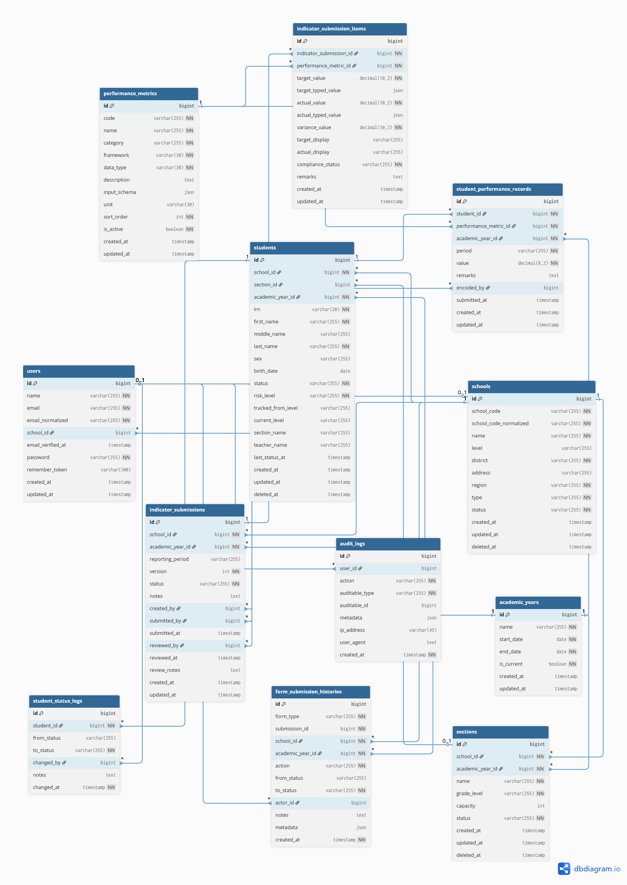
- One School can have many Sections and many Students.
- One Academic Year can have many Sections, Students, Performance Records, and Indicator Submissions.
- One Section can contain many Students.
- One Student can have many Performance Records and many Status Logs.
- One Indicator Submission can have many Indicator Submission Items and many Submission History records.
- One User can create or update many records.
- Audit Logs record actions performed on system entities.
Input Process Output Analysis
The IPO model for CSPMS illustrates the transformation of raw educational data into actionable insights for the DepEd Sch
Input
Process
Output
- The inputs of the system include school records, student records, academic year information, sections, learner status data, performance entries, indicator compliance data, user accounts, and role permissions.
- The processes of the system include user authentication, validation of records, storage and updating of data, learner lifecycle tracking, indicator package preparation, submission and review, reporting, dashboard computation, and audit logging.
- CSPMS: A Centralized School Performance and Monitoring System for SMM&E

ANALYSIS:
The proposed system helps to streamline school operations by bringing all student and school information into one centralized platform. Student information, learner records, enrollment data, and compliance forms are processed to produce outputs such as school performance summaries, enrollment reports, and dropout alerts. The system also tracks student status changes and monitors school compliance with DepEd standards, ensuring that all required data is complete and up to date.
Additionally, the system provides insights into student performance and school progress, allowing school head and division monitors to make data-driven decisions. School heads can easily access their school's records, while division monitors can view city-wide trends and identify schools that need assistance. The management system saves time and resources by eliminating manual paperwork and repeated site visits, reduces errors through automated calculations, and provides better service to students and staff by ensuring that learner records are always accurate and readily available when needed.
Description of the prototype
The CSPMS prototype is a web-based monitoring and record management system developed for division-school workflows. The current prototype is composed of integrated modules that correspond to the actual implemented scope of the project.
- the system includes role-based authentication for School Heads and Division Monitors. The project documentation states that School Head accounts use a 6-digit school code, while monitor users have their own monitor credentials. The authentication flow also includes password reset capabilities and role-scoped access.
- the prototype provides master data and learner management. It includes modules for schools, academic years, sections, and students. The system supports learner tracking through school and student records and uses a database-backed structure to keep those records organized.
- the system includes learner lifecycle tracking. The repository documents status management and status timeline logs, while the user manual describes status-oriented student record management that includes enrolled, returning, transferee, at-risk, dropped out, completer, and graduated states. This enables the system to capture changes in student condition over time instead of storing only a single static record.
- the prototype includes indicator compliance workflows. School Heads can prepare compliance packages, save them as drafts, and submit them for review. Division Monitors can access these submissions, review them, validate them, or return them with notes, while the system preserves workflow history.
- the system includes dashboard and reporting features. The README documents KPI overviews, lifecycle distribution, submission snapshots, at-risk watchlists, and trend views. The user manual also documents report generation and export-oriented workflows.
- the system includes governance and security features such as scoped access by role, audit logging, and permission control. These features are important because the records handled by the system are operationally sensitive and should only be accessible to authorized users.
System Implementation Plan
The researchers propose the parallel implementation method for CSPMS. In this method, the present manual process and the proposed computerized system are run side by side for a limited pilot period. This approach is recommended because school and student records are critical and must not be disrupted by an abrupt transition.
During the initial stage, the current manual process remains available while selected users begin using CSPMS for actual encoding, submission, and monitoring tasks. The outputs of the system may then be compared with the existing process to verify correctness, completeness, and usability. Any errors, mismatches, or workflow issues identified during this period can be corrected before wider implementation.
The implementation plan may follow these stages:
- Preparation Stage – installation, account setup, and orientation of pilot users.
- Data Validation Stage – checking initial school and learner records for accuracy.
- Pilot Parallel Run – running manual and digital processes simultaneously.
- User Training and Refinement – collecting feedback and improving the system.
- Operational Adoption – increasing actual use of the system in regular workflows; and
- Maintenance and Support – handling updates, issue resolution, and continued monitoring.
This implementation plan is appropriate for CSPMS because it reduces operational risk and allows the researchers and users to validate the system progressively.
Respondents of the study
The primary respondents and participants for the system's testing and evaluation include the School Heads and the DepEd SMM&E Unit Monitors. School Heads serve as the primary users who are responsible for managing student records, updating enrollment statuses through the use of Learner Reference Numbers (LRN), and submitting required digital forms.
Method Used in Data Gathering
This section of the chapter presents the methods the researchers used to gather and measure the necessary data, particularly on the variables of relevance for the study. The following are used by the researchers to obtain the needed information required in the study was gathered through a multi-faceted approach:
Interview Method
The interview method was used to gather information directly from the intended users of the system, such as school personnel and monitoring staff. Through interview sessions, the researchers identified the present workflow, reporting requirements, challenges in manual monitoring, delays in submission, and the common reasons for repeated school visits and incomplete records. This method helped the researchers understand how the current process operates in actual practice.
Observation Method
Observation was used to examine the actual manner by which data are manually collected, checked, and consolidated. This method enabled the researchers to see the practical difficulties experienced by the users, including repeated follow-ups, physical visits, incomplete documentation, and delayed validation of records. Observation was important because it provided first-hand knowledge of the operational gaps that the system must address.
Document Review Method
The researchers reviewed available forms, reporting formats, school records, and related documents used in the current workflow. This method was necessary to determine the data fields, reporting structure, and compliance information that must be represented in the system. It also helped in defining the entities, modules, and reports needed in CSPMS.
Internet and Library Method
The internet and library methods were used as supplementary sources of information. These sources were consulted to gather references on software development, prototyping, database design, web-based systems, access control, system evaluation, and related studies. These references guided the technical and methodological structure of the project. The uploaded Chapter III template also includes internet and library research as supporting data-gathering approaches, which this draft retains.
Survey Questionnaire
A survey questionnaire was used to collect evaluative feedback from the respondents regarding the proposed system. The questionnaire focused on the system’s usability, convenience, organization of records, speed of access, ease of navigation, and overall usefulness. The results of the questionnaire served as a basis for assessing the acceptability of the system.
Method used in Data Analysis
To determine the effectiveness of the CSPMS project, the researchers analyze the accuracy of automated calculations and the speed of report generation compared to manual methods.
Pre-Survey Questionnaire
Part I. Profile and Current Practice
Direction: Put a check mark on the answer that applies to you.
Yes / No Questions
- Are you currently involved in student monitoring, school reporting, or compliance-related tasks? Yes / No
- Do you handle or review student records as part of your work? Yes / No
- Do you experience delays in collecting or consolidating records manually? Yes / No
- Have you encountered incomplete or missing data during manual collection? Yes / No
- Do you need to revisit or follow up with schools because of incomplete submissions? Yes / No
- Do you use paper-based or manually encoded records in your current process? Yes / No
- Have you experienced difficulty retrieving old student or school records when needed? Yes / No
- Do you think the current monitoring process consumes too much time and effort? Yes / No
- Have you used any digital system before for monitoring or reporting? Yes / No
- Do you believe a centralized system could help improve the current process? Yes / No

Part II. Initial Perception of the Proposed System
Direction: Indicate whether you Agree or Disagree with each statement.
- The current manual process of monitoring and reporting is difficult to manage. Agree / Disagree
- Manual collection of school and student data can lead to delays. Agree / Disagree
- Repeated follow-ups with schools make the monitoring process less efficient. Agree / Disagree
- Organizing records manually increases the risk of errors or missing information. Agree / Disagree
- A computerized system would make record management easier. Agree / Disagree
- A centralized database would help improve data retrieval and monitoring. Agree / Disagree
- A web-based monitoring system would be useful in the actual work setting. Agree / Disagree
- Role-based access is important in a system that handles student and school records. Agree / Disagree
- A system like CSPMS could improve reporting and submission workflows. Agree / Disagree
- I am willing to use a system like CSPMS if it is implemented. Agree / Disagree

Frequency Scale Formula used in computing the result is:
To compute the frequency of specific system errors or user interactions, the following formula is used:
$$Rating= \frac{Total Number of Answers}{Total Number ofRespondents}x 100=Average Yes/No$$
The researchers used the Likert Scale statistical technique to analyze the post-survey result of the proposed system. The respondents were asked based on their agreement with the statement using responses such as Outstanding (O), Very Satisfactory (VS), Satisfactory (S), Unsatisfactory (US), and Needs Improvement (NI). The Likert Scale statistical technique is regarded as the most precise and objective method in research
The Likert Scale Formula used in computing the result is:
$$Rating =\frac{(SA * 5) + (A * 4) + (U * 3) + (D * 2) + (SD * 1)}{Total number of Respondents}$$
The proposed system was evaluated wherein Likert Scale was used to determine the result of the survey among its users. Each response receives a rating 1 to 5.
Qualitative Description | Rating Scale
Strongly Agree (SA) | 4.51 – 5.00
Agree(A) | 3.51 – 4.50
Undecided(U) | 2.51 – 3.50
Disagree(D) | 1.51 – 2.50
Strongly Disagree (SD) | 1.00 – 1.50

Methods Used in System Development.
The structured system development methodology in the design and development of the Centralized School Performance Analytics and Monitoring System (CSPMS).
A Gantt Chart was used as a major planning and scheduling tool. The Gantt Chart outlined a timeline of each development phase of the project, helped to identify relationships between tasks, and guided the sequence of implementation phases.
The ERD was the primary tool that was utilized in the development of the database design of the CSPMS. The ERD was the logical data model that identified the basic data entities that the database would be composed of, namely the learners, the schools, the school sections, the school periods, the submissions, and the records, as well as the relationship of these data entities to one another. By means of the ERD, the essential data attributes that the system would be required to have were specifically identified, as well as the relationship of these data attributes to one another, in order to store, retrieve, and report the data accurately.
Flowcharts, storyboards, and the Input–Process–Output (IPO) model were used to document and communicate how the system works from both a procedural and user-interaction perspective.
- Flowchart - was developed to represent the sequence of steps in the existing manual workflow and the proposed CSPMS workflow
- Storyboard - was used to illustrate the user’s experience and screen-by-screen interaction with the system
- Input – Process – Output - model was used to present the system’s conceptual structure in a clear and logical format. It summarized: (a) the inputs required by CSPMS (e.g., learner details, performance indicators, submissions, and records), (b) the processing performed by the system (e.g., validation, computation, categorization, consolidation, and report generation), and (c) the outputs produced (e.g., monitoring summaries, dashboards, status reports, and analytics views). The IPO model supported requirement validation by ensuring that every required output is traceable to explicit inputs and system processes.
- Cost-Benefit Analysis - was conducted as part of the feasibility study to determine whether implementing CSPMS is justified in terms of resource requirements and expected benefits.
Methods Used in System Evaluation
To appraise the effectiveness and performance of CSPMS, various systematic methods of evaluation were used.
System Evaluation (Operational and Economic Feasibility). The evaluation of the assessment involves determining how well it performs and whether it makes economic sense by examining whether the system meets the goals it was designed for.
Usability Testing. For usability testing, we used real users, who are either school administrators or heads, along with the monitoring staff. They were asked to perform tasks using the CSPMS prototype.
Inspection Method. The inspection method is used to evaluate the user interface (UI) through the examination of the screens in order to identify potential areas for enhancement. This approach enabled the early detection of usability and consistency issues in the interface and refinement towards enhancing its comprehensibility and usability for the end-user.
Inquiry Method. It is a method of collecting qualitative data from the user through questioning them. This method assists in collecting user comments, suggestions, needs, and preferences, helping the researcher to identify certain system functions or features of the dashboard that need improvement, hence aligning the features with user expectations.
Questionnaire. A questionnaire is developed and administered for the respondents; it is primarily used to collect information to measure user perceptions in relation to how accurate, convenient, and how the system is understood, as well as whether the respondent could absorb the system. It collects similar data from different schools in our division, which allowed us to evaluate user responses for the CSPMS evaluation process.

