KubeVision
An Image Classification Pipeline on Kubernetes — Milestone 1: Architecture
Course: CSC 478 — Cloud Engineering
Instructor: Dr. Linh Ngo
Student: Angeudy Brisita Perez
Milestone: 1 of 3 — Architecture (design only)
Submitted: October 5, 2026
Revised: October 23, 2026 (renamed from KubeBalancer; overview rewritten to match the classification premise)
Repository: https://github.com/angeudybp/csc478-project
Project idea: Image Classification Pipeline on Kubernetes

1. Overview
Photos pile up faster than anyone can sort them. Tagging a folder of pictures, checking what a trail camera caught, or routing product photos to the right catalog section all start with the same question: what is in this image? KubeVision answers it. Upload a JPEG or PNG and get back the most likely label, how confident the model is, and the next two candidates, all in one request. Every upload is saved with its result, so a past prediction can be looked up later and both the original and the exact 224×224 image the model saw can be downloaded. Behind that single request is a small pipeline built to keep working: each stage runs as its own Kubernetes service, the model tier scales out to three replicas, and a failed pod is replaced while the others keep serving. KubeVision follows the course’s template project, an image classification pipeline on Kubernetes, and uses a small pre-trained model (MobileNetV2) so the work goes into orchestration rather than training.
KubeVision is a small image classification service on Kubernetes. A user uploads an image to a single REST endpoint and gets back the label and the confidence score. Four microservices perform different parts of the task:
- Gateway — performs uploads validation and orchestrates the rest of the services;
- Preprocess — resizes and normalizes images for the model;
- Inference — executes MobileNetV2 model (scaled to 3 replicas with metrics sidecar);
- Storage — stores the original image, the preprocessed image, and the output so that they could be retrieved later.
Everything runs on a single-node Minikube cluster which allows this project to be replicated in any user’s machines. Three design choices drive the architecture:
- A centralized gateway instead of chain of calls from one service to another. The solution introduces one additional network hop, but ensures that there is precisely one public entrypoint in the system and all the other components are easy to implement.
- Synchronous requests instead of message queue. While the queue could handle a higher load more efficiently, implementing it would mean moving the project focus from Kubernetes to distributed messaging.
- Single service to store the data. Only the storage service has a persistent volume.

2. User Stories and Data Flow
US-1 — Image classification. I want to send an image, to get the predicted class of it with the corresponding confidence score so that I can use it for image classification without installing any software.
• POST /api/v1/images with a valid file less than 8MB returns 200 with the imageId, label, confidence and the first 3 classes.
• The image file bigger than 8 MB results in error 413; non-image file bigger than 0 bytes results in 415. None of the errors causes pod crash.
• Tests: T1-T6.
US-2 — Retrieve a result. I want to be able to get my previous prediction and the associated with it image IDs to have my results available for retrieval later.
• GET /api/v1/results/{imageId} gives me the saved prediction and if I request a wrong imageId, the system returns 404 error.
• I can download the original and the processed images using image ID.
• The results stay available even after recreating the storage pod. Tests: T7, T11.
US-3 — Scale out and survive. I want to scale the inference tier and lose individual pods, so that the traffic never stops.
• The inference scales up to 3 replicas and the metrics sidecar shows the request load on each one of the pods.
• Deleting one of the inference pods automatically triggers creating it while the rest continue working.
• The gateway returns 503 code, when I stop the inference, instead of hang.
• kubectl delete -f . && kubectl apply -f . restores the whole stack without additional actions. Tests: T8-T10, T12, T13.
Figure 1 depicts the data path. An image upload goes through the pre-processing, inference and storage stages. Retrieving involves only gateway and storage services.
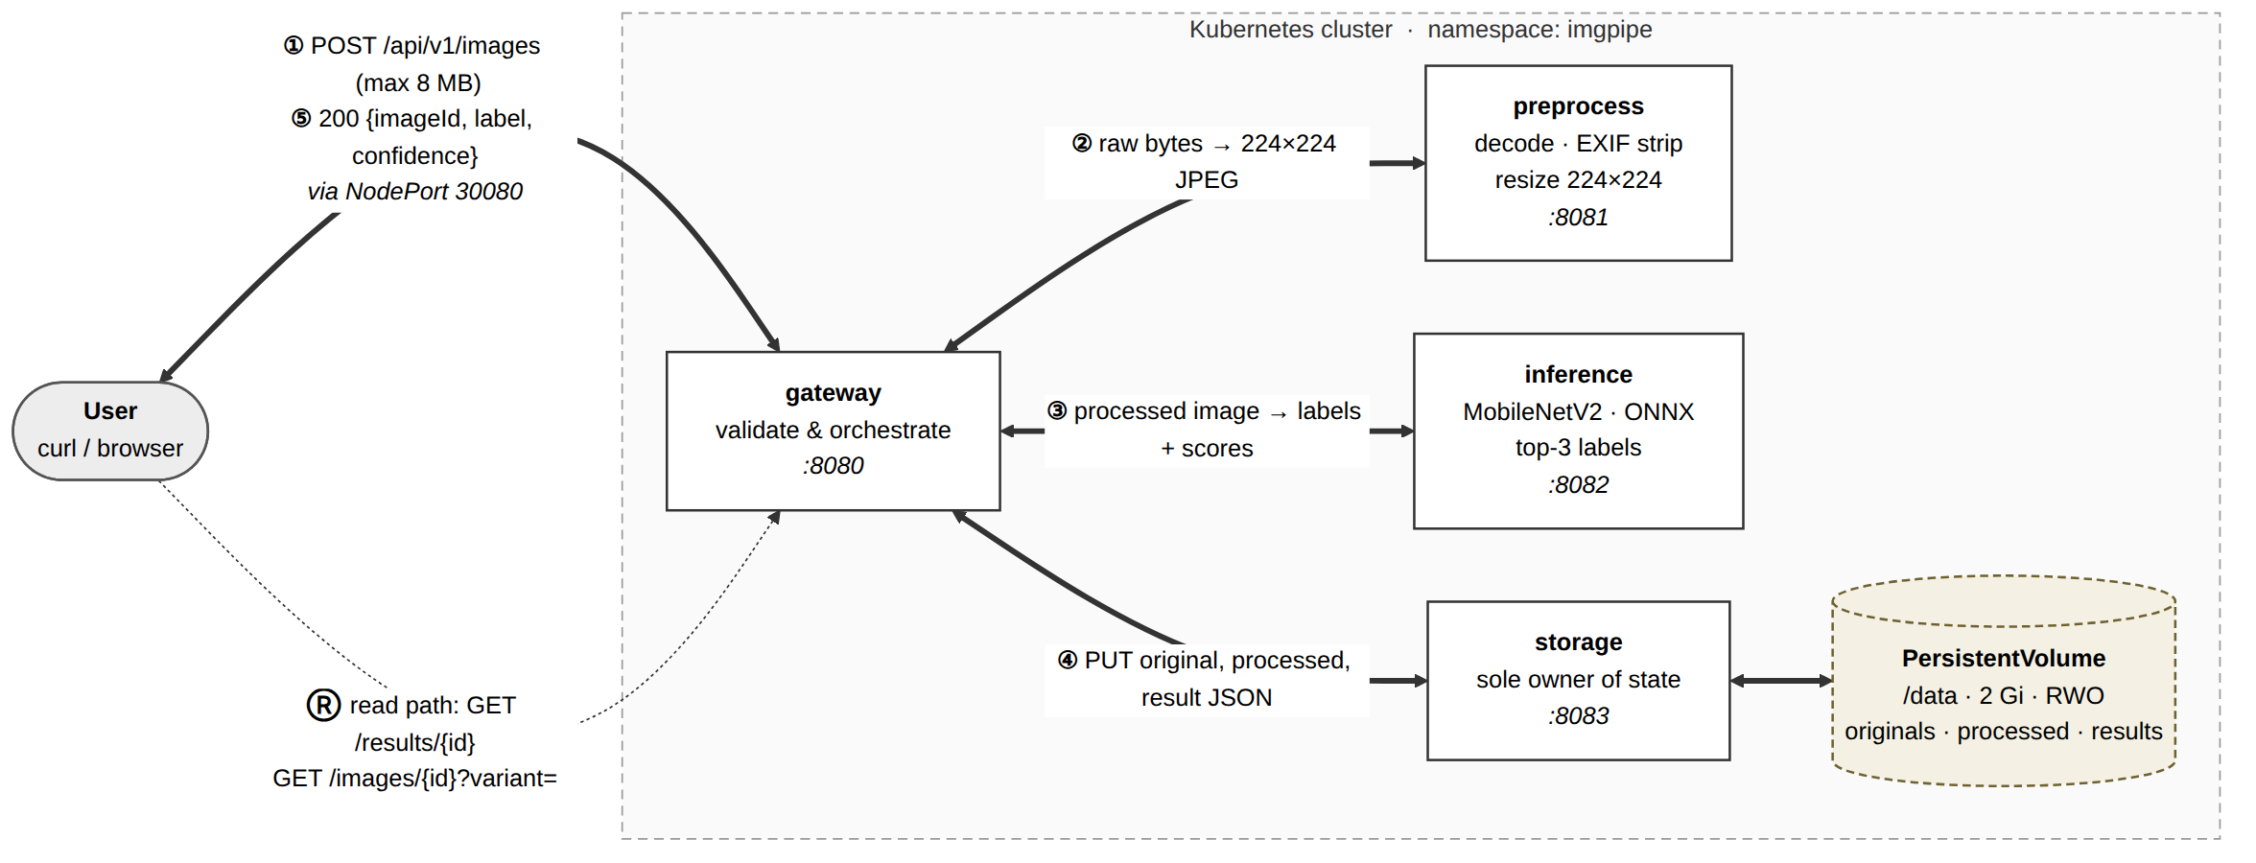
Figure 1. Data flow. Solid arrows are the upload path; dashed arrows are the retrieval path. Only the gateway is reachable from outside the cluster.

3. Architecture
The design follows the brief's constraints: exactly one external entrypoint, at least one multi-container pod, and one component scaled to three or more replicas. It targets single-node Minikube, which has no cloud load balancer and only one node for storage.

3.1 Components
Component | Containers | Replicas | Port | Responsibility
gateway | 1 | 1 | 8080 | Only public entrypoint. Validates uploads, calls the other services in order, and serves retrieval requests.
preprocess | 1 | 2 | 8081 | Decodes the image, removes metadata, resizes to 224×224, and normalizes it (Pillow).
inference | 2 | 3 | 8082, 9100 | Runs MobileNetV2 with ONNX Runtime and returns the top labels. Includes the metrics sidecar.
storage | 1 | 1 | 8083 | Owns the only persistent volume. Saves images and prediction records.
Table 1. Components. Inference is the only multi-container pod.
Why a separate gateway? Without it, the preprocessor would have to coordinate the whole pipeline, and storage would need to be public for retrieval to work. A gateway keeps preprocessing and inference focused on one job each and keeps stored data off the public network.
Why is preprocessing its own service? It is the stage most likely to change (image size, model type), and it is CPU-heavy while the gateway mostly waits on network calls. Splitting them lets each be scaled or replaced on its own.

3.2 Multi-Container Pod: Inference + Metrics Sidecar
Each inference pod includes two containers using an emptyDir volume at /var/log/app/:
- inference — model server, writes one JSON line (time, request ID, latency, result) per request into requests.jsonl.
- metrics-exporter — sidecar, reads the file and provides the request count, error count and p50/p95 latency statistics via HTTP at 9100 port.
They must be in one pod because the sidecar must read the file written by the application and must provide statistics for the specific replica. Separate Deployments cannot use shared emptyDir volumes. The placement of the sidecar on the scaled component proves the effectiveness of the load balancing – if there are three replicas, their metrics endpoints must have about the same number of requests. Drawback – metrics are stored in memory and are lost after the restart, and no Prometheus is provided; metrics are gathered via kubectl port-forward and curl.
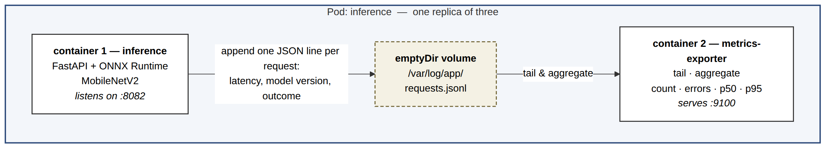
Figure 2. The inference pod. Both containers share a volume and network, so they run in one pod. Each replica has its own exporter.

3.3 Services and External Access
Service | Type | Ports | Reason
gateway-svc | NodePort | 30080 → 8080 | The single public entrypoint. Minikube has no cloud load balancer, so a LoadBalancer Service would stay Pending; NodePort works out of the box.
preprocess-svc | ClusterIP | 8081 | Internal only; balances across the two replicas.
inference-svc | ClusterIP | 8082, 9100 | Internal only; balances across the three replicas.
storage-svc | ClusterIP | 8083 | Internal only; only the gateway calls it.
Table 2. Service choices. Only gateway-svc is reachable from outside the cluster.
Services are reached by DNS name (e.g. preprocess-svc.imgpipe.svc.cluster.local), so no configuration changes when pods move. Figure 3 shows the full layout.
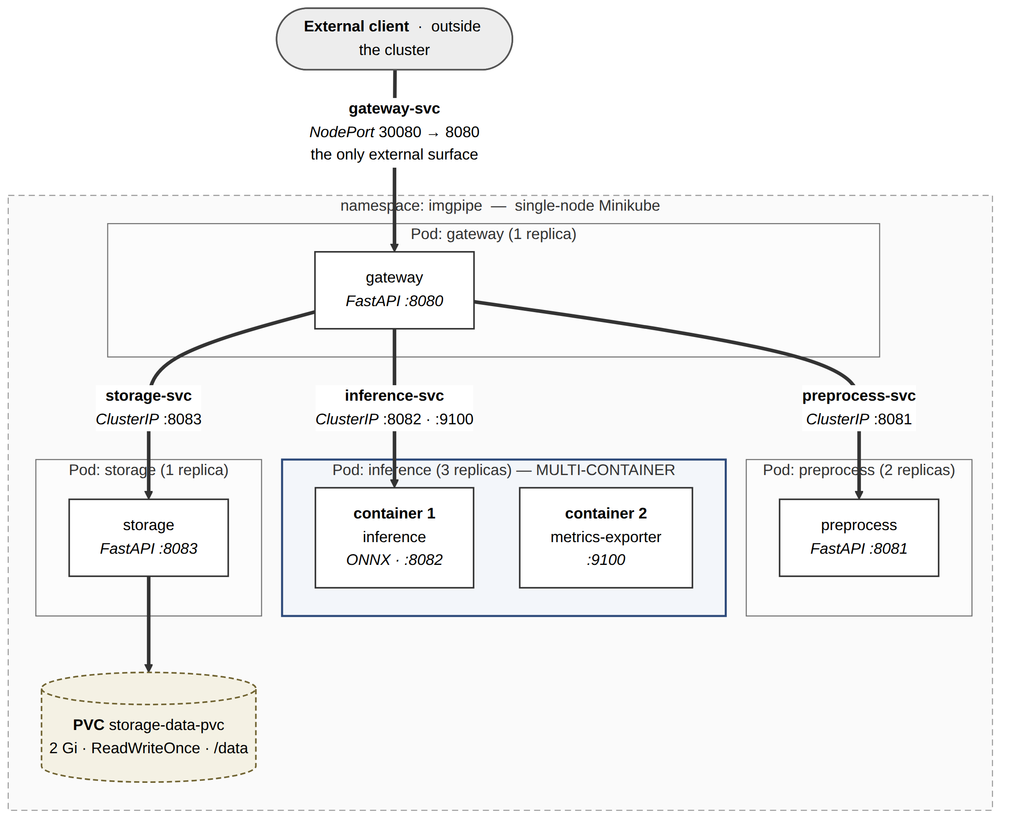
Figure 3. Kubernetes topology. Outlined regions are pods with replica counts; only gateway-svc crosses the cluster edge.

3.4 Request Flow and Timeouts
The gateway assigns each request an X-Request-Id and passes it to every service, so one request can be traced through all logs. The steps are:
- Validate — check file type and the 8 MB size limit before reading the whole upload.
- Preprocess — send the image to preprocess and get back a 224×224 JPEG.
- Infer — send the processed image to inference and get back the top labels.
- Store — save the original, processed image, and prediction to storage, then respond.
Hop | Timeout (target) | Retry
Client → gateway | 30 s | None — the client decides.
Gateway → preprocess | 5 s | Once, only if the connection failed.
Gateway → inference | 15 s | Never. Retrying a slow, overloaded tier makes it worse.
Gateway → storage | 5 s | Once, only if the connection failed.
Table 3. Timeout budget. Internal timeouts add up to less than 30 s, so a slow service produces a clean error instead of a dropped connection. These are targets, not measurements.

3.5 Scaling Target
Inference is scaled to 3 replicas. It holds no state, so replicas are interchangeable, and running the model is the most CPU-heavy step in the pipeline, so it will be the first to slow down under load. The gateway stays at 1 replica (it mostly waits on network calls), preprocess runs 2 for availability, and storage is fixed at 1 because its volume can only be attached to one pod (§5).

3.6 Main Tradeoff: Synchronous Requests
The gateway keeps the client connection open for the whole pipeline and returns the prediction in the same response. The alternative is a queue: accept the upload, return a job ID, and let workers process it in the background. A queue handles traffic spikes better, but it adds a message broker, retry handling, and job tracking — a lot of work that is not about Kubernetes. The synchronous design is simpler, and its failures are easy to see. The cost: when inference is overloaded, requests time out instead of waiting in line. Adding a queue is planned as a future improvement.

3.7 Reliability Settings
- Health checks. Every service has /healthz (is the process alive?) and /readyz (can it handle traffic?). Inference only reports ready after the model has loaded, so new pods never receive requests too early.
- Resource limits. Inference requests 256 Mi memory / 0.25 CPU, limited to 768 Mi / 1 CPU, with OMP_NUM_THREADS=1 so three replicas do not fight over CPU. Other services: 64 Mi / 0.05 CPU, limited to 256 Mi / 0.5 CPU.
- Images. Fixed version tags (never latest), loaded into Minikube with minikube image load. Model weights are built into the image so pods start without downloading anything.

3.8 Repository Layout
Everything runs in the imgpipe namespace. Manifest files are numbered so kubectl apply -f . creates them in the right order:
deployments/ 00-namespace.yaml 10-gateway.yaml 11-preprocess.yaml
12-inference.yaml 13-storage.yaml
services/ 20-gateway-svc.yaml 21-preprocess-svc.yaml
22-inference-svc.yaml 23-storage-svc.yaml
storage/ 05-storage-pvc.yaml
services-src/ gateway/ preprocess/ inference/ metrics-sidecar/ storage/

4. API Contracts
All services use JSON over HTTP (FastAPI, Python 3.11). Every error uses the same format so the gateway can pass errors along consistently:
{ "error": { "code": "PAYLOAD_TOO_LARGE", "message": "Upload exceeds 8 MB" },
"requestId": "7f3c1e9a" }

4.1 Public API (gateway)
Endpoint | Purpose
POST /api/v1/images | Upload an image (multipart, JPEG/PNG, max 8 MB) and get a prediction.
GET /api/v1/results/{imageId} | Get a saved prediction.
GET /api/v1/images/{imageId}?variant=original|processed | Download the original or processed image.
GET /api/v1/results?limit=20 | List recent predictions, newest first.
Table 4. Gateway endpoints.
Example request and response:
curl -X POST "http://$(minikube ip):30080/api/v1/images" -F "file=@dog.jpg"

{ "imageId": "img_01JAR7K2M9QX4T8B",
"label": "golden retriever", "confidence": 0.8734,
"topK": [ {"label": "golden retriever", "score": 0.8734},
{"label": "Labrador retriever", "score": 0.0612},
{"label": "kuvasz", "score": 0.0188} ],
"modelVersion": "mobilenetv2-1.0-onnx", "mock": false,
"timings": {"preprocessMs": 38, "inferenceMs": 121, "storageMs": 44, "totalMs": 207},
"requestId": "7f3c1e9a" }
Timings above are example values only.
Code | Error code | When
200 | — | Success.
400 | EMPTY_UPLOAD | Empty file or missing file field.
404 | NOT_FOUND | Unknown imageId.
413 | PAYLOAD_TOO_LARGE | Upload over 8 MB.
415 | UNSUPPORTED_MEDIA_TYPE | Not a JPEG/PNG, or not a valid image.
502 | UPSTREAM_FAILED | An internal service returned an error.
503 | UPSTREAM_UNAVAILABLE | No healthy replica of an internal service.
504 | UPSTREAM_TIMEOUT | An internal service took too long (Table 3).
Table 5. Gateway status codes.

4.2 Internal APIs
Service | Endpoint | Input → Output
preprocess | POST /preprocess | Raw image bytes → 224×224 JPEG (base64) with original dimensions. 415 if not an image.
inference | POST /predict | { data, topK } → top labels and scores, model version, mock flag.
inference sidecar | GET /metrics (port 9100) | Request count, error count, p50/p95 latency (Prometheus format).
storage | PUT / GET /objects/{imageId}/{variant} | Save or fetch image bytes (original or processed).
storage | PUT / GET /results/{imageId} | Save or fetch a prediction record. Saving the same ID twice overwrites it.
storage | GET /results?limit=n | List recent records.
all | GET /healthz, GET /readyz | Liveness and readiness checks (§3.7).
Table 6. Internal endpoints. None are reachable from outside the cluster.
Mock mode. With MOCK_MODE=1, inference returns a predictable fake label based on the image bytes, so the pipeline can be built and tested without the real model. Every response includes a mock field so fake results are never mistaken for real ones.

5. Persistence Plan
Milestone 2 uses temporary storage; Milestone 3 adds the persistent volume described here. Each upload produces three saved items:
Item | Size (est.) | Why it is saved
Original image | 0.1–8 MB | Lets a prediction be re-run later without re-uploading.
Processed image (224×224) | ~20 KB | Shows exactly what the model saw.
Prediction record (JSON) | ~1 KB | The result: labels, scores, model version, timings, timestamp.
Table 7. Data saved per upload. Logs are not saved to disk; they are read with kubectl logs.
Volume. One PersistentVolumeClaim, storage-data-pvc: 2 Gi, ReadWriteOnce, Minikube's default standard storage class, mounted at /data in the storage pod only. Reclaim policy is Retain, so deleting the claim does not immediately delete the data. A manually created hostPath volume is the backup plan if automatic provisioning fails.
/data/
├── originals/<yyyy>/<mm>/<dd>/<imageId>.<ext> original upload
├── processed/<yyyy>/<mm>/<dd>/<imageId>.jpg 224x224 model input
├── results/<imageId>.json prediction record
└── index/manifest.jsonl one line per upload (for listing)
Images are grouped by date so no folder grows too large. The index file is append-only, which makes listing recent results fast and avoids rewriting a shared file.
Single-writer limit. A ReadWriteOnce volume can only be attached to one pod, so storage runs 1 replica with the Recreate update strategy (a rolling update would get stuck trying to attach the volume to a second pod). The tradeoff is a short write outage during storage restarts; uploads in that window get a 503. In return, there is never more than one process writing files, so no locking is needed. Moving to an object store such as MinIO would remove this limit and is a possible next step.
Verification (Milestone 3):
- Upload three images and record their IDs.
- Confirm all three can be retrieved.
- Delete the storage pod: kubectl delete pod -l app.kubernetes.io/component=storage -n imgpipe.
- Wait for Kubernetes to recreate it, then retrieve all three again — the results must match exactly.
- Repeat with kubectl rollout restart deployment/storage and with a full kubectl delete -f . && kubectl apply -f ., recording whether data survives each.

6. Risk and Test Plan
# | Risk | L / I | Mitigation | Test
R1 | Large model image slows pod startup or fails to load on Minikube. | M / M | Small model (MobileNetV2, ~14 MB) on a slim base image; weights built in; imagePullPolicy: IfNotPresent. | T12
R2 | Timeouts cascade: one slow service hangs the whole request. | M / H | Per-hop timeouts that add up to less than the client timeout; no retries on errors. | T8
R3 | Out of memory with three inference replicas on one node. | M / H | Memory/CPU limits and OMP_NUM_THREADS=1. | T10, T13
R4 | Storage volume cannot attach to two pods. | L / H | Storage fixed at 1 replica with Recreate. | T11
R5 | Requests reach a pod before the model loads. | H / M | Separate readiness check that waits for the model. | T9, T14
R6 | Huge or malicious images exhaust memory. | M / H | 8 MB limit checked early, file-type allowlist, pixel-count limit in Pillow. | T2, T4, T5
R7 | Teardown/rebuild fails for grading. | M / H | Numbered manifests, dedicated namespace, fixed NodePort. | T12
R8 | Solo schedule: getting stuck on the model blocks everything. | M / M | Mock mode lets the pipeline be built without the real model. | T1
Table 8. Top risks. L = likelihood, I = impact (Low / Medium / High).
Test approach. Unit tests (pytest) cover each service's logic. Each service is then tested alone with curl. Integration tests run the full pipeline through the public endpoint using a script in the repository. Operational tests (scaling, pod deletion, persistence) use kubectl, and their output is saved as evidence. Milestone 2 uses mock mode so that Kubernetes problems are not confused with model problems.
ID | Case | Action | Expected result | When
T1 | Happy path | Upload a 500 KB dog JPEG | 200 with a label; three items saved | M2
T2 | Too large | Upload a 12 MB JPEG | 413; no pod restart | M2
T3 | Near limit | Upload a 7.5 MB JPEG | 200 within 30 s | M2
T4 | Invalid image | Text file renamed .jpg | 415; no crash | M2
T5 | Wrong format | Upload GIF and SVG | 415 for both | M2
T6 | Empty file | Upload a 0-byte file | 400 | M2
T7 | Unknown ID | GET /results/img_doesnotexist | 404 | M2
T8 | Service down | Scale inference to 0 | Quick 503, recovers when scaled back | M2
T9 | Self-healing | Delete one inference pod | Pod recreated; other requests keep working | M2
T10 | Scaling | Scale inference to 3 | All 3 ready; sidecars show balanced requests | M2
T11 | Persistence | Upload 3, delete storage pod, re-fetch | Identical results after restart | M3
T12 | Clean rebuild | kubectl delete -f . && kubectl apply -f . | Everything ready, no manual steps | M2
T13 | Concurrency | 10 uploads at once | All 200; first measured p95 latency | M2
T14 | Readiness | Restart inference, poll /readyz | Not ready until model loads; no early traffic | M2
Table 9. Test matrix. M3 tests need the persistent volume.

7. Team Charter
This is a solo project, so the charter defines roles, a working schedule, and a Definition of Done for one person.
Role | Responsibility | Effort
Platform | Minikube, manifests, Services, health checks, resource limits, PV/PVC, teardown and rebuild. | ~45%
Services | The four FastAPI apps, the metrics sidecar, Dockerfiles, the model and mock mode. | ~35%
Docs & demo | Reports, diagrams, evidence screenshots, demo video. | ~20%
Table 10. Roles. Platform gets the most time because the project is graded on Kubernetes work.
Checkpoint | How often | Output
Work session | 2–3 per week, ~2 hours | Commits pushed; nothing left uncommitted.
Self-review | Weekly | Short note in docs/journal.md: progress, updated risks, blockers.
Milestone check | Before each submission | Go through every deliverable on the checklist.
Table 11. Working schedule.
Definition of Done. A task is done only when all of these are true:
- It deploys on a fresh cluster with no manual steps.
- It works when tested with a curl command saved in the repository.
- Its test from Table 9 passes, and the output is saved.
- kubectl delete -f . && kubectl apply -f . still works.
- Any change from this design is written down with the reason.
- It is committed with a clear message.
Milestone | Scope
M1 | Architecture and design (this document).
M2 | Deployments, Services, sidecar, scaling and self-healing evidence; no persistence.
M3 | PV/PVC, persistence checks, health checks, resource limits, demo video, final report.
Table 12. Milestones. In M2, the mock pipeline is built first so a working end-to-end system exists early.

