**INFO 3400: Complex Data Analytics**

Lesson 14: Visualizing and interpreting Facebook networks

**Topics**

* Introduction
* Why Map a Facebook Network?
* Friendship network
* Different types of Facebook networks
* Acquiring Data (Exercise included)
* Visualization and Network Metrics (Exercise included)

**Task 1)** By observing this graph, can you tell individuals (pick some) mostly connecting other groups in the network? If you want to look for individuals who are important by connecting to popular individuals in the network, what feature of the node you should look at? (Note: the highest degree is the ego in the network)

Beckett, Luke, Elias, and Lena seem to have high betweenness centrality (represent by size). It also seems like that they are connecting between groups by looking at the graph. To look for important individuals, I will look at the opacity of the nodes (because it represents eigenvector value). Note: the node with the highest degree should be the ego in the network. In the above graph, no special treatment was taken to “Beckett”. But since Beckett is the ego, you can consider hiding this node, or checking “ignore outliers” when using “Autofill” so that the high degree/betweenness centrality of Beckett will not skew the data and scale.

**Task 2)** When is it appropriate to construct a user-based Facebook fan page network? When is it appropriate to construct a post-based Facebook fan page network? Think of two different business questions suitable for these two different types of networks.

User-based: focuses on the relationship among users.

* Who should a company campaign to if the company wants to reach as many people as possible?
* Among all Taylor Swift’s fans on Facebook, are there distinguish user groups? Are there some users who connect those groups?

Post-based: focuses on the relationship among posts/content.

* Which posts attract same group of users?
* For all the posts discussed in the BIA group on Facebook, are there distinguish post groups (clusters)? What topic do they represent?

**Analyzing and visualizing user-based Facebook fan pages**

In this example, we pick Facebook Pages of “University of Denver” and “University of Colorado – Boulder”

* We can create a network (of relationships) based on how a Facebook page owner’s posts are “liked” or “commented“ or “tagged” by its fans.
* By using network properties of “Co-Likers” for their (DU and CU) 5 recent posts, we may identify and compare differences between two universities’ social media campaign.
* NodeXL>Data> Import> From Facebook Fan Page Network> Using your Facebook account, login the importer so that it connects to Facebook API> Type “University of Denver” in Name/ID

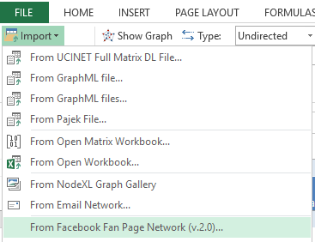--> 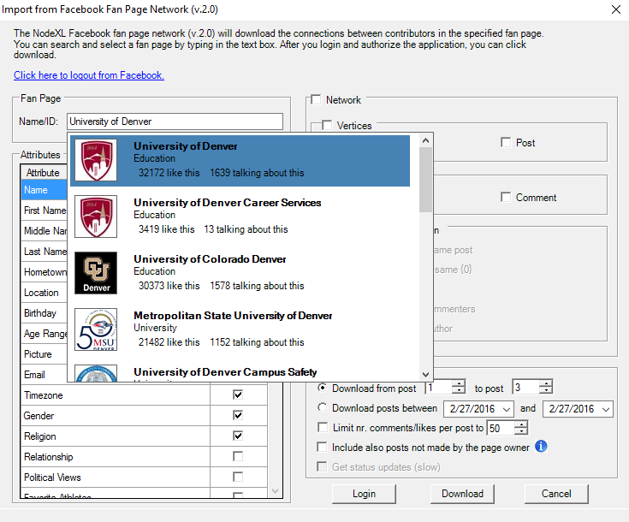

* Let’s assume the follows for this instruction in the importer dialog box (select network>select only user for vertices>select only like for relationship>select only “users who liked the same post”>Options-download posts from 1 to 5.

Assumptions:

1. The network should show username (check network, vertices, user and post)
2. We assume that we only investigate relationship based on “Like”, not “comment”.
3. In other words, an edge will be constructed between two Facebook users if both users “***liked****”* the same post. (***Undirected***)
4. The network only considers the recent 5 posts.

* Click “Download”, click “Yes” to the Text Wrapping notification (it would take about 2-3 minutes and loading to Excel also takes some time, be patient!
* Download “***DU_Facebook_CoLiker-5posts.xlsx*** and ***CU_Facebook_ CoLiker-5posts.xlsx*** from canvas for this practice)
* To prepare the data (prepare for the duplicate edges), File>prepare data> count and merge duplicate edges> select both count and merge>ok (make sure now you have a new field “Edge weight” in Edges worksheet.
* Do the same for CU boulder (CU one takes a bit longer because it has a larger network, please be patient).
* For both networks, show only edges with edge weights>=2 (so that we focus on those Fans who liked posts together frequently in the network).

Three different ways: Dynamic filter; Autofill Columns (fill visibility based on weight); select data; make sure one is not overwriting the other

**Task 3)** For edges whose weights are smaller than 2, will they be used in the visualization and matrices calculation?

No they will not be used. (visibility vs. opacity: visibility: skipped ones will not be used; opacity: every edge is used even when it is transparent)

All the followings should be done for both networks:

* Set the opacity of edges by edge weight (the opacity should range from 50%-100%).

**Task 4)** In the “Autofill columns”, clear the Vertex label column (“Clear vertex visibility column now” ). Using one of grouping methods in NodeXL, visualize groups (use different colors and shapes) for both networks. In the graph, click the “Select the algorithm” dropdown list (the second icon in the top row), change the “Layout options” to “Lay out each of the graph’s groups in its own box (see below). Copy and paste the clustered graphs for both networks below. How many groups did you find? Do you think they are quite distinguished groups or not?

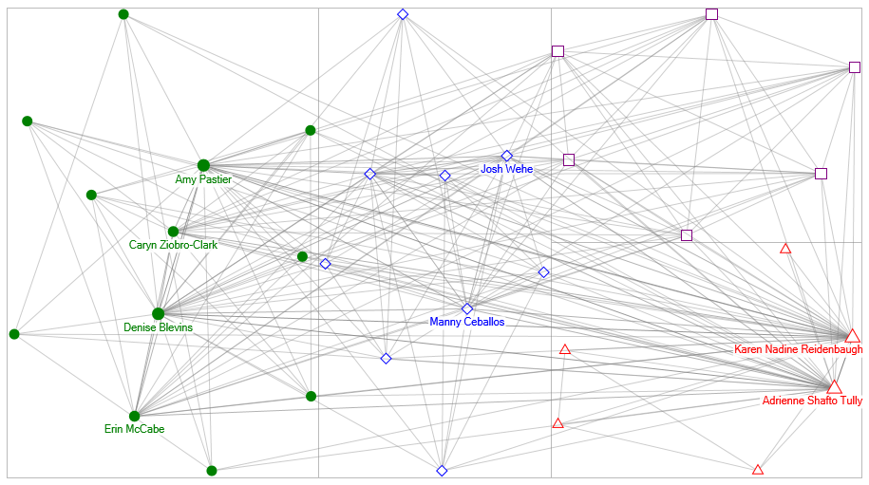

* **Calculate degree, betweenness, closeness, eigenvector centralities. Then, change your network visual to reflect the follows using Autofill Columns:**

1. The strength of degree of vertex by Vertex color
2. The strength of betweenness of vertex by Vertex size (ranging 5 – 100)
3. The strength of closeness of vertex by Vertex shape (Solid Diamond if closeness>=the average of closeness in the network).
4. Set the vertex tooltip to “vertex” (when you hover over the node, the vertex name will show up)
5. Now that the color of vertices should be determined by degree, however, in Task 4 NodeXL determines the color for each group based on clustering. To make sure the degree-based color overwrites the group-based color, go to Analysis>Groups>Group options (see below). You can then make changes to the selections.

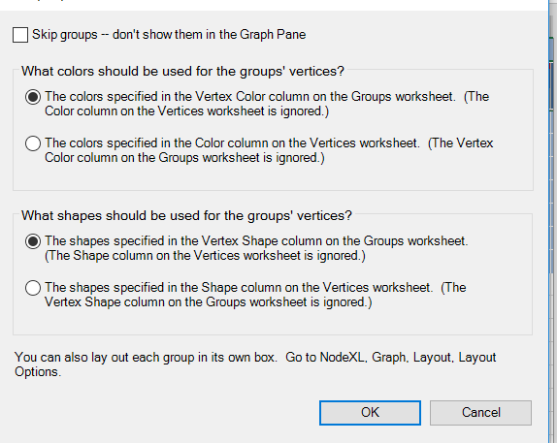

1. Do the same for the vertex shape.
2. Show only the names of the highest betweenness person (In the “Autofill column”, under “Vertex Label”, clear the column. Go to the “Vertices” worksheet, sort Betweenness centrality column in descending order, then select the first few vertices, and copy their names to the “Label” column.
3. Show only the names of the highest closeness person(s).
4. You can use any other techniques (Autofill, dynamic filter, etc.) to make this graph more meaningful/readable. You can do this by focusing on stronger relationships only (edge weight), skipping actors who only have 1-2 friends, and changing the vertex/edge visual features (size, color, width, etc.).

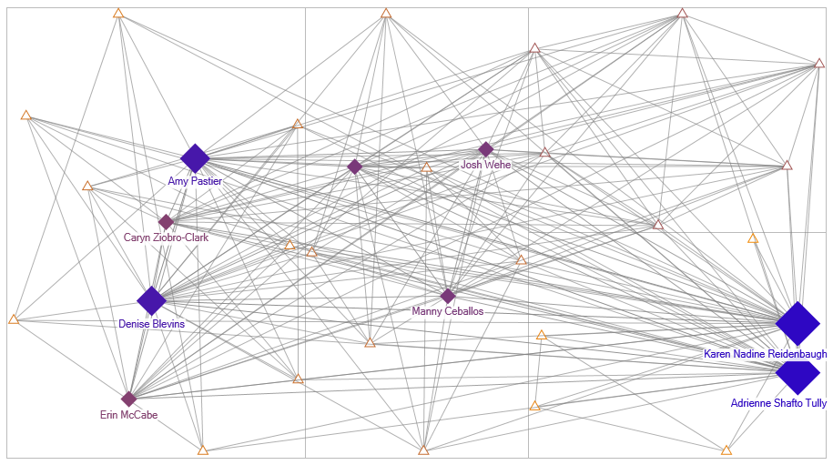

**Task 5)** Show the graphs for DU and CU here and, answer the following questions

* Who are those individuals (pick several, not all) mostly connecting other groups in your network?

Betweenness

* And who are those individuals DU and CU want to send their campaign in Facebook pages?

Eigenvector, degree, and betweenness

* Which one (between DU and CU’s frequent likers networks) has a higher density than the other? Why?

Density measures

* Which network looks tighter in terms of betweenness, closeness and eigenvector? Why?

Average closeness: the higher, the tighter. (inverse, shorter distance, higher closeness)