# Section 1 - Connecting to & Preparing Data

1. Which of the following is the best reason to create a saved data source as a .TDS file
   * 1. Those who wish to use the data do not have access to the underlying data.
     2. You want to save the default field properties such as number formats and sort order.
     3. You want to save a snapshot of the data that will not update even when the underlying data changes.
     4. You need to apply an aggregation that takes too long when using a live connection.

Correct answer is B. TDS files save the data source metadata, such as the connection information, default field formatting, and sort order. They do not save the data source itself, and hence you should use this format if everyone who will use the data source has access to the underlying file or database defined in the connection information.

Documentation here: <https://onlinehelp.tableau.com/current/pro/desktop/en-us/export_connection.html>

1. When creating a union between tables, what will happen if the field names do not match?
   * 1. Tableau will return an error message, explaining that you must modify the tables so that all tables used in the union have the same field names.
     2. Tableau will automatically merge the fields, combining fields with similar field names.
     3. Fields in the union that do not have matching field names will contain null values.
     4. Fields with non-matching field names will be dropped, so that the union will contain only those fields with matching field names

Correct answer is C – if the field names do not match, the fields will be included in the UNION but will contain null values for the rows from the table that is missing the field.

<https://onlinehelp.tableau.com/current/pro/desktop/en-us/union.html>

1. After setting up two data source connections, how can you create a blend?
   * 1. Add at least one field from the primary data source to your view. Then, in the Data pane, click the data source that you want to designate as the secondary data source and click the broken link icon.
     2. On the data sources pane, drag tables from both connections onto the canvas. Then click the venn diagram and select the blending fields.
     3. On the data source page, double-click New Blend to set up the blend. Drag a table from the left pane to the blend dialog box.
     4. Select Data, then Edit Relationships, tthen Select the secondary data source in the Secondary data source pane, select Custom in the relationships list, and then click the Add button.

Correct answer is A. Editing the relationships will not by itself establish a blend.

<https://onlinehelp.tableau.com/current/pro/desktop/en-us/multiple_connections.html>

1. Which of the following uses a primary and secondary data source?
   * 1. Cross-database joins
     2. Unions
     3. Aggregation
     4. Blending

Correct answer is D. Data blending involves a primary and secondary data source.

<https://onlinehelp.tableau.com/current/pro/desktop/en-us/multiple_connections.html>

1. Union the Stocks 2010-2013 and Stocks 2014 tables, and then create a chart showing average Open by year and for each Company from 2010 to 2014. In which year was the average open for Biogen Idec closest to Amazon’s average open?
   1. 2011
   2. 2012
   3. 2013
   4. 2014

Solution: D, 2014

Create union of Stocks 2010-2013 and Stocks 2014 tables:

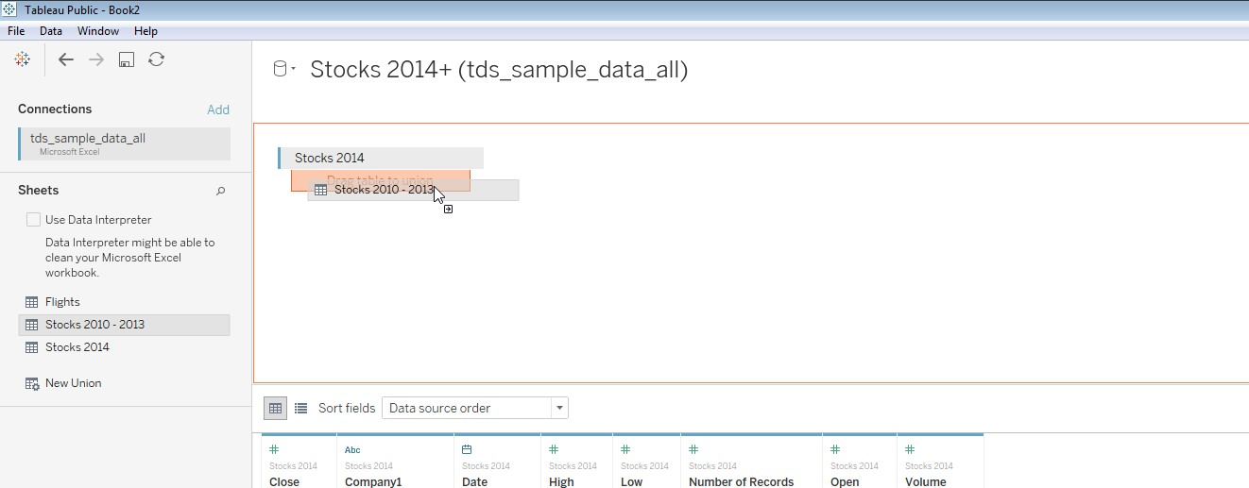

This view shows average open by year and company. We can see Amazon and Biogen Idec are closest in 2014.

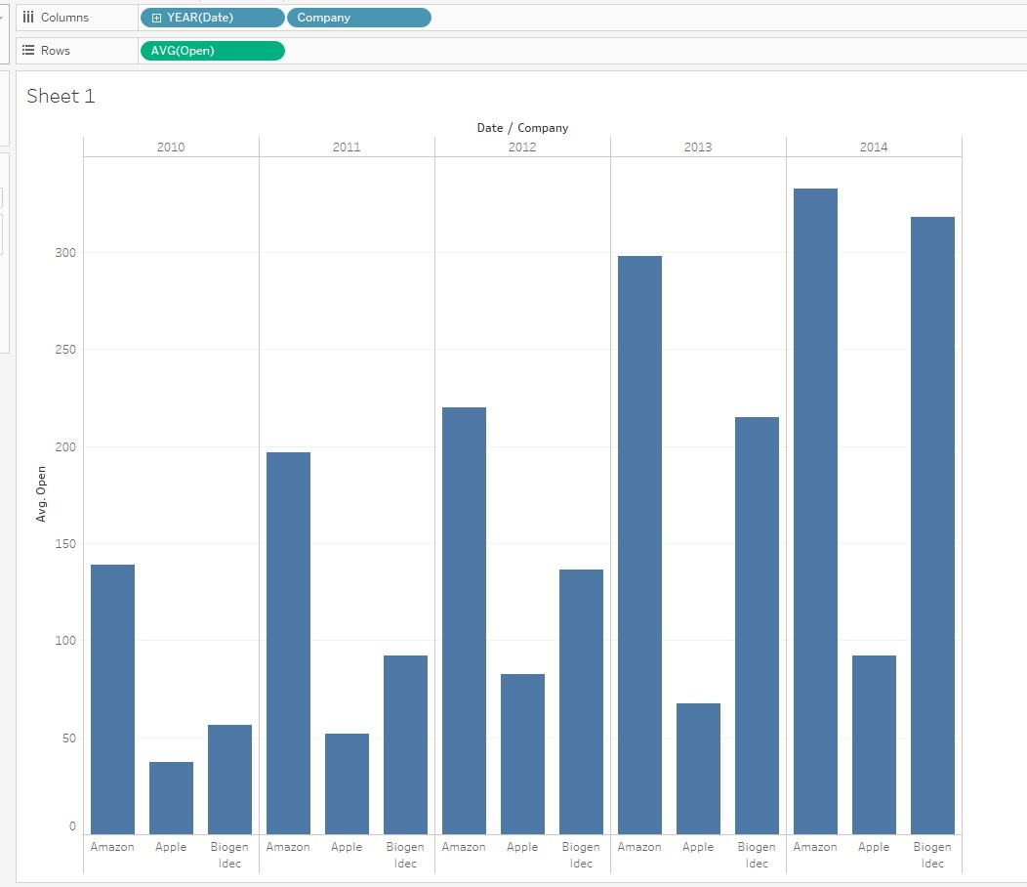

1. Blend the Southern Region table from the South_Superstore file with the Subcategory Profit Targets table from the Subcategory Profit Targets file. Add subcategory, AVG(Profit) and Profit Target to the view. For which of the following subcategories was average profit higher than the target?
   1. Appliances
   2. Art
   3. Binders
   4. Bookcases

Correct Answer: A

Add a connection to the South_Superstore, then add a new data source:

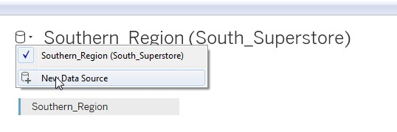

Select Subcateogry Profit Targets

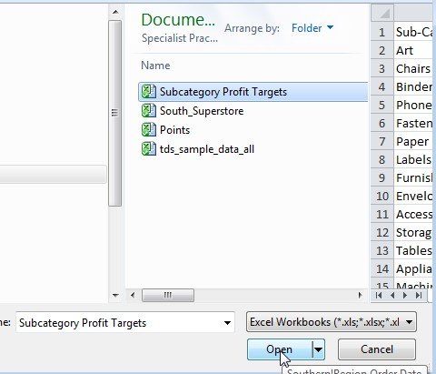

From Southern Region, add Subcategory and Profits, Set profits to Average

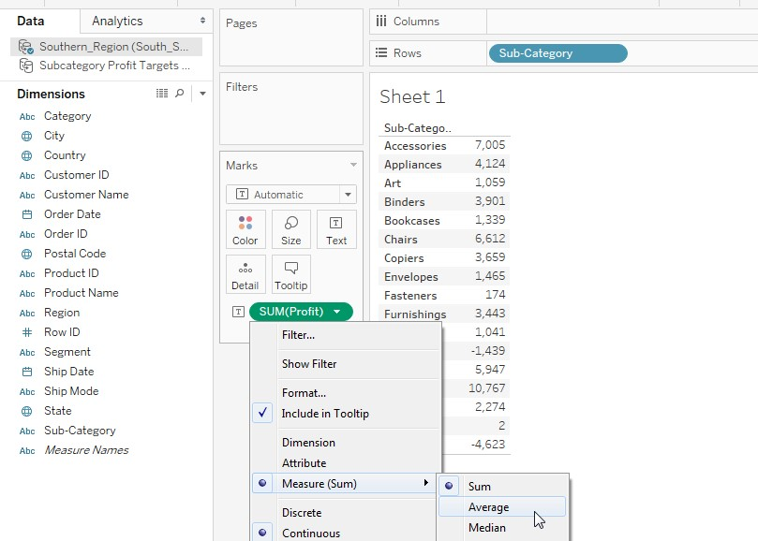

Select the Subcateogry Profit Targets dat source, and add Profit Target:

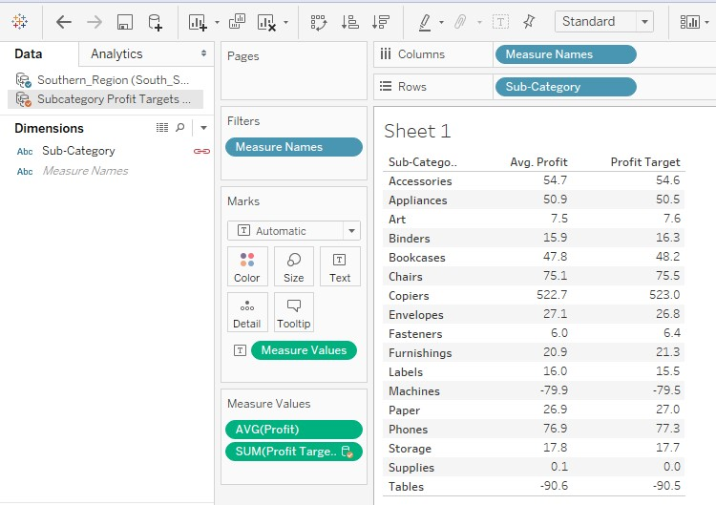

1. Inner join Southern_Region with Returns using Order ID. This will limit the data to only those orders which were returned by the customer. Create a chart that shows sales by year of order date. In which year was the sales value of the returned items the lowest?
   1. 2013
   2. 2014
   3. 2015
   4. 2016

Answer: A. 2013

On the Data Source tab, create the Inner Join on Order ID

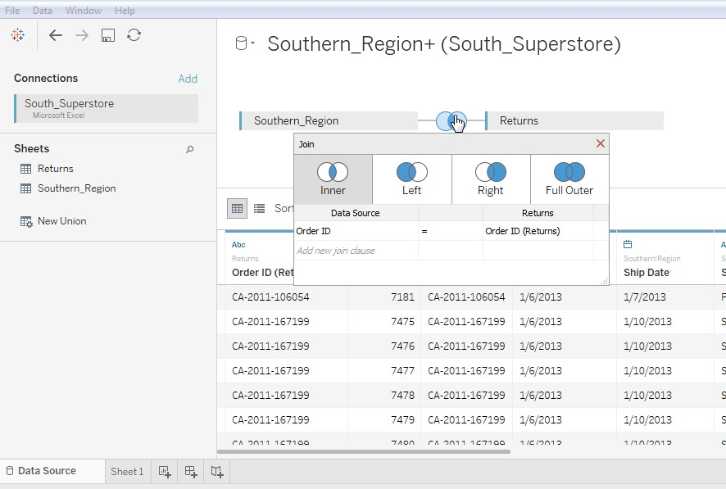

Add Sales and YEAR(Order Date) to the view. SUM(Sales) is lowest in 2013.

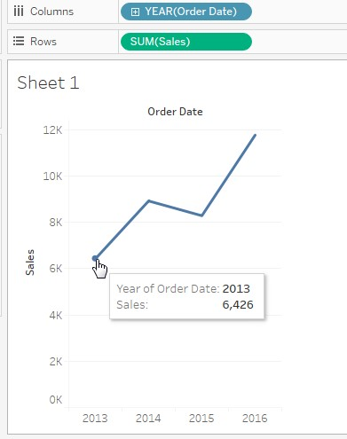

1. Open the Flights data and assign the geographic role for Airport Code as airport. Add the airport code to the view and drag the Airport Name to the Label mark. Which airport shown on the map is closest to HartsfieldJackson Atlanta (ATL)?
   * 1. Chattanooga Metropolitan Airport (CHA)
     2. Charlotte Douglas International (CTL)
     3. Orlando International (MCO)
     4. George Bush Intercontinental (IAH)

Answer: B - Charlotte Douglas International (CTL) is closest to Hartsfield-Jackson Atlanta

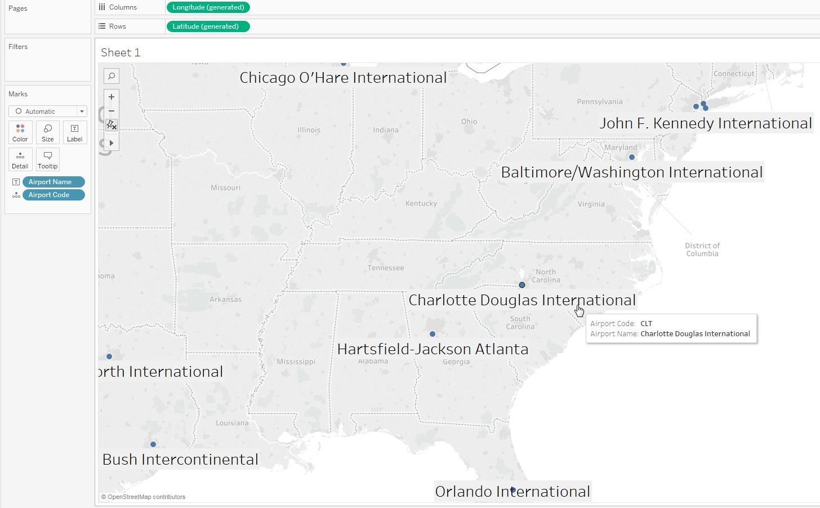

# Section 2 - Exploring & Analyzing Data

1. In the Southern Region Superstore data, the Product Category, Product Subcategory, and Product Name might be combined using which of the following:
   1. Set
   2. Group
   3. Hierarchy
   4. Parameter

Correct Answer: C - Hierarchy. Hierarchies allow you combine similar fields while Groups and Sets combine values within a field. Parameters allow the user to change a value, which can then be used in calculations, filters, and reference lines.

1. Which chart type will best visualize the relationship between two continuous measures? a. Bar chart
   1. Scatter Plot
   2. Line Chart
   3. Stacked Bar

B – Scatter Plot. Scatter plots to visualize relationships between numerical variables. Bar charts to compare data across categories. Line charts compare numeric data over time. Stacked bar charts compare numeric data over two dimensions.

[https://onlinehelp.tableau.com/current/pro/desktop/enus/help.html#buildexamples_scatter.html?Highlight=scatter](https://onlinehelp.tableau.com/current/pro/desktop/en-us/help.html?Highlight=scatter#buildexamples_scatter.html)

1. Which of the following is a table calculation?
   1. SUM
   2. TOTAL
   3. AVG
   4. STDEV

B - Of these, only TOTAL is a table calculation:

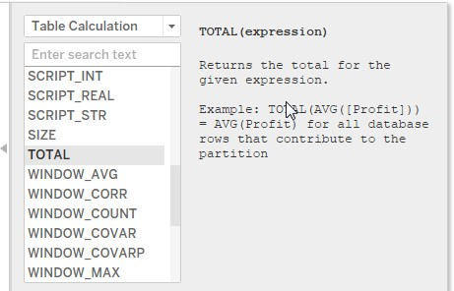

1. You would like to a view that displays a filter allowing you to select the state, and use a Set to displaying the top 5 products with the greatest total sales within the selected state. What type of filter should you use to filter on the state?
   1. Multiselect Filter
   2. Dimension Filter
   3. Context Filter
   4. Wildcard Filter

You would like to filter on the state, and then select the top 5 products with the greatest sales from within the selected state. Therefore, you need a filter which will execute before the Set. Dimension filters execute after sets, so they are the wrong choice. If you make the filter on the state a context filter, Tableau will filter on the state, and then the set will determine the top 5 products by sales within the selected state. More detail here: [https://onlinehelp.tableau.com/current/pro/desktop/enus/order_of_operations.html#DimtoCtxt](https://onlinehelp.tableau.com/current/pro/desktop/en-us/order_of_operations.html#DimtoCtxt)

1. Bins can be created for which type of field?
   1. Dimension
   2. Discrete
   3. Continuous measure
   4. Date

Answer is C. A bin can be created on a continuous measure or numeric dimension <https://onlinehelp.tableau.com/current/pro/desktop/en-us/calculations_bins.html>

1. Using the Flights table, create a bar chart showing the average of Minutes of Delay per Flight broken down by Airport, and filtered by date to show only the last September, October, and November 2013. Which airport had the lowest average minutes of delay per flight between September and November?
   1. Baltimore / Washington International
   2. George Bush Intercontinental
   3. Seattle/Tacoma International
   4. Chicago/O’Hare International

Answer: A - Baltimore / Washington International

Add a filter for September, October, and November 2013. Add Minutes of Delay to the view, and change the aggregation type to average. Add Airport Name to the view. Sort the chart to make it easier to see which airport has the lowest average minutes of delay.

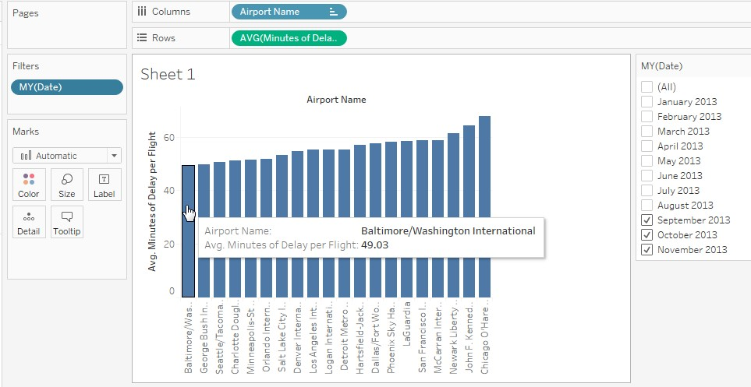

1. Using the Flights table, create a crosstab showing the sum of Flights broken out by ontime category and airport, then add grand totals to the view. Use a filter to exclude flights that were ontime. For Dallas/Fort Worth, what number of flights were not ontime, and what number were Delayed by Security? a. 54,692 and 53
   1. 1,001 and 650,751
   2. 72,489 and 51
   3. 45,677 and 93

Correct Answer: A - 54,692 and 53

Create a crosstab with Airport Name and Ontime Category, showing SUM of Number of Flights. You should see Dallas/Fort Worth has 54,692 not ontime, and 53 flight delayed by security.

Exclude Ontime Flights:

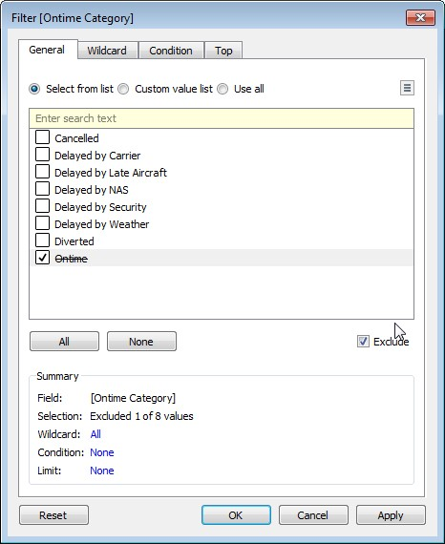

Create a crosstab:

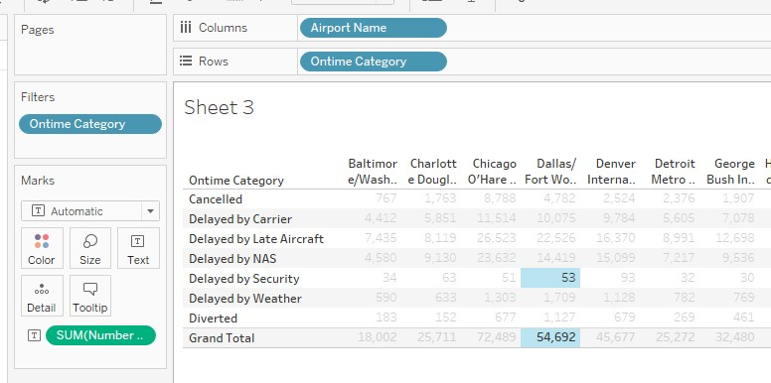

1. Using the Flights data, create a line chart showing the average minutes of delay per flight by month. Create a filter for carrier name of US Airways. Which month saw the biggest decrease in average minutes of delay per flight compared with the previous month?

* 1. January 2013
  2. February 2013
  3. March 2013
  4. April 2013

Answer: C, March 2013

Add Month(Date) to the column shelf and and AVG(Minutes of Delay) to the row shelf:

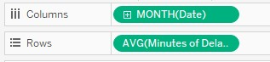

Add a filter for US Airways:

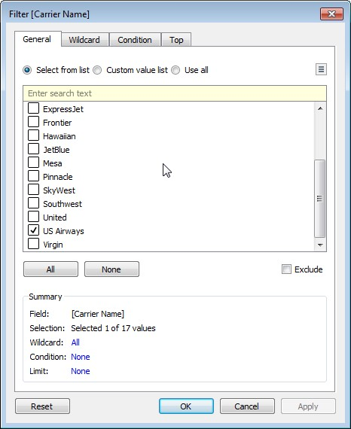

Your view should now looks like this:

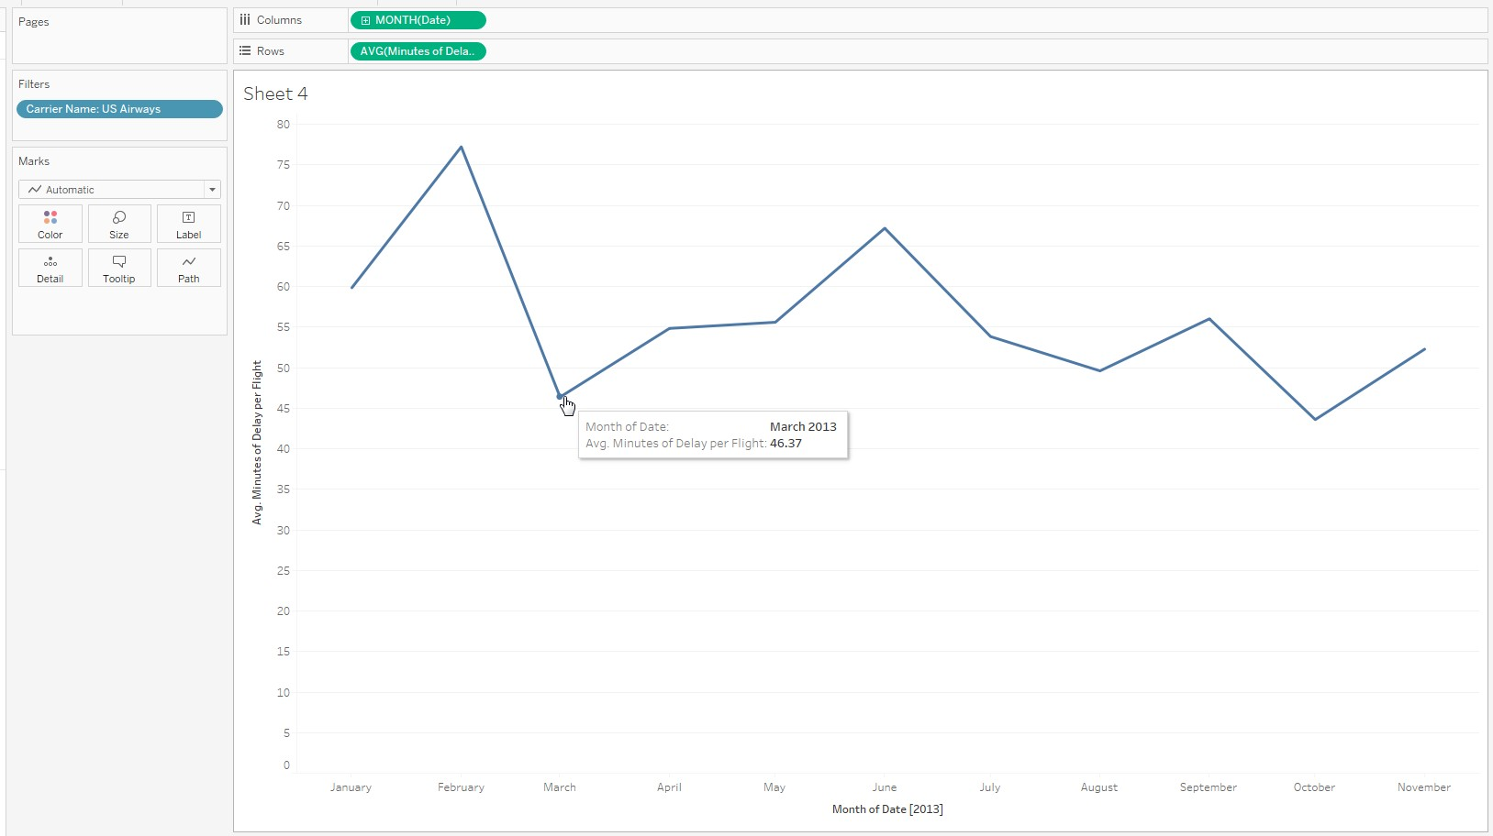

1. Using the Stocks 2014 table, create a dual axis chart showing the daily Open and Close values. Use a filter to limit to filter on October 2014 and use a filter to limit the data to Biogen Idec. On which date was there the greatest difference between Open and Close
   1. October 12th
   2. October 15th
   3. October 20th
   4. October 13nd Correct Answer: D, October 13nd Add company filter:

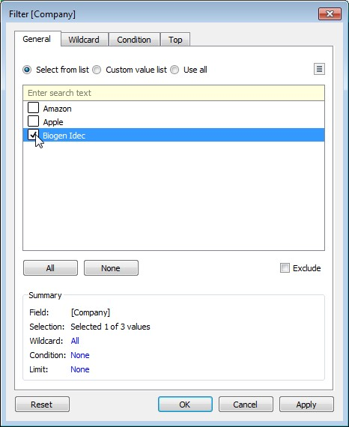

Add Month/Year filter:

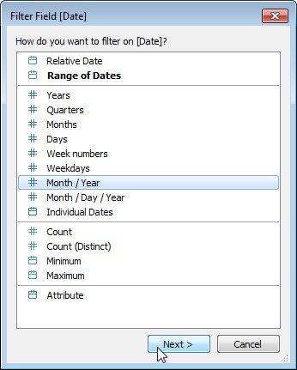

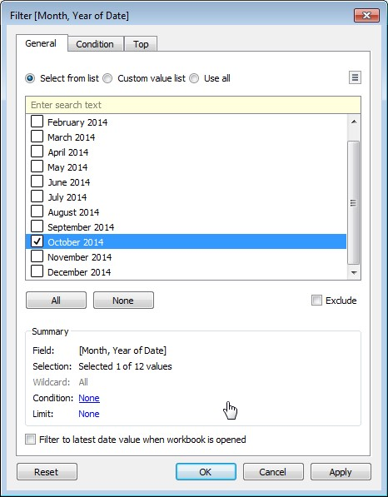

Add a calculation for the difference between open and close:

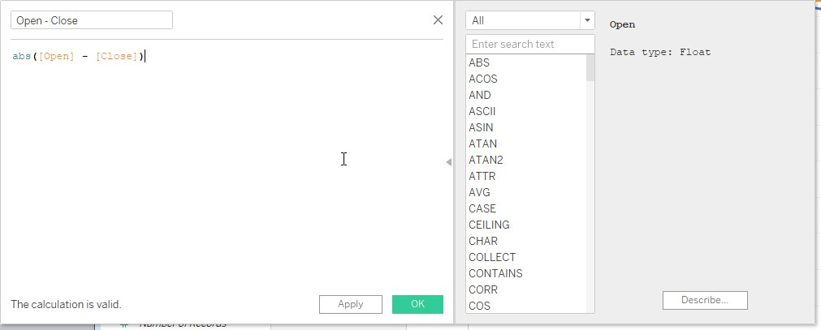

Add date and the new calculation, then sort:

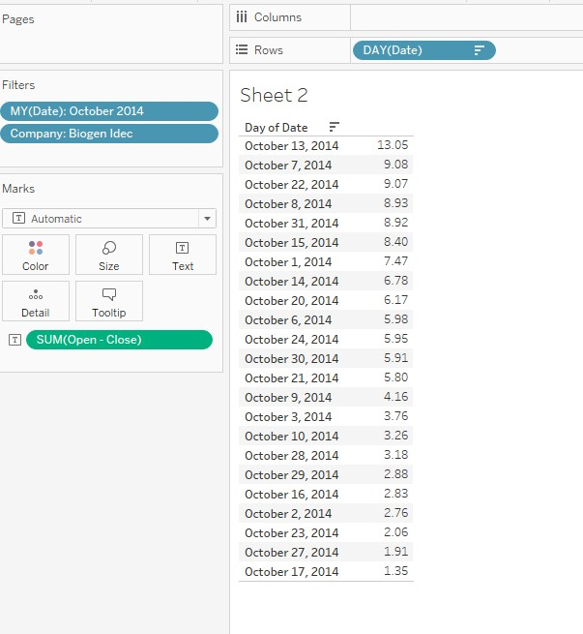

1. Using the Flights data, determine the average minutes of delay per flight by the month (using Date). Using a table calculation, find the % difference in average minute of delay per flight between from June 2013 compared with May 2013.
   1. 14.11%
   2. -8.2%
   3. 59.5%
   4. 60%

Answer: A – 14.11%

Determine the average minutes of delay per flight by the month:

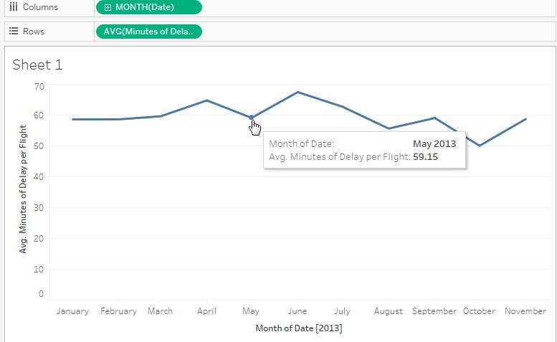

Use a table calculation to determine the % change compared with the previous month:

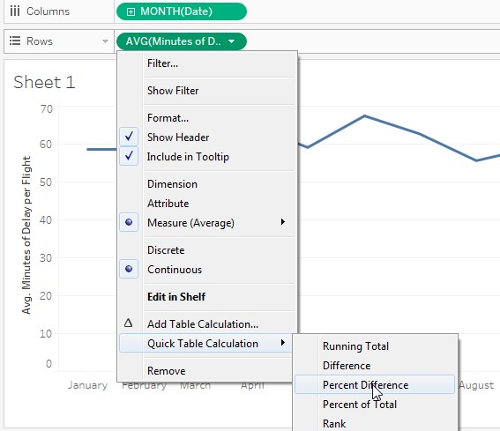

You should now be able to see the % change in average minutes of delay from May to June:

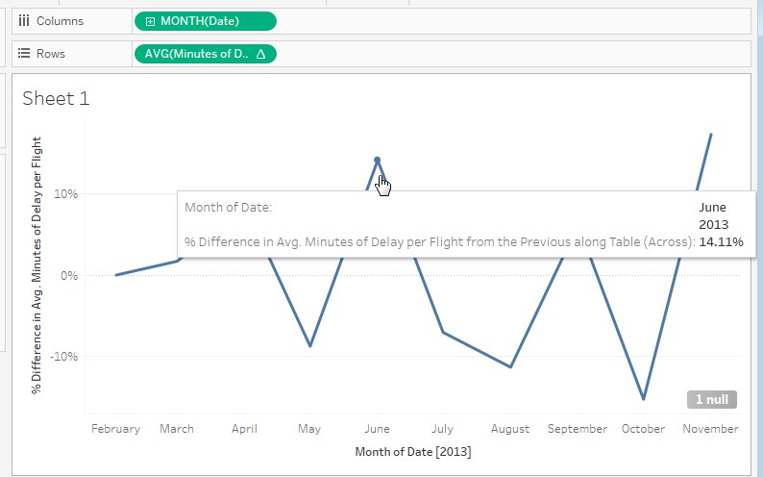

19. Analysts hope that Apple stock price will increase by 10% in 2015. Using the Stocks table, create a calculated field called 2015 High that multiplies the value of High by 1.1. Use MAX aggregation to determine the maximum value of New High for Apple Stock.

1. 131.7
2. 23,439
3. 119.8
4. 448.9

Create a caclulated field called “New High”

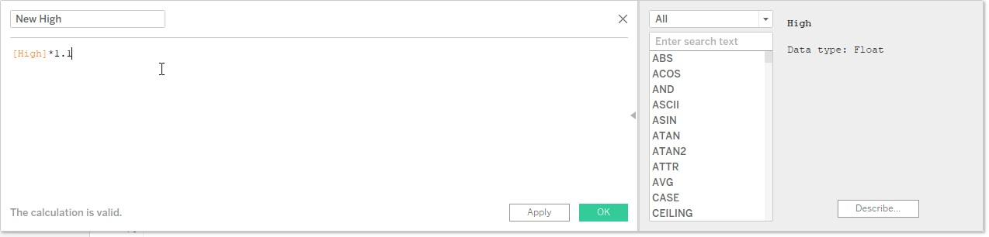

Add a filter for Apple:

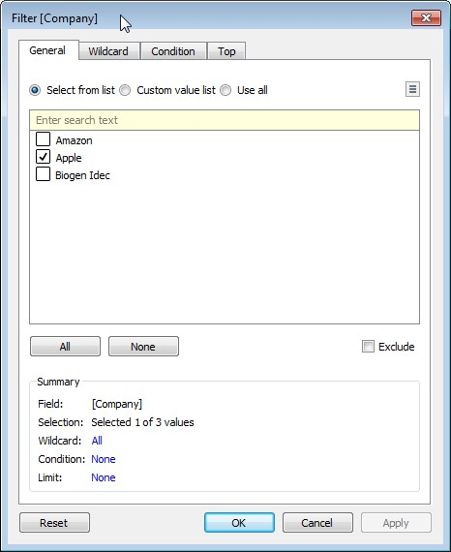

Add New High to the view:

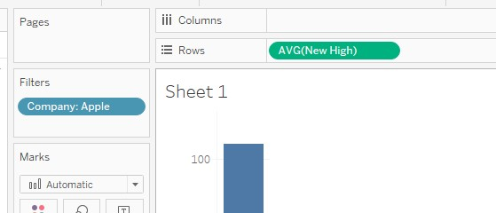

Change the calculation from SUM to MAX:

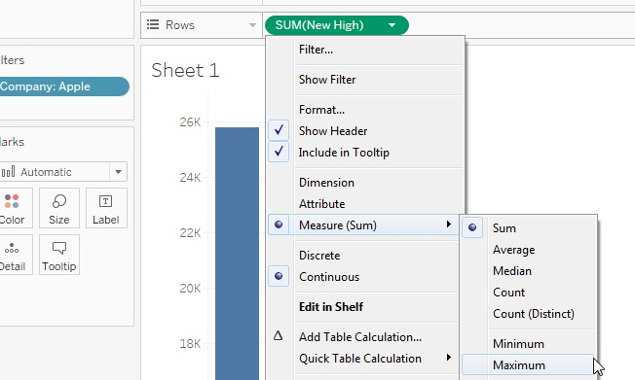

View the MAX value of New High:

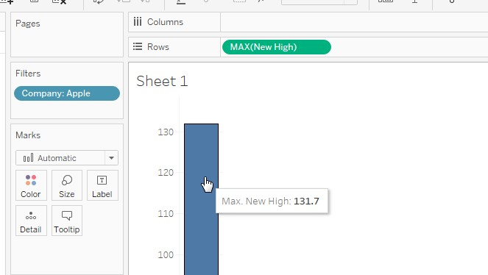

# Section 3 - Sharing Insights

20. The most important items on a dashboard should be positioned where? a. Center

* 1. Upper Left
  2. Upper Right
  3. Bottom

B – Upper Left. Place the most important view at the top of your dashboard, or in the upper left corner. When looking at a dashboard, your eye is usually drawn to that corner first. 21. You have a dashboard and you want to add a feature so that selecting an element on one of the worksheets on the dashboard causes a change on another worksheet in the same dashboard. What features will do this? (select all that apply)

1. Filter Action
2. Url Action
3. Highlight Action
4. Drilldown Action

Answer: A & C. A filter action can filter items on another worksheet, and a highlight action can highlight items on another worksheet.

22. What steps should you take to add a phone view to a dashboard?

1. Instruct the those viewing the dashboard on mobile to put “m.” in front of the dashboard URL to get the mobile-friendly view.
2. Select Layout, then adjust the dimensions until they are appropriate for a phone (750x1334)
3. On the “Show Me” menu, click the Phone icon
4. Select Device Preview, then select Phone for Device Type, then click the button labeled “Add Phone Layout”

Answer: D. You create a phone view by following the steps listed.

<https://onlinehelp.tableau.com/current/pro/desktop/en-us/dashboards_dsd_create.html>

# Understanding Tableau Concepts

1. You start with a blank worksheet and add a continuous field to the row shelf. How will this new field change your view?
   1. It will add a horizontal axis
   2. It will add a horizontal header
   3. It will add a vertical axis
   4. It will add a vertical header Answer: C - vertical axis

[https://onlinehelp.tableau.com/current/pro/desktop/enus/help.html#datafields_typesandroles.html?Highlight=discrete](https://onlinehelp.tableau.com/current/pro/desktop/en-us/help.html?Highlight=discrete#datafields_typesandroles.html)

1. You have a scatter plot showing sales on the x-axis and profit on the y-axis, with each dot representing a different product subcategory. You want to show how the points on the scatter plot vary based on Net Profit, a third continuous variable. Which would be most appropriate? (Select all that apply) a. Tooltip
   1. Label
   2. Size
   3. Color

Answer C & D: Size would be most appropriate, because with size it is clear that larger values are respresened by larger points on the plot. This is easier for the eye to process than understanding which color or size is associated with the larger values than it is to read a label or tooltip value on each point in the scatter plot. Th[e Visual Analysis Best Practices Guidebook](https://www.tableau.com/learn/whitepapers/tableau-visual-guidebook) explains, “a rule of thumb is to put the most important data on the X- or Y- axis and less important data on color, size, or shape.”

# Section 4 - Understanding Tableau Concepts

1. If you have bar chart with a single bar, but you want to subdivide that bar into multiple categories, what should you add to your view?
   1. A measure
   2. A dimension
   3. A discrete field
   4. A continuous field

The answer is B – you need to add a dimension to your view to subdivide the bar.

1. Which of the following fields will have AGG in front of it when you add it to the view?
   1. A calculated field with the formula SUM([Profit])
   2. A measure called Profit
   3. A date field
   4. A calculated field with the formula 5 * [Profit]

Answer: A, since this is a measure that has an aggregation already built in, when you add it to the view you will see AGG in front of the field name

1. A histogram shows the distribution of ________ data by creating bins that are _________.
   1. numeric, continuous
   2. discrete, continuous
   3. continuous, discrete
   4. date, discrete

Correct answer is C. A histogram uses bins to subdivide a continuous measure into a discrete bins.

1. Which of the following functions can be used on string to create a measure?
   1. SUM
   2. COUNTD
   3. +
   4. DATEDIFF

Answer B. Of these functions, only COUNTD will take a string and return a measure.

1. You have SUM([Minutes of Delay]) in your view. If aggregate measures is unchecked, what will the view show instead of SUM([Minutes of Delay])?
   1. Minutes of Delay
   2. ATTR([Minutes of Delay])
   3. AGG([Minutes of Delay])
   4. Minutes of Delay (bin)

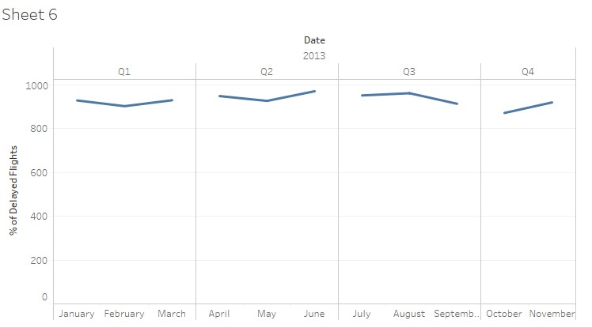A – disaggregating will show the underlying values. The aggregation will be removed, so we will see just “Minutes of Delay” [https://onlinehelp.tableau.com/current/pro/desktop/enus/help.html#calculations_aggregation.html#DisAggData](https://onlinehelp.tableau.com/current/pro/desktop/en-us/help.html#calculations_aggregation.html)

30. What field types are used in this view?

1. Discrete for the Date, continuous measure for % of Delayed Flights
2. Continuous for the x and y axis
3. String for the x-axis, continuous measure for the y-axis
4. String for the x-axis, continuous measure for the y-axis

A. The date is discrete, because otherwise the line would not be segmented % of Delayed Flights is used as an axis, so it must be a continuous measure.