# Connecting to & Preparing Data

1. Which of the following should be used if, for security purposes, you’d like users to enter their database credentials in order to access the workbook:
   1. Live connection
   2. Extract
   3. Hyper
   4. Packaged data source

Correct answer is A – “If your organization enforces user-level permissions to databases, use a live connection for workbooks that connect to those databases. That way, users who interact with workbooks and data sources that require authentication will be prompted for credentials.” [https://onlinehelp.tableau.com/current/guides/everybody-install/enus/everybody_admin_data.htm#tradeoffs-live-connection-and-extract](https://onlinehelp.tableau.com/current/guides/everybody-install/en-us/everybody_admin_data.htm#tradeoffs-live-connection-and-extract)

1. Which feature will allow you to show more relevant or descriptive dimension values in your view than what the original data provides?
   1. field renaming
   2. hierarchy
   3. alias
   4. group
2. – “Aliasing is the alternative name that you can assign to a value in a dimension field. You can use aliases to rename specific values within a dimension. This can be useful when you want to show more relevant or descriptive dimension values in your view than what the original data provides.” [https://onlinehelp.tableau.com/current/pro/desktop/enus/multipleconnections_edit_primary_aliases.htm](https://onlinehelp.tableau.com/current/pro/desktop/en-us/multipleconnections_edit_primary_aliases.htm) 
   1. Which of the following is not a default property which can be set for a measure?
      1. Number Format
      2. Color
      3. Aggregation
      4. Sort
3. – Sort is a default property for dimensions but not for measures.
   1. This type of join will include all values from the left table:
      1. Inner
      2. Right
      3. Left
      4. Blend

C – A left join will include all values from the left table. <https://onlinehelp.tableau.com/current/pro/desktop/en-us/joining_tables.htm#jointypes>

1. Left join Southern_Region with Returns using Order ID. Add Sales and Status to the view. What is the value for SUM(Sales) for Status returned?
   1. 40,980
   2. 35,407
   3. 356,315
   4. 5,769

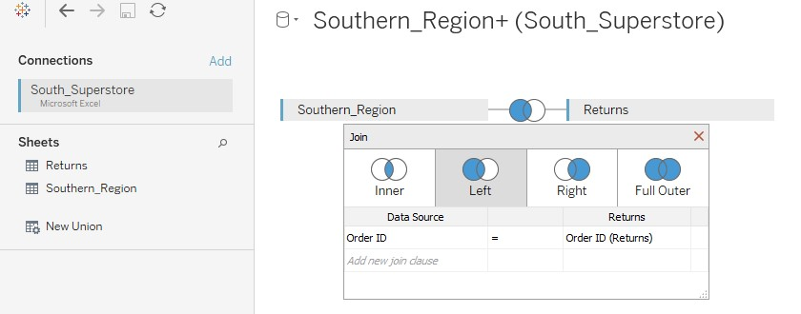

Add status and sales to the view:

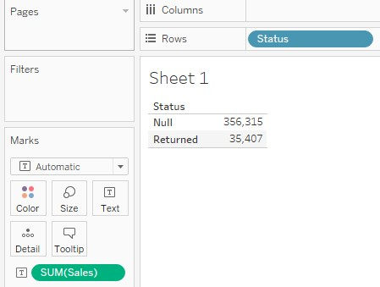

1. Create a union of World Literacy Rate 1976 to 1991 and World Literacy Rate 1992 to 2016. What is the percent increase in the literacy rate from 1976 to 2016?
   1. 17.36%
   2. 20.12%
   3. 34.71%
   4. 25.17%

Create the union:

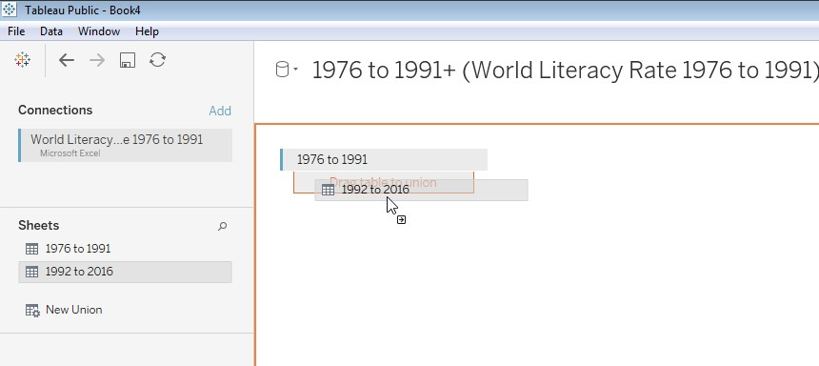

Add date to the sheet, and remove all but 1976 and 2016:

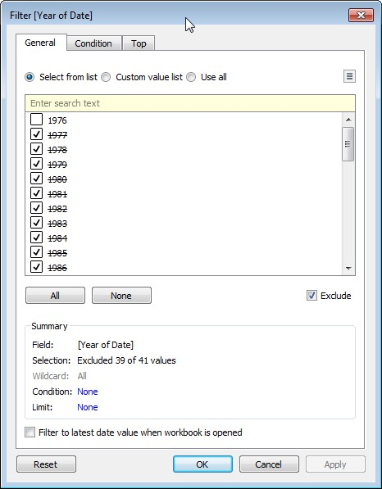

Add the rate and the year to the view. Then do a % Difference table calculation:

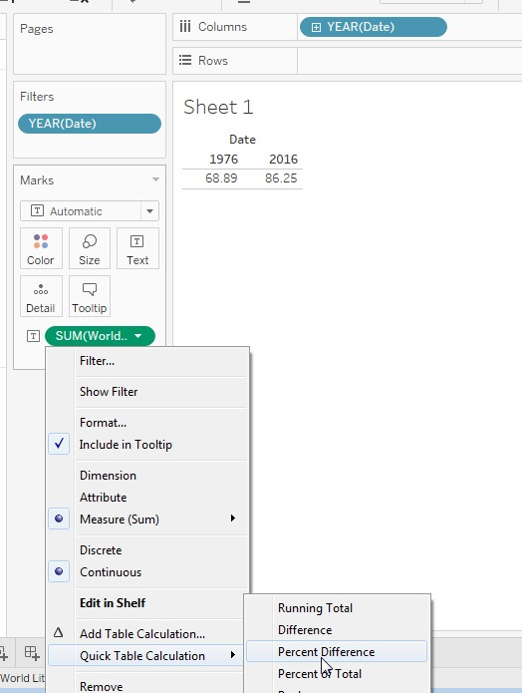

Use a table calculation to determine the difference between the 1976 rate and the 2016 rate:

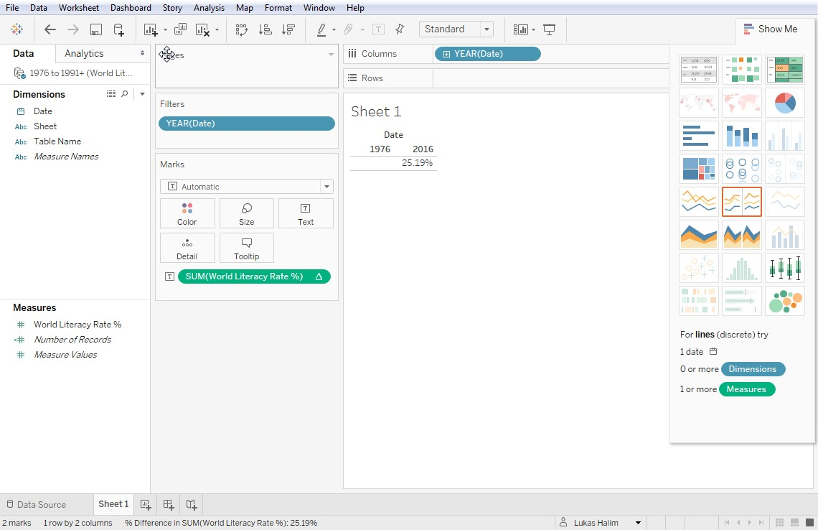

1. Your data has a column which should be treated as a date, but when you change the data type to date you see a lot of null values or obviously incorrect dates like 12/30/1899. What can you do next since the date conversion did not work?
   1. Edit your computer’s date settings to that they correspond to the format of the date you’re trying to use in Tableau
   2. Instead of setting the field to Date, set to Date & Time
   3. Set the type back to string, then try date conversion functions like DateParse and Date
   4. Switch the metadata grid, then right click the field and select “date format settings”

If changing type to date doesn’t work, you should change the data type back to string and use a date parse function <https://onlinehelp.tableau.com/current/pro/desktop/en-us/data_dateparse.htm>

# Exploring & Analyzing Data

1. You want to create a line chart showing the daily “Open” and “Close” values for a stock. The yaxis shows the opening stock price and the x-axis shows the date. What steps should you take?
   * 1. Drag and drop the field “Close” to the x-axis.
     2. Drag and drop the field “Close” to the y-axis.
     3. Drag the field “Close” to the path mark.
     4. Drag the field “Close” to the row shelf, then select the dual lines on the worksheet menu.

<https://kb.tableau.com/articles/howto/dual-axis-bar-chart-multiple-measures>

The correct answer is D.

Example of dragging “Close” to the y-axis - Select “Dual Lines” on the show me menu

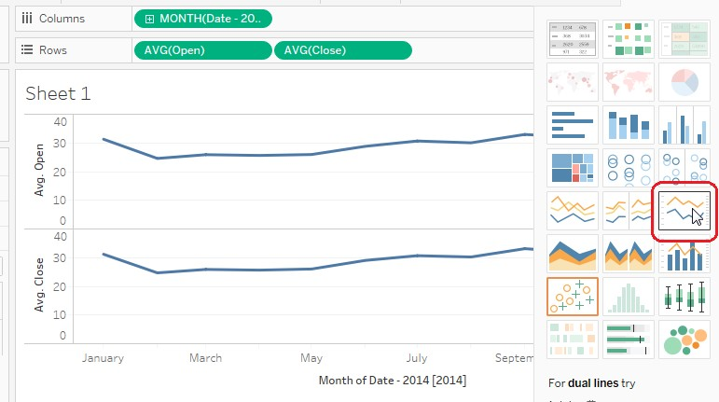

Result: Dual axis chart. You see an axis on the right side as well as the left:

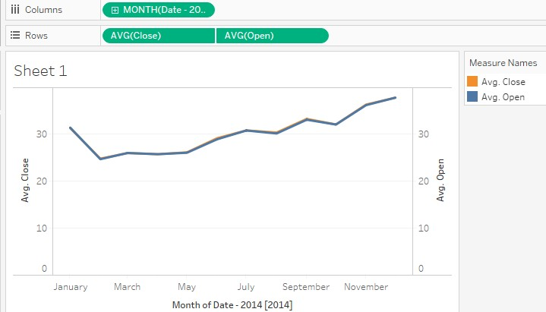

Answer A is not correct because dragging Result to the y-axis will give you a chart with two lines, but not a dual axis chart.

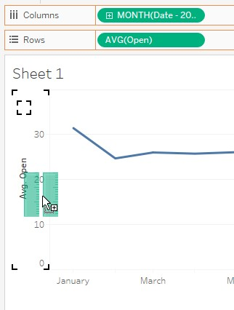

The chart below has two lines, but only one y-axis:

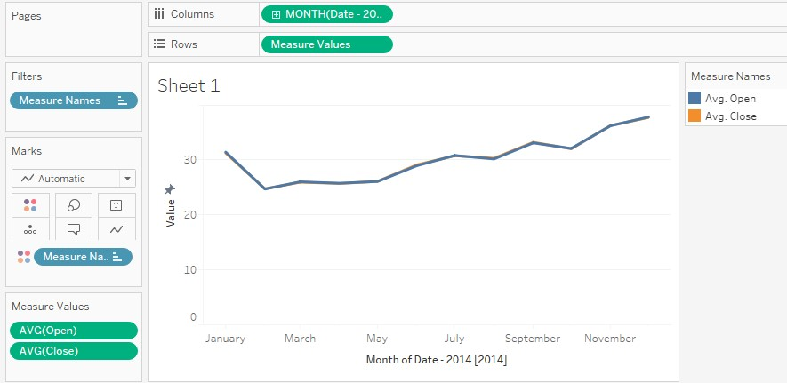

1. You would like the person using your dashboard to select the year, and based on the year to adjust the interest rate in some related calculated fields. You will like the year selection to limit the data in the view. What Tableau element should you to let the user select the interest rate? a. Dimension Filter
   1. Context Filter
   2. Parameter
   3. Change Set values Dashboard Action

Correct answer is C. A parameter will allow the user to set a value which you can then use in a calculated field. You can also use a parameter in a calculation, and then use that calculated field in a filter to limit the data in the view.

1. Which type of visualization is ***not*** typically effective in showing change over time? a. Bar Chart
   * 1. Line Chart
     2. Area Chart
     3. Scatter Plot

According to the tableau visual analysis guidebook, “Some of the best visualizations for showing trends over time are line charts, area charts, and bar charts.” A scatter plot does not show change over time as effectively. See the visual analysis guidebook [https://www.tableau.com/learn/whitepapers/tableauvisual-guidebook.](https://www.tableau.com/learn/whitepapers/tableau-visual-guidebook)

Also, here I have a line chart showing sales by order date and the scatter plot option is grayed out:

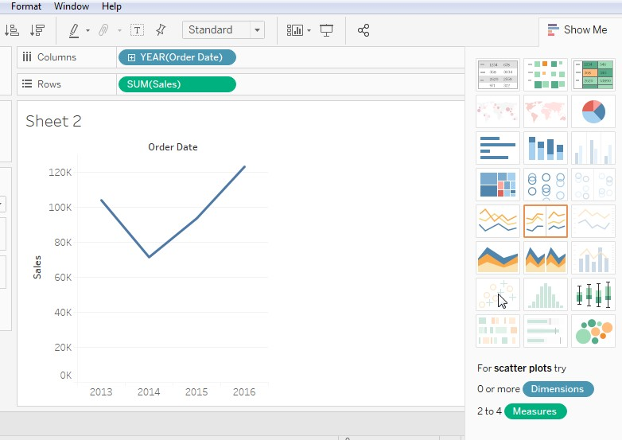

1. Which types of plots are most often used to visualize the distribution of a single continuous measure? (select all that apply)
   * 1. Scatter Plot
     2. Tree Maps
     3. Box Plot
     4. Histogram

Correct answer is C & D - The box plot and histogram visualize the distribution of a continuous measure.

“A histogram is a chart that displays the shape of a distribution. A histogram looks like a bar chart but groups values for a continuous measure into ranges, or bins.” <https://onlinehelp.tableau.com/current/pro/desktop/en-gb/buildexamples_histogram.htm>

“Use box plots, also known as box-and-whisker plots, to show the distribution of values along an axis.” <https://onlinehelp.tableau.com/current/pro/desktop/en-us/buildexamples_boxplot.htm>

Scatter plots are used to understand the relationship between two or more variables rather than a single measure.

1. A bullet chart combines a bar chart with:
   * 1. Scatter plot
     2. Filled bubbles
     3. Reference lines
     4. Circle views

Correct answer is C – a bullet chart combines a bar chart with a reference line

1. Which of the following will result in an error
   * 1. A calculation that includes more than one aggregation
     2. Aggregation on a field that is already aggregated
     3. A table calculation on a field that is already aggregated
     4. An aggregation on a level of detail expression

Correct answer is B. If you try to aggregate an aggregated field, you will get the error message saying that an aggregate cannot be further aggregated.

1. Using the Southern Region sheet of the South Superstore data, find the total sales value of items shipped in January and February 2014.
   * 1. 46,474
     2. 44,239
     3. 6,122
     4. 6,132

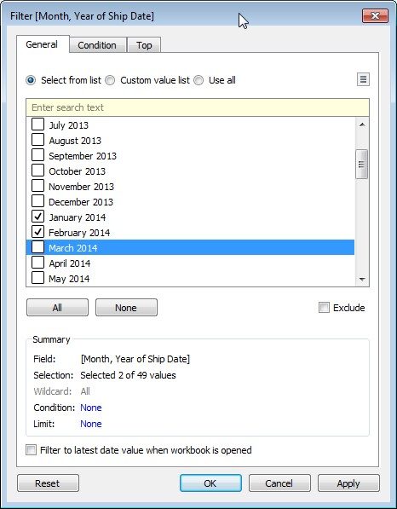

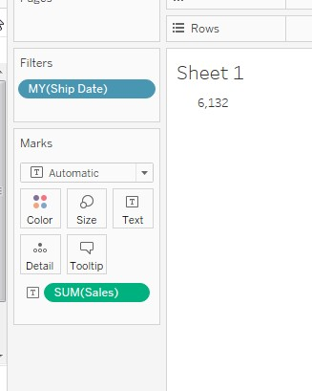

1. Using the Southern Region sheet of the South Superstore data, find the customer name with the largest number of unique order ids.
   1. Christopher Martinez
   2. Barry Gonzalez
   3. Paul Prost
   4. Sean Miller

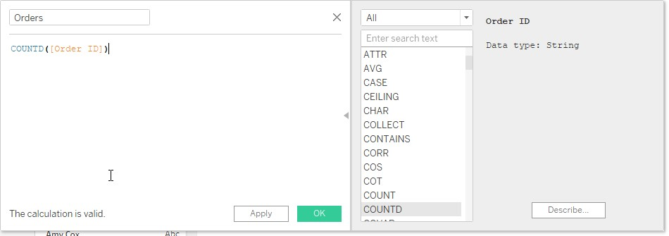

Add this and Customer name to the view. Sort descending:

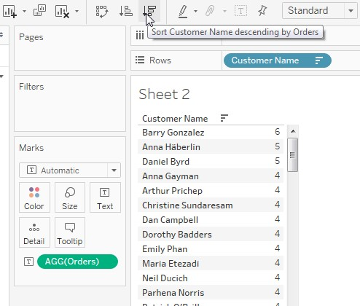

1. Using the Southern Region sheet of the South Superstore data, which state bordering Mississippi had the highest Sales?
   * 1. Arkansas
     2. Tennessee
     3. Alabama
     4. Florida

Add State and Sales to the view:

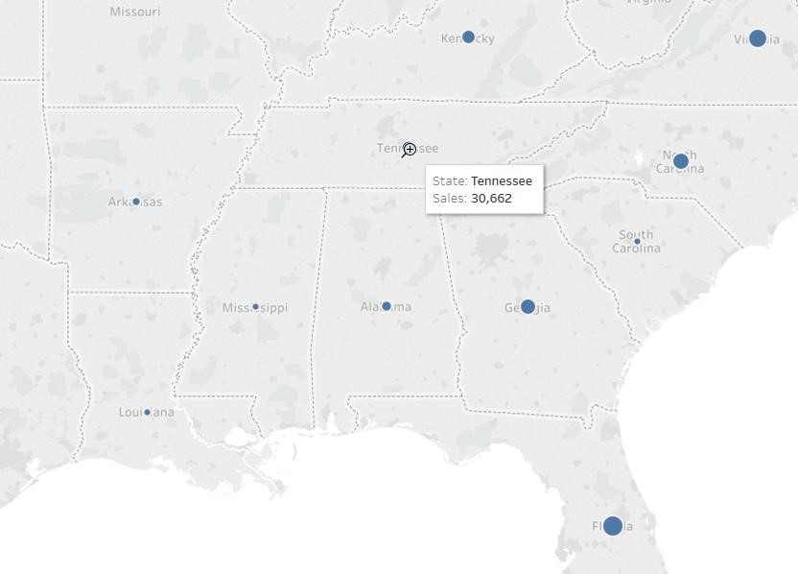

Florida has higher sales that Tennessee, but it does not border Mississippi.

If your computer is not set to the USA, you may need to do Map => Edit Locations and set the country to United States:

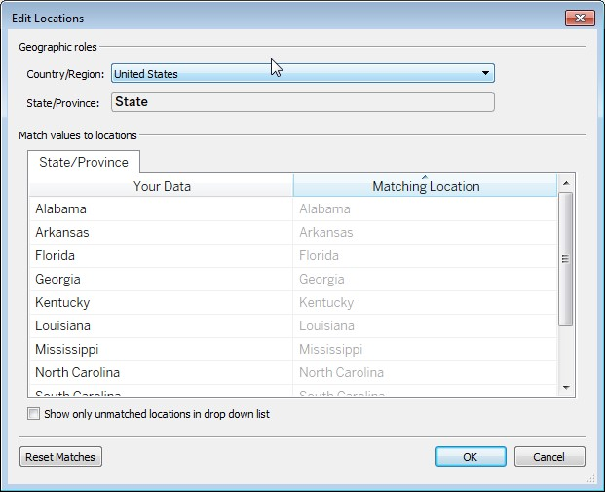

1. Which type of filter usually works best with date fields?
   * 1. Slider filters
     2. List filters
     3. Checkboxes
     4. Text search

*The Visual Analysis Best Practices* explains, “Remember that slider filters are great for date and numerical values—while list filters are better for categorical data.”

1. A relative date filter works relative to:
   * 1. A parameter or field you select when creating the filter
     2. The anchor date
     3. The data the workbook was created or updated
     4. The current date when the workbook is viewed

B – Relative date filters work relative to the anchor date. By default this will be the current date, but this can be changed:

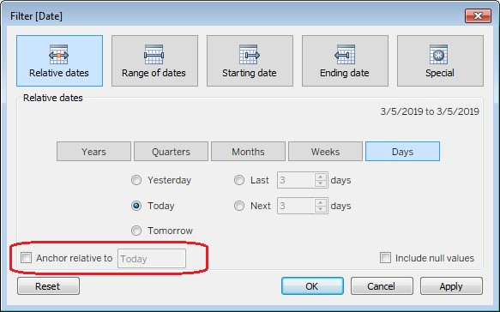

If you keep the default option, “Anchor relative to Today” then the relative date will work relative to the date when the workbook is viewed (answer D) but this can be changed.

Documentation on relative dates: [https://onlinehelp.tableau.com/current/pro/desktop/enus/qs_relative_dates.htm](https://onlinehelp.tableau.com/current/pro/desktop/en-us/qs_relative_dates.htm)

# Sharing Insights

1. Which of the following is true?
   1. A dashboard cannot include a story, but a story can include a dashboard
   2. A dashboard can include a story, but a story cannot include a dashboard
   3. A dashboard can include a story, and a story can include a dashboard
   4. A dashboard cannot include a story, and a story cannot include a dashboard

Here is a workbook with a dashboard and a story. On the dashboard, I do not see the option to add my story:

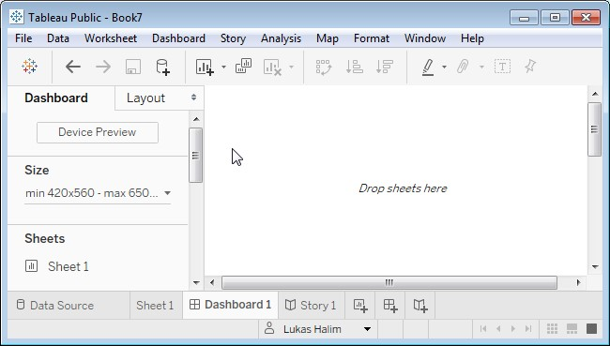

But when I switch to Story 1, I see the option to add Dashboard 1

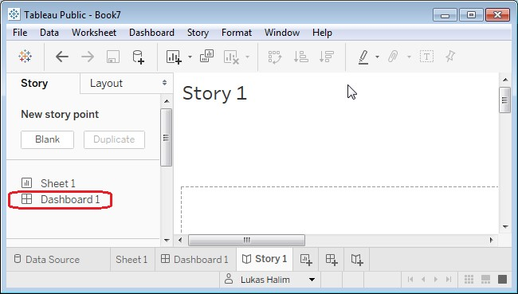

1. Which of the following will create a dashboard action?
   1. Click the “More Options” arrow on the worksheet included in the dashboard layout, then select “use as filter”
   2. Click the “More Options” arrow on the worksheet included in the dashboard layout, then select “use as Filters” and select the filter that you’d like to apply to the whole dashboard
   3. Click the “More Options” arrow on the worksheet included in the dashboard layout, then select “use as Filters” and select the filter that you’d like to apply to the whole dashboard. Then go to the filter menu, right click, and select “apply to all using this data source”
   4. Click the “More Options” arrow on the worksheet included in the dashboard layout, then select “action,” add action, and Filter

Correct answer is A. C will create a context filter, not a filter action. D is not the right choice because there is no action option in the “More Options” menu.

1. Which of the following mark types cannot be adjusted using the Size slider? a. Line
   1. Pie
   2. Bar
   3. Area

The Size of Marks button is disabled when the marks type is Area:

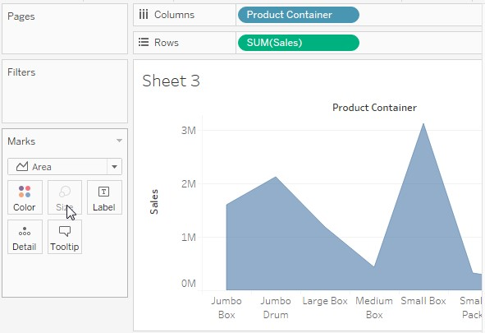

[https://onlinehelp.tableau.com/current/pro/desktop/enus/viewparts_marks_markproperties.htm#SizeProp](https://onlinehelp.tableau.com/current/pro/desktop/en-us/viewparts_marks_markproperties.htm#SizeProp)

1. How would you change the font color of the tooltip? (Select all that apply)
   1. Click on “color” in the marks area, select “tooltip” in the dropdown, and select the desired color.
   2. Right-click on the view, select “Format” and select the dropdown next to tooltip. Then select the color.
   3. Click on the tooltip button in the Marks area, highlight the text, and select the desired color using the dropdown
   4. Right-click on the view, select “Format” and you will see several tabs in the formatting menu – “Sheets,” “Rows,” Columns” and “Tooltip.” Select the tootip tab and then use the formatting menu to select the color.

Answers are B & C. The color button in the marks area will not show you a tooltip option, and there is no tooltip tab in the format menu.

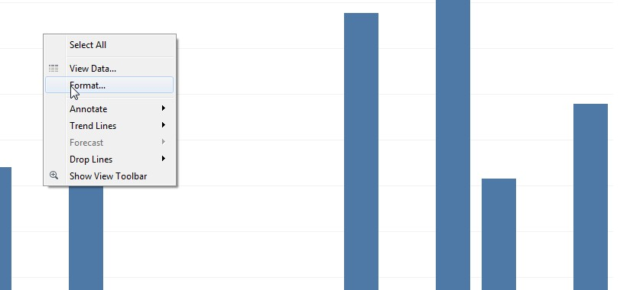

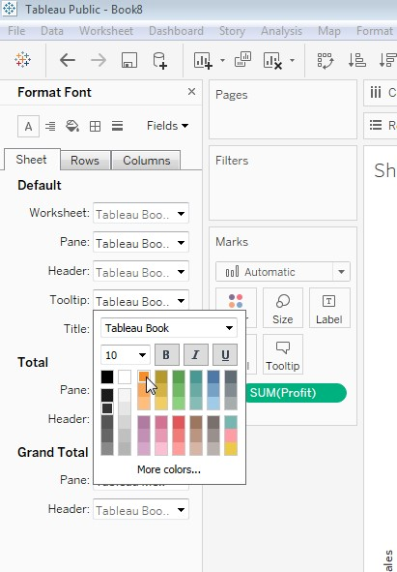

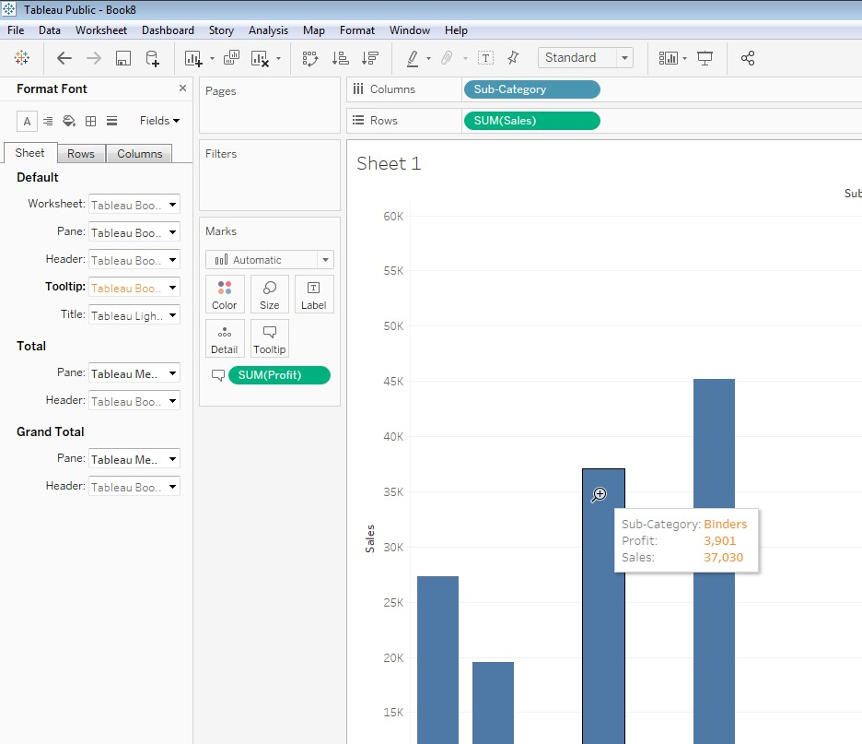

1. Which of the following action types can be used to create proportional brushing? a. URL Action
   1. Filter Action
   2. Set Action
   3. Sheet Action

Answer is C. See [https://onlinehelp.tableau.com/current/pro/desktop/enus/actions_sets.htm#Examples](https://onlinehelp.tableau.com/current/pro/desktop/en-us/actions_sets.htm#Examples) and [https://www.tableau.com/about/blog/2018/8/how-doproportional-highlighting-set-actions-latest-tableau-beta-92168](https://www.tableau.com/about/blog/2018/8/how-do-proportional-highlighting-set-actions-latest-tableau-beta-92168) for a demonstration of how a set action can use used to achieve proportional brushing.

# Understanding Tableau Concepts

24. Which of the following describes the *Measure Names* field (select all that apply)

1. It is a Measure automatically created by Tableau
2. When you create a view with multiple measures on a single continuous axis, Tableau will automatically add Measure Names to the view.
3. When you add *Measure Names* to a view, all of the measure names appear as row or column headers in the view. The headers include each measure name. This feature becomes useful when you are working with a text table that shows multiple measures.
4. Measure Names is a system generated field that contains the names of all the measures in your Tableau workbook, including the system generated measures such as *Latitude* and *Longitude*.

A is incorrect because *Measure Name* is a Dimension, not a value.

D is incorrect because *Measure Names* does not include Latitude and Longitude.

Explanation of *Measure Names* - [https://onlinehelp.tableau.com/current/pro/desktop/enus/datafields_understanddatawindow_meavalues.htm#AboutMN](https://onlinehelp.tableau.com/current/pro/desktop/en-us/datafields_understanddatawindow_meavalues.htm#AboutMN)

1. You add two fields to your Tableau view, “Profit” and “Average Profit.” When you add Profit to the view, you see a pill with the label, “SUM(Profit)” but when you add Average Profit to the view, you see a pill with the label, “AGG(Average Profit).” Why does one field have SUM and another AGG?
   1. Each field has default properties, including default aggregation. Profit had SUM set as its default aggregation, while Average Profit had AGG set as its default.
   2. AGG is applied by default to discrete fields, while SUM is applied to continuous fields. Average Profit was set to discrete, while Profit was set to continuous.
   3. AGG is applied by default to dimensions, while SUM is applied to measures. Average Profit is a dimension, while Profit is a measure.
   4. AGG indicates that the “Average Profit” already includes some type of aggregation. “Profit” does not include aggregation, so an aggregate function is applied when the field is added to the view.

The correct answer is D. When a calculated field which already includes aggregation is added to a view with aggregated measures, AGG indicates that the field already includes aggregation. Measures without aggregation will be aggregated when they are added to the view.

1. Which of the following field types will create a color palette?
   1. Measure
   2. Dimension
   3. Continuous
   4. Discrete

A continuous field will create a color gradient, while a discrete field will create a color palette.

[https://onlinehelp.tableau.com/current/pro/desktop/enus/viewparts_marks_markproperties_color.htm#Categorical_Palettes](https://onlinehelp.tableau.com/current/pro/desktop/en-us/viewparts_marks_markproperties_color.htm#Categorical_Palettes)

1. Examine the following view and describe the most likely field type for Order Priority and Sum(Sales)

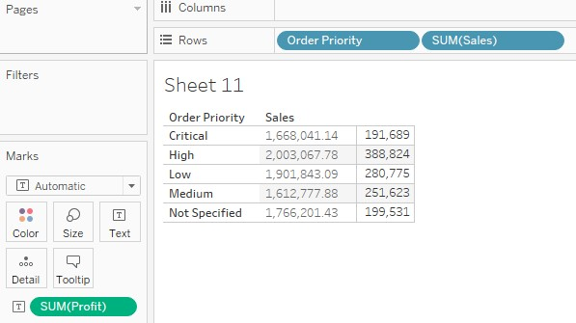

* 1. Order Priority is a discrete measure, and Sum(Sales) is a discrete dimension.
  2. Order Priority is a discrete measure, and Sum(Sales) is a continuous measure.
  3. Order Priority is a discrete dimension, and Sum(Sales) is a continuous dimension.
  4. Order Priority is a discrete dimension, and Sum(Sales) is a discrete measure.

Correct answer is D – Order priority and SUM(Sales) both create headers, so both are discrete. SUM(Sales) is a measure, since you cannot take the sum of a dimension. Order Priority is a string, so it must be a dimension.

1. You connect Tableau to a Excel file which includes a column that has mostly numeric data, but has a few date and text values mixed in. Tableau set the data type for this field as Number.

What happens to the date and text values when the data is imported to Tableau?

* 1. The date and text values are both set to null
  2. The date and text values are both set to zero
  3. The date values are set to the number of days since 1/1/1900 and the text value is set to null.
  4. The date values are set to the number of days since 1/1/1900 and the text value is set to zero.

The correct answer is C: when the data type is mapped as numbers, text is treated as null while dates are treated as the number of days since 1/1/1900. See the section titled, “Mixed data types in data from files” here: [https://onlinehelp.tableau.com/current/pro/desktop/enus/datafields_typesandroles_datatypes.htm](https://onlinehelp.tableau.com/current/pro/desktop/en-us/datafields_typesandroles_datatypes.htm)

1. Which field types are more common?
   1. Discrete dimension, continuous measure
   2. Continuous dimension, continuous measure
   3. Discrete dimension, discrete measure
   4. Continuous dimension, discrete measure

In Tableau, it is more common to have discrete dimensions and continuous measures, although fields can also be set as continuous dimensions and discrete measure.

<https://onlinehelp.tableau.com/current/pro/desktop/en-us/datafields_typesandroles.htm#About> 30. The visualization shows ship date and order date. Are the dates discrete or continuous?

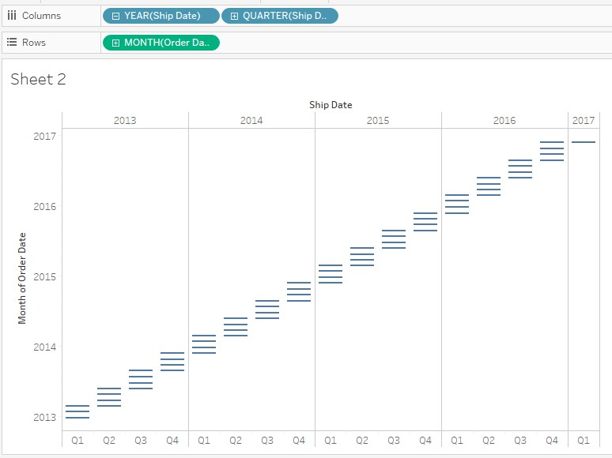 a. Ship date is discrete, order date is continuous

* 1. Ship date is discrete, order date is discrete
  2. Ship date is continuous, order date is discrete
  3. Ship date is continuous, order date is continuous

Correct answer is A. Blue pills indicates discrete and creates headers, while green pill indicates continuous and creates axis.

