**Adding the Widget to the Web AppBuilder**

To add this widget to your ArcGIS WebApp Builder,

* download the zip file of the widget and unzip it
* Copy the SaveSession folder from the zip file into client\stemapp\widgets directory

[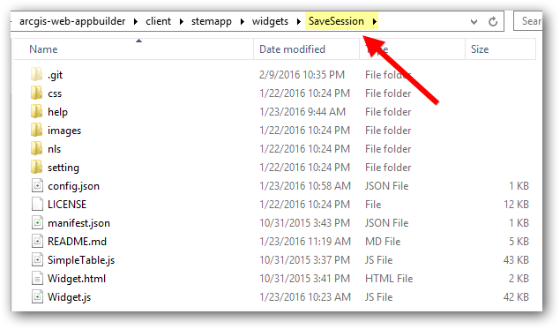](https://github.com/softwhere/SaveSession-Widget/blob/master/help/InstallFolder.png)

* edit the \client\stemapp\config.json and enter the SaveSession widget in the widgets entry

Example:

"widgets": [

{

"uri": "widgets/SaveSession/Widget"

}

...

]

## Configuring the Widget

Using the Web AppBuilder, click the edit icon on the SaveSession widget in the in-panel widgets to display the Configure Dialog.

[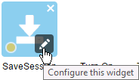](https://github.com/softwhere/SaveSession-Widget/blob/master/help/Configure-icon.png)

[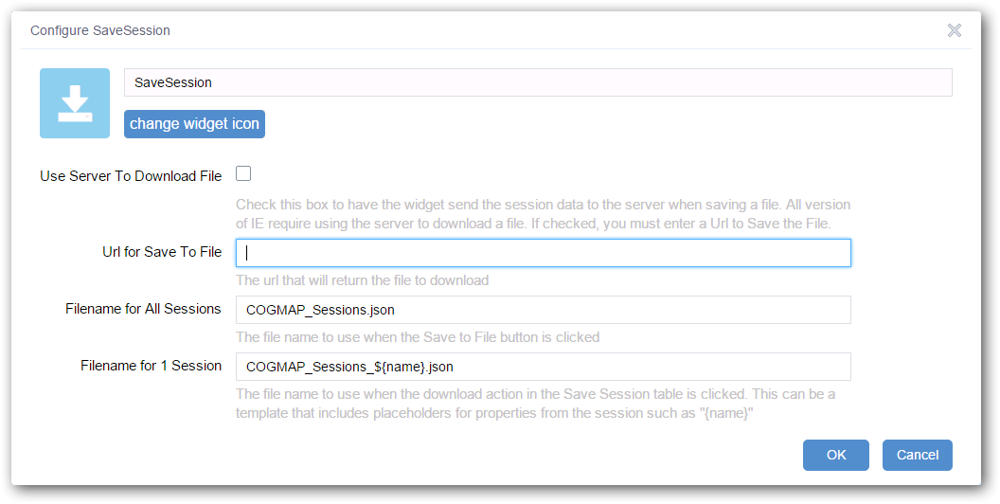](https://github.com/softwhere/SaveSession-Widget/blob/master/help/Configure.png)

**Use Server To Download File** = All browsers support downloading a file from a server. Some browsers like Chrome or Edge can support downloading a file of data without a round trip to the server by using a data url. Visit<http://caniuse.com/#feat=download> to see if your browser supports downloading from data urls. To enable downloading from a data url, uncheck the box. To enable downloading from a server side service, check the box and enter a Url for Save to File.

**Url for Save To File** = the Url that will return a file for the given data. The SaveSession widget will post the data to the url and the web service should respond with the file as an attachment. This is only needed if Use Server To Download File is checked.

**Filename for All Sessions** = the file name to use when the Save to File link is clicked.

**Filename for 1 Session** = the file name to use when the Download action is used to save a single session to a file. Include the "{name}" placeholder that will be replaced with the session name at runtime.

## FAQ

### The Save to File link does not work?

Visit <http://caniuse.com/#feat=download> to see if your browser supports downloading from data urls. If not, then you'll need to enable the Use Server To Download File option and create a service that returns the session file as an attachment.

Note that a web service that downloads the session file is not included in the widget. It lives outside the widget on your own web server.