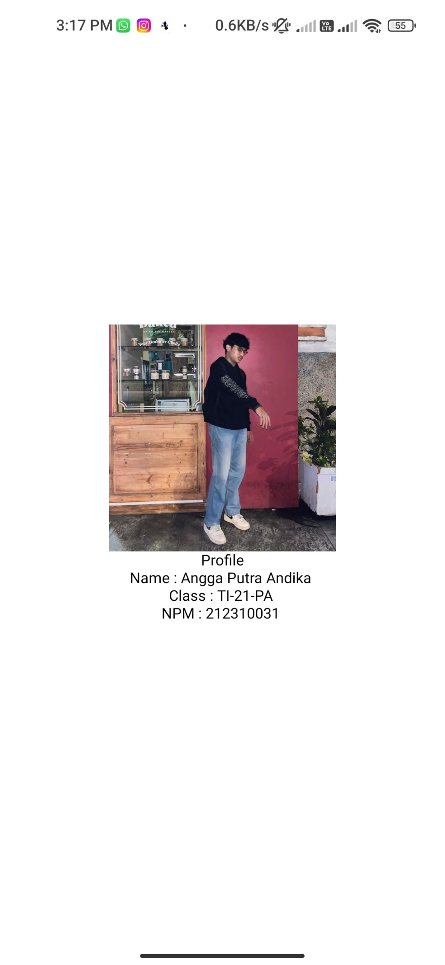

import { StatusBar } from 'expo-status-bar';

import { StyleSheet, Text, View, Image } from 'react-native';

export default function App() {

  return (

    <View style={styles.container}>

       <Image source={require('./assets/angga.jpg')}

         style={{width: 200, height: 200}} />

      <Text>Profile</Text>

      <Text>Name : Angga Putra Andika </Text>

      <Text>Class : TI-21-PA </Text>

      <Text>NPM : 212310031 </Text>

      <StatusBar style="auto" />

    </View>

  );

}

const styles = StyleSheet.create({

  container: {

    flex: 1,

    backgroundColor: '#fff',

    alignItems: 'center',

    justifyContent: 'center',

  },

});