A Study of an Optimal ​​Controller for a Ship’s Central Cooling Water System with the Model Based on Operating Data

Tae-Youl Jeon a, Chang-Min Lee b, Byung-Gun Jung c,*

a. American Bureau of Shipping (Korea Ulsan Branch Office); 1000, Bangeojinsunhwando-ro, Dong-gu, Ulsan 44032 Korea

b. Division of Marine System Engineering, Korea Maritime and Ocean University, 727, Taejong-ro, Yeongdo-gu, Busan 49112, Korea; Korea Maritime & Ocean University;

c. Division of Marine System Engineering, Korea Maritime and Ocean University, 727, Taejong-ro, Yeongdo-gu, Busan 49112, Korea; Korea Maritime & Ocean University;

E-Mail:

**Abstract**

Since the controllers of the variable speed seawater pump and the 3way valve of a ship central cooling system are received the feedback signal from the same output, the two controllers may interfere and operate inefficiently in a specific operating condition. Studying the efficient control method for the central cooling water system is necessary. First, this study models the central cooling water system using MATLAB Simulink based on the actual operation data and estimate parameters of the unknown parameters. Then another operating data set is used to verify the simulation model. An optimal controller is designed and applied to the simulation model. It is compared the efficiency of energy saving and control performance between the conventionally used two PI controllers and the optimal controller. And it is found that the developed optimal control method is more efficient and has better control performance.

***Keywords*:** ship central cooling system; optimal control; energy saving

1. Introduction

The control system has become essential for ships' safety and efficient navigation. Various control methods have been applied to ships. In particular, in the modern era, when oil prices continuously rise, the importance of motor control for reducing ship operating costs has been highlighted[1,2]. As a representative example, a variable speed control device that adjust the frequency of voltage power according to the fresh water temperature output from the central cooling water system(CCWS) is applied to the cooling seawater pump motor to save energy.

A. T. de Almeida[3,4] proposed a motor design and control system to reduce energy and water loss in feedwater pump systems using PLC with variable speed motors in buildings and industrial plants. After that, Jin-seok Oh [5], Ji-young Lee[6], and Yun-hyung Kim [7,8] suggested applying a variable speed pump to save electrical energy in the ship CCWS. Furthermore, Sung-hee Hong[9] also studied the case of applying a variable speed seawater pump motor.

The energy saving evaluation method of the CCWS to which the ship's variable speed drive(VFD) seawater pump is applied was also studied. Chun-Lien Su and S. Yimchoy[10,11] proposed a calculation method for the immediate energy savings of ships with VFD applied to the central cooling seawater pump. Kocak and Gazi [12] analyzed the potential energy savings of a central cooling system with a variable speed seawater pump and calculated the annual energy cost saved by the variable speed seawater pump according to the seawater temperature.

Pariotis, E. G. [13] studied the importance of using an integrated approach for reliable evaluation of retrofit solutions of CCWs of variable speed seawater pumps to maximize the fuel economy of ships.

Giannoutsos, S.V [14] confirmed a reduction in fuel consumption of diesel generators compared to when a fixed speed seawater pump was applied by designing a data-driven PID process controller and applying a variable speed seawater pump and controller to an actual tanker. In addition, Chang-seop Lee [15] applied the feed-forward control method, and TY Jeon[16] changed the PI controller's feedback position for the seawater pump's speed control and confirmed the energy saving through simulation.

In this study, the central cooling water system is modeled close to reality using actual operating data. In addition, we would like to prove their effectiveness by developing the MIMO(Multi Input Multi Output) optimal controller for seawater pump speed control and 3-way valve opening control.

2. Simulation modeling of ship central cooling system

2.1. Configuration of central cooling system on a ship

**Figure 1** shows the CCWS of an actual ship to be modeled[17]. It consists of a seawater(SW) pump that supplies seawater, a freshwater pump(FW) that circulates fresh water, a heat exchanger(HEX) that cools the heat of hot fresh water into cold seawater, and a 3-way valve that bypasses the supply of hot fresh water to the heat exchanger.

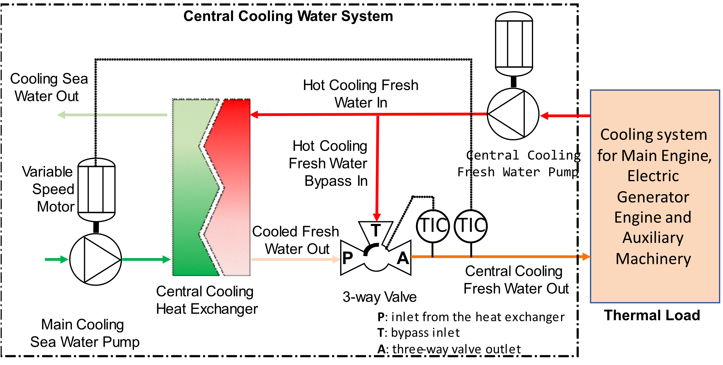

**Figure 1.** An example of a central cooling system on a ship

The FW pump circulates fresh water to cool the thermal load at a constant rotation speed. The FW cooled by the thermal load is supplied to the CCWS at a temperature of about 38-43℃. The FW is supplied to the HEX, and the 3-way valve adjusts the bypassed flow rate. The FW supplied to the HEX is cooled by a low-temperature SW. The cooled FW is mixed with high-temperature FW bypassing the HEX by a three-way valve. And the mixed and cooled FW returns to the thermal load.

Meanwhile, the low-temperature SW is supplied to the HEX through the SW pump. The SW pump is rotated by a variable speed motor driven by an inverter. By changing the frequency of the input power supplied to the SW pump motor by an inverter, the amount of SW supplied to the HEX is able to be adjusted.

1.2 Configuration for simulation

As shown in **Figure 2**, the CCWS is implemented without the controller using Matlab Simulink [18-20].

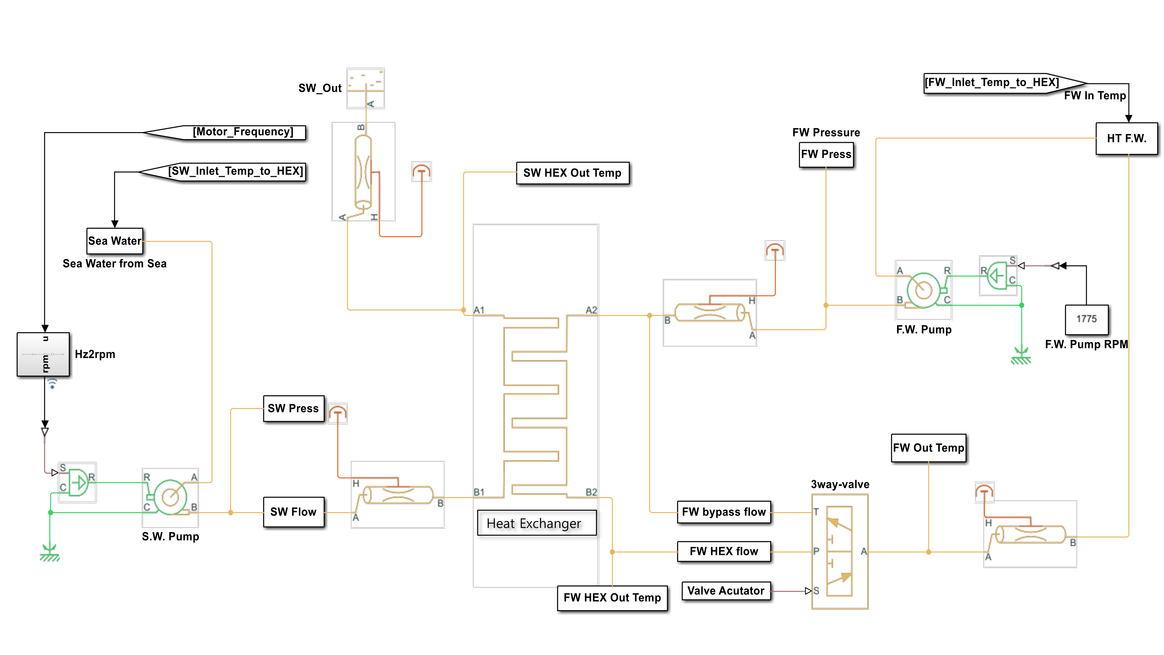

**Figure 2**. Modeling of the central cooling system

It is referred to as the datasheet information [21-23] for each FW pump, SW pump, 3-way valve, and HEX model's parameter values.

The FW pump is driven by a 4-pole, 3-phase, 440V, and 60Hz motor. Referring to the FAT report, it is modeled as a constant rotation at 1775 rpm, considering the motor slip. The SW pump also is driven the motor with the same specifications as the FW pump. However, the frequency input to the SW pump motor can be adjusted from 30 to 60 Hz through the inverter. The variable rotational speed in the SW pump motor is set to 1775 rpm maximum, considering the slip. Furthermore, the minimum rotation speed is set to 887 rpm when the frequency input to the motor is 30Hz as set on the actual operation ship. In addition, the suction pressures of the SW pump and FW pump are set by referring to the pressures applied to the suction gauges when the actual pumps are stopped.

The 3-way valve outputs FW bypassing the HEX through the T port, FW coming through the HEX through the P port, and FW mixed with the two FW through the A port. In the 3-way valve, the FW bypassing the HEX is connected to the T port, the FW coming through the HEX is connected to the P port, and the combined output of the two FW is set to the A port. The bypass FW flow regulated by an actuator is set to change linearly. In addition, the offset of the T and P ports is set to zero, and if the T port side is fully opened, the P port is completely closed. And the P port is fully opened the T port is fully closed.

It refers to the HEX datasheet and FAT(Factory Acceptance Test) report for the necessary parameters for the modeling, such as the HEX area, overall heat transfer coefficient (OHTC), thermal conductivity, pressure drop, pipe size, etc.

2.3 Tuning for the simulation model

As shown in **Figure 2**, it is modeled referring to each equipment's FAT reports and datasheets. However, similar simulation outputs with the actual CCWS are not obtained due to unknown parameters such as pipeline roughness, the thermal mass of the heat exchanger, and wall thermal resistance. Therefore, using the actual operation data, find the parameter values ​not mentioned in the datasheets so that the output results are close to the actual CCWS outputs.

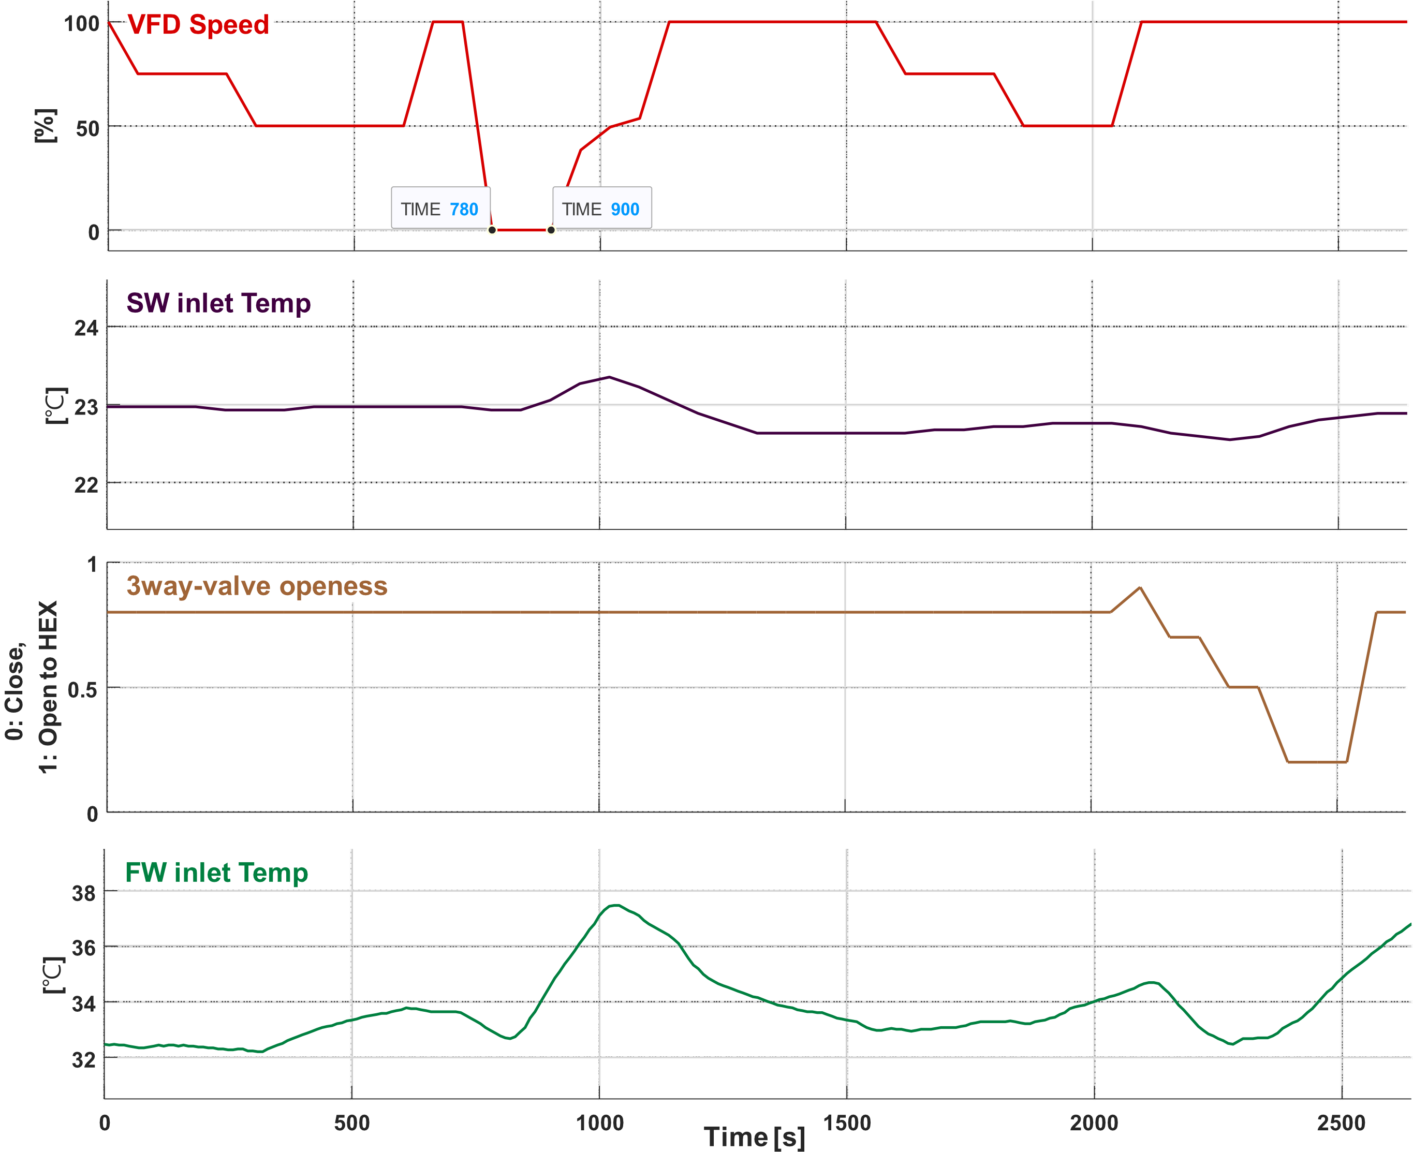

**Figure 3**. Operation input data for parameter tuning



**Figure 4**. Operation output data for parameter tuning

Of the actual operation data, the FW pump pressure and 3-way valve FW outlet temperature data are recorded at 10-second intervals, and the remaining data are collected at 60-second intervals.

The actual operation data shown in **Figure 3** is input data to the model of CCWS and simulated. The input data are the frequency of the SW pump motor, SW temperature, the degree of opening of the 3-way valve, and the temperature of FW. From 0 to 1000 seconds, the opening of the 3-way valve is fixed at 0.8, and only the rotational speed of the SW pump is varied. And from 2000 to 2,600 seconds, the SW pump is fixed at the maximum rotation speed, and only the 3-way valve openness is changed.

When the input to the actual CCWS is shown in **Figure 3**, the output is shown in **Figure 4**. The output of the modeled CCWS, as shown in **Figure 4**, is approximated through the parameter estimator. The pipeline roughness values, HEX thermal mass, and wall thermal resistance parameters are found through iterative simulations.

**Figure 5-6** compares the tuning result with actual operation data, SW pressure, FW pressure, HEX FW outlet temperature, and HEX SW outlet temperature.

**Figure 5** shows that the SW pressure of the simulation result and the actual operation value changes similarly.

**Figure 6** shows that the FW pressure change is similar to the actual operation data and the model simulation result.

**Figure 7** shows the change in the HEX outlet temperature and FW temperature. The deviation between the simulation result and the actual operation data is about 0.5°C.



**Figure 5**. Sea water pressure tuning result



**Figure 6**. Fresh water pressure tuning result

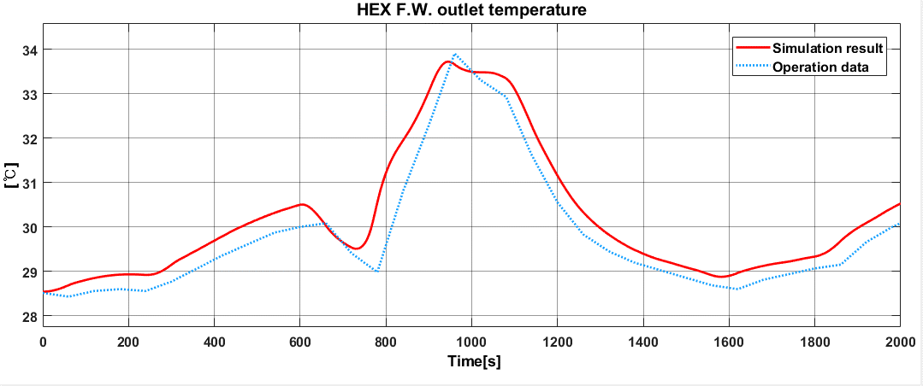

**Figure 7**. Heat exchanger fresh water outlet temperature after tuning



**Figure 8**. Heat exchanger sea water out temperature tuning result

In **Figure 3**, Between 780 and 900 seconds during the SW pump is stopped, the difference between the actual operation values and the simulation result is about 1.5°C. However, in other sections, the deviation of about 0.5°C occurs. The minimum speed of rotation of the SW pump is 887 [rpm], so the SW pump does not stop during operation. Therefore, the difference occurring in the section where the SW pump is stopped is negligible.

2.4. Verification the simulation model

The model tuned in the previous section 2.3 is verified using the another actual operation data set achieved at different times. The input and output data, which are actual operation data to be used in this simulation, are shown in **Figure 9** and **Figure 10**. Input data are SW pump motor input frequency, SW temperature, 3-way valve opening degree, and FW temperature. And the output data are HEX outlet SW temperature, HEX FW outlet temperature, SW pressure, FW pressure, and 3-way valve outlet FW temperature.



**Figure 9**. Operation input data for the model verification



**Figure 10.** Operation output data for model verification

Among the results in **Figure 10**, the SW and FW outlet temperatures of the HEX and the FW outlet temperatures of the 3-way valve are compared with the simulation results.

2.4.1 Comparing the temperatures between SW outlets from the HEX

**Figure 11** shows the actual operating data and simulation results of the SW temperature at the outlet of the HEX. The simulation result is lower than the actual operation data by about 0.7℃ after 300 seconds.



**Figure 11**. Comparing HEX SW outlet temperature

2.4.2 Comparing the temperatures between FW outlets from the HEX

**Figure 12** shows the actual operation data and simulation results of the FW temperature in the HEX outlet. The maximum difference between the simulation result and the actual operation data is +0.4℃.



**Figure 12**. Comparing HEX FW outlet temperature

2.4.3 Comparing the temperatures between FW outlets from the 3way-valve

**Figure 13** shows the actual operation data and simulation results of the FW temperature at the outlet of the 3-way valve. The actual operation data shows the difference is +0.7℃ maximum and -0.6℃ minimum. The showing deviation between two data is affected the data recorded interval time.



**Figure 13**. Comparing controlled F.W. temperature at the 3way-valve outlet

3. Developing an optimal controller

3.1 Mathematical modeling of the CCWS

In order to develop an optimal controller for the CCWS, mathematical modeling with two inputs for SW pump rotation speed control and 3-way valve opening control and one output for FW outlet temperature at a 3-way valve outlet is required. This mathematical modeling is modeled by performing linearization in the vicinity of the operating point [16].

3.1.1 Mathematical modeling of the SW pump

The discharge amount of the SW pump is proportional to the rotational speed of the pump. Since the SW pump motor is an induction motor, it is linearized as equation (1).[24-27]

|  |  |
| --- | --- |
|  | (1) |

Where, is the ratio of a flow rate change to pump rotation speed change. is the input power frequency, and is the number of poles of the SW pump motor.

3.1.2 Mathematical modeling of the 3-way valve

If the opening volume to which the 3-way valve opens toward the HEX is , has a value of . When is 0, it is completely closed, the flow rate flowing to the HEX becomes 0, and the flow rate bypassing the HEX becomes maximum. Conversely, when is 1, it is fully open, the flow rate flowing to the HEX becomes maximum, and the flow rate bypassing the HEX becomes 0. Therefore, the flow rate of FW flowing through the HEX is as follows.

|  |  |
| --- | --- |
|  | * (2) |

On the other hand, the FW flow rate that bypasses the HEX can be described as in equation (3) by applying instead of and instead of in equation (2).

|  |  |
| --- | --- |
|  | (3) |

And the FW outlet temperature of the 3-way valve is the sum of the temperature of and the temperature of by each flow rate. So the rate of change in the 3-way valve outlet temperature can be expressed as in equation (4).

|  |  |
| --- | --- |
|  |  |
|  |  |
|  |  |
|  | (4) |

Where is FW specific heat, is FW density, and is FW volume in the 3-way valve.

3.1.3 Mathematical Modeling of the Heat Exchanger

The temperature change rate of SW and FW passing through the HEX can be expressed as equations (5) and (6).[28-31]

|  |  |
| --- | --- |
|  | (5) |
|  | (6) |

3.1.4 Linearize the modeling near the operation point

Mathematical model equations (1) and (2) obtained above are substituted into equations (4), (5), and (6) and summarized as equations (7), (8), and (9).

|  |  |
| --- | --- |
|  | * (7) |
|  | * (8) |
|  | * (9) |

As shown in equation (10), the SW pump motor power frequency and 3-way valve opening degree , which are the control inputs, are selected as the input of the CCWS. And as shown in equation (11), the output variable and the state variable select the HEX outlet FW and SW temperatures , , and the 3-way valve outlet FW temperature .

|  |  |
| --- | --- |
|  | * (10) |
|  | * (11) |

Finally, equations (7), (8), and (9) for the CCWS are linearized near the operating point and arranged in the form of state space equation as in equations (12) and (13). [32]

|  |  |
| --- | --- |
|  | * (12) |
|  | * (13) |

Then the A, B, C, and D matrices are given by equations (14), (15), (16), and (17).

|  |  |
| --- | --- |
|  | * (14) |
|  | * (15) |
|  | * (16) |
|  | * (17) |

**Table 1.** Parameters of the central cooling system.

|  |  |  |  |  |  |
| --- | --- | --- | --- | --- | --- |
| **Symbol** | **Value** | **Unit** | **Symbol** | **Value** | **Unit** |
|  | 180.8 | m2 |  | 1000 | kg/m3 |
|  | 3.93 | kJ/kg°C |  | 25 | °C |
|  | 4.18 | kJ/kg°C |  | 27.7 | °C |
|  | 60 | Hz |  | 41 | °C |
|  | 9 | m3/min |  | 28.3 | °C |
|  | 0.0071 | m3/rpm |  | 450.6 | kJ/m2 min°C |
|  | 0.98 |  |  | 0.014 | m3 |
|  | 4 | pole |  | 0.27 | m3 |
|  | 1025 | kg/m3 |  | 0.27 | m3 |

By substituting the parameters of the CCWS in Table 1 into equations (14) and (15), equations (18) and (19) are as follows.

|  |  |
| --- | --- |
|  | * (18) |
|  | * (19) |

3.2 Optimal Controller

If the optimal control vector for equation (12) is equal to equation (20),

|  |  |
| --- | --- |
|  | * (20) |

The gain K that minimizes the performance index J of equation (21) is designed [33].

|  |  |
| --- | --- |
|  | * (21) |

where Q is a positive-definite(or positive-semidefinite) Hermitian or real symmetric matrix and R is a positive-definite Hermitian or real symmetric matrix. The matrices Q and R determine the relative importance of the error and the expenditure of this energy.

In the CCWS, the FW outlet temperature of the 3-way valve and the FW outlet temperature of the HEX should be kept constant. Therefore, referring to equation (11), the value of the matrix Q corresponding to and is increased to 1000 and set as equation (22). The matrix R is set as shown in equation (23).

|  |  |
| --- | --- |
|  | * (22) |
|  | * (23) |

Equation (24) is obtained when the matrice K minimizes t the performance index J.

|  |  |
| --- | --- |
|  | * (24) |

The control gain K is a 2 by 3 matrix. As shown in **Figure 14**, K1 is the SW pump power frequency, u1 and K2 are connected to the opening input u2 of the 3-way valve.

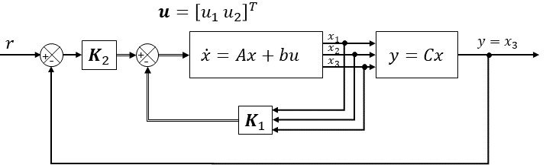

**Figure 14**. Optimal control diagram for central cooling system

4. Simulation Result

The simulation results are compared between the PI and optimal controllers. The comparison target is the change in the FW outlet temperature of the 3-way valve, which indicates control performance, and the rotational speed of the SW pump, which is closely related to energy saving. In the configuration of the CCWS in **Figure 1**, referring to the SW temperature [34] in the Korean offshore waters in spring and autumn, the SW input temperature is set to 23℃. For the FW input temperature, referring to the heat balance data of the model ship[17], step up from 39℃ to 43℃ by 2℃ and then step down again in reverse. Each step interval is maintained at 200 seconds.



**Figure 15**. Comparing 3way-valve FW outlet temperature between PI & optimal control

**Figure 15** compares the outlet FW temperature of the 3-way valve. When the FW temperature is entered step-up and step-down, it shows that both the PI controller and the optimal controller maintain the set temperature of 36℃ well.



**Figure 16**. Comparing 3way-valve openness between PI & optimal control

**Figure 16** shows the change in the opening of the 3-way valve. From 0 to 300 seconds, the PI control and the optimal control show similar patterns. After 300 seconds, it can be seen that the optimal control opens the 3-way valve slightly more than the PI control.



**Figure 17**. Comparing S.W. pump motor rpm between PI & optimal control

**Figure 17** shows the rotational speed change of the SW pump. There is no significant difference in the SW pump's rotational speed between the PI and the optimum controller in 0-200 seconds. However, after 250 seconds, the rotation speed of the SW pump using the optimal controller is lower than that of the SW pump using the PI controller. After 300 seconds, the FW input temperature is step-down to CCWS. In addition, the maximum rotation speed of the SW pump in the 250-300 seconds is also kept low by the optimum controller. The CCWS with the optimum controller performs better than the applied PI controller.

5. Conclusion

Simulation Modeling was carried out on a ship's central cooling water system. In addition, to increase the simulation's accuracy, the unknown parameter values ​​of the central cooling water system were estimated using actual operating data. Then to verify the modeled CCWS, another operation data was used, and the simulation results were compared with the operation data. By verifying based on the actual operating data, the CCWS approximate to the actual was modeled.

The CCWS was mathematically modeled to develop a optimal controller. And the CCWS modeled by the state equation was linearized near the operating point. Using a linearized model, a control gain K that minimizes the performance index function J was obtained by giving a state weight to the FW outlet temperature of the HEX and the FW outlet temperature of the 3-way valve.

The developed optimum controller and a PI controller were applied on the simulation model to perfom the step input of the FW temperature at the SW temperature of 23℃ in the CCWS. The performance of the optimal controller was confirmed through the simulation and it was more efficient in controlling the sea-water pump rotation speed than the PI controller.

As a result, it was confirmed that the CCWS could be efficiently controlled with one controller rather than the two PI controllers.

Acknolowledgments

References

[1] Global 4 Ports Average Prices Singapore-Rotterdam-LA/LB Houston. Available online: <https://shipandbunker.com/prices/av> (Accessed on .4.27 2022).

[2] Lindstad, H.; Asbjørnslett, B.E.; Strømman, A.H. Reductions in greenhouse gas emissions and cost by shipping at lower speeds. Energy Policy 2011, 39, 3456-3464.

[3] A. T. de Almeida; F. J. T. E. Ferreira; D. Both Technical and economical considerations in the application of variable speed drives with electric motor systems, - Conference, 2004 IEEE Industrial and Commercial Power Systems Technical, 2004; , pp. 136-144.

[4] De Almeida, A.; Ferreira, F.; Fonseca, P.; Chretien, B.; Falkner, H.; Reichert, J.C.; West, M.; Nielsen, S.B.; Both, D. VSDs for electric motor systems. Final Report, SAVE Programme, European Commission, Brussels 2001.

[5] Oh, J.; Jo, K.; Kwak, J.; Jin, S.; Kim, J.; Lee, H. A Study on the Energy Saving System with the LabVIEW, Proceedings of the Korean Society of Marine Engineers Conference, The Korean Society of Marine Engineering: 2005; , pp. 250-251.

[6] Lee, J.; Yoo, H.; Kim, Y.; Oh, J. A Study on the Energy Saving Method by controlling Capacity of Sea Water Pump in Central Cooling System for Vessel. Journal of Advanced Marine Engineering and Technology 2007, 31, 592-598.

[7]. Yun-Hyung Kim A Study on Suitable Electric Energy Saving System for the Cooling System of Vessel . Korea Maritime and Ocean University 2008.

[8] Kim, Y.; Bae, S.; Jung, S.; Oh, J. Study on the electric energy saving system in marine cooling system. Journal of Advanced Marine Engineering and Technology 2008, 32, 1157-1163.

[9] Hong, S.H.; Kim, C.S.; Hong, K.E.; Oh, J.S.; Lee, J.U. Application for RPM Control of Cooling Sea Water Pump in Central Cooling System for Ship. Journal of the Korean Society of Marine Engineering 2007, 2007, 29-32.

[10] C. Su; W. Chung; K. Yu An Energy-Savings Evaluation Method for Variable-Frequency-Drive Applications on Ship Central Cooling Systems. IEEE Transactions on Industry Applications 2014, 50, 1286-1294, DOI 10.1109/TIA.2013.2271991.

[11] S. Yimchoy; U. Supatti An Energy-Savings Evaluation Method for Variable-Frequency-Drive Applications on Water Pump Systems, - 2021 24th International Conference on Electrical Machines and Systems (ICEMS), 2021; , pp. 603-608.

[12] Kocak, G.; Durmusoglu, Y. Energy efficiency analysis of a ship’s central cooling system using variable speed pump. null 2018, 17, 43-51, DOI 10.1080/20464177.2017.1283192. Available online: <https://doi-org.libproxy.kmou.ac.kr/10.1080/20464177.2017.1283192.>

[13] Pariotis, E.G.; Zannis, T.C.; Katsanis, J.S. An Integrated Approach for the Assessment of Central Cooling Retrofit Using Variable Speed Drive Pump in Marine Applications. J Mar Sci Eng 2019, 7, 253, DOI 10.3390/jmse7080253.

[14] Giannoutsos, S.V.; Manias, S.N. A data-driven process controller for energy-efficient variable-speed pump operation in the central cooling water system of marine vessels. IEEE Trans Ind Electron 2014, 62, 587-598.

[15] Lee, C.; Jeon, T.; Jung, B.; Lee, Y. Design of Energy Saving Controllers for Central Cooling Water Systems. Journal of Marine Science and Engineering 2021, 9, 513.

[16] Jeon, T.; Lee, C.; Hur, J. A Study on the Control Solution of Ship’s Central Fresh Water-Cooling System for Efficient Energy Control Based on Merchant Training Ship. Journal of Marine Science and Engineering 2022, 10, 679.

[17] Hanjin Heavy Industry S148, T/S Hannara, Heat Balance Calculation. 2018.

[18] MATLAB Help Center - Simscape Centrifugal Pump (TL). Available online: <https://www.mathworks.com/help/releases/R2020b/physmod/hydro/ref/centrifugalpumptl.html.>

[19] MATLAB Help Center - Simscape 3-Way Directional Vave(TL). Available online: <https://www.mathworks.com/help/physmod/hydro/ref/3waydirectionalvalvetl.html> (Accessed on .7.18 2022).

[20] MATLAB Help Center- Simscape Heat Exchanger(TL-TL). Available online: <https://www.mathworks.com/help/releases/R2020b/physmod/hydro/ref/heatexchangertltl.html> (Accessed on .7.15 2022).

[21] BY Controls, I. S148, T/S Hannara, Control Valve Specification Sheet. Hanjin Heavy Industries 2018.

[22] Hanjin Heavy Industry S148,T/S Hannara, Plate Cooler Final. 2018.

[23] Shin Shin Machinery Co., L. S148, T/S Hannara, Pump Test Record. Hanjin Heavy Industries 2017.

[24] On the modeling of a centrifugal pump. Available online: <https://www.researchgate.net/publication/333292922_On_the_modeling_of_a_centrifugal_pump> (Accessed on .5.13 2022).

[25] Chantasiriwan, S. Performance of variable-speed centrifugal pump in pump system with static head. International Journal of Power and Energy Systems 2013, 33.

[26] Wang, Y.; Zhang, H.; Han, Z.; Ni, X. Optimization design of centrifugal pump flow control system based on adaptive control. Processes 2021, 9, 1538.

[27] T. Li; Q. Ren; H. Zhao Research on Optimal Control of Cooling Water System in Central Air Conditioning System, - 2013 Fourth International Conference on Intelligent Systems Design and Engineering Applications, 2013; , pp. 511-514.

[28] Al-Dawery, S.K.; Alrahawi, A.M.; Al-Zobai, K.M. Dynamic modeling and control of plate heat exchanger. Int J Heat Mass Transfer 2012, 55, 6873-6880, DOI <https://doi-org.libproxy.kmou.ac.kr/10.1016/j.ijheatmasstransfer.2012.06.094.> Available online: <https://www-sciencedirect-com.libproxy.kmou.ac.kr/science/article/pii/S001793101200525X.>

[29] Wang, Y.; You, S.; Zheng, W.; Zhang, H.; Zheng, X.; Miao, Q. State space model and robust control of plate heat exchanger for dynamic performance improvement. Appl Therm Eng 2018, 128, 1588-1604.

[30] Iu, I.; Weber, N.A.; Bansal, P.; Fisher, D.E. DA-07-056 Applying the Effectiveness-NTU Method to Elemental Heat Exchanger Models. ASHRAE Trans 2007, 113, 504-513.

[31] Vega, D.M.; Acevedo, H.G. Advanced Control System Design for a Plate Heat Exchanger, 2020 IX International Congress of Mechatronics Engineering and Automation (CIIMA), IEEE: 2020; , pp. 1-6.

[32] Bequette, W.B. Process control: modeling, design, and simulation, Prentice Hall PTR: 2003; pp. 65.

[33] Ogata, K. Modern control engineering, Fifth (International Edition) ed.; Prentice Hall: Upper Saddle River, NJ, 2009; pp. 803-816.

[34] World Sea Water Temperature. Available online: <https://www.seatemperature.org> (Accessed on .7.18 2022).