{OOP}
in PHP
Try OOP in PHP
(Pokemon case)

Basic OOP Concepts

- Class (variable member, function member, object, call fuction)
- Constructor Function
- Inheritance (extends)
- Function Overriding
- Public Members
- Private Members
- Protected Members
- Interfaces
- Constant
- Abstract Classes
- Static Keyword
- Final Keyword

1. Class
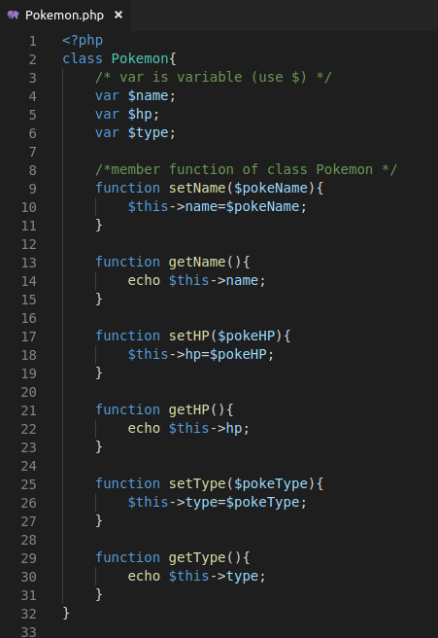

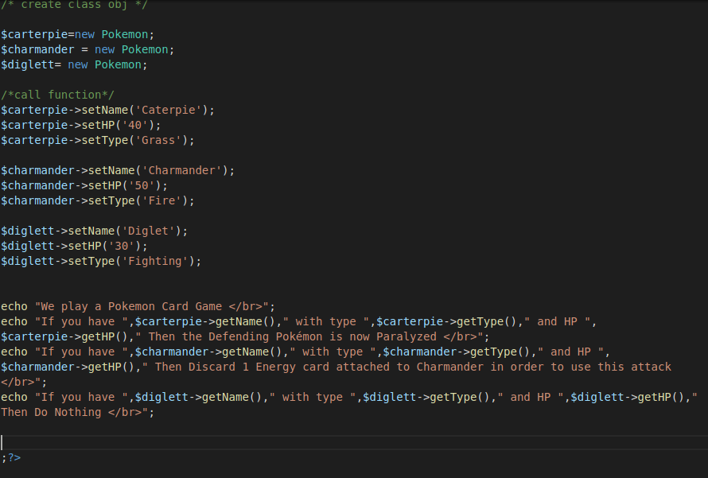

2. Constructor Function
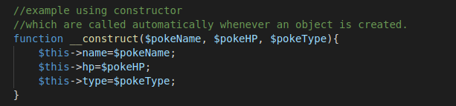
Comment /**/ all setter then create object
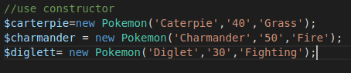

Output:

3. Inheritance

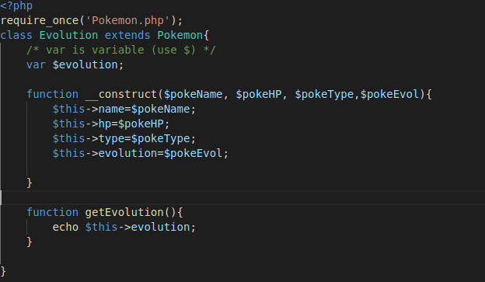
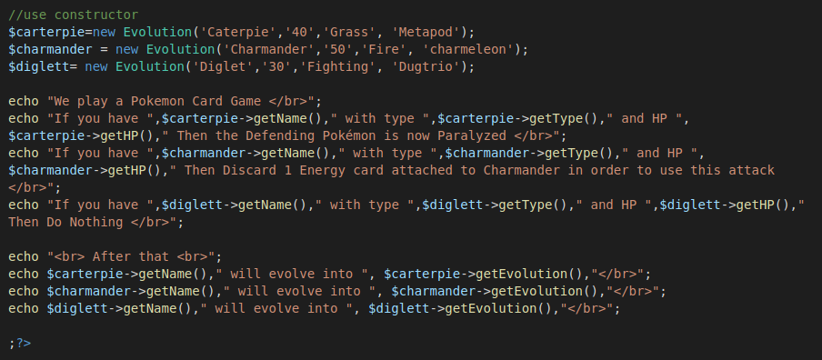
output :
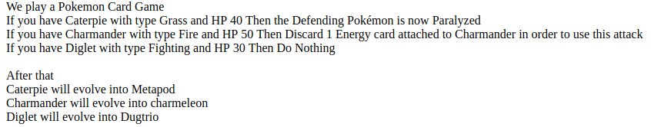

4. Function Overriding
Function getHP in child override function in parent with same name.
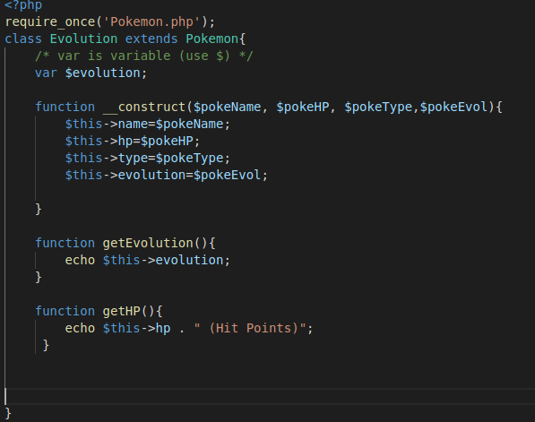

Output :

5. Public Members
By default var and functions is public, can be accessed outside class, within class, or another class.

6. Private Members
Example 1
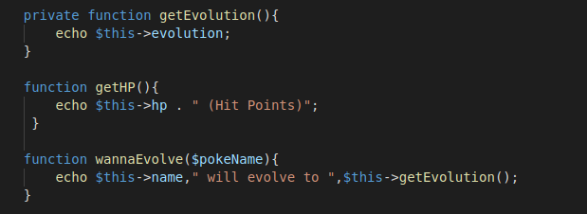
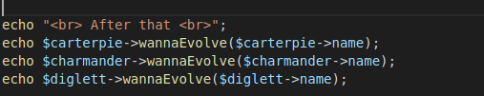

Output
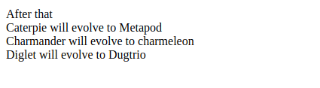

Example 2
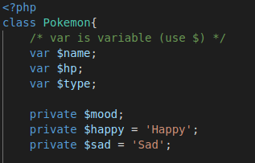

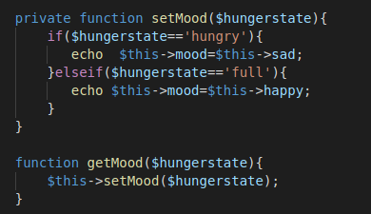

call the function in evolve class *).
*) I’m not allowed to set directly the mood of the pokemon.
Output :


7. Protected members
Pokemon Class
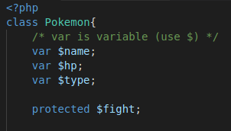

Evolution Class extend Pokemon
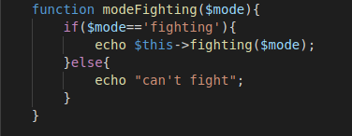

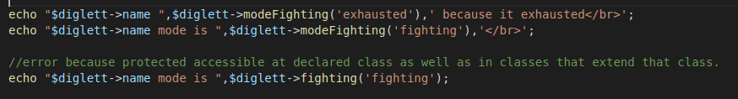
output :
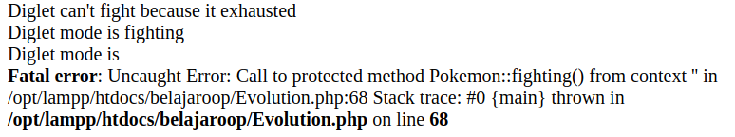

8. Interfaces
Poke_Interface.php
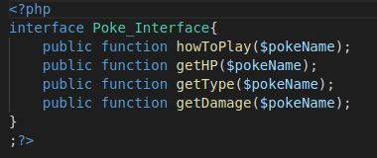

Example 1 :
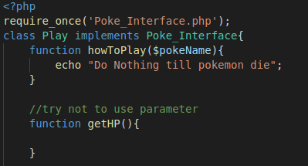

Output :
Example 2:
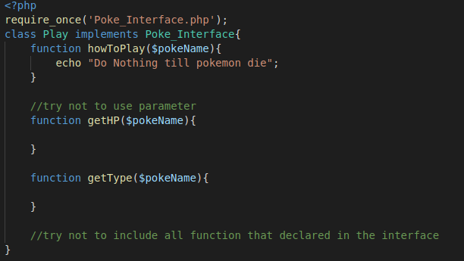

Output :
Example 3 :
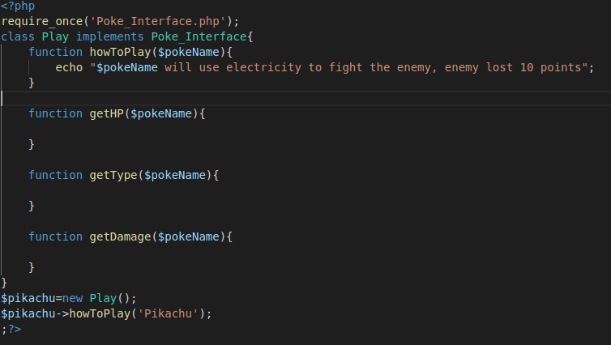
Ouput :

9. Constant
Const vs Var
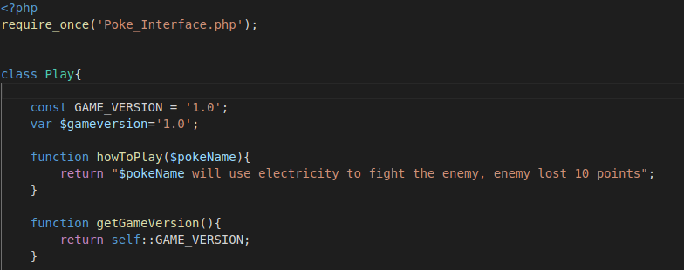
Example
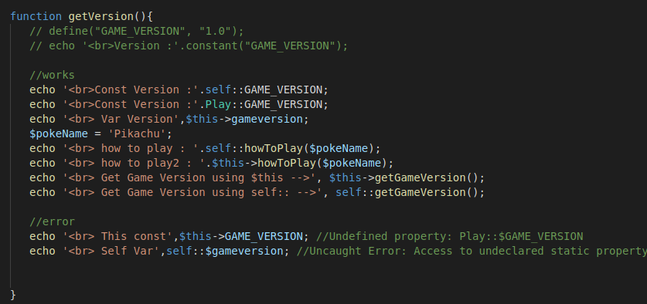
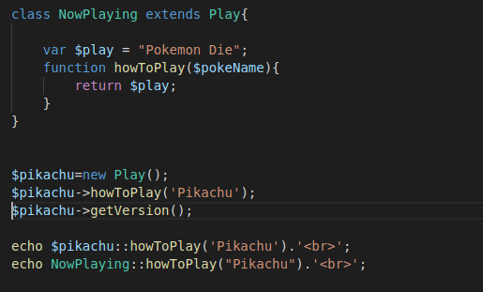
Output :
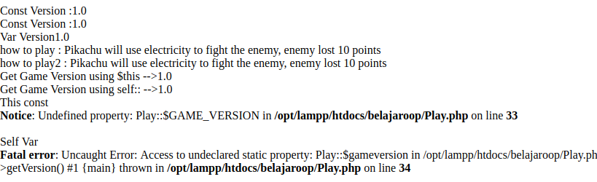

10. Abstract Classes
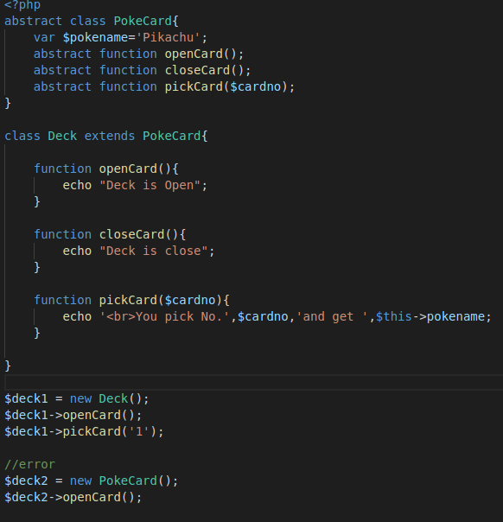

Output :
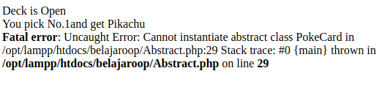

11. Static Keyword
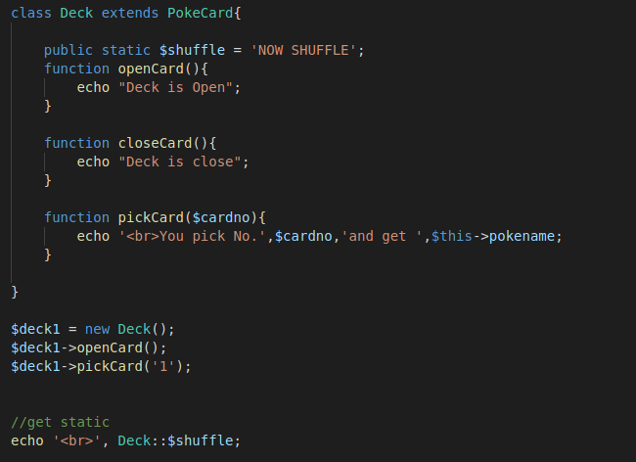
Output :


12. Final Keyword
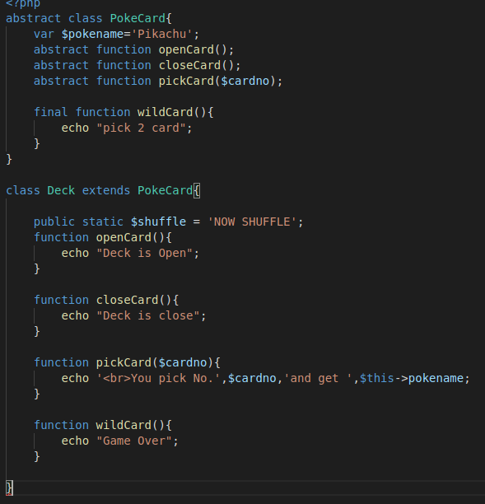
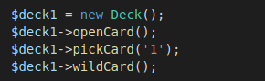

Ouput :
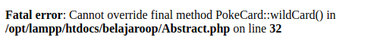

13. Calling Parent constructor
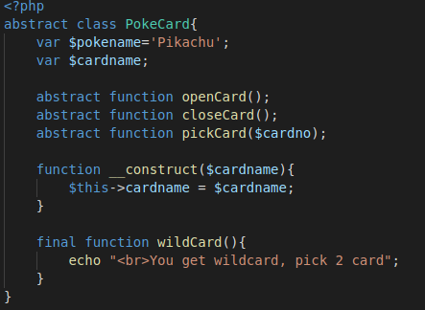

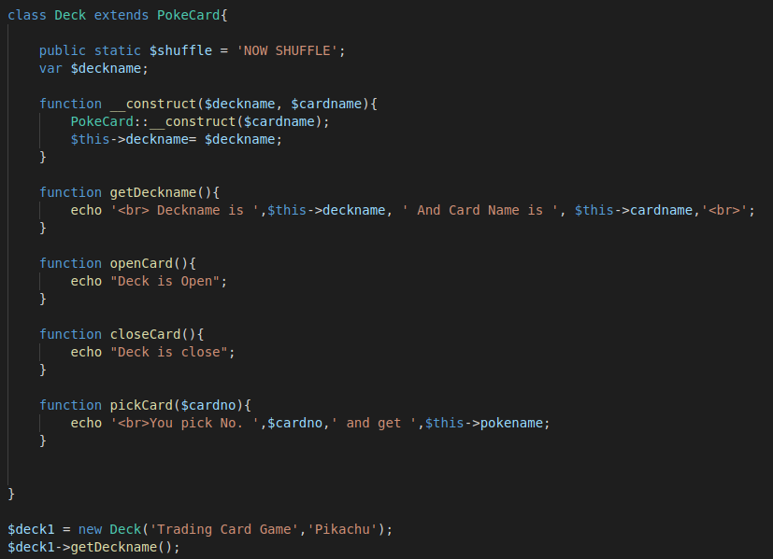
Output:

