College of Computer Science and Engineering Department of Information System and Technology Data Science and analysis program

University of Jeddah, Saudi Arabia

**Applied Machine Learning CCDS-322 (Lab#1)**

* **Download the attached dataset and apply the following steps:**
  1. Import the dataset and show the table.

* 1. Separate the Independent and dependent variables.

Independent

Dependent

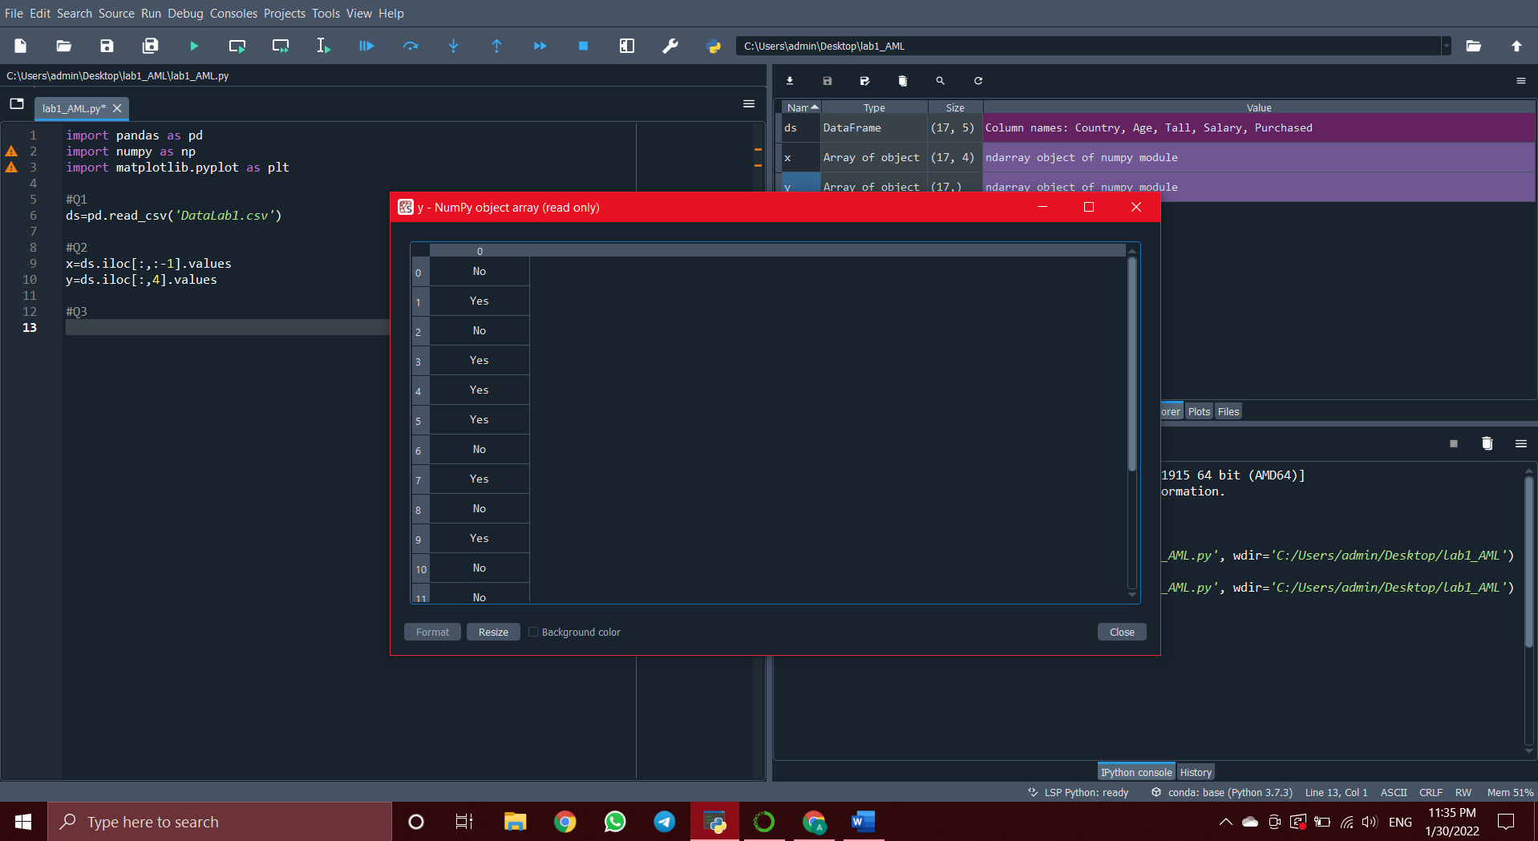

* 1. Calculate the median for each feature or column that contains a missing value and replace the result for the missing value.

* 1. Encode the categorical data.

* 1. Splitting the dataset into the Training set and Test Set and assign 30% for test set. (random_state = 0).

Y_test

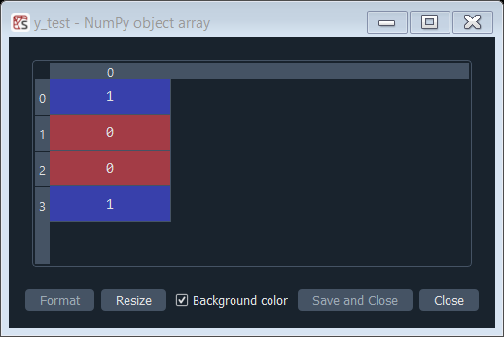

Y_train

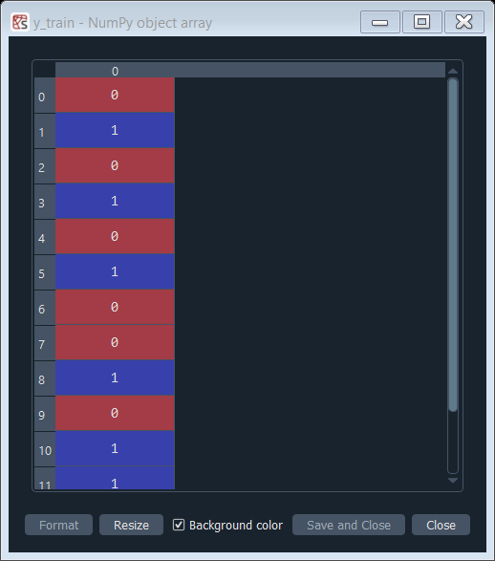

X_train

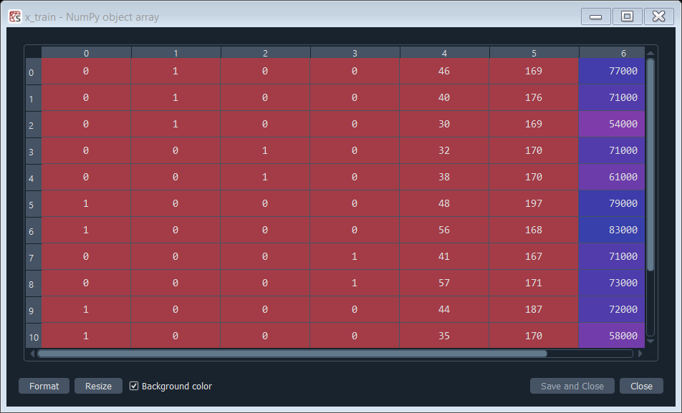

X_test

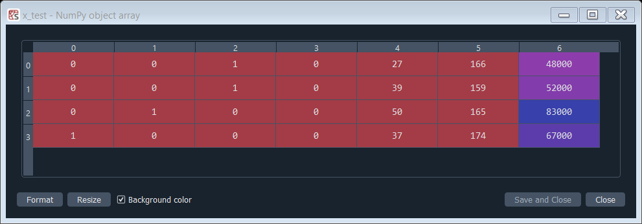

Code

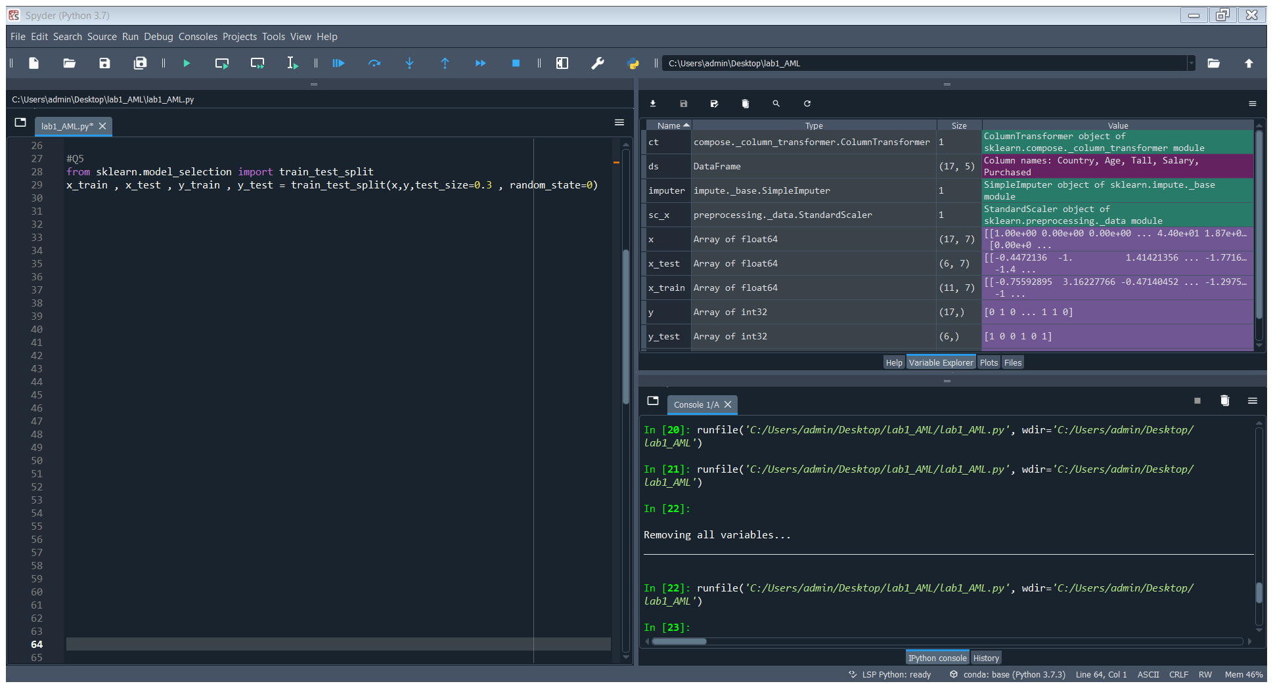

* 1. Apply the Feature Scaling

**Note: Show the results of all required steps in your report.**

**Anan Abdulghaffar 1910912**