Assignment 5

Angie Bouche, Tara Jagadeesh, Andrea Cheung

November 27, 2018

Load Tidyverse Etc

library(tidyverse)

## -- Attaching packages ------------------------------------------------------------ tidyverse 1.2.1 --

## v ggplot2 3.0.0 v purrr 0.2.5  
## v tibble 1.4.2 v dplyr 0.7.6  
## v tidyr 0.8.1 v stringr 1.3.1  
## v readr 1.1.1 v forcats 0.3.0

## -- Conflicts --------------------------------------------------------------- tidyverse_conflicts() --  
## x dplyr::filter() masks stats::filter()  
## x dplyr::lag() masks stats::lag()

library(RColorBrewer)  
library(kableExtra)  
library(car)

## Loading required package: carData

##   
## Attaching package: 'car'

## The following object is masked from 'package:dplyr':  
##   
## recode

## The following object is masked from 'package:purrr':  
##   
## some

library(reshape2)

##   
## Attaching package: 'reshape2'

## The following object is masked from 'package:tidyr':  
##   
## smiths

library(stargazer)

##   
## Please cite as:

## Hlavac, Marek (2018). stargazer: Well-Formatted Regression and Summary Statistics Tables.

## R package version 5.2.2. https://CRAN.R-project.org/package=stargazer

library(scales)

##   
## Attaching package: 'scales'

## The following object is masked from 'package:purrr':  
##   
## discard

## The following object is masked from 'package:readr':  
##   
## col_factor

read.csv("Doctoral_Salaries.csv")

## Field Employment_Male  
## 1 Agricultural sciences and natural resources 78,000  
## 2 Biological and biomedical sciences 75,000  
## 3 Health sciences 75,000  
## 4 Chemistry 80,000  
## 5 Geosciences, atmospheric, and ocean sciences 75,167  
## 6 Physics and astronomy 95,000  
## 7 Mathematics and computer sciences 105,000  
## 8 Psychology 63,000  
## 9 Economics 105,000  
## 10 Social sciences 64,000  
## 11 Engineering 95,000  
## 12 Education 71,000  
## 13 Humanities and arts 52,000  
## 14 Business management and administration 123,500  
## 15 Other non-S&E fields 62,800  
## Employment_Female Postdoc_Male Postdoc_Female  
## 1 66,000 42,750 44,000  
## 2 66,000 42,000 42,000  
## 3 75,000 43,000 43,250  
## 4 75,000 42,000 42,000  
## 5 71,750 50,000 50,000  
## 6 97,650 50,000 53,000  
## 7 90,000 58,000 55,000  
## 8 60,000 42,000 42,000  
## 9 95,750 65,000 65,000  
## 10 62,000 48,000 49,250  
## 11 90,000 45,000 45,000  
## 12 63,000 50,000 45,000  
## 13 50,000 45,000 45,000  
## 14 120,000 60,000 63,500  
## 15 61,000 50,000 44,000

read.csv("Faculty_Salaries.csv")

## Faculty_Rank Discipline Years_Since_PhD Years_Faculty_Service Sex  
## 1 Prof B 19 18 Male  
## 2 Prof B 20 16 Male  
## 3 AsstProf B 4 3 Male  
## 4 Prof B 45 39 Male  
## 5 Prof B 40 41 Male  
## 6 AssocProf B 6 6 Male  
## 7 Prof B 30 23 Male  
## 8 Prof B 45 45 Male  
## 9 Prof B 21 20 Male  
## 10 Prof B 18 18 Female  
## 11 AssocProf B 12 8 Male  
## 12 AsstProf B 7 2 Male  
## 13 AsstProf B 1 1 Male  
## 14 AsstProf B 2 0 Male  
## 15 Prof B 20 18 Male  
## 16 Prof B 12 3 Male  
## 17 Prof B 19 20 Male  
## 18 Prof A 38 34 Male  
## 19 Prof A 37 23 Male  
## 20 Prof A 39 36 Female  
## 21 Prof A 31 26 Male  
## 22 Prof A 36 31 Male  
## 23 Prof A 34 30 Male  
## 24 Prof A 24 19 Male  
## 25 AssocProf A 13 8 Female  
## 26 Prof A 21 8 Male  
## 27 Prof A 35 23 Male  
## 28 AsstProf B 5 3 Male  
## 29 AsstProf B 11 0 Male  
## 30 Prof B 12 8 Male  
## 31 Prof B 20 4 Male  
## 32 AsstProf B 7 2 Male  
## 33 Prof B 13 9 Male  
## 34 AsstProf B 4 2 Male  
## 35 AsstProf B 4 2 Female  
## 36 AsstProf B 5 0 Female  
## 37 Prof B 22 21 Male  
## 38 AsstProf B 7 4 Male  
## 39 Prof B 41 31 Male  
## 40 AssocProf B 9 9 Male  
## 41 Prof B 23 2 Male  
## 42 AssocProf B 23 23 Male  
## 43 Prof B 40 27 Male  
## 44 Prof B 38 38 Male  
## 45 Prof B 19 19 Male  
## 46 Prof B 25 15 Male  
## 47 Prof B 40 28 Male  
## 48 Prof B 23 19 Female  
## 49 Prof B 25 25 Female  
## 50 AsstProf B 1 1 Male  
## 51 Prof B 28 28 Male  
## 52 Prof B 12 11 Male  
## 53 AsstProf B 11 3 Female  
## 54 Prof B 16 9 Male  
## 55 AssocProf B 12 11 Male  
## 56 AssocProf B 14 5 Male  
## 57 Prof B 23 21 Male  
## 58 AssocProf B 9 8 Male  
## 59 AssocProf B 10 9 Male  
## 60 AsstProf B 8 3 Male  
## 61 AssocProf B 9 8 Male  
## 62 AsstProf B 3 2 Male  
## 63 Prof B 33 31 Male  
## 64 AssocProf B 11 11 Female  
## 65 AsstProf B 4 3 Male  
## 66 AssocProf B 9 8 Male  
## 67 Prof B 22 12 Male  
## 68 Prof B 35 31 Male  
## 69 Prof B 17 17 Female  
## 70 Prof B 28 36 Male  
## 71 Prof B 17 2 Male  
## 72 Prof B 45 45 Male  
## 73 Prof B 29 19 Male  
## 74 Prof B 35 34 Male  
## 75 Prof B 28 23 Male  
## 76 AsstProf B 8 3 Male  
## 77 Prof B 17 3 Male  
## 78 Prof B 26 19 Male  
## 79 AsstProf B 3 1 Male  
## 80 AsstProf B 6 2 Male  
## 81 Prof B 43 28 Male  
## 82 Prof B 17 16 Male  
## 83 Prof B 22 20 Male  
## 84 AsstProf B 6 2 Male  
## 85 Prof B 17 18 Female  
## 86 Prof B 15 14 Male  
## 87 Prof B 37 37 Male  
## 88 AsstProf B 2 2 Male  
## 89 Prof B 25 25 Male  
## 90 AssocProf B 9 7 Male  
## 91 AsstProf B 10 5 Female  
## 92 AssocProf B 10 7 Male  
## 93 AssocProf B 10 7 Male  
## 94 Prof B 38 38 Male  
## 95 Prof B 21 20 Male  
## 96 AsstProf B 4 0 Male  
## 97 AssocProf B 17 12 Male  
## 98 Prof B 13 7 Male  
## 99 Prof B 30 14 Male  
## 100 Prof B 41 26 Male  
## 101 Prof B 42 25 Male  
## 102 Prof B 28 23 Male  
## 103 Prof B 16 5 Male  
## 104 Prof B 20 14 Female  
## 105 AssocProf A 18 10 Male  
## 106 Prof A 31 28 Male  
## 107 AssocProf A 11 8 Male  
## 108 AssocProf A 10 8 Male  
## 109 AssocProf A 15 8 Male  
## 110 Prof A 40 31 Male  
## 111 Prof A 20 16 Male  
## 112 AssocProf A 19 16 Male  
## 113 AsstProf A 3 1 Male  
## 114 Prof A 37 37 Male  
## 115 Prof A 12 0 Female  
## 116 Prof A 21 9 Male  
## 117 Prof A 30 29 Male  
## 118 Prof A 39 36 Male  
## 119 AsstProf A 4 1 Male  
## 120 AsstProf A 5 3 Female  
## 121 Prof A 14 14 Male  
## 122 Prof A 32 32 Male  
## 123 Prof A 24 22 Male  
## 124 AssocProf A 25 22 Female  
## 125 Prof A 24 22 Male  
## 126 Prof A 54 49 Male  
## 127 Prof A 28 26 Male  
## 128 AsstProf A 2 0 Female  
## 129 Prof A 32 30 Male  
## 130 AsstProf A 4 2 Male  
## 131 AssocProf A 11 9 Male  
## 132 Prof A 56 57 Male  
## 133 AssocProf A 10 8 Female  
## 134 AsstProf A 3 1 Female  
## 135 Prof A 35 25 Male  
## 136 Prof A 20 18 Male  
## 137 Prof A 16 14 Male  
## 138 Prof A 17 14 Male  
## 139 AssocProf A 10 7 Male  
## 140 Prof A 21 18 Male  
## 141 AssocProf A 14 8 Male  
## 142 AssocProf A 15 10 Male  
## 143 Prof A 19 11 Male  
## 144 AsstProf B 3 3 Male  
## 145 Prof B 27 27 Male  
## 146 Prof B 28 28 Male  
## 147 AsstProf B 4 4 Male  
## 148 Prof B 27 27 Male  
## 149 Prof B 36 26 Female  
## 150 AsstProf B 4 3 Male  
## 151 Prof B 14 12 Male  
## 152 AsstProf B 4 4 Male  
## 153 Prof B 21 9 Male  
## 154 AssocProf B 12 10 Female  
## 155 AsstProf B 4 0 Male  
## 156 Prof B 21 21 Male  
## 157 AssocProf B 12 18 Male  
## 158 AsstProf B 1 0 Male  
## 159 AssocProf B 6 6 Male  
## 160 Prof B 15 16 Male  
## 161 AsstProf B 2 2 Male  
## 162 Prof B 26 19 Male  
## 163 AssocProf B 22 7 Male  
## 164 AsstProf B 3 3 Male  
## 165 AsstProf B 1 0 Male  
## 166 Prof B 21 8 Male  
## 167 Prof B 16 16 Male  
## 168 Prof B 18 19 Male  
## 169 AssocProf B 8 6 Male  
## 170 Prof B 25 18 Male  
## 171 AsstProf B 5 5 Male  
## 172 Prof B 19 19 Male  
## 173 Prof B 37 24 Male  
## 174 Prof B 20 20 Male  
## 175 AssocProf B 17 6 Male  
## 176 Prof B 28 25 Male  
## 177 AssocProf B 10 7 Male  
## 178 AssocProf B 13 9 Male  
## 179 Prof B 27 14 Male  
## 180 AsstProf B 3 3 Female  
## 181 Prof B 11 11 Male  
## 182 Prof B 18 5 Male  
## 183 AssocProf B 8 8 Male  
## 184 Prof B 26 22 Male  
## 185 Prof B 23 23 Male  
## 186 Prof B 33 30 Male  
## 187 AssocProf B 13 10 Female  
## 188 Prof B 18 10 Male  
## 189 AssocProf B 28 28 Male  
## 190 Prof B 25 19 Male  
## 191 Prof B 22 9 Male  
## 192 Prof B 43 22 Male  
## 193 Prof B 19 18 Male  
## 194 AssocProf B 19 19 Male  
## 195 AssocProf B 48 53 Male  
## 196 AssocProf B 9 7 Male  
## 197 AsstProf B 4 4 Male  
## 198 AsstProf B 4 4 Male  
## 199 Prof B 34 33 Male  
## 200 Prof B 38 22 Male  
## 201 AsstProf B 4 4 Male  
## 202 Prof B 40 40 Male  
## 203 Prof B 28 17 Male  
## 204 Prof B 17 17 Male  
## 205 Prof B 19 5 Male  
## 206 Prof B 21 2 Male  
## 207 Prof B 35 33 Male  
## 208 Prof B 18 18 Male  
## 209 AsstProf B 7 2 Male  
## 210 Prof B 20 20 Male  
## 211 AsstProf B 4 3 Male  
## 212 Prof B 39 39 Male  
## 213 Prof B 15 7 Male  
## 214 Prof B 26 19 Male  
## 215 AssocProf B 11 1 Male  
## 216 Prof B 16 11 Male  
## 217 Prof B 15 11 Male  
## 218 AssocProf B 29 22 Male  
## 219 AssocProf B 14 7 Female  
## 220 Prof B 13 11 Male  
## 221 Prof B 21 21 Male  
## 222 Prof B 23 10 Male  
## 223 AssocProf B 13 6 Male  
## 224 Prof B 34 20 Male  
## 225 Prof A 38 35 Male  
## 226 Prof A 20 20 Male  
## 227 AsstProf A 3 1 Male  
## 228 AssocProf A 9 7 Male  
## 229 Prof A 16 11 Male  
## 230 Prof A 39 38 Male  
## 231 Prof A 29 27 Female  
## 232 AssocProf A 26 24 Female  
## 233 Prof A 38 19 Male  
## 234 Prof A 36 19 Female  
## 235 AsstProf A 8 3 Male  
## 236 Prof A 28 17 Male  
## 237 Prof A 25 25 Male  
## 238 AsstProf A 7 6 Female  
## 239 Prof A 46 40 Male  
## 240 Prof A 19 6 Male  
## 241 AsstProf A 5 3 Male  
## 242 Prof A 31 30 Male  
## 243 Prof A 38 37 Male  
## 244 Prof A 23 23 Male  
## 245 Prof A 19 23 Male  
## 246 Prof A 17 11 Female  
## 247 Prof A 30 23 Male  
## 248 Prof A 21 18 Male  
## 249 Prof A 28 23 Male  
## 250 Prof A 29 7 Male  
## 251 Prof A 39 39 Male  
## 252 Prof A 20 8 Male  
## 253 Prof A 31 12 Male  
## 254 AsstProf A 4 2 Female  
## 255 Prof A 28 7 Female  
## 256 AssocProf A 12 8 Male  
## 257 Prof A 22 22 Male  
## 258 AssocProf A 30 23 Male  
## 259 AsstProf A 9 3 Male  
## 260 Prof A 32 30 Male  
## 261 AssocProf A 41 33 Male  
## 262 Prof A 45 45 Male  
## 263 Prof A 31 26 Male  
## 264 Prof A 31 31 Male  
## 265 Prof A 37 35 Male  
## 266 Prof A 36 30 Male  
## 267 Prof A 43 43 Male  
## 268 Prof A 14 10 Male  
## 269 Prof A 47 44 Male  
## 270 Prof A 13 7 Male  
## 271 Prof A 42 40 Male  
## 272 Prof A 42 18 Male  
## 273 AsstProf A 4 1 Male  
## 274 AsstProf A 8 4 Male  
## 275 AsstProf A 8 3 Female  
## 276 Prof A 12 6 Male  
## 277 Prof A 52 48 Male  
## 278 Prof A 31 27 Male  
## 279 Prof A 24 18 Male  
## 280 Prof A 46 46 Male  
## 281 Prof A 39 38 Male  
## 282 Prof A 37 27 Male  
## 283 Prof A 51 51 Male  
## 284 Prof A 45 43 Male  
## 285 AssocProf A 8 6 Male  
## 286 AssocProf A 49 49 Male  
## 287 Prof A 28 27 Male  
## 288 AsstProf A 2 0 Male  
## 289 Prof A 29 27 Male  
## 290 AsstProf A 8 5 Male  
## 291 Prof A 33 7 Male  
## 292 Prof A 32 28 Male  
## 293 Prof A 39 9 Male  
## 294 AssocProf A 11 1 Male  
## 295 Prof A 19 7 Male  
## 296 Prof A 40 36 Male  
## 297 Prof A 18 18 Male  
## 298 Prof A 17 11 Male  
## 299 Prof A 49 43 Male  
## 300 AssocProf A 45 39 Male  
## 301 Prof A 39 36 Male  
## 302 Prof A 27 16 Male  
## 303 Prof A 28 13 Male  
## 304 Prof A 14 4 Male  
## 305 Prof A 46 44 Male  
## 306 Prof A 33 31 Male  
## 307 AsstProf A 7 4 Male  
## 308 Prof A 31 28 Male  
## 309 AsstProf A 5 0 Male  
## 310 Prof A 22 15 Male  
## 311 Prof A 20 7 Male  
## 312 Prof A 14 9 Male  
## 313 Prof A 29 19 Male  
## 314 Prof A 35 35 Male  
## 315 Prof A 22 6 Male  
## 316 AsstProf B 6 3 Male  
## 317 AssocProf B 12 9 Female  
## 318 Prof B 46 45 Male  
## 319 Prof B 16 16 Male  
## 320 Prof B 16 15 Male  
## 321 Prof B 24 23 Male  
## 322 AssocProf B 9 9 Male  
## 323 AssocProf B 13 11 Male  
## 324 Prof B 24 15 Female  
## 325 Prof B 30 31 Male  
## 326 AsstProf B 8 4 Male  
## 327 Prof B 23 15 Male  
## 328 Prof B 37 37 Male  
## 329 AssocProf B 10 10 Male  
## 330 Prof B 23 23 Male  
## 331 Prof B 49 60 Male  
## 332 Prof B 20 9 Male  
## 333 Prof B 18 10 Female  
## 334 Prof B 33 19 Male  
## 335 AssocProf B 19 6 Female  
## 336 Prof B 36 38 Male  
## 337 Prof B 35 23 Male  
## 338 Prof B 13 12 Male  
## 339 Prof B 32 25 Male  
## 340 Prof B 37 15 Male  
## 341 Prof B 13 11 Male  
## 342 Prof B 17 17 Female  
## 343 Prof B 38 38 Male  
## 344 Prof B 31 31 Male  
## 345 Prof B 32 35 Male  
## 346 Prof B 15 10 Male  
## 347 Prof B 41 27 Male  
## 348 Prof B 39 33 Male  
## 349 AsstProf B 4 3 Male  
## 350 Prof B 27 28 Male  
## 351 Prof B 56 49 Male  
## 352 Prof B 38 38 Male  
## 353 Prof B 26 27 Male  
## 354 Prof B 22 20 Male  
## 355 AsstProf B 8 1 Male  
## 356 Prof B 25 21 Male  
## 357 Prof A 49 40 Male  
## 358 Prof A 39 35 Male  
## 359 Prof A 28 14 Female  
## 360 AsstProf A 11 4 Male  
## 361 Prof A 14 11 Male  
## 362 Prof A 23 15 Female  
## 363 Prof A 30 30 Male  
## 364 AssocProf A 20 17 Male  
## 365 Prof A 43 43 Male  
## 366 Prof A 43 40 Male  
## 367 Prof A 15 10 Male  
## 368 AssocProf A 10 1 Male  
## 369 Prof A 35 30 Male  
## 370 Prof A 33 31 Male  
## 371 AssocProf A 13 8 Male  
## 372 Prof A 23 20 Male  
## 373 Prof A 12 7 Male  
## 374 Prof A 30 26 Male  
## 375 Prof A 27 19 Male  
## 376 Prof A 28 26 Male  
## 377 AsstProf A 4 1 Male  
## 378 AsstProf A 6 3 Male  
## 379 Prof A 38 38 Male  
## 380 AssocProf A 11 8 Male  
## 381 AsstProf A 8 3 Male  
## 382 Prof A 27 23 Male  
## 383 AssocProf A 8 5 Male  
## 384 Prof A 44 44 Male  
## 385 Prof A 27 21 Male  
## 386 Prof A 15 9 Male  
## 387 Prof A 29 27 Male  
## 388 Prof A 29 15 Male  
## 389 Prof A 38 36 Male  
## 390 Prof A 33 18 Male  
## 391 Prof A 40 19 Male  
## 392 Prof A 30 19 Male  
## 393 Prof A 33 30 Male  
## 394 Prof A 31 19 Male  
## 395 Prof A 42 25 Male  
## 396 Prof A 25 15 Male  
## 397 AsstProf A 8 4 Male  
## Salary  
## 1 139750  
## 2 173200  
## 3 79750  
## 4 115000  
## 5 141500  
## 6 97000  
## 7 175000  
## 8 147765  
## 9 119250  
## 10 129000  
## 11 119800  
## 12 79800  
## 13 77700  
## 14 78000  
## 15 104800  
## 16 117150  
## 17 101000  
## 18 103450  
## 19 124750  
## 20 137000  
## 21 89565  
## 22 102580  
## 23 93904  
## 24 113068  
## 25 74830  
## 26 106294  
## 27 134885  
## 28 82379  
## 29 77000  
## 30 118223  
## 31 132261  
## 32 79916  
## 33 117256  
## 34 80225  
## 35 80225  
## 36 77000  
## 37 155750  
## 38 86373  
## 39 125196  
## 40 100938  
## 41 146500  
## 42 93418  
## 43 101299  
## 44 231545  
## 45 94384  
## 46 114778  
## 47 98193  
## 48 151768  
## 49 140096  
## 50 70768  
## 51 126621  
## 52 108875  
## 53 74692  
## 54 106639  
## 55 103760  
## 56 83900  
## 57 117704  
## 58 90215  
## 59 100135  
## 60 75044  
## 61 90304  
## 62 75243  
## 63 109785  
## 64 103613  
## 65 68404  
## 66 100522  
## 67 101000  
## 68 99418  
## 69 111512  
## 70 91412  
## 71 126320  
## 72 146856  
## 73 100131  
## 74 92391  
## 75 113398  
## 76 73266  
## 77 150480  
## 78 193000  
## 79 86100  
## 80 84240  
## 81 150743  
## 82 135585  
## 83 144640  
## 84 88825  
## 85 122960  
## 86 132825  
## 87 152708  
## 88 88400  
## 89 172272  
## 90 107008  
## 91 97032  
## 92 105128  
## 93 105631  
## 94 166024  
## 95 123683  
## 96 84000  
## 97 95611  
## 98 129676  
## 99 102235  
## 100 106689  
## 101 133217  
## 102 126933  
## 103 153303  
## 104 127512  
## 105 83850  
## 106 113543  
## 107 82099  
## 108 82600  
## 109 81500  
## 110 131205  
## 111 112429  
## 112 82100  
## 113 72500  
## 114 104279  
## 115 105000  
## 116 120806  
## 117 148500  
## 118 117515  
## 119 72500  
## 120 73500  
## 121 115313  
## 122 124309  
## 123 97262  
## 124 62884  
## 125 96614  
## 126 78162  
## 127 155500  
## 128 72500  
## 129 113278  
## 130 73000  
## 131 83001  
## 132 76840  
## 133 77500  
## 134 72500  
## 135 168635  
## 136 136000  
## 137 108262  
## 138 105668  
## 139 73877  
## 140 152664  
## 141 100102  
## 142 81500  
## 143 106608  
## 144 89942  
## 145 112696  
## 146 119015  
## 147 92000  
## 148 156938  
## 149 144651  
## 150 95079  
## 151 128148  
## 152 92000  
## 153 111168  
## 154 103994  
## 155 92000  
## 156 118971  
## 157 113341  
## 158 88000  
## 159 95408  
## 160 137167  
## 161 89516  
## 162 176500  
## 163 98510  
## 164 89942  
## 165 88795  
## 166 105890  
## 167 167284  
## 168 130664  
## 169 101210  
## 170 181257  
## 171 91227  
## 172 151575  
## 173 93164  
## 174 134185  
## 175 105000  
## 176 111751  
## 177 95436  
## 178 100944  
## 179 147349  
## 180 92000  
## 181 142467  
## 182 141136  
## 183 100000  
## 184 150000  
## 185 101000  
## 186 134000  
## 187 103750  
## 188 107500  
## 189 106300  
## 190 153750  
## 191 180000  
## 192 133700  
## 193 122100  
## 194 86250  
## 195 90000  
## 196 113600  
## 197 92700  
## 198 92000  
## 199 189409  
## 200 114500  
## 201 92700  
## 202 119700  
## 203 160400  
## 204 152500  
## 205 165000  
## 206 96545  
## 207 162200  
## 208 120000  
## 209 91300  
## 210 163200  
## 211 91000  
## 212 111350  
## 213 128400  
## 214 126200  
## 215 118700  
## 216 145350  
## 217 146000  
## 218 105350  
## 219 109650  
## 220 119500  
## 221 170000  
## 222 145200  
## 223 107150  
## 224 129600  
## 225 87800  
## 226 122400  
## 227 63900  
## 228 70000  
## 229 88175  
## 230 133900  
## 231 91000  
## 232 73300  
## 233 148750  
## 234 117555  
## 235 69700  
## 236 81700  
## 237 114000  
## 238 63100  
## 239 77202  
## 240 96200  
## 241 69200  
## 242 122875  
## 243 102600  
## 244 108200  
## 245 84273  
## 246 90450  
## 247 91100  
## 248 101100  
## 249 128800  
## 250 204000  
## 251 109000  
## 252 102000  
## 253 132000  
## 254 77500  
## 255 116450  
## 256 83000  
## 257 140300  
## 258 74000  
## 259 73800  
## 260 92550  
## 261 88600  
## 262 107550  
## 263 121200  
## 264 126000  
## 265 99000  
## 266 134800  
## 267 143940  
## 268 104350  
## 269 89650  
## 270 103700  
## 271 143250  
## 272 194800  
## 273 73000  
## 274 74000  
## 275 78500  
## 276 93000  
## 277 107200  
## 278 163200  
## 279 107100  
## 280 100600  
## 281 136500  
## 282 103600  
## 283 57800  
## 284 155865  
## 285 88650  
## 286 81800  
## 287 115800  
## 288 85000  
## 289 150500  
## 290 74000  
## 291 174500  
## 292 168500  
## 293 183800  
## 294 104800  
## 295 107300  
## 296 97150  
## 297 126300  
## 298 148800  
## 299 72300  
## 300 70700  
## 301 88600  
## 302 127100  
## 303 170500  
## 304 105260  
## 305 144050  
## 306 111350  
## 307 74500  
## 308 122500  
## 309 74000  
## 310 166800  
## 311 92050  
## 312 108100  
## 313 94350  
## 314 100351  
## 315 146800  
## 316 84716  
## 317 71065  
## 318 67559  
## 319 134550  
## 320 135027  
## 321 104428  
## 322 95642  
## 323 126431  
## 324 161101  
## 325 162221  
## 326 84500  
## 327 124714  
## 328 151650  
## 329 99247  
## 330 134778  
## 331 192253  
## 332 116518  
## 333 105450  
## 334 145098  
## 335 104542  
## 336 151445  
## 337 98053  
## 338 145000  
## 339 128464  
## 340 137317  
## 341 106231  
## 342 124312  
## 343 114596  
## 344 162150  
## 345 150376  
## 346 107986  
## 347 142023  
## 348 128250  
## 349 80139  
## 350 144309  
## 351 186960  
## 352 93519  
## 353 142500  
## 354 138000  
## 355 83600  
## 356 145028  
## 357 88709  
## 358 107309  
## 359 109954  
## 360 78785  
## 361 121946  
## 362 109646  
## 363 138771  
## 364 81285  
## 365 205500  
## 366 101036  
## 367 115435  
## 368 108413  
## 369 131950  
## 370 134690  
## 371 78182  
## 372 110515  
## 373 109707  
## 374 136660  
## 375 103275  
## 376 103649  
## 377 74856  
## 378 77081  
## 379 150680  
## 380 104121  
## 381 75996  
## 382 172505  
## 383 86895  
## 384 105000  
## 385 125192  
## 386 114330  
## 387 139219  
## 388 109305  
## 389 119450  
## 390 186023  
## 391 166605  
## 392 151292  
## 393 103106  
## 394 150564  
## 395 101738  
## 396 95329  
## 397 81035

enrollment <- read.csv("Grad_enrollment.csv")  
read.csv("phd.csv")

## Field.of.Study field sex year number percent  
## 1 All all male 1985 20552 65.7  
## 2 All all female 1985 10,743 34.3  
## 3 Life sciences lifesci male 1985 3,946 67.8  
## 4 Life sciences lifesci female 1985 1,876 32.2  
## 5 Physical and earth sciences physearth male 1985 2,922 83.7  
## 6 Physical and earth sciences physearth female 1985 569 16.3  
## 7 Mathematics and computer sciences mathcomp male 1985 859 86.1  
## 8 Mathematics and computer sciences mathcomp female 1985 139 13.9  
## 9 Psychology and social sciences psychsoc male 1985 3,517 58.4  
## 10 Psychology and social sciences psychsoc female 1985 2,510 41.6  
## 11 Engineering eng male 1985 2,968 93.7  
## 12 Engineering eng female 1985 198 6.3  
## 13 Education edu male 1985 3,242 48.2  
## 14 Education edu female 1985 3,491 51.8  
## 15 Humanities and arts humarts male 1985 2,014 59.1  
## 16 Humanities and arts humarts female 1985 1,392 40.9  
## 17 Other other male 1985 1,084 65.6  
## 18 Other other female 1985 568 34.4  
## 19 All all male 1990 22,960 63.7  
## 20 All all female 1990 13,104 36.3  
## 21 Life sciences lifesci male 1990 4,163 62.6  
## 22 Life sciences lifesci female 1990 2,492 37.4  
## 23 Physical and earth sciences physearth male 1990 3,421 81.2  
## 24 Physical and earth sciences physearth female 1990 791 18.8  
## 25 Mathematics and computer sciences mathcomp male 1990 1,329 83.2  
## 26 Mathematics and computer sciences mathcomp female 1990 268 16.8  
## 27 Psychology and social sciences psychsoc male 1990 3,378 53.4  
## 28 Psychology and social sciences psychsoc female 1990 2,953 46.6  
## 29 Engineering eng male 1990 4,479 91.5  
## 30 Engineering eng female 1990 415 8.5  
## 31 Education edu male 1990 2,758 42.4  
## 32 Education edu female 1990 3,751 57.6  
## 33 Humanities and arts humarts male 1990 2,188 56.8  
## 34 Humanities and arts humarts female 1990 1,666 43.2  
## 35 Other other male 1990 1,244 61.8  
## 36 Other other female 1990 768 38.2  
## 37 All all male 1995 25,160 60.5  
## 38 All all female 1995 16,416 39.5  
## 39 Life sciences lifesci male 1995 4,598 57.8  
## 40 Life sciences lifesci female 1995 3,358 42.2  
## 41 Physical and earth sciences physearth male 1995 3,499 77.4  
## 42 Physical and earth sciences physearth female 1995 1,020 22.6  
## 43 Mathematics and computer sciences mathcomp male 1995 1,727 79.3  
## 44 Mathematics and computer sciences mathcomp female 1995 451 20.7  
## 45 Psychology and social sciences psychsoc male 1995 3,380 48.9  
## 46 Psychology and social sciences psychsoc female 1995 3,526 51.1  
## 47 Engineering eng male 1995 5,270 88.3  
## 48 Engineering eng female 1995 696 11.7  
## 49 Education edu male 1995 2,546 38.4  
## 50 Education edu female 1995 4,092 61.6  
## 51 Humanities and arts humarts male 1995 2,695 53.5  
## 52 Humanities and arts humarts female 1995 2,339 46.5  
## 53 Other other male 1995 1,445 60.7  
## 54 Other other female 1995 934 39.3  
## 55 All all male 2000 23,165 56.1  
## 56 All all female 2000 18,131 43.9  
## 57 Life sciences lifesci male 2000 4,568 53.0  
## 58 Life sciences lifesci female 2000 4,043 47.0  
## 59 Physical and earth sciences physearth male 2000 3,041 74.8  
## 60 Physical and earth sciences physearth female 2000 1,022 25.2  
## 61 Mathematics and computer sciences mathcomp male 2000 1,507 79.0  
## 62 Mathematics and computer sciences mathcomp female 2000 400 21.0  
## 63 Psychology and social sciences psychsoc male 2000 3,370 45.3  
## 64 Psychology and social sciences psychsoc female 2000 4,073 54.7  
## 65 Engineering eng male 2000 4,459 84.2  
## 66 Engineering eng female 2000 838 15.8  
## 67 Education edu male 2000 2,260 35.1  
## 68 Education edu female 2000 4,179 64.9  
## 69 Humanities and arts humarts male 2000 2,786 51.0  
## 70 Humanities and arts humarts female 2000 2,672 49.0  
## 71 Other other male 2000 1,174 56.5  
## 72 Other other female 2000 904 43.5  
## 73 All all male 2005 23,737 54.8  
## 74 All all female 2005 19,582 45.2  
## 75 Life sciences lifesci male 2005 4,561 49.1  
## 76 Life sciences lifesci female 2005 4,735 50.9  
## 77 Physical and earth sciences physearth male 2005 3,141 72.1  
## 78 Physical and earth sciences physearth female 2005 1,216 27.9  
## 79 Mathematics and computer sciences mathcomp male 2005 1,782 76.5  
## 80 Mathematics and computer sciences mathcomp female 2005 547 23.5  
## 81 Psychology and social sciences psychsoc male 2005 3,159 44.2  
## 82 Psychology and social sciences psychsoc female 2005 3,985 55.8  
## 83 Engineering eng male 2005 5,226 81.6  
## 84 Engineering eng female 2005 1,182 18.4  
## 85 Education edu male 2005 2,065 33.2  
## 86 Education edu female 2005 4,152 66.8  
## 87 Humanities and arts humarts male 2005 2,600 50.2  
## 88 Humanities and arts humarts female 2005 2,581 49.8  
## 89 Other other male 2005 1,203 50.4  
## 90 Other other female 2005 1,184 49.6  
## 91 All all male 2010 25,526 53.2  
## 92 All all female 2010 22,489 46.8  
## 93 Life sciences lifesci male 2010 5,101 45.1  
## 94 Life sciences lifesci female 2010 6,213 54.9  
## 95 Physical and earth sciences physearth male 2010 3,379 67.7  
## 96 Physical and earth sciences physearth female 2010 1,615 32.3  
## 97 Mathematics and computer sciences mathcomp male 2010 2,409 74.7  
## 98 Mathematics and computer sciences mathcomp female 2010 814 25.3  
## 99 Psychology and social sciences psychsoc male 2010 3,358 42.6  
## 100 Psychology and social sciences psychsoc female 2010 4,524 57.4  
## 101 Engineering eng male 2010 5,829 77.0  
## 102 Engineering eng female 2010 1,746 23.0  
## 103 Education edu male 2010 1,662 31.4  
## 104 Education edu female 2010 3,624 68.6  
## 105 Humanities and arts humarts male 2010 2,462 49.1  
## 106 Humanities and arts humarts female 2010 2,553 50.9  
## 107 Other other male 2010 1,326 48.6  
## 108 Other other female 2010 1,400 51.4  
## 109 All all male 2015 29,596 53.8  
## 110 All all female 2015 25,403 46.2  
## 111 Life sciences lifesci male 2015 5,578 44.6  
## 112 Life sciences lifesci female 2015 6,941 55.4  
## 113 Physical and earth sciences physearth male 2015 3,935 66.4  
## 114 Physical and earth sciences physearth female 2015 1,988 33.6  
## 115 Mathematics and computer sciences mathcomp male 2015 2,880 75.3  
## 116 Mathematics and computer sciences mathcomp female 2015 943 24.7  
## 117 Psychology and social sciences psychsoc male 2015 3,762 41.4  
## 118 Psychology and social sciences psychsoc female 2015 5,332 58.6  
## 119 Engineering eng male 2015 7,596 76.8  
## 120 Engineering eng female 2015 2,301 23.2  
## 121 Education edu male 2015 1,614 31.5  
## 122 Education edu female 2015 3,502 68.5  
## 123 Humanities and arts humarts male 2015 2,767 49.4  
## 124 Humanities and arts humarts female 2015 2,832 50.6  
## 125 Other other male 2015 1,464 48.3  
## 126 Other other female 2015 1,564 51.7

# Part 1

#### Exploratory Scatterplot for Males and Females

enrollment_line <- ggplot(enrollment, aes(x=Year))+  
 geom_line(aes(y=Total_Males, colour = "Male Enrollment"))+  
 geom_line(aes(y=Total_Females, colour = "Female Enrollment"))  
 #Scatterplot of female enrollment  
  
enrollment_line

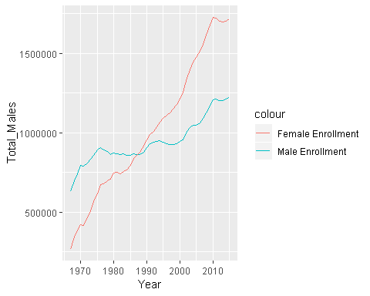

#### Linear Regression for Male and Female Enrollment

menroll_model <- lm(Total_Males ~ Year, data = enrollment)  
menroll_model

##   
## Call:  
## lm(formula = Total_Males ~ Year, data = enrollment)  
##   
## Coefficients:  
## (Intercept) Year   
## -17112153 9069

#results in equation y = - 17112153 + 9069x  
  
fenroll_model <- lm(Total_Females ~ Year, data = enrollment)  
fenroll_model

##   
## Call:  
## lm(formula = Total_Females ~ Year, data = enrollment)  
##   
## Coefficients:  
## (Intercept) Year   
## -58955502 30126

#results in equation y = - 58955502 + 30126x

##### Model Diagnostics, Fit and Significance

plot(menroll_model)

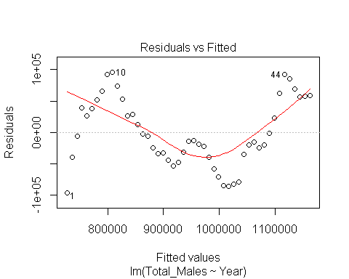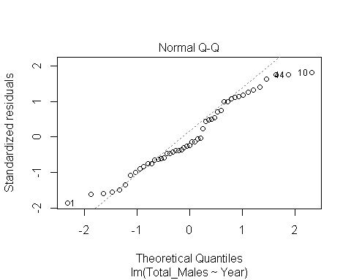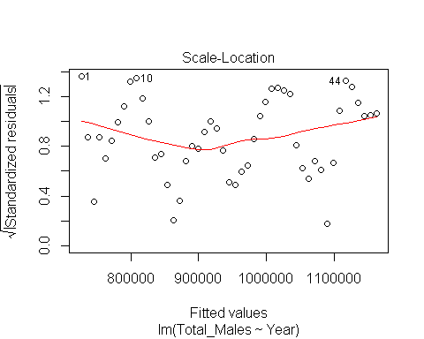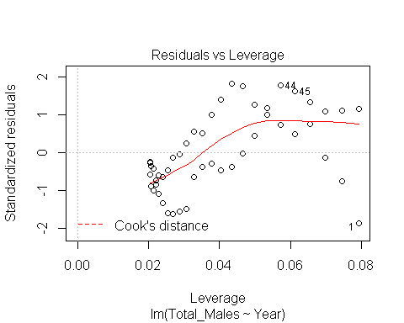

par(mfrow = c(2,2))  
plot(menroll_model)

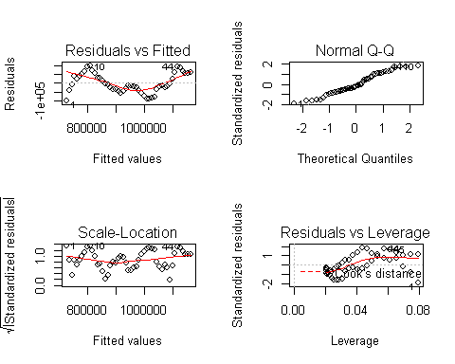

#Q-Q plot appears normally distributed, but there seems to be peaks that don't match up with the red line on Residuals vs. Fitted graph.  
  
summary(menroll_model)

##   
## Call:  
## lm(formula = Total_Males ~ Year, data = enrollment)  
##   
## Residuals:  
## Min 1Q Median 3Q Max   
## -96461 -34861 -12841 51876 95766   
##   
## Coefficients:  
## Estimate Std. Error t value Pr(>|t|)   
## (Intercept) -17112153 1087024 -15.74 <2e-16 ***  
## Year 9069 546 16.61 <2e-16 ***  
## ---  
## Signif. codes: 0 '***' 0.001 '**' 0.01 '*' 0.05 '.' 0.1 ' ' 1  
##   
## Residual standard error: 54050 on 47 degrees of freedom  
## Multiple R-squared: 0.8545, Adjusted R-squared: 0.8514   
## F-statistic: 276 on 1 and 47 DF, p-value: < 2.2e-16

#Multiple R-squared: 0.8545, Adjusted R-squared: 0.8514   
#F-statistic: 276 on 1 and 47 DF, p-value: < 2.2e-16  
#Standard error 1087024 and 546  
  
plot(fenroll_model)  
par(mfrow = c(2,2))  
plot(fenroll_model)

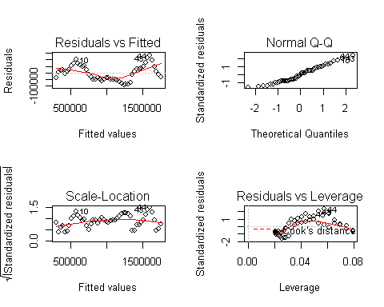

#Q-Q plot appears normally distributed, but there seems to be peaks that don't match up with the red line on Residuals vs. Fitted graph.  
  
summary(fenroll_model)

##   
## Call:  
## lm(formula = Total_Females ~ Year, data = enrollment)  
##   
## Residuals:  
## Min 1Q Median 3Q Max   
## -89397 -48101 -7633 45267 129727   
##   
## Coefficients:  
## Estimate Std. Error t value Pr(>|t|)   
## (Intercept) -5.896e+07 1.161e+06 -50.77 <2e-16 ***  
## Year 3.013e+04 5.832e+02 51.66 <2e-16 ***  
## ---  
## Signif. codes: 0 '***' 0.001 '**' 0.01 '*' 0.05 '.' 0.1 ' ' 1  
##   
## Residual standard error: 57730 on 47 degrees of freedom  
## Multiple R-squared: 0.9827, Adjusted R-squared: 0.9823   
## F-statistic: 2669 on 1 and 47 DF, p-value: < 2.2e-16

#Multiple R-squared: 0.9827, Adjusted R-squared: 0.9823   
#F-statistic: 2669 on 1 and 47 DF, p-value: < 2.2e-16  
#Standard error 1161000 and 583.2

##### Finalized Graph for Male and Female Enrollment

enrollment_graph <- ggplot(enrollment, aes(x=Year))+  
 geom_point(aes(y=Total_Males/1000000, color="Male"))+ #add cl smooth  
 geom_point(aes(y = Total_Females/1000000, color="Female"))+  
 geom_smooth(method = lm, se = TRUE, size = 0.5, color = "midnightblue",(aes(y=Total_Males/1000000)))+  
 geom_smooth(method = lm, se = TRUE, size = 0.5, color = "orange1",(aes(y=Total_Females/1000000)))+  
 theme_classic()+  
 scale_x_continuous(expand= c(0,0), limits= c(1966,2016))+  
 labs(x= "Year", y = "Number of Students Enrolled (In Millions)", color = "Gender")  
  
enrollment_graph + scale_color_manual(values=c("orange1", "midnightblue"))

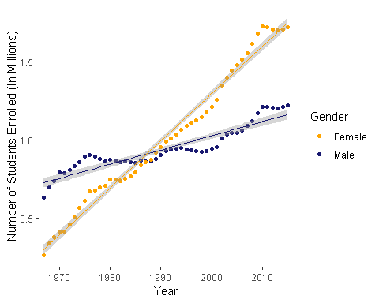

## Part 2

#read csv file  
phd <- read_csv("phd.csv")

## Parsed with column specification:  
## cols(  
## `Field of Study` = col_character(),  
## field = col_character(),  
## sex = col_character(),  
## year = col_integer(),  
## number = col_number(),  
## percent = col_double()  
## )

ac_phd <- phd %>%   
 filter(sex == "female") %>%   
 filter(year != "1990") %>%   
 filter(year != "1995") %>%  
 filter(year != "2005") %>%   
 filter(year != "2010") %>%  
 filter(field != "all") %>%  
 filter(field != "lifesci") %>%  
 filter(field != "mathcomp") %>%  
 filter(field != "other") %>%  
 filter(field != "psychsoc") %>%   
 select("field", "sex", "year", "number", "percent")  
  
phd_prop <- ac_phd %>%   
 select("field", "year", "number")   
  
phd_dcast <- dcast(phd_prop, year~field) %>%   
 select(-year)

## Using number as value column: use value.var to override.

rownames(phd_dcast) <- c("1985", "2000", "2015")  
  
phd_proptable <- prop.table(as.matrix(phd_dcast),1)  
  
female_phd_x2 <- chisq.test(phd_dcast)  
female_phd_x2

##   
## Pearson's Chi-squared test  
##   
## data: phd_dcast  
## X-squared = 2073.3, df = 6, p-value < 2.2e-16

Pie chart for 1985

dfpie1985 <- data.frame(  
 group = c("Education", "Engineering", "Humanities & Arts", "Physical & Earth Sciences"),  
 value = c(0.6178761, 0.03504425, 0.2463717, 0.1007080)  
 )  
  
pie1985 <- ggplot(dfpie1985, aes(x="", y=value, fill=group)) + geom_bar(stat="identity", width=1)  
  
  
pie1985 = pie1985 + coord_polar("y", start=0) + geom_text(aes(label = paste0(round(value*100), "%")), position = position_stack(vjust = 0.5))  
  
pie1985 = pie1985 + scale_fill_manual(values=c("#a3d9db", "#33658A", "#2F4858", "#e78f21", "#999999"))  
  
pie1985 = pie1985 + theme_classic() + theme(legend.title=element_blank())+ labs(title = "1985", align=c)+ theme(axis.line = element_blank(),  
 axis.text = element_blank(),  
 axis.ticks = element_blank(),  
 plot.title = element_text(hjust = 0.5, color = "#666666"))  
  
pie1985

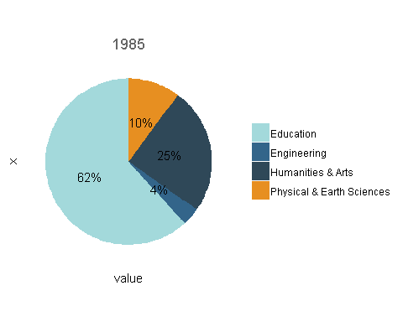

Pie chart for 2000

dfpie2000 <- data.frame(  
 group = c("Education", "Engineering", "Humanities & Arts", "Physical & Earth Sciences"),  
 value = c(0.4797383, 0.09620021, 0.3067386, 0.1173229)  
 )  
  
pie2000 <- ggplot(dfpie2000, aes(x="", y=value, fill=group)) + geom_bar(stat="identity", width=1)  
  
  
pie2000 = pie2000 + coord_polar("y", start=0) + geom_text(aes(label = paste0(round(value*100), "%")), position = position_stack(vjust = 0.5))  
  
pie2000 = pie2000 + scale_fill_manual(values=c("#a3d9db", "#33658A", "#2F4858", "#e78f21", "#999999"))  
  
pie2000 = pie2000 + theme_classic() + theme(legend.title=element_blank())+ labs(title = "2000", align=c)+ theme(axis.line = element_blank(),  
 axis.text = element_blank(),  
 axis.ticks = element_blank(),  
 plot.title = element_text(hjust = 0.5, color = "#666666"))  
  
pie2000

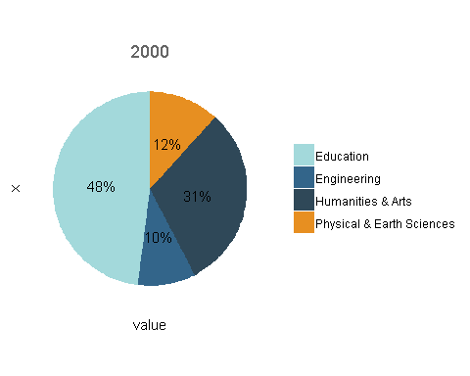

Pie Chart for 2010

dfpie2015 <- data.frame(  
 group = c("Education", "Engineering", "Humanities & Arts", "Physical & Earth Sciences"),  
 value = c(0.3296621, 0.21660548, 0.2665914, 0.1871411)  
 )  
  
pie2015 <- ggplot(dfpie2015, aes(x="", y=value, fill=group)) + geom_bar(stat="identity", width=1)  
  
  
pie2015 = pie2015 + coord_polar("y", start=0) + geom_text(aes(label = paste0(round(value*100), "%")), position = position_stack(vjust = 0.5))  
  
pie2015 = pie2015 + scale_fill_manual(values=c("#a3d9db", "#33658A", "#2F4858", "#e78f21", "#999999"))  
  
pie2015 = pie2015 + theme_classic() + theme(legend.title=element_blank())+ labs(title = "2015", align=c)+ theme(axis.line = element_blank(),  
 axis.text = element_blank(),  
 axis.ticks = element_blank(),  
 plot.title = element_text(hjust = 0.5, color = "#666666"))  
  
pie2015

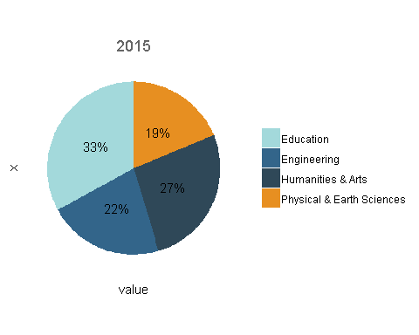

# Part 3 - Male and female salaries for starting postdoctoral and other employment positions (2015)

Compare median salaries for male and female doctorate recipients in 2015. Answer these two questions:

Does median salary differ significantly between male and female starting postdoc positions? Does median salary differ significantly between male and female PhD recipients in non-postdoc employment positions?

Wilcoxon signed-rank - two sample paired

doctoral <- read_csv("Doctoral_Salaries.csv")

## Parsed with column specification:  
## cols(  
## Field = col_character(),  
## Employment_Male = col_number(),  
## Employment_Female = col_number(),  
## Postdoc_Male = col_number(),  
## Postdoc_Female = col_number()  
## )

## Data visualization - boxplots

doctoral_melt <- melt(doctoral[c('Field', 'Employment_Male', 'Employment_Female', 'Postdoc_Male', 'Postdoc_Female')],id.vars = 1)  
  
  
employment_box <- ggplot(doctoral_melt, aes(x = variable, y = value, fill = variable))+  
 geom_boxplot()  
employment_box

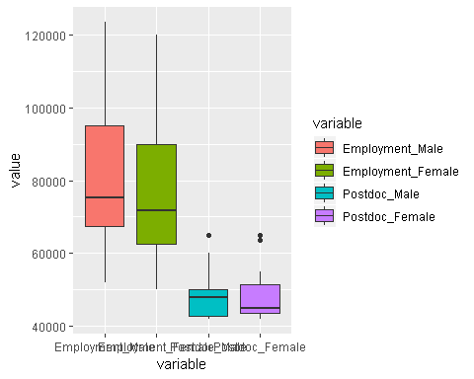

## Wilcox rank test

employment_wilcox <- wilcox.test(doctoral$Employment_Male, doctoral$Employment_Female, paired = TRUE)

## Warning in wilcox.test.default(doctoral$Employment_Male, doctoral  
## $Employment_Female, : cannot compute exact p-value with ties

## Warning in wilcox.test.default(doctoral$Employment_Male, doctoral  
## $Employment_Female, : cannot compute exact p-value with zeroes

employment_wilcox #V = 101, p-value = 0.002572

##   
## Wilcoxon signed rank test with continuity correction  
##   
## data: doctoral$Employment_Male and doctoral$Employment_Female  
## V = 101, p-value = 0.002572  
## alternative hypothesis: true location shift is not equal to 0

postdoc_wilcox <- wilcox.test(doctoral$Postdoc_Male, doctoral$Postdoc_Female, paired = TRUE)

## Warning in wilcox.test.default(doctoral$Postdoc_Male, doctoral  
## $Postdoc_Female, : cannot compute exact p-value with ties

## Warning in wilcox.test.default(doctoral$Postdoc_Male, doctoral  
## $Postdoc_Female, : cannot compute exact p-value with zeroes

postdoc_wilcox #V = 19.5, p-value = 0.8884

##   
## Wilcoxon signed rank test with continuity correction  
##   
## data: doctoral$Postdoc_Male and doctoral$Postdoc_Female  
## V = 19.5, p-value = 0.8884  
## alternative hypothesis: true location shift is not equal to 0

# Part 4 - Multivariate linear regression

Exploring academic salaries for professors in U.S. colleges. Explore relationships between variables in the ‘Faculty salary data (2008 - 2009 survey)’ dataset. Develop a model describing faculty salary based on data for faculty sex, rank, years in current position, field, and number of years since doctoral degree was earned. You should make decisions regarding which variables should remain in your final model. Describe the results qualitatively and quantitatively (i.e., don’t just report the statistical results of the model – make sure you describe interesting findings in text). You can also discuss any concerns that you have with the model(s) you present, if any.

Dependent variable (y): faculty salary Possible predictor variables: faculty sex, rank, years in current position, field, and number of years since doctoral degree was earned

Steps: 1) Explore data - find means of salary, make density plot of salary by diff predictor variables 2) Make initial model 3) Test for colinearity 4) Refine model 3) Run diagnostic plots (to test Linearity, Independence, Homoscedasticity (residuals variance), Normality) 5) AIC to compare different models

## Make new dataframe

faculty_salary <- read_csv("Faculty_Salaries.csv")

## Parsed with column specification:  
## cols(  
## Faculty_Rank = col_character(),  
## Discipline = col_character(),  
## Years_Since_PhD = col_integer(),  
## Years_Faculty_Service = col_integer(),  
## Sex = col_character(),  
## Salary = col_integer()  
## )

#Reorder columns  
faculty_salary <- faculty_salary[c("Salary", "Discipline", "Sex", "Faculty_Rank", "Years_Since_PhD", "Years_Faculty_Service")]

## Explore data

#Salary means by Sex  
sex_mean <- faculty_salary %>%   
 group_by(Sex) %>%   
 summarize(  
 mean = mean(Salary)  
 )  
  
#Salary means by Discipline  
discipline_mean <- faculty_salary %>%   
 group_by(Discipline) %>%   
 summarize(  
 mean = mean(Salary)  
 )  
  
#Relationship between salary and faculty years of service  
salary_service <- ggplot(faculty_salary, aes(x = Years_Faculty_Service, y = Salary)) +  
 geom_point(aes(color = Sex, pch = Discipline))+  
facet_wrap(~Discipline)  
  
salary_service

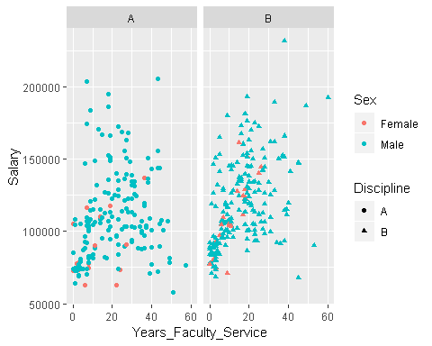

#Relationship between salary and faculty rank, by sex and discipline  
salary_yrs <- ggplot(faculty_salary, aes(x = Faculty_Rank, y = Salary)) +  
 geom_point(aes(color = Sex, pch = Discipline), alpha = 0.5) +  
 facet_wrap(~Discipline)  
  
salary_yrs

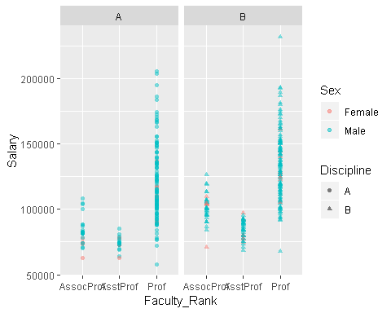

## Linear regression model - Saturated (all variables)

salary_lm1 <- lm(Salary ~ Discipline + Sex + Faculty_Rank + Years_Since_PhD + Years_Faculty_Service, data = faculty_salary)  
summary(salary_lm1)

##   
## Call:  
## lm(formula = Salary ~ Discipline + Sex + Faculty_Rank + Years_Since_PhD +   
## Years_Faculty_Service, data = faculty_salary)  
##   
## Residuals:  
## Min 1Q Median 3Q Max   
## -65248 -13211 -1775 10384 99592   
##   
## Coefficients:  
## Estimate Std. Error t value Pr(>|t|)   
## (Intercept) 78862.8 4990.3 15.803 < 2e-16 ***  
## DisciplineB 14417.6 2342.9 6.154 1.88e-09 ***  
## SexMale 4783.5 3858.7 1.240 0.21584   
## Faculty_RankAsstProf -12907.6 4145.3 -3.114 0.00198 **   
## Faculty_RankProf 32158.4 3540.6 9.083 < 2e-16 ***  
## Years_Since_PhD 535.1 241.0 2.220 0.02698 *   
## Years_Faculty_Service -489.5 211.9 -2.310 0.02143 *   
## ---  
## Signif. codes: 0 '***' 0.001 '**' 0.01 '*' 0.05 '.' 0.1 ' ' 1  
##   
## Residual standard error: 22540 on 390 degrees of freedom  
## Multiple R-squared: 0.4547, Adjusted R-squared: 0.4463   
## F-statistic: 54.2 on 6 and 390 DF, p-value: < 2.2e-16

Salary = 78862.8 + 14417.6(Discipline B) + 4783.5(Sex Male) - 12907.6(AsstProf) + 32158.4(Prof) + 535.1(Years_Since_PhD) - 489.5 (Years_Faculty_Service)

Reference levels: Discipline A (0), Female (0), AssocProf (0)

But… this says that as you increase years of service, your salary decreases -> Might indicate collinearity

## Test for collinearity

salary_simple <- faculty_salary %>%   
 select(Salary, Years_Since_PhD, Years_Faculty_Service)  
  
cor(salary_simple) #High correlation bw Years_Since_PhD and Years_Faculty_Service

## Salary Years_Since_PhD Years_Faculty_Service  
## Salary 1.0000000 0.4192311 0.3347447  
## Years_Since_PhD 0.4192311 1.0000000 0.9096491  
## Years_Faculty_Service 0.3347447 0.9096491 1.0000000

#VIF  
vif(salary_lm1)

## GVIF Df GVIF^(1/(2*Df))  
## Discipline 1.064105 1 1.031555  
## Sex 1.030805 1 1.015285  
## Faculty_Rank 2.013193 2 1.191163  
## Years_Since_PhD 7.518936 1 2.742068  
## Years_Faculty_Service 5.923038 1 2.433729

High correlation bw Years_Since_PhD and Years_Faculty_Service: 0.91

VIF Years_Since_PhD: 7.51 Years_Faculty_Service: 5.92

So we should remove Years_Since_PhD or Years_Faculty_Service - which makes sense conceptually

## Linear regression model - subsets

#Model without Years_Since_PhD   
salary_lm2 <- lm(Salary ~ Discipline + Sex + Faculty_Rank + Years_Faculty_Service, data = faculty_salary)  
summary(salary_lm2)

##   
## Call:  
## lm(formula = Salary ~ Discipline + Sex + Faculty_Rank + Years_Faculty_Service,   
## data = faculty_salary)  
##   
## Residuals:  
## Min 1Q Median 3Q Max   
## -64202 -14255 -1533 10571 99163   
##   
## Coefficients:  
## Estimate Std. Error t value Pr(>|t|)   
## (Intercept) 82912.07 4668.39 17.760 < 2e-16 ***  
## DisciplineB 13473.38 2315.50 5.819 1.24e-08 ***  
## SexMale 4771.25 3878.00 1.230 0.219311   
## Faculty_RankAsstProf -14560.40 4098.32 -3.553 0.000428 ***  
## Faculty_RankProf 34599.24 3382.52 10.229 < 2e-16 ***  
## Years_Faculty_Service -88.78 111.64 -0.795 0.426958   
## ---  
## Signif. codes: 0 '***' 0.001 '**' 0.01 '*' 0.05 '.' 0.1 ' ' 1  
##   
## Residual standard error: 22650 on 391 degrees of freedom  
## Multiple R-squared: 0.4478, Adjusted R-squared: 0.4407   
## F-statistic: 63.41 on 5 and 391 DF, p-value: < 2.2e-16

vif(salary_lm2)

## GVIF Df GVIF^(1/(2*Df))  
## Discipline 1.029040 1 1.014416  
## Sex 1.030803 1 1.015284  
## Faculty_Rank 1.597441 2 1.124233  
## Years_Faculty_Service 1.627110 1 1.275582

#Model without Years_Faculty_Service   
salary_lm3 <- lm(Salary ~ Discipline + Sex + Faculty_Rank + Years_Since_PhD, data = faculty_salary)  
summary(salary_lm3)

##   
## Call:  
## lm(formula = Salary ~ Discipline + Sex + Faculty_Rank + Years_Since_PhD,   
## data = faculty_salary)  
##   
## Residuals:  
## Min 1Q Median 3Q Max   
## -67451 -13860 -1549 10716 97023   
##   
## Coefficients:  
## Estimate Std. Error t value Pr(>|t|)   
## (Intercept) 80988.47 4931.84 16.422 < 2e-16 ***  
## DisciplineB 13937.47 2346.53 5.940 6.32e-09 ***  
## SexMale 4349.37 3875.39 1.122 0.26242   
## Faculty_RankAsstProf -13104.15 4167.31 -3.145 0.00179 **   
## Faculty_RankProf 32928.40 3544.40 9.290 < 2e-16 ***  
## Years_Since_PhD 61.01 127.01 0.480 0.63124   
## ---  
## Signif. codes: 0 '***' 0.001 '**' 0.01 '*' 0.05 '.' 0.1 ' ' 1  
##   
## Residual standard error: 22660 on 391 degrees of freedom  
## Multiple R-squared: 0.4472, Adjusted R-squared: 0.4401   
## F-statistic: 63.27 on 5 and 391 DF, p-value: < 2.2e-16

vif(salary_lm3)

## GVIF Df GVIF^(1/(2*Df))  
## Discipline 1.055727 1 1.027486  
## Sex 1.028359 1 1.014080  
## Faculty_Rank 1.987205 2 1.187301  
## Years_Since_PhD 2.065517 1 1.437191

#Model without Years_Since_PhD and Years_Faculty_Service  
salary_lm4 <- lm(Salary ~ Discipline + Sex + Faculty_Rank, data = faculty_salary)  
summary(salary_lm4)

##   
## Call:  
## lm(formula = Salary ~ Discipline + Sex + Faculty_Rank, data = faculty_salary)  
##   
## Residuals:  
## Min 1Q Median 3Q Max   
## -66268 -14127 -1566 10813 97718   
##   
## Coefficients:  
## Estimate Std. Error t value Pr(>|t|)   
## (Intercept) 81947 4506 18.187 < 2e-16 ***  
## DisciplineB 13709 2295 5.972 5.25e-09 ***  
## SexMale 4492 3860 1.164 0.245291   
## Faculty_RankAsstProf -13723 3959 -3.466 0.000586 ***  
## Faculty_RankProf 33680 3177 10.600 < 2e-16 ***  
## ---  
## Signif. codes: 0 '***' 0.001 '**' 0.01 '*' 0.05 '.' 0.1 ' ' 1  
##   
## Residual standard error: 22640 on 392 degrees of freedom  
## Multiple R-squared: 0.4469, Adjusted R-squared: 0.4412   
## F-statistic: 79.18 on 4 and 392 DF, p-value: < 2.2e-16

vif(salary_lm4)

## GVIF Df GVIF^(1/(2*Df))  
## Discipline 1.012236 1 1.006099  
## Sex 1.022339 1 1.011108  
## Faculty_Rank 1.034437 2 1.008500

Model lm2 (Model without Years_Since_PhD): Salary = 82912.1 + 13473.4(Discipline B) + 4771.3(Sex Male) - 14560.4(AsstProf) + 34599.2(Prof) - 88.8 (Years_Faculty_Service)

Model lm3 (Model without Years_Faculty_Service): Salary = 80988.5 + 13937.5(Discipline B) + 4349.4(Sex Male) - 13104.2(AsstProf) + 32928.4(Prof) + 61.0 (Years_Since_PhD)

Model lm4: Salary = 81947 + 13709(Discipline B) + 4492(Sex Male) - 13723(AsstProf) + 33680(Prof)

## Interaction terms?

salary_lm5 <- lm(Salary ~ Sex + Faculty_Rank + Discipline + Years_Faculty_Service + Discipline*Years_Faculty_Service, data = faculty_salary)  
  
summary(salary_lm5)

##   
## Call:  
## lm(formula = Salary ~ Sex + Faculty_Rank + Discipline + Years_Faculty_Service +   
## Discipline * Years_Faculty_Service, data = faculty_salary)  
##   
## Residuals:  
## Min 1Q Median 3Q Max   
## -70632 -14191 -2098 9937 94331   
##   
## Coefficients:  
## Estimate Std. Error t value Pr(>|t|)   
## (Intercept) 86338.5 4880.9 17.689 < 2e-16 ***  
## SexMale 5196.1 3861.9 1.345 0.179254   
## Faculty_RankAsstProf -13899.7 4086.8 -3.401 0.000741 ***  
## Faculty_RankProf 34121.8 3371.0 10.122 < 2e-16 ***  
## DisciplineB 6255.7 3916.2 1.597 0.110989   
## Years_Faculty_Service -266.8 135.8 -1.965 0.050128 .   
## DisciplineB:Years_Faculty_Service 406.3 178.3 2.279 0.023221 *   
## ---  
## Signif. codes: 0 '***' 0.001 '**' 0.01 '*' 0.05 '.' 0.1 ' ' 1  
##   
## Residual standard error: 22530 on 390 degrees of freedom  
## Multiple R-squared: 0.455, Adjusted R-squared: 0.4467   
## F-statistic: 54.27 on 6 and 390 DF, p-value: < 2.2e-16

vif(salary_lm5)

## GVIF Df GVIF^(1/(2*Df))  
## Sex 1.033210 1 1.016469  
## Faculty_Rank 1.625251 2 1.129094  
## Discipline 2.975161 1 1.724865  
## Years_Faculty_Service 2.432170 1 1.559542  
## Discipline:Years_Faculty_Service 3.484050 1 1.866561

#Relationship between salary and Years_Faculty_Service, by discipline  
service_model <- lm(Salary ~ Years_Faculty_Service + Discipline, data = faculty_salary)  
  
service_graph1 <- ggplot(faculty_salary, aes(x = Years_Faculty_Service, y = Salary))+  
geom_point(aes(color = Discipline))+  
 facet_wrap(~Discipline)+  
 geom_smooth(method = lm, se = TRUE, size = 0.5, color = "gray20")  
service_graph1

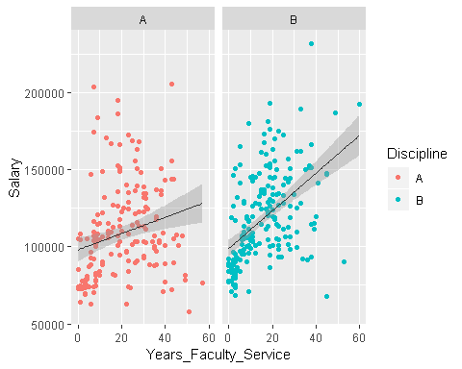

service_graph2 <- ggplot(faculty_salary, aes(x = Years_Faculty_Service, y = Salary))+  
geom_point()+  
 geom_smooth(method = lm, se = TRUE, size = 0.5, color = "gray20")  
service_graph2

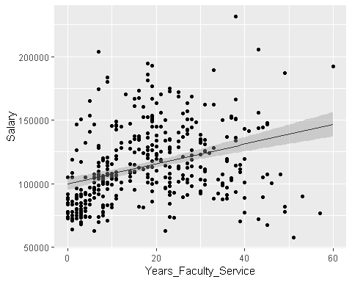

service_graph3 <- ggplot(faculty_salary, aes(x = Years_Since_PhD, y = Salary))+  
geom_point()+  
 geom_smooth(method = lm, se = TRUE, size = 0.5, color = "gray20")  
service_graph3

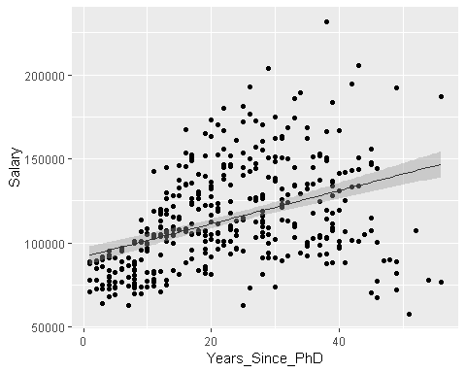

## Diagnostic plots

plot(salary_lm2)

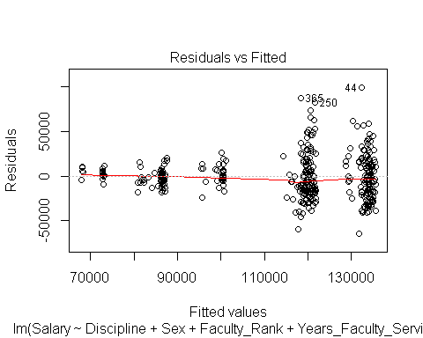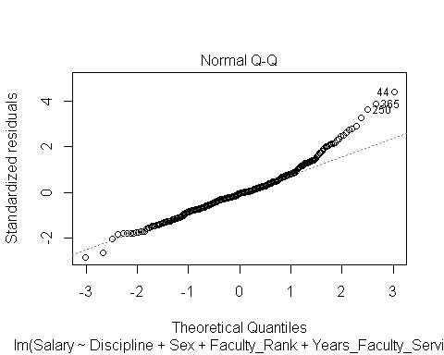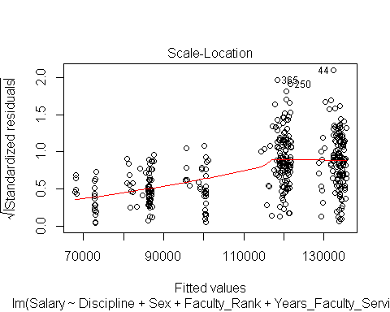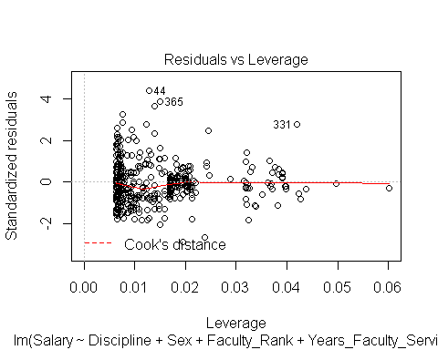

plot(salary_lm3)

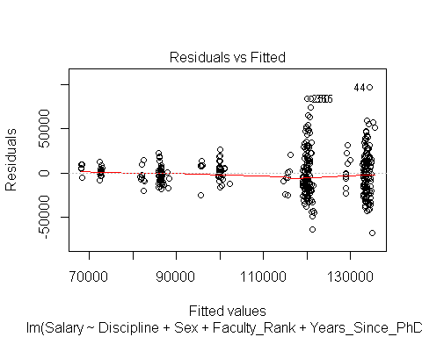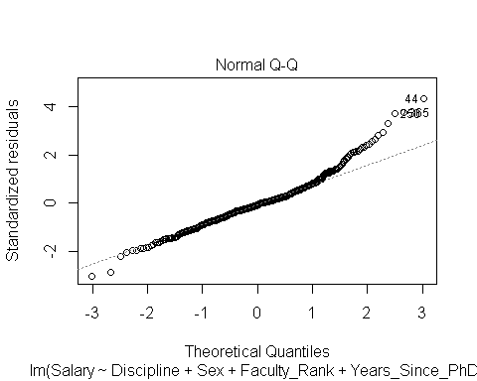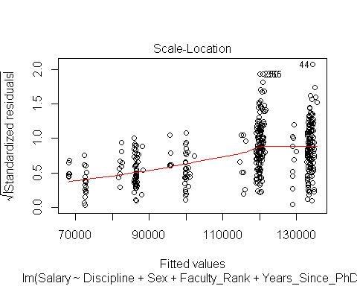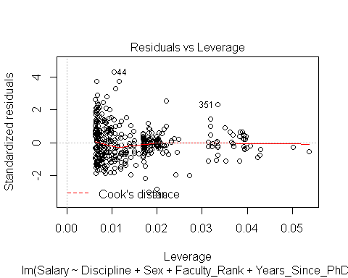

plot(salary_lm4)

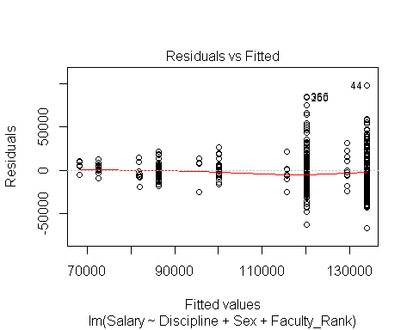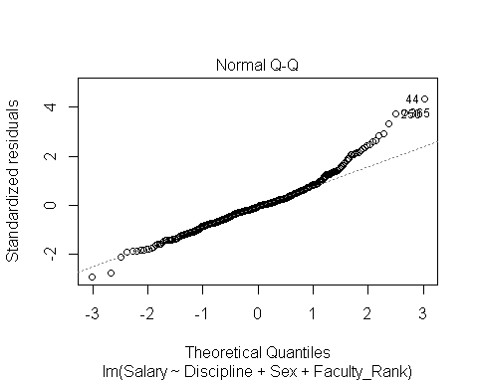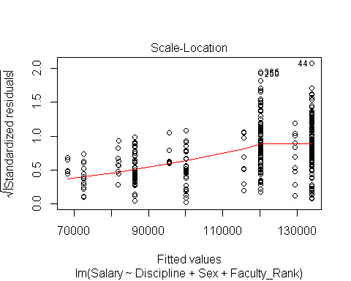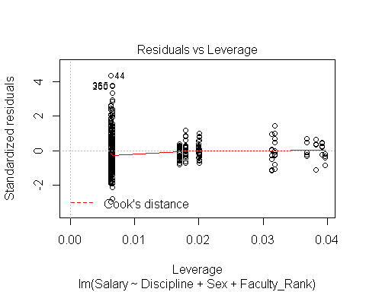

plot(salary_lm5)

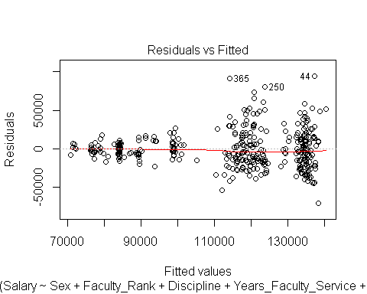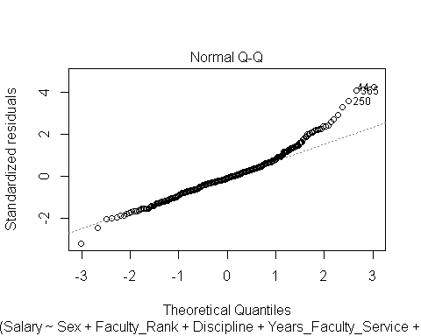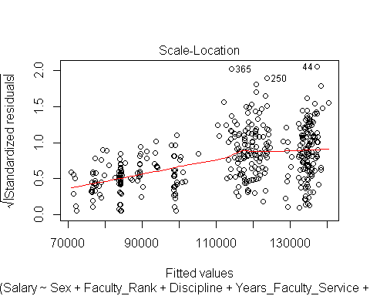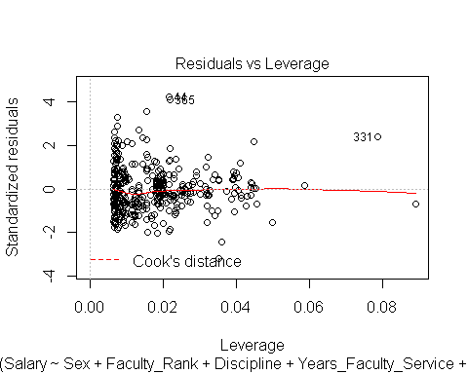 Residuals: homoscedastic?? Normality: yes??

## Akaike Information Criterion

sat_aic <- AIC(salary_lm1)  
sat_aic #9093.8

## [1] 9093.826

lm2_aic <- AIC(salary_lm2)  
lm2_aic #9096.8

## [1] 9096.813

lm3_aic <- AIC(salary_lm3)  
lm3_aic #9097.2

## [1] 9097.22

lm4_aic <- AIC(salary_lm4)  
lm4_aic #9095.5

## [1] 9095.454

lm5_aic <- AIC(salary_lm5)  
lm5_aic #9093.6

## [1] 9093.562

#lm4 < lm3 < lm2

None of the interactions significantly change the AIC value of the model. SO: The best model is lm3

Model lm3 (Model without Years_Faculty_Service): Salary = 80988.5 + 13937.5(Discipline B) + 4349.4(Sex Male) - 13104.2(AsstProf) + 32928.4(Prof) + 61.0 (Years_Since_PhD)

## Model data table

lm_table <- stargazer(salary_lm3, type = "html")

##   
## <table style="text-align:center"><tr><td colspan="2" style="border-bottom: 1px solid black"></td></tr><tr><td style="text-align:left"></td><td><em>Dependent variable:</em></td></tr>  
## <tr><td></td><td colspan="1" style="border-bottom: 1px solid black"></td></tr>  
## <tr><td style="text-align:left"></td><td>Salary</td></tr>  
## <tr><td colspan="2" style="border-bottom: 1px solid black"></td></tr><tr><td style="text-align:left">DisciplineB</td><td>13,937.470<sup>***</sup></td></tr>  
## <tr><td style="text-align:left"></td><td>(2,346.534)</td></tr>  
## <tr><td style="text-align:left"></td><td></td></tr>  
## <tr><td style="text-align:left">SexMale</td><td>4,349.366</td></tr>  
## <tr><td style="text-align:left"></td><td>(3,875.393)</td></tr>  
## <tr><td style="text-align:left"></td><td></td></tr>  
## <tr><td style="text-align:left">Faculty_RankAsstProf</td><td>-13,104.150<sup>***</sup></td></tr>  
## <tr><td style="text-align:left"></td><td>(4,167.315)</td></tr>  
## <tr><td style="text-align:left"></td><td></td></tr>  
## <tr><td style="text-align:left">Faculty_RankProf</td><td>32,928.400<sup>***</sup></td></tr>  
## <tr><td style="text-align:left"></td><td>(3,544.403)</td></tr>  
## <tr><td style="text-align:left"></td><td></td></tr>  
## <tr><td style="text-align:left">Years_Since_PhD</td><td>61.011</td></tr>  
## <tr><td style="text-align:left"></td><td>(127.010)</td></tr>  
## <tr><td style="text-align:left"></td><td></td></tr>  
## <tr><td style="text-align:left">Constant</td><td>80,988.470<sup>***</sup></td></tr>  
## <tr><td style="text-align:left"></td><td>(4,931.844)</td></tr>  
## <tr><td style="text-align:left"></td><td></td></tr>  
## <tr><td colspan="2" style="border-bottom: 1px solid black"></td></tr><tr><td style="text-align:left">Observations</td><td>397</td></tr>  
## <tr><td style="text-align:left">R<sup>2</sup></td><td>0.447</td></tr>  
## <tr><td style="text-align:left">Adjusted R<sup>2</sup></td><td>0.440</td></tr>  
## <tr><td style="text-align:left">Residual Std. Error</td><td>22,663.240 (df = 391)</td></tr>  
## <tr><td style="text-align:left">F Statistic</td><td>63.266<sup>***</sup> (df = 5; 391)</td></tr>  
## <tr><td colspan="2" style="border-bottom: 1px solid black"></td></tr><tr><td style="text-align:left"><em>Note:</em></td><td style="text-align:right"><sup>*</sup>p<0.1; <sup>**</sup>p<0.05; <sup>***</sup>p<0.01</td></tr>  
## </table>