1. Given the provided data, what are three conclusions we can draw about Kickstarter campaigns?

* The mode in the Goal’s amount was US5K since 111 projects set this amount as their goal although the average amount to reach was US71K. 53% of all projects are considered successful.
* Theater has 20% of the successful projects in this data set. (839 successful projects), however, the Technology projects raised more donations, 3.8x more than theater, this because technology had the most backers in this data set and the highest average donation, USD133.89.
* Even though Technology seems a very good category to attract people to invest in different projects, 60% of all projects either fail or they are cancelled. Specially the gadgets, web and wearables subcategories.

1. What are some limitations of this dataset?
   1. There are a few projects with very low goals (less than USD100). Would be good to double check if that data is correct.
   2. Unlike other data sets we saw during the classes where the country columns had their metrics, in this case, there is only one with all the country values. And to have certain graphs as a scatter plot comparing countries was not possible.
   3. To know if the spotlight column refers to added inversion to promote donations or a website’s position.
   4. To add more subcategories, for example, in the case of the plays, even though the blurb variable explains, it would be easier to know if certain plays are more successful because of a specific genre.
2. What are some other possible tables and/or graphs that we could create?
   1. Pivot table with a column of category and/or subcategory, row of state, values on backers count, to see if there is a relation between the backers count and the success of the projects.

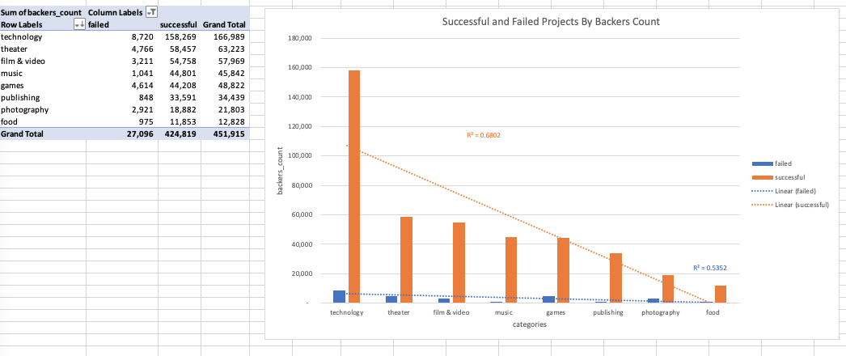

* 1. Pivot table with a column of category and/or subcategory, row of state, values on pledged amount, backers count and a calculated field to determine their average donation. To see which projects raised the highest amount of donations.

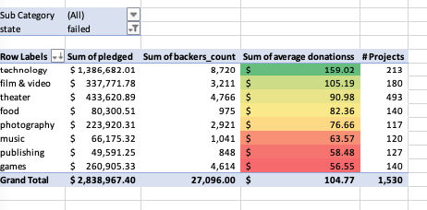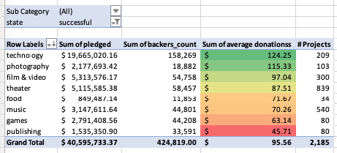

* 1. Quartiles to see outliers depending the category or average donations
  2. 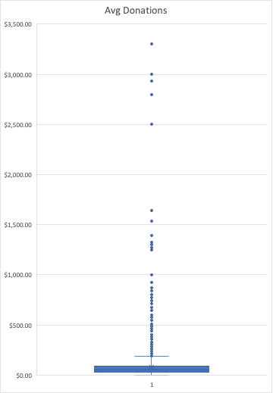

Bonus Statistical Analysis

* Bakers Count

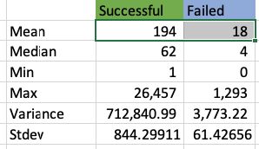

* Evidently, the average for successful projects has more backers than the failed ones.
* As for the standard deviation, the *successful* projects' data have a bigger spread of distribution, meaning, the data points are more far away from the mean. Therefore it could be less reliable to determine if the success of the projects depend on the backers count they have.