



**Introduction to GIS**

A geographic information system (GIS) is a framework for gathering, managing, and analysing data. Rooted in the science of geography, GIS integrates many types of data. It analyses spatial location and organizes layers of information into visualizations using maps and 3D scenes. ​With this unique capability, GIS reveals deeper insights into data, such as patterns, relationships, and situations—helping users make smarter decisions.

Here is a slightly dorky introduction to GIS as a concept:

<https://www.youtube.com/watch?v=-ZFmAAHBfOU>

Running through this tutorial as a team from a standing start should take you about 30 to 45 minutes. Ask anyone in the room walking around for help if you need it. By the end you should have the basic software loaded onto one or more computers in the team, a basic map loaded up, the ability to draw on top of that map, the ability to load data from a file and the ability to load data from an API.

There is so much more to GIS, but this should help you get to grips with the first key steps towards working with these tools. As always explore on your own and ask others to help when you are stuck!

**Step 1 - Installing QGIS on your computer**

QGIS is a free and open-source desktop geographic information system (GIS) application that supports viewing, editing, and analysis of geospatial data. This kind of spatial data is found in abundance on the North Ayrshire Open Data Portal:

<https://maps-north-ayrshire.opendata.arcgis.com/>

1. First we need to download the QGIS installer, to do this you’ll need to go to the QGIS website here: <https://www.qgis.org/en/site/>
2. Click on the green ‘Download Now’ button

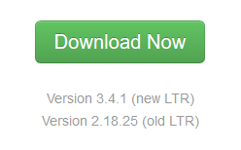

1. On the next page you will have to select the correct download for your computer and setup, if you are unsure ask someone in the room to help you choose the right installer.
2. After downloading the installer you will need to find and run the file
3. On the first install screen you need to select ‘Express Desktop Install’ and then click ‘Next’

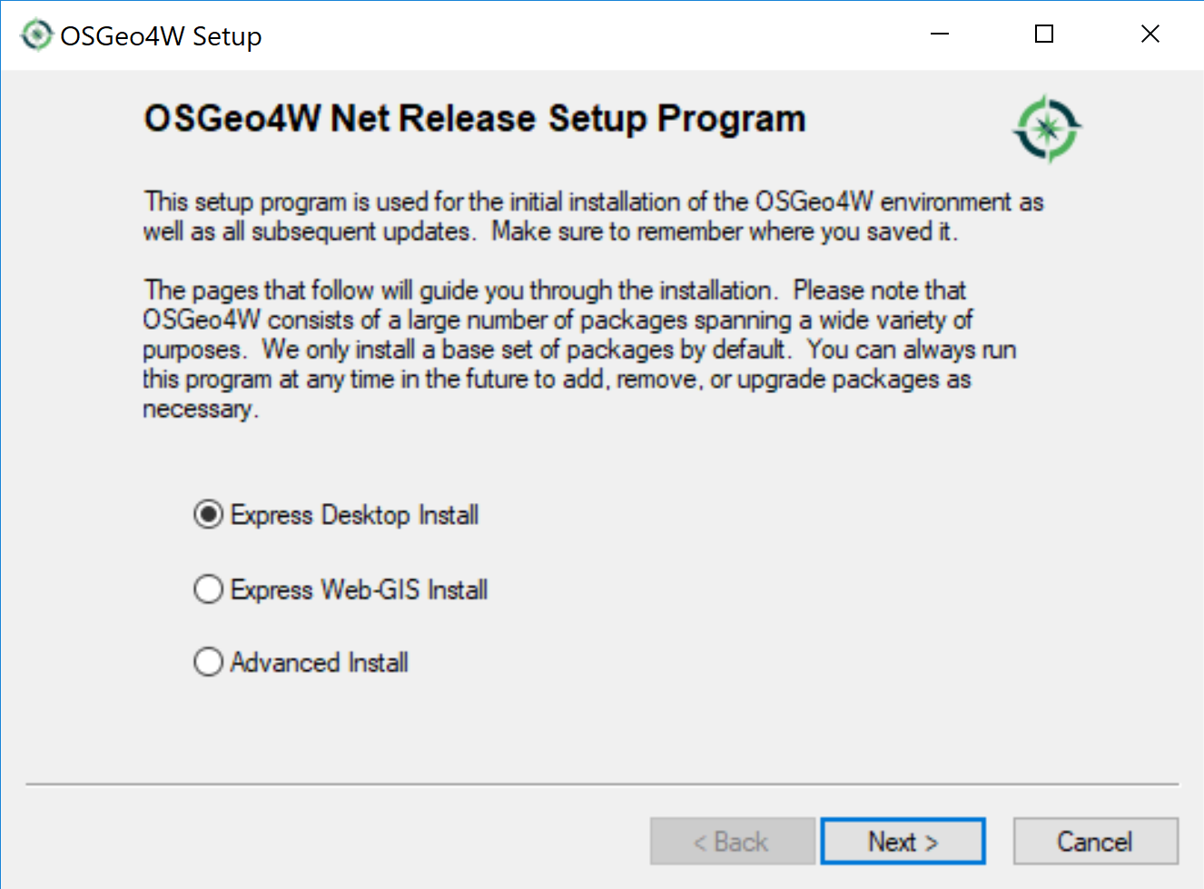

1. On the second install screen you need to select the top download site by clicking on it highlighting it blue and then clicking ‘Next’

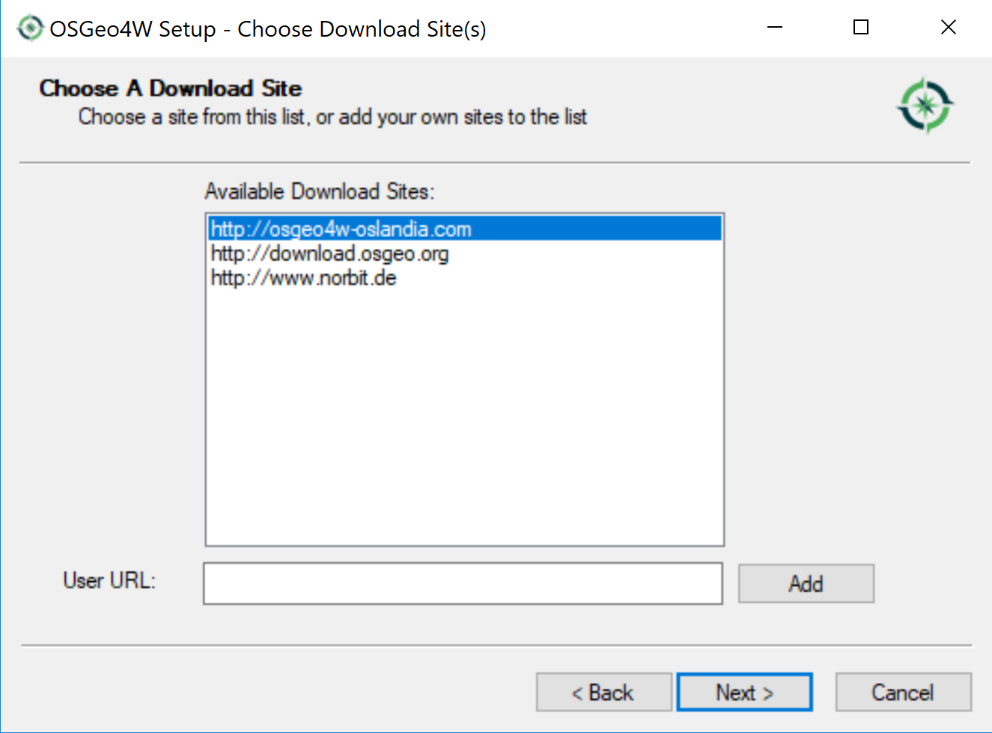

1. On the third install screen several options will exist and be checked. Make sure that QGIS and GDAL are selected unselect GRASS GIS if it is selected. Then click ‘Next’

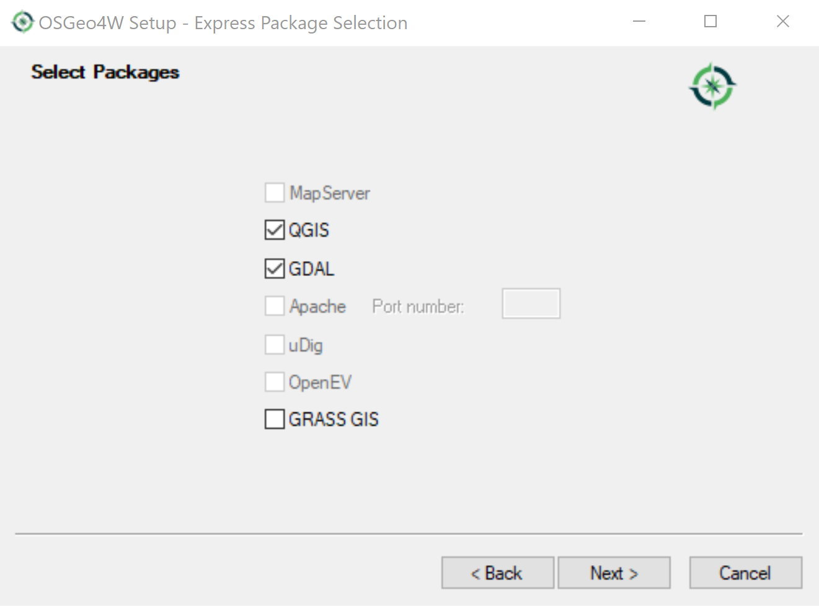

1. On the fourth screen make sure that the tick box next to ‘Install thee packages to meet dependencies (RECOMMENDED)’ is ticked before clicking ‘Next’

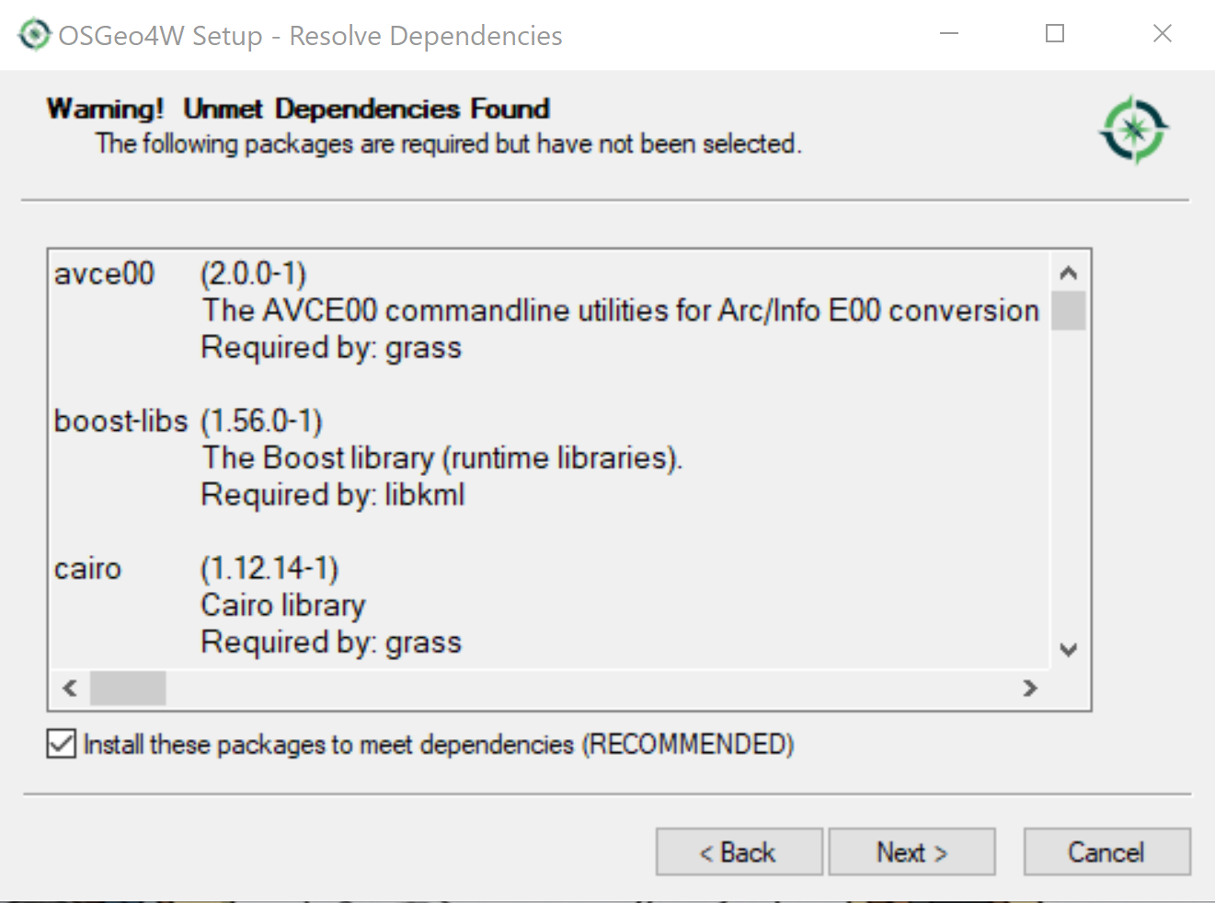

1. Some of those dependencies have their own licenses agreements and you will need to check the tickbox for each agreeing to its terms and clicking ‘Next’ There can be several of these pages. (Some times the installer will flash messages that a certain file was not found at the download location. These are alright to click ‘OK’ to and move on)

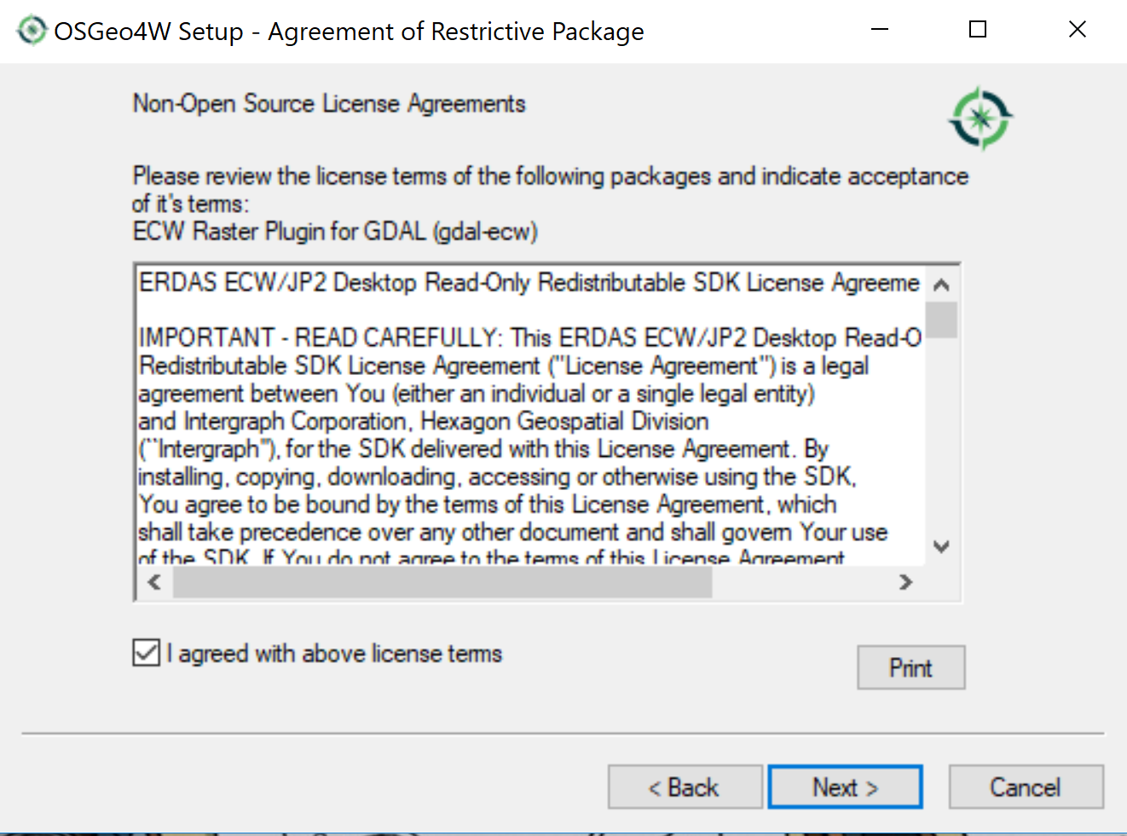

1. The installer will now set to work install QGIS on your computer. This will take several minutes to complete.
2. When the installation is complete click ‘Finish’
3. Now find the program in your computer to start. For example in windows this would be accomplished by clicking the home icon and scrolling through the ‘Program Menu’ for the folder ‘OSGeo4W’ clicking it and then in the resulting list clicking ‘QGIS Desktop 3.4.1’
4. On the welcome screen click ‘Let’s get started!’ (If asked to import your settings you must already have a version of QIS installed and we’d expect you to know what to pick, however if you don’t choose ‘I want a clean start. Don’t import my QGIS 2 settings.’)

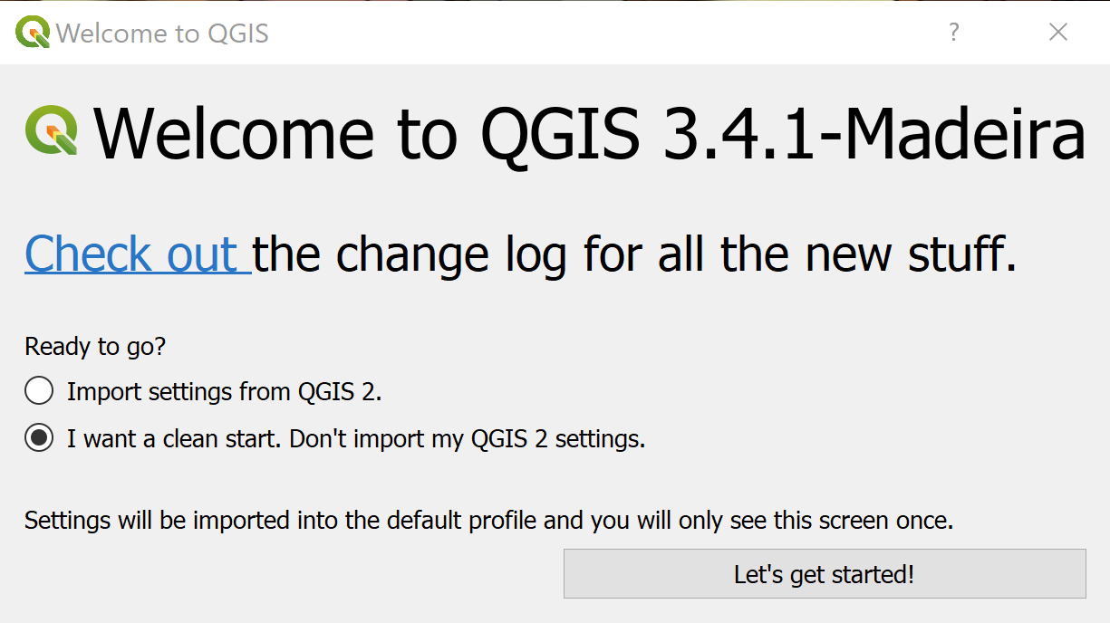

1. QGIS will load up, this will take a few minutes to complete.
2. Once loaded up the QGIS software will look like below. Don’t be intimidated by all of the buttons. QGIS is a very powerful program, but taken a step at a time what at first appears daunting can be understood.

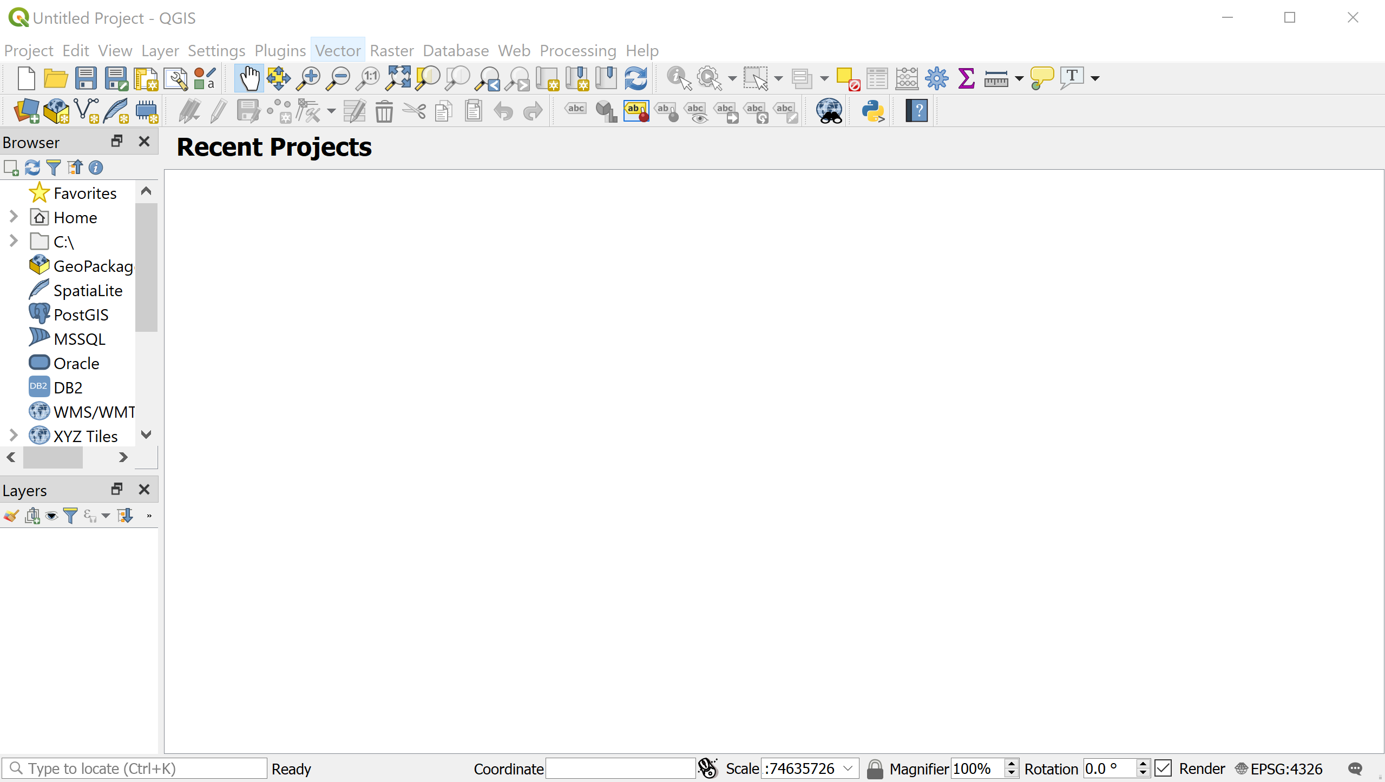

1. Congratulations you now have a GIS software installed and ready to use on your computer. It’s a bit longer in duration, but if you fancy a decent explanation of your way around QGIS then you could do worse than this video: <https://www.youtube.com/watch?v=aLmMovuydqI>

**Step 2 – Set Up QuickMapServices to Access a Base Map**

1. Click on the ‘Plugins’ menu item then click on ‘Manage and Install Plugins…’
2. Write ‘quickmapservices’ into the search box and click on the ‘Install plugin’ button

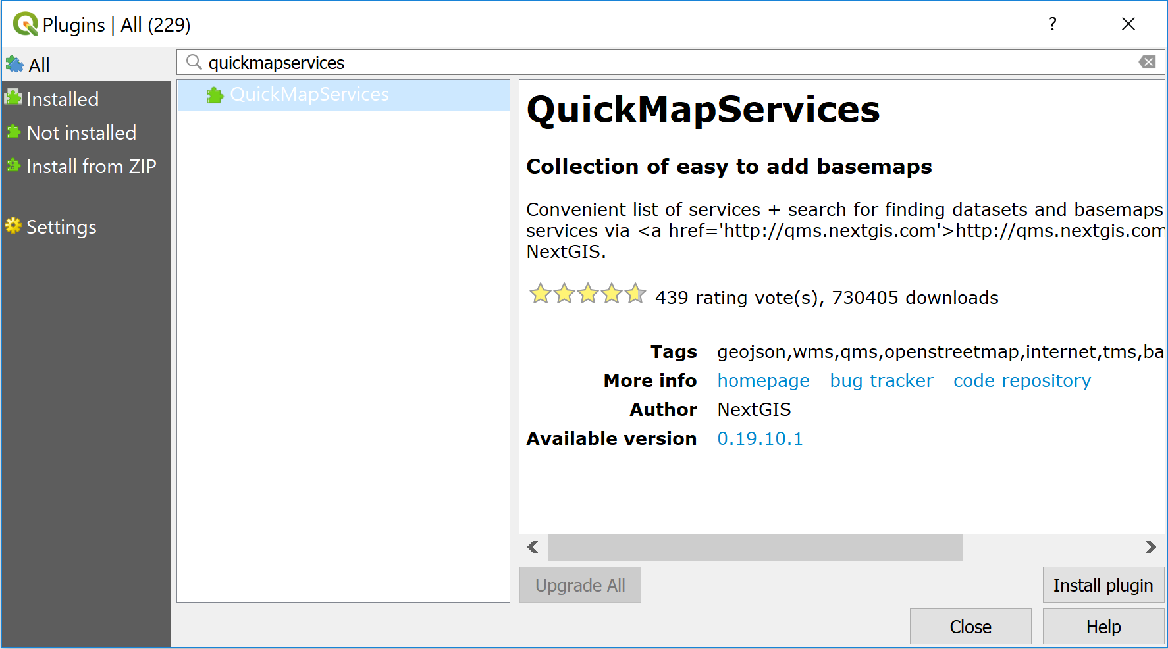

1. Close the Plugins dialogue by clicking the ‘Close’ button
2. Click on the ‘Web’ menu item then click on ‘QuickMapServices’ then click on ‘OSM’ and finally click on ‘OSM Standard’
3. An Open Street Map will be loaded into the main window

**Step 3 – Build a test layer or two**

1. Manoeuvre the map to find Garnock Community Campus

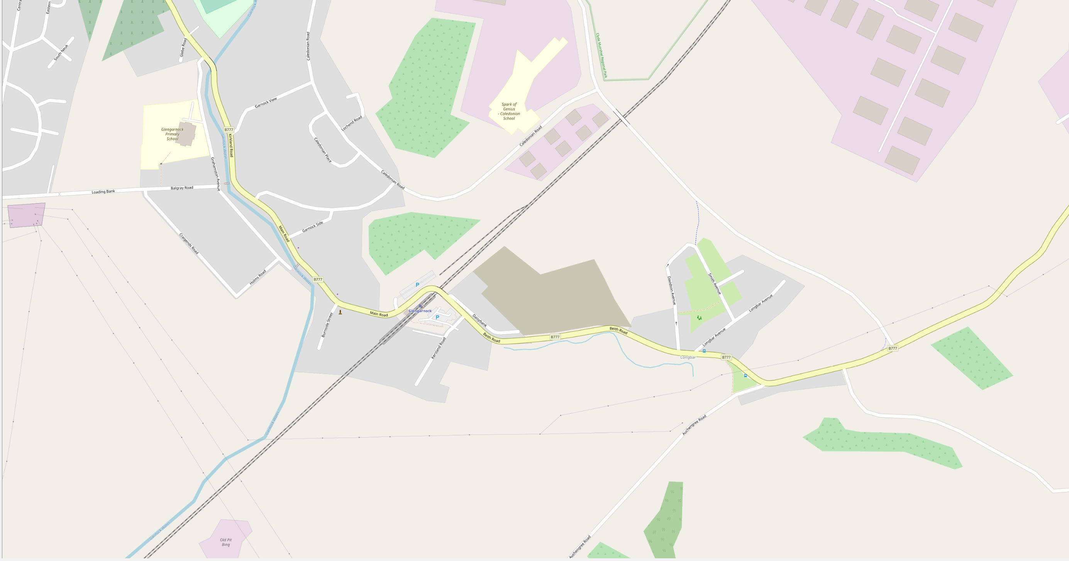

1. Create a layer by clicking on ‘New temporary scratch layer’

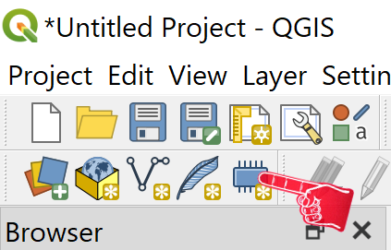

1. In the dialogue that pops up give the layer the name ‘campus’, select ‘Polygon / CurvePolygon’ from the dropdown and click the ‘OK’ button.

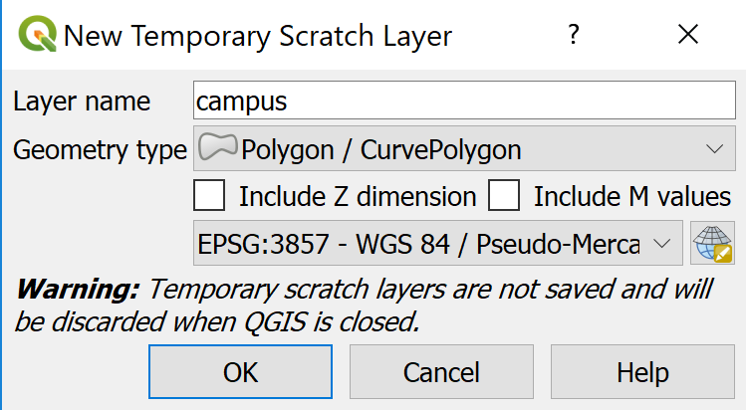

1. Right click the ‘campus’ layer from the ‘Layers Panel’ and then click on ‘Open Attribute Table’ from the list.

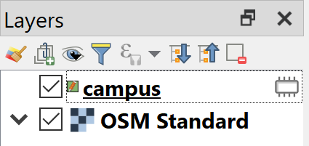

1. In the Attribute table click on the ‘New Field’ button

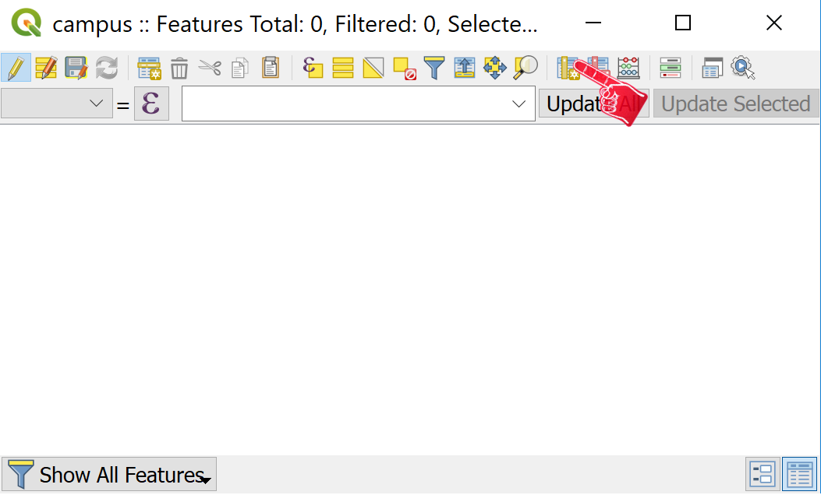

1. In the pop up dialogue give the attribute a name in this case ‘Name’ and then change the type drop down to ‘Text (string)’

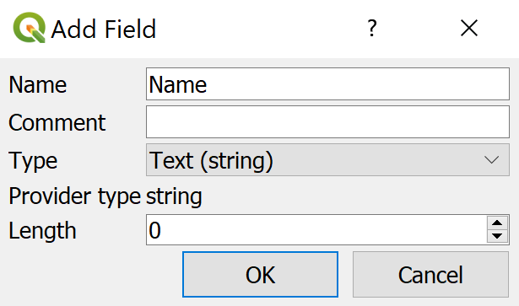

1. Click the ‘Add Polygon Feature’ button from the menu

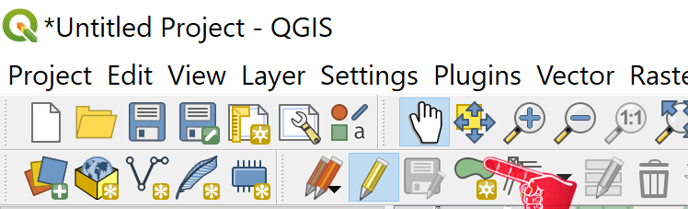

1. Draw a polygon around the campus building as marked on the map. This is done by left clicking on all corners of the building and when they have all been clicked on clicking the right mouse button to complete.

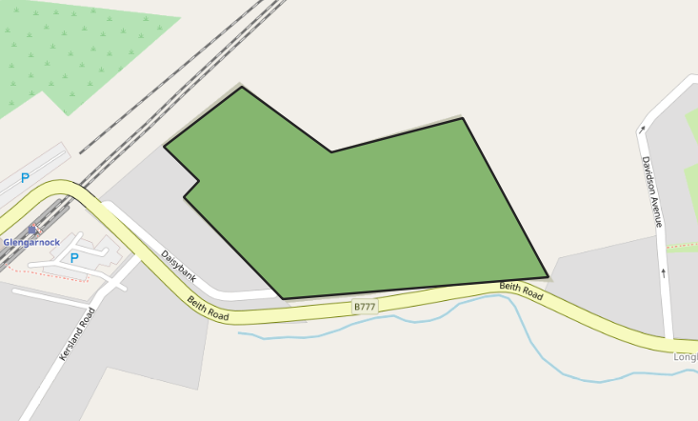

1. When you are finished a pop up will appear where you can fill in the Name attribute you created, in this case call it ‘campus’

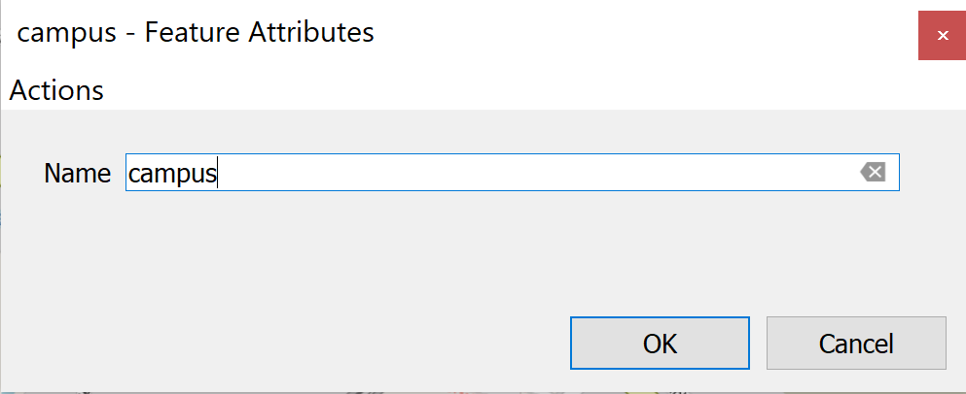

1. Now we need to save our project. Click on the ‘Project’ menu item and then click on ‘Save’ to save the project for later.

**Step 4 – Import data from a file**

1. Go online to the North Ayrshire Open Data Portal: <https://maps-north-ayrshire.opendata.arcgis.com/>
2. Type ‘Polling’ into the search box and you should find two results. Click on the result titled ‘Polling Places’
3. At the top right of the ‘Polling Places’ page click on ‘Download’ and then in the dropdown menu click on ‘Shapefile’

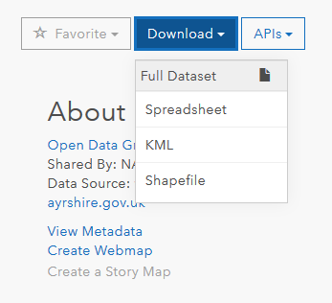

1. The data will download onto your computer as a zip file, move the file to your desktop
2. Then using the ‘Browser Panel’ navigate to the zip file. If you are on windows the steps will likely be C:\Users\<computer username>\Desktop\Polling_Places.zip\Polling_Places.shp Clicking the file name will load the data as a new layer and display the points across your map.

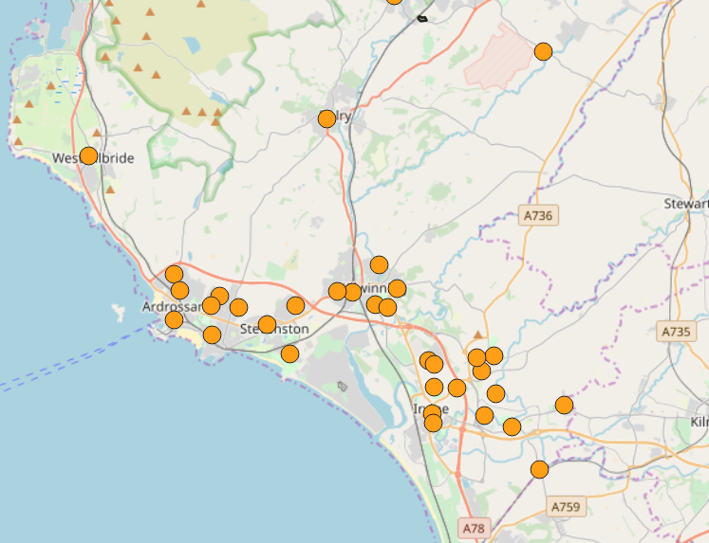

1. Marvel in the miracle that is spatial data

**Step 5 – Import data through an API**

1. Return to the North Ayrshire Open Data Portal: <https://maps-north-ayrshire.opendata.arcgis.com/>
2. Type ‘Polling’ into the search box and you should find two results. Click on the result titled ‘Polling Districts’ this time
3. At the top right of the ‘Polling Districts’ page click on ‘APIs’ and then in the dropdown copy the URL for OGC WFS: <https://www.maps.north-ayrshire.gov.uk/arcgis/services/AGOL/Open_Data_Portal/MapServer/WFSServer?request=GetCapabilities&service=WFS>

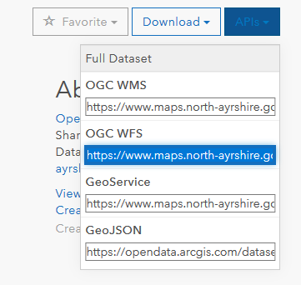

1. In the ‘Browser Panel’ right click ‘WFS’ and click on ‘New Connection’
2. In the pop up name the connection ‘districts’ and paste the WFS URL that you copied above into the ‘URL’ box. Then click the ‘OK’ button

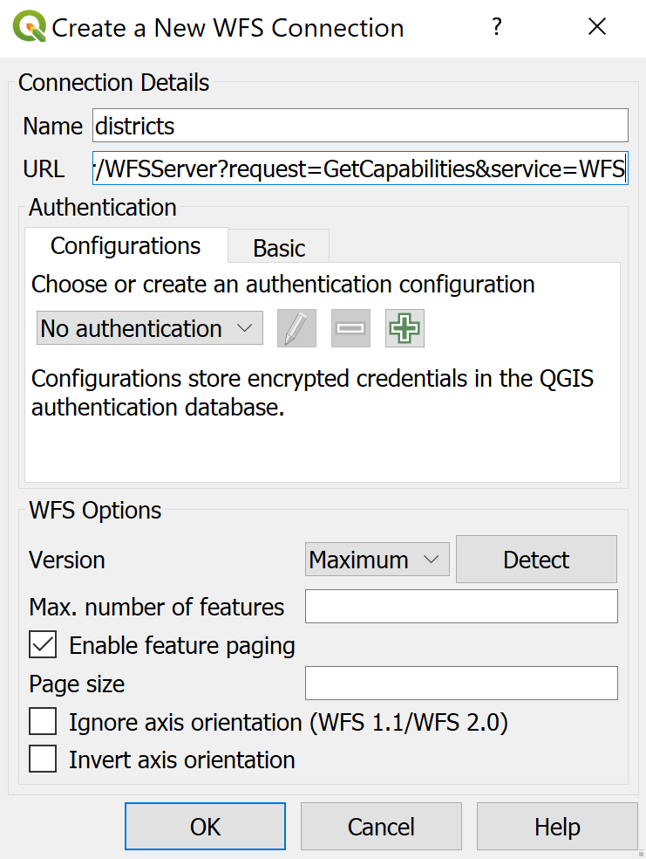

1. Back in the browser panel click the arrow next to ‘WFS’ and there will be a list of connections beneath one of which will be the one you just named ‘districts’ Click the arrow next to districts.
2. You will now see a list of all the spatial data sets within the North Ayrshire Open Data Portal, scroll down until you reach ‘Polling_Districts’ Click on it.
3. Moving the ‘Polling_Places’ layer above ‘Polling_Districts’ in the ‘Layers Panel’ will bring that layer above on the map

