**An "Open Robot Battle Near Earth" remake of "Nether Earth"**

**Specification, Design, and User Manual**

**By**

**Team 9:**

**Marc-André Moreau <marcandre.moreau@gmail.com>**

**Mark Foo Bonasoro <foo_mark@q8ismobile.com>**

**Tina Salameh <tina.salameh@gmail.com>**

**Astou Sene <chanelsene@hotmail.com>**

**COMP371**

**Concordia University**

**Winter 2012**

Contents

1. Overview 1

2. Dependencies 2

3. Licensing 3

4. Source Code 4

5. Compilation 5

6. Directory Structure 6

7. Software Architecture 7

8. Screenshots 9

APPENDIX A: MPL 2.0 10

# Overview

Rawbots is a game inspired from Nether Earth. It is written in C#, and is meant to be cross-platform on Windows, Mac OS X and Linux using Mono and MonoDevelop.

# Dependencies

Rawbots comes with libraries such as OpenTK, Tao and QuickFont inside the Libraries folder. OpenTK and Tao provide C# bindings to OpenGL and GLUT, while QuickFont is an OpenTK extension that provides support for font drawing.

If you wish to download those libraries separately, here is where they can be obtained:

OpenTK: <http://www.opentk.com>

QuickFont: <http://www.opentk.com/project/QuickFont>

Tao Framework: <http://sourceforge.net/projects/taoframework/>

Besides the libraries used by Rawbots, you will need the proper runtime environment and development tools. On Windows, you can use the Microsoft .NET Framework and Visual Studio.

The usage of the .NET Framework and Visual Studio is optional, since Rawbots is fully compatible with Mono and MonoDevelop. On Linux and Mac OS X this is the only option available for obvious reasons.

Here is the download page for Mono:

<http://www.go-mono.com/mono-downloads/download.html>

If you are on Windows, you will need to install "Gtk# for .NET" and "Mono for Windows, Gtk# and XSP" as well.

Once Mono is installed, you can download and install MonoDevelop:

http://monodevelop.com/

Installation should be pretty straightforward. If you're on Linux, there's nothing to say really, just get the Mono runtime and MonoDevelop from your distribution's package manager.

# Licensing

Rawbots is licensed under the Mozilla Public License (MPL) 2.0. A copy of the license can be found in the LICENSE file, otherwise the license can be found either in appendix A of this document or at <http://www.mozilla.org/MPL/2.0/index.txt>

MPL 2.0 was chosen because it is a weak copyleft license that would allow others to build on our work past the end of this course. When spending a lot of time on a team project it's usually better if the end result is not wasted and forgotten afterwards. We encourage future teams to use our work for reference if they wish, or even build on top of it if the course allows for it.

# Source Code

The Rawbots source code is available on GitHub: <https://github.com/rawbots/rawbots>

You can obtain a copy of the source code through the GitHub web interface or using a git client.

If you are not familiar with git, it is a very powerful version control system. Unfortunately, powerful tools made by power users are not necessarily easy to learn at first. However, by the end of this project, all of our team members were comfortable enough with it.

Here is some help on git usage:

<http://help.github.com/>

<https://github.com/FreeRDP/FreeRDP/wiki/Git-Version-Control>

The read-only git URL for Rawbots is git://github.com/rawbots/rawbots.git

You can clone the repository without developer access using:

git clone git://github.com/rawbots/rawbots.git

# Compilation

If you have properly set up your development environment and the dependencies as described earlier, Rawbots compilation should be straightforward. Open the solution file (Rawbots.sln) either in Visual Studio or MonoDevelop, build and run. That's it, nothing more complicated than that.

# Directory Structure

# Software Architecture

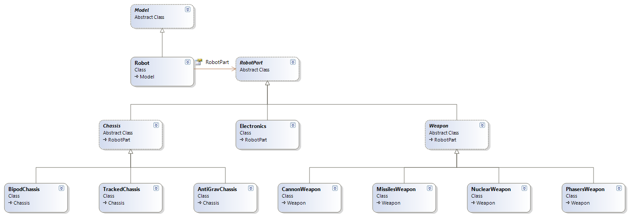

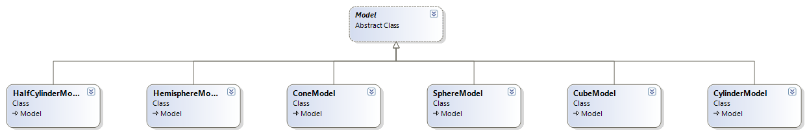

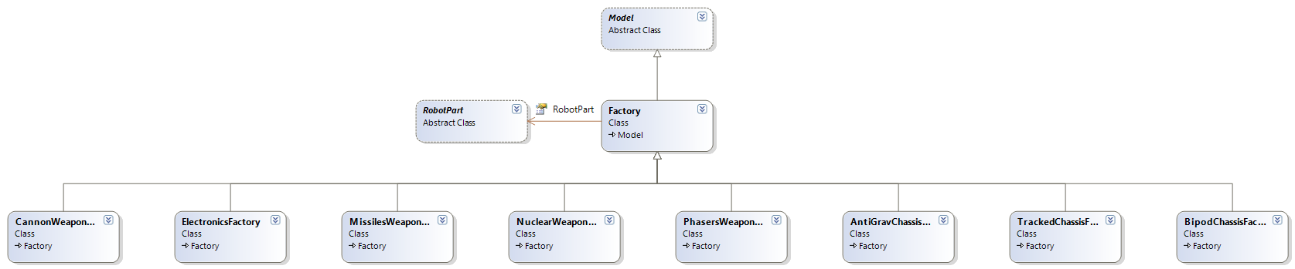

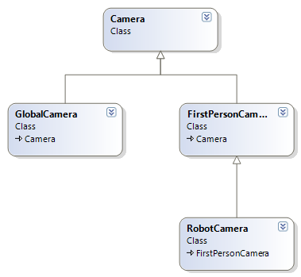

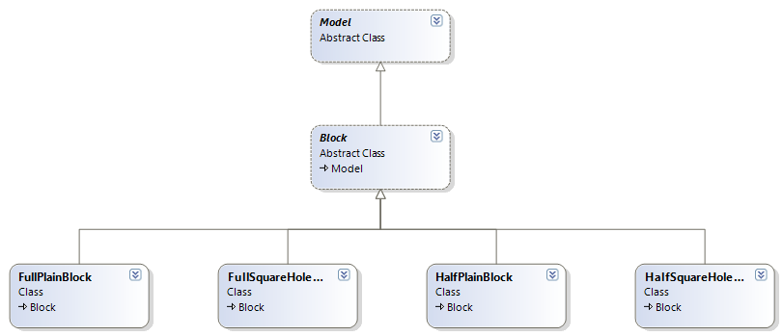

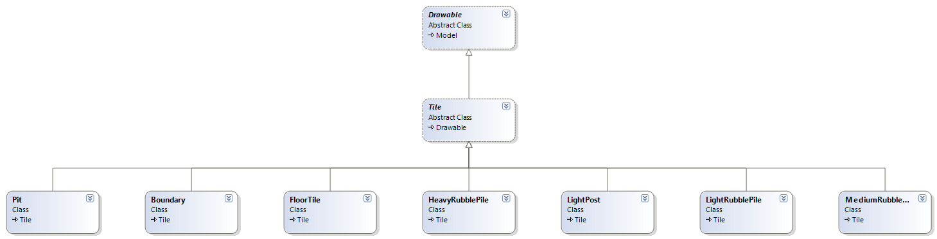

# Screenshots

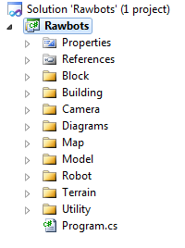

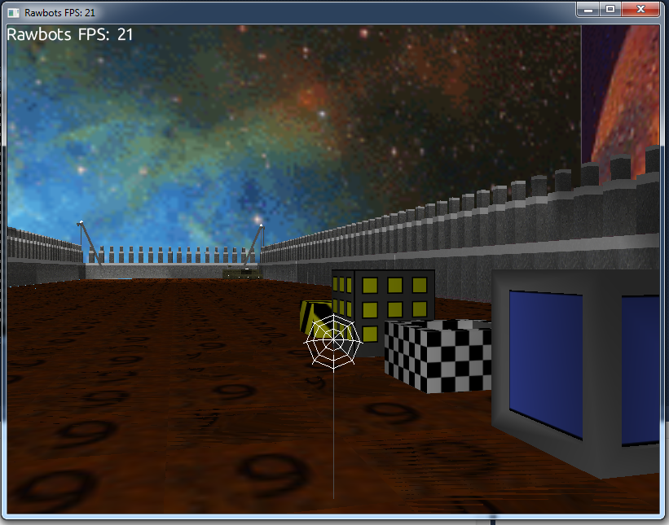

# APPENDIX A: MPL 2.0

Mozilla Public License Version 2.0

==================================

1. Definitions

--------------

1.1. "Contributor"

means each individual or legal entity that creates, contributes to

the creation of, or owns Covered Software.

1.2. "Contributor Version"

means the combination of the Contributions of others (if any) used

by a Contributor and that particular Contributor's Contribution.

1.3. "Contribution"

means Covered Software of a particular Contributor.

1.4. "Covered Software"

means Source Code Form to which the initial Contributor has attached

the notice in Exhibit A, the Executable Form of such Source Code

Form, and Modifications of such Source Code Form, in each case

including portions thereof.

1.5. "Incompatible With Secondary Licenses"

means

(a) that the initial Contributor has attached the notice described

in Exhibit B to the Covered Software; or

(b) that the Covered Software was made available under the terms of

version 1.1 or earlier of the License, but not also under the

terms of a Secondary License.

1.6. "Executable Form"

means any form of the work other than Source Code Form.

1.7. "Larger Work"

means a work that combines Covered Software with other material, in

a separate file or files, that is not Covered Software.

1.8. "License"

means this document.

1.9. "Licensable"

means having the right to grant, to the maximum extent possible,

whether at the time of the initial grant or subsequently, any and

all of the rights conveyed by this License.

1.10. "Modifications"

means any of the following:

(a) any file in Source Code Form that results from an addition to,

deletion from, or modification of the contents of Covered

Software; or

(b) any new file in Source Code Form that contains any Covered

Software.

1.11. "Patent Claims" of a Contributor

means any patent claim(s), including without limitation, method,

process, and apparatus claims, in any patent Licensable by such

Contributor that would be infringed, but for the grant of the

License, by the making, using, selling, offering for sale, having

made, import, or transfer of either its Contributions or its

Contributor Version.

1.12. "Secondary License"

means either the GNU General Public License, Version 2.0, the GNU

Lesser General Public License, Version 2.1, the GNU Affero General

Public License, Version 3.0, or any later versions of those

licenses.

1.13. "Source Code Form"

means the form of the work preferred for making modifications.

1.14. "You" (or "Your")

means an individual or a legal entity exercising rights under this

License. For legal entities, "You" includes any entity that

controls, is controlled by, or is under common control with You. For

purposes of this definition, "control" means (a) the power, direct

or indirect, to cause the direction or management of such entity,

whether by contract or otherwise, or (b) ownership of more than

fifty percent (50%) of the outstanding shares or beneficial

ownership of such entity.

2. License Grants and Conditions

--------------------------------

2.1. Grants

Each Contributor hereby grants You a world-wide, royalty-free,

non-exclusive license:

(a) under intellectual property rights (other than patent or trademark)

Licensable by such Contributor to use, reproduce, make available,

modify, display, perform, distribute, and otherwise exploit its

Contributions, either on an unmodified basis, with Modifications, or

as part of a Larger Work; and

(b) under Patent Claims of such Contributor to make, use, sell, offer

for sale, have made, import, and otherwise transfer either its

Contributions or its Contributor Version.

2.2. Effective Date

The licenses granted in Section 2.1 with respect to any Contribution

become effective for each Contribution on the date the Contributor first

distributes such Contribution.

2.3. Limitations on Grant Scope

The licenses granted in this Section 2 are the only rights granted under

this License. No additional rights or licenses will be implied from the

distribution or licensing of Covered Software under this License.

Notwithstanding Section 2.1(b) above, no patent license is granted by a

Contributor:

(a) for any code that a Contributor has removed from Covered Software;

or

(b) for infringements caused by: (i) Your and any other third party's

modifications of Covered Software, or (ii) the combination of its

Contributions with other software (except as part of its Contributor

Version); or

(c) under Patent Claims infringed by Covered Software in the absence of

its Contributions.

This License does not grant any rights in the trademarks, service marks,

or logos of any Contributor (except as may be necessary to comply with

the notice requirements in Section 3.4).

2.4. Subsequent Licenses

No Contributor makes additional grants as a result of Your choice to

distribute the Covered Software under a subsequent version of this

License (see Section 10.2) or under the terms of a Secondary License (if

permitted under the terms of Section 3.3).

2.5. Representation

Each Contributor represents that the Contributor believes its

Contributions are its original creation(s) or it has sufficient rights

to grant the rights to its Contributions conveyed by this License.

2.6. Fair Use

This License is not intended to limit any rights You have under

applicable copyright doctrines of fair use, fair dealing, or other

equivalents.

2.7. Conditions

Sections 3.1, 3.2, 3.3, and 3.4 are conditions of the licenses granted

in Section 2.1.

3. Responsibilities

-------------------

3.1. Distribution of Source Form

All distribution of Covered Software in Source Code Form, including any

Modifications that You create or to which You contribute, must be under

the terms of this License. You must inform recipients that the Source

Code Form of the Covered Software is governed by the terms of this

License, and how they can obtain a copy of this License. You may not

attempt to alter or restrict the recipients' rights in the Source Code

Form.

3.2. Distribution of Executable Form

If You distribute Covered Software in Executable Form then:

(a) such Covered Software must also be made available in Source Code

Form, as described in Section 3.1, and You must inform recipients of

the Executable Form how they can obtain a copy of such Source Code

Form by reasonable means in a timely manner, at a charge no more

than the cost of distribution to the recipient; and

(b) You may distribute such Executable Form under the terms of this

License, or sublicense it under different terms, provided that the

license for the Executable Form does not attempt to limit or alter

the recipients' rights in the Source Code Form under this License.

3.3. Distribution of a Larger Work

You may create and distribute a Larger Work under terms of Your choice,

provided that You also comply with the requirements of this License for

the Covered Software. If the Larger Work is a combination of Covered

Software with a work governed by one or more Secondary Licenses, and the

Covered Software is not Incompatible With Secondary Licenses, this

License permits You to additionally distribute such Covered Software

under the terms of such Secondary License(s), so that the recipient of

the Larger Work may, at their option, further distribute the Covered

Software under the terms of either this License or such Secondary

License(s).

3.4. Notices

You may not remove or alter the substance of any license notices

(including copyright notices, patent notices, disclaimers of warranty,

or limitations of liability) contained within the Source Code Form of

the Covered Software, except that You may alter any license notices to

the extent required to remedy known factual inaccuracies.

3.5. Application of Additional Terms

You may choose to offer, and to charge a fee for, warranty, support,

indemnity or liability obligations to one or more recipients of Covered

Software. However, You may do so only on Your own behalf, and not on

behalf of any Contributor. You must make it absolutely clear that any

such warranty, support, indemnity, or liability obligation is offered by

You alone, and You hereby agree to indemnify every Contributor for any

liability incurred by such Contributor as a result of warranty, support,

indemnity or liability terms You offer. You may include additional

disclaimers of warranty and limitations of liability specific to any

jurisdiction.

4. Inability to Comply Due to Statute or Regulation

---------------------------------------------------

If it is impossible for You to comply with any of the terms of this

License with respect to some or all of the Covered Software due to

statute, judicial order, or regulation then You must: (a) comply with

the terms of this License to the maximum extent possible; and (b)

describe the limitations and the code they affect. Such description must

be placed in a text file included with all distributions of the Covered

Software under this License. Except to the extent prohibited by statute

or regulation, such description must be sufficiently detailed for a

recipient of ordinary skill to be able to understand it.

5. Termination

--------------

5.1. The rights granted under this License will terminate automatically

if You fail to comply with any of its terms. However, if You become

compliant, then the rights granted under this License from a particular

Contributor are reinstated (a) provisionally, unless and until such

Contributor explicitly and finally terminates Your grants, and (b) on an

ongoing basis, if such Contributor fails to notify You of the

non-compliance by some reasonable means prior to 60 days after You have

come back into compliance. Moreover, Your grants from a particular

Contributor are reinstated on an ongoing basis if such Contributor

notifies You of the non-compliance by some reasonable means, this is the

first time You have received notice of non-compliance with this License

from such Contributor, and You become compliant prior to 30 days after

Your receipt of the notice.

5.2. If You initiate litigation against any entity by asserting a patent

infringement claim (excluding declaratory judgment actions,

counter-claims, and cross-claims) alleging that a Contributor Version

directly or indirectly infringes any patent, then the rights granted to

You by any and all Contributors for the Covered Software under Section

2.1 of this License shall terminate.

5.3. In the event of termination under Sections 5.1 or 5.2 above, all

end user license agreements (excluding distributors and resellers) which

have been validly granted by You or Your distributors under this License

prior to termination shall survive termination.

************************************************************************

* *

* 6. Disclaimer of Warranty *

* ------------------------- *

* *

* Covered Software is provided under this License on an "as is" *

* basis, without warranty of any kind, either expressed, implied, or *

* statutory, including, without limitation, warranties that the *

* Covered Software is free of defects, merchantable, fit for a *

* particular purpose or non-infringing. The entire risk as to the *

* quality and performance of the Covered Software is with You. *

* Should any Covered Software prove defective in any respect, You *

* (not any Contributor) assume the cost of any necessary servicing, *

* repair, or correction. This disclaimer of warranty constitutes an *

* essential part of this License. No use of any Covered Software is *

* authorized under this License except under this disclaimer. *

* *

************************************************************************

************************************************************************

* *

* 7. Limitation of Liability *

* -------------------------- *

* *

* Under no circumstances and under no legal theory, whether tort *

* (including negligence), contract, or otherwise, shall any *

* Contributor, or anyone who distributes Covered Software as *

* permitted above, be liable to You for any direct, indirect, *

* special, incidental, or consequential damages of any character *

* including, without limitation, damages for lost profits, loss of *

* goodwill, work stoppage, computer failure or malfunction, or any *

* and all other commercial damages or losses, even if such party *

* shall have been informed of the possibility of such damages. This *

* limitation of liability shall not apply to liability for death or *

* personal injury resulting from such party's negligence to the *

* extent applicable law prohibits such limitation. Some *

* jurisdictions do not allow the exclusion or limitation of *

* incidental or consequential damages, so this exclusion and *

* limitation may not apply to You. *

* *

************************************************************************

8. Litigation

-------------

Any litigation relating to this License may be brought only in the

courts of a jurisdiction where the defendant maintains its principal

place of business and such litigation shall be governed by laws of that

jurisdiction, without reference to its conflict-of-law provisions.

Nothing in this Section shall prevent a party's ability to bring

cross-claims or counter-claims.

9. Miscellaneous

----------------

This License represents the complete agreement concerning the subject

matter hereof. If any provision of this License is held to be

unenforceable, such provision shall be reformed only to the extent

necessary to make it enforceable. Any law or regulation which provides

that the language of a contract shall be construed against the drafter

shall not be used to construe this License against a Contributor.

10. Versions of the License

---------------------------

10.1. New Versions

Mozilla Foundation is the license steward. Except as provided in Section

10.3, no one other than the license steward has the right to modify or

publish new versions of this License. Each version will be given a

distinguishing version number.

10.2. Effect of New Versions

You may distribute the Covered Software under the terms of the version

of the License under which You originally received the Covered Software,

or under the terms of any subsequent version published by the license

steward.

10.3. Modified Versions

If you create software not governed by this License, and you want to

create a new license for such software, you may create and use a

modified version of this License if you rename the license and remove

any references to the name of the license steward (except to note that

such modified license differs from this License).

10.4. Distributing Source Code Form that is Incompatible With Secondary

Licenses

If You choose to distribute Source Code Form that is Incompatible With

Secondary Licenses under the terms of this version of the License, the

notice described in Exhibit B of this License must be attached.

Exhibit A - Source Code Form License Notice

-------------------------------------------

This Source Code Form is subject to the terms of the Mozilla Public

License, v. 2.0. If a copy of the MPL was not distributed with this

file, You can obtain one at http://mozilla.org/MPL/2.0/.

If it is not possible or desirable to put the notice in a particular

file, then You may include the notice in a location (such as a LICENSE

file in a relevant directory) where a recipient would be likely to look

for such a notice.

You may add additional accurate notices of copyright ownership.

Exhibit B - "Incompatible With Secondary Licenses" Notice

---------------------------------------------------------

This Source Code Form is "Incompatible With Secondary Licenses", as

defined by the Mozilla Public License, v. 2.0.