login

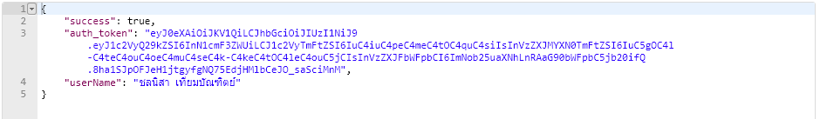

read-project

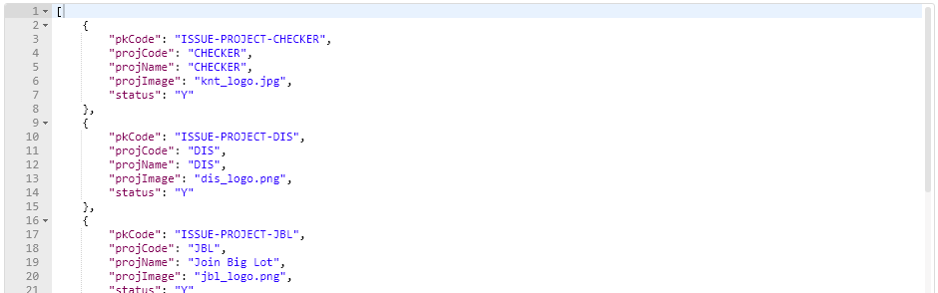

readById-project

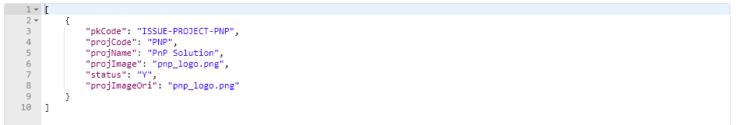

Insert-project

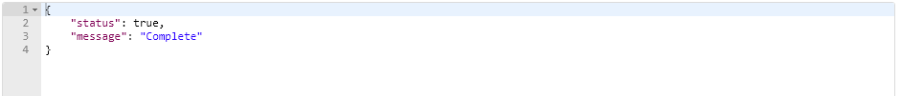

update-project



delete-project

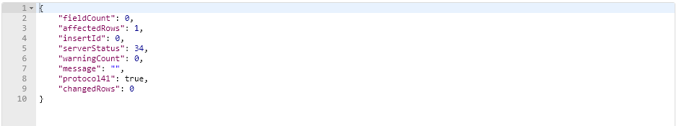

read-pic

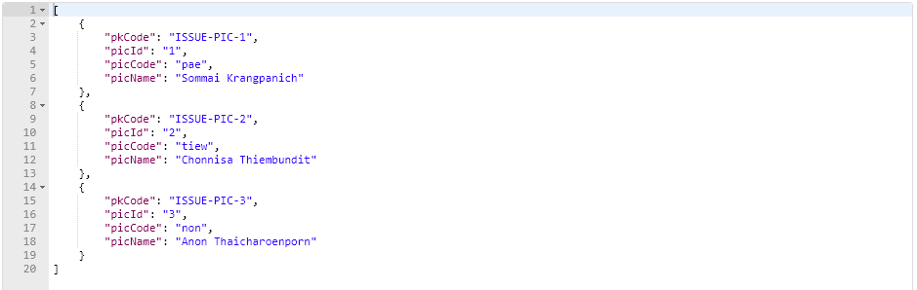

readById-pic

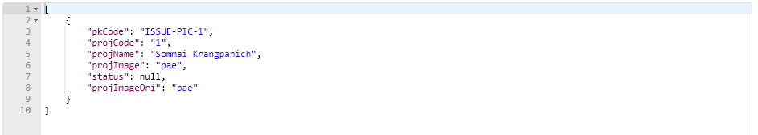

insert-pic



update_pic



delete-pic

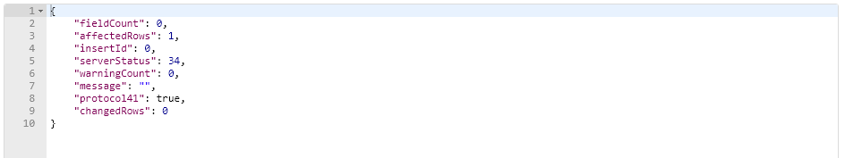

search-issue

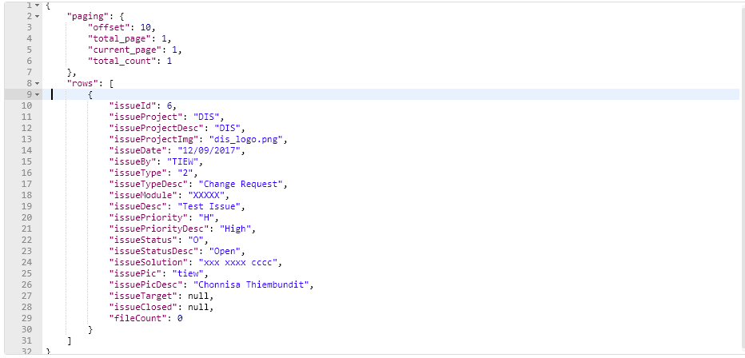

insert-issue

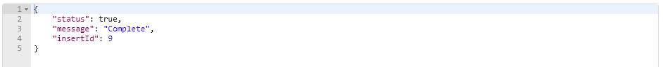

update-issue



findByID-issue

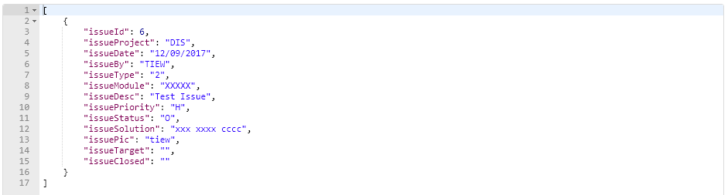

getDataDDL-issue

{

"projectList": [

{

"pkCode": "CHECKER",

"itemCode": "CHECKER",

"itemDesc": "CHECKER",

"itemValue": "knt_logo.jpg"

},{

"pkCode": "DIS",

"itemCode": "DIS",

"itemDesc": "DIS",

"itemValue": "dis_logo.png"

}

],

"priorityList": [

{

"pkCode": "H",

"itemCode": "H",

"itemDesc": "High",

"itemValue": "H"

}, {

"pkCode": "L",

"itemCode": "L",

"itemDesc": "Low",

"itemValue": "L"

}

],

"typeList": [

{

"pkCode": "2",

"itemCode": "2",

"itemDesc": "Change Request",

"itemValue": "2"

}

],

"picList": [

{

"pkCode": "3",

"itemCode": "3",

"itemDesc": "Anon Thaicharoenporn",

"itemValue": "non"

}

],

"statusList": [

{

"pkCode": "C",

"itemCode": "C",

"itemDesc": "Closed",

"itemValue": "C"

}

]

}

getIssueByProject-issue

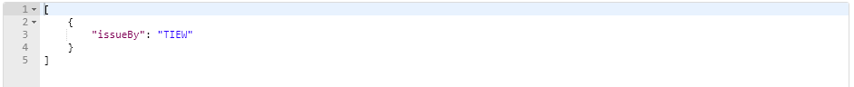

delete-issue

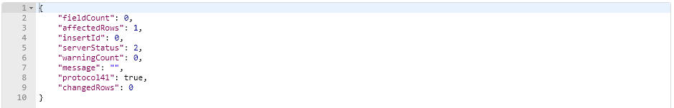

attach-issue

87.PNG

view-attach-issue (view in browser)

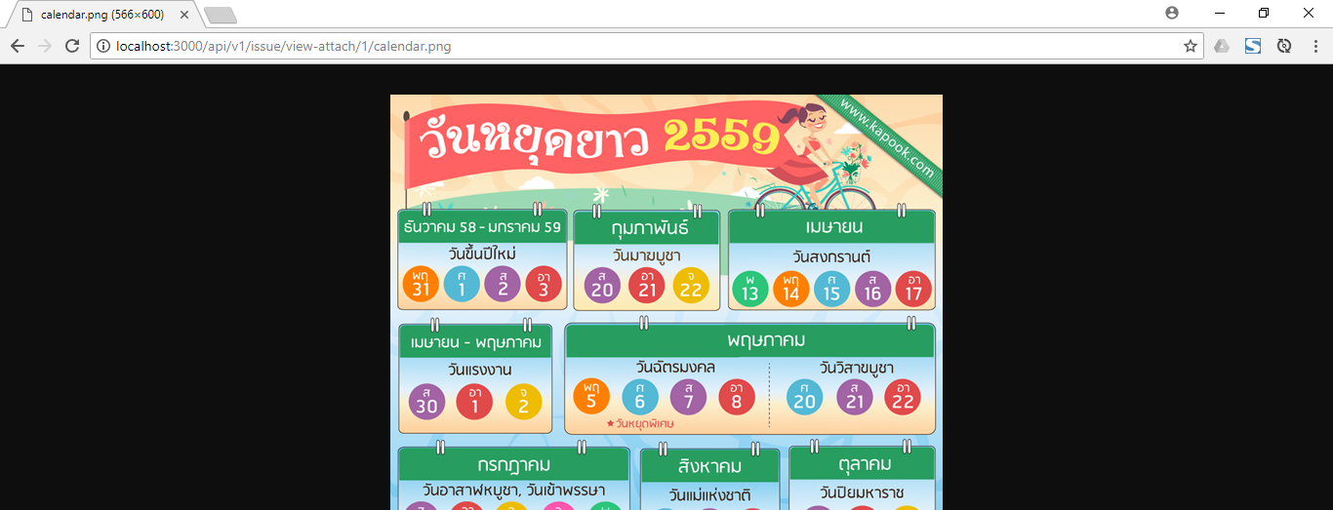

removeFile-issue



read-user

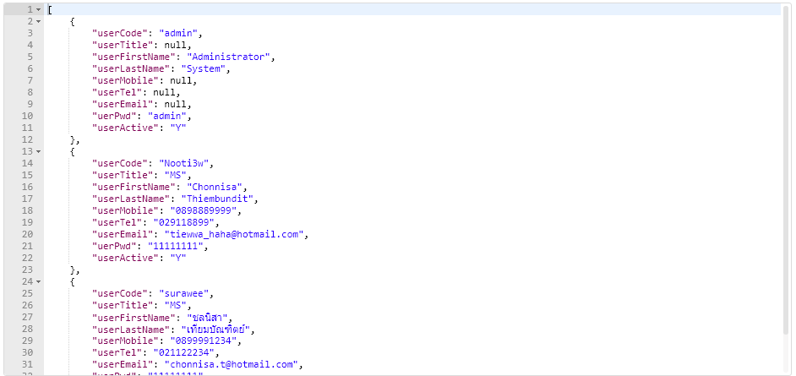

readById-user

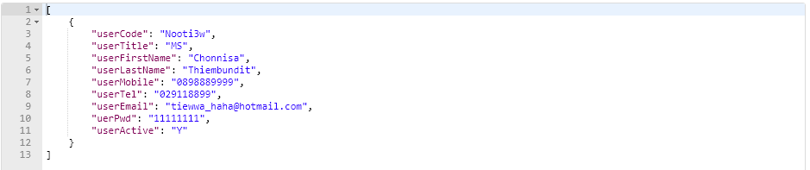

insert-user



update-user



delete-user

