# Azure DevOps shopping-crat Projects

Lets being with the procedure which I had done to execute the project

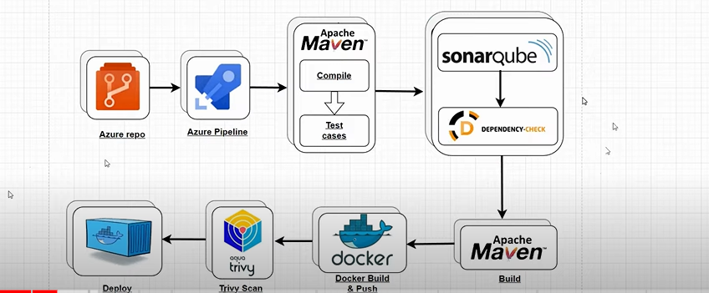

**Agent Creation**

1. Took a virtual machine in azure for execution of project , virtual machine configuration 1gb & 2cpu
2. Logged into dev.azure.com portal & went to project setting , where we have a option to Created agent pool
3. Added agent in agent pool as show in below fig & executed the cmd

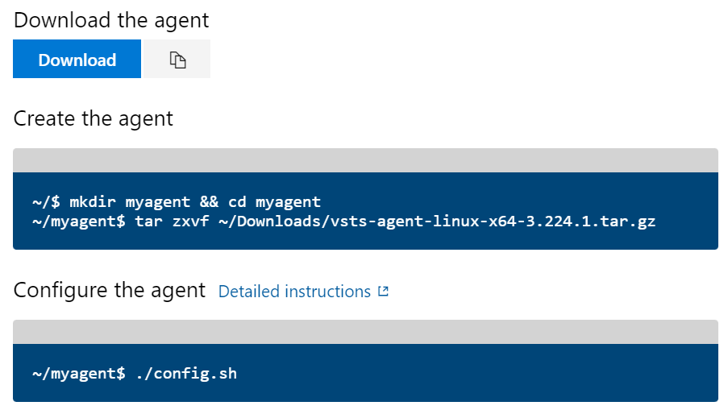

./run.sh 🡺 agent will be online

1. Imported azure repos from github repo’s
2. Created a pipeline lets see how it can be done
3. stage 1: imported from azure repos to pipeline
4. stage 2: build through maven (java-based project for shopping-crat)
5. stage 3: build image through docker-file & run as a container
6. stage 4: took a port number & instance ip to check it & saw application as running

pic shown below will illustrate the process which commands needs to execute

c

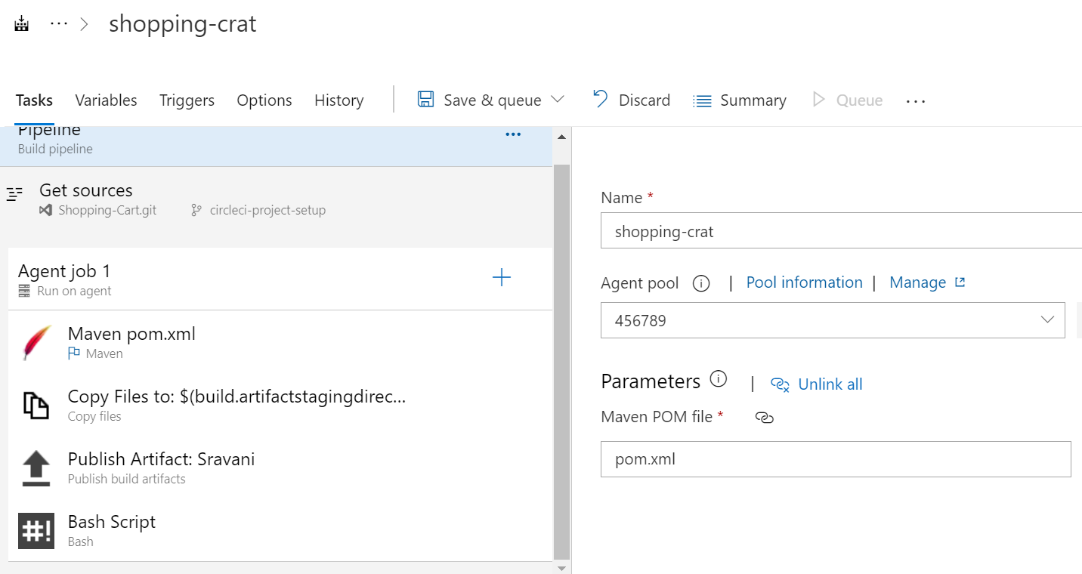

We will get the output as shown below

