
CRM Scope Document
PREPARED BY:
ANGLER TECHNOLOGIES INDIA PVT. LTD
Date: 16.06.2025
Version No 1.0
Doc ID: 9.1: PC /D 05/2.0
PREPARED FOR:
Angler and Trinetra
COMPANY OVERVIEW



ANGLER is an India-based Software ISO 9001 quality-certified company with a committed vision of being a reliable, competitive and Preferred Offshore Development Partner for Software / Technology companies and end-clients in USA, Canada, UK, Europe, Middle East, Singapore, Hong Kong and Australia.
We are a customer-focused company, willing to go the extra mile to ensure customer delight. Discover the unique ways in which we continue to bring in the Best of India offshore Advantage to our global clients in 10 countries around the world.

Awards & Accolades






Business Requirment

The objective is to implement CRM for Angler and Trinetra Sales and Mktg team

Users will be able to post leads generated thru direct and digital marketing

User would be able to update the lead status of each stage from Presales to Order closure

Admin would be able to create credentials and set privileges for all users of the system

Admin should be able to manage masters

Scope of Work

1. Project Overview
This document defines the detailed scope for the CRM system, focusing on both Admin and User features as outlined. The objective is to deliver a robust, user-friendly CRM platform that streamlines lead management, opportunity tracking, campaign management, and reporting, with strong administrative controls and user management.

A. Admin Features
Login Page
- Email address-based authentication.
- "Forgot Password" functionality enabling password reset via email.
Masters
- Company Master:
  - Add, edit, deactivate/activate company records.
- Users Management:
  - Create, edit, deactivate/activate user accounts.
  - Assign users to companies/teams.
- Privilege Management:
  - Define and assign user roles and privileges (e.g., admin, manager, sales rep).
  - Control access to modules and data.
- Presales Stages:
  - Configure and manage presales pipeline stages.
- Activity Type:
  - Define and manage types of activities (e.g., call, meeting, email).
Reports
- Generate and export admin-level reports on:
  - User activity
  - Lead status
  - Opportunity pipeline
  - Campaign performance

B. User Features
Login Page
- Email address-based login.
- "Forgot Password" option for password recovery.
Transaction Modules
- Lead Management:
  - Create, view, edit, and update leads.
  - Assign leads to self or team members.
- Assign Leads to Team:
  - Allocate leads to specific users or teams.
- Campaign Management:
  - Create and manage marketing campaigns.
  - Associate leads and opportunities with campaigns.
- Opportunities Management:
  - Convert qualified leads to opportunities.
  - Track opportunities through various sales stages.
- Activity Management:
  - Schedule, log, and track activities (calls, meetings, emails) related to leads/opportunities.
Dashboard & Reports
- Personalized dashboard displaying:
  - Lead and opportunity pipeline
  - Activity calendar
  - Key performance indicators (KPIs)
- User-level reports (exportable) on:
  - Lead conversion rates
  - Activity completion
  - Campaign effectiveness
Email Notifications
- Automated notifications for:
  - New lead assignments
  - Upcoming/scheduled activities
  - Opportunity stage changes
  - Password resets and system alerts

C. General Features
- Lead Qualification:
  - Assign, prioritize, and score leads based on predefined criteria.
- Lead Conversion:
  - Convert leads to opportunities with a single action.
- Opportunity Management:
  - Drag & drop interface to move opportunities across sales stages.
- Activity Scheduling:
  - Calendar integration for scheduling and reminders of activities.

Disclaimers

OUR DeVELOPMENT PROCESS
We take a structured approach to E commerce web design. Our development process was created to ensure every project is delivered on-time and on-budget. Once your E commerce project kicks off, here's what to expect:

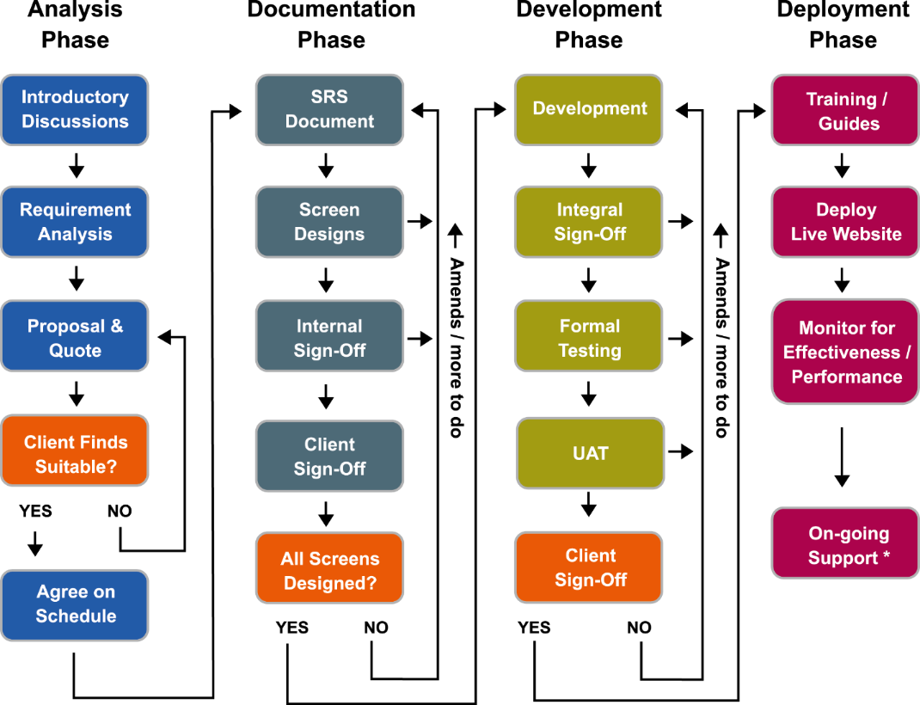

PROJECT COSTING

S.No. |  | Description | Project Cost
 | 1.
 |  | Project Cost in Rs.
 |  | Special Discount on the Customization @10%
 |  | Discounted Project Cost
 |  | GST@18%
 |  | Project Cost with GST

Project Schedule
- We estimate the project will take approximately _ weeks
- The timeline given is tentative based on the High level requirements specified by client. After confirming the SRS, will share the project plan & Timeline

NOTE
1. All rates are valid only for the project in question. These rates are subject to change from time to time to reflect the usage of new tools and/or technologies that might be used and new features incorporated
2. If a client requests components/features which differ in scope/ depth from the features covered in this document, then additional enhancement charges would be applicable
3. The pricing is a ‘special pricing’ considering the possible long-term relationship and the above development costs quoted are lower compared to our regular quotes.
4. The Optional AMC (Annual Maintenance Contract) is <17.5%> payable annually and the start date is applicable from the date of completion of project or client confirmation
5. All textual content and visual images to be provided by the client.

PAYMENT TERMS
- 30% of Project cost in advance
- 30% of Project cost on completion of Visual Prototype
- 30% of Project cost on release for user acceptance testing
- 10% of Project cost within 15 days of final UAT release or project sign off whichever is earlier.

Summary & Next Steps
ANGLER have been working to get our clients up and running with their Digital Transformation solutions, that realizes their business goals in a short span of time and we have repeatedly produced positive business impact for our clients.
A lot of time and careful thought have gone into drafting this business proposal for your company and we are confident our solution will bring cost benefits & value addition for you.

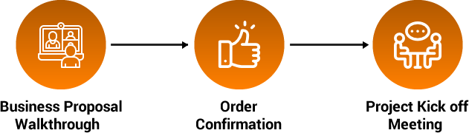

Look forward to working with you
as your long-term
Digital Transformation Partner!

