
ODOO CRM Scope Document
PREPARED BY:
ANGLER TECHNOLOGIES INDIA PVT. LTD
Date: 23.07.2025
Version No 1.1
Doc ID: 9.1: PC /D 05/2.0
PREPARED FOR:
Angler and Trinetra
COMPANY OVERVIEW



ANGLER is an India-based Software ISO 9001 quality-certified company with a committed vision of being a reliable, competitive and Preferred Offshore Development Partner for Software / Technology companies and end-clients in USA, Canada, UK, Europe, Middle East, Singapore, Hong Kong and Australia.
We are a customer-focused company, willing to go the extra mile to ensure customer delight. Discover the unique ways in which we continue to bring in the Best of India offshore Advantage to our global clients in 10 countries around the world.

Awards & Accolades






Business Requirment

The objective is to implement CRM for Angler and Trinetra Sales and Mktg team

Users will be able to post leads generated thru direct and digital marketing

User would be able to update the lead status of each stage from Presales to Order closure

Admin would be able to create credentials and set privileges for all users of the system

Admin should be able to manage masters

Scope of Work

- Project Overview
This document defines the detailed scope for the CRM system, focusing on both Admin and User features as outlined. The objective is to deliver a robust, user-friendly CRM platform that streamlines lead management, opportunity tracking, campaign management, and reporting, with strong administrative controls and user management.
- Admin Features
  - Login Page
- Email address-based authentication
- "Forgot Password" functionality enabling password reset via email
  - Masters
- Company Master
  - Add, edit, deactivate/activate company records
- Users Management
  - Create, edit, deactivate/activate user accounts
  - Assign users to companies/teams
- Privilege Management
  - Define and assign user roles and privileges (e.g., admin, manager, sales rep)
  - Control access to modules and data
- Presales Stages
  - Configure and manage presales pipeline stages
- Activity Type
  - Define and manage types of activities (e.g., call, meeting, email)
  - Reports
- Generate and export admin-level reports on,
  - User activity
  - Lead status
  - Opportunity pipeline
  - Campaign performance
- User Features
  - Login Page
- Email address-based login
- "Forgot Password" option for password recovery
  - Transaction Modules
- Lead Management
  - Create, view, edit, and update leads
  - Assign leads to self or team members
- Assign Leads to Team
  - Allocate leads to specific users or teams
- Campaign Management
  - Create and manage marketing campaigns
  - Associate leads and opportunities with campaigns
- Opportunities Management
  - Convert qualified leads to opportunities
  - Track opportunities through various sales stages
- Activity Management
  - Schedule, log, and track activities (calls, meetings, emails) related to leads/opportunities
- Dashboard & Reports
  - Personalized dashboard displaying
  - Lead and opportunity pipeline
  - Activity calendar
  - Key performance indicators (KPIs)
  - User-level reports (exportable) on
  - Lead conversion rates
  - Activity completion
  - Campaign effectiveness
- Email Notifications
  - Automated notifications for
  - New lead assignments
  - Upcoming/scheduled activities
  - Opportunity stage changes
  - Password resets and system alerts
- General Features
  - Lead Qualification
  - Assign, prioritize, and score leads based on predefined criteria.
  - Lead Conversion
  - Convert leads to opportunities with a single action.
  - Opportunity Management
  - Drag & drop interface to move opportunities across sales stages.
  - Activity Scheduling
  - Calendar integration for scheduling and reminders of activities.
- Logics and other features to include
  - Lead Management & Quadrant Classification
  - Quadrant-based tracking
  - Q1 (Interested): Potential to close in >30 days
  - Q2 (Progressing): Expected to close in 20–30 days
  - Q3 (Warm): Likely to close in 10–15 days
  - Q4 (Hot): High priority, to close in ≤7–10 days
  - Automatic quadrant progression: Flag leads stuck in a quadrant beyond their timeframe (e.g., Q2 lead not progressing after 25 days)
  - BANT Scoring & Data Capture
  - Score leads (1–10) on BANT criteria
  - Budget: Record allocated budget, approval stage
  - Authority: Decision-maker’s role/contact details
  - Need: Pain points, urgency
  - Timeline: Expected closure date
  - Dashboard: Visualize BANT scores alongside quadrant status
  - Call Tracking & Productivity
  - Daily call register: Log calls/visits (target: 100/day) with
  - Lead name, contact, follow-up date, outcome (e.g., "Demo scheduled")
  - Status dropdown: New, Contacted, Demo Scheduled, Proposal Sent, Negotiation, Closed/Won, Lost.
  - Missed call alerts: Highlight days with <100 calls
  - Lead Source Tracking
  - Categorize leads by source
  - Tele calling, Client Referral, Management Referral, Website Inquiry, Others
  - Conversion analytics: Compare close rates by source
  - Reporting & Alerts
  - Stagnant leads: Auto-flag leads stuck in a quadrant (e.g., Q1 >30 days)
  - Performance reports
  - Calls/day, quadrant movement, closure rates
  - Individual/team performance vs. targets
  - Email/SMS reminders: For overdue follow-ups or quadrant transitions
  - Report of individual sales person performance against targets for monthly sales, monthly Q1 to Q4 through a month to date and year to date report, with an option to query performance details from a specific date to a specific date
  - User Interface
  - Simple UI: Tables for Sales person wise leads, forms for call logging, filters by quadrant/source
  - Visual dashboards: Pie charts (lead distribution), bar graphs (calls/day), funnel (quadrant progression)
  - Data
  - Store data to a XL file and provide option for Export and import from Excel files for all users
  - Prioritize ease of use for sales reps with minimal training overhead

DeVELOPMENT PROCESS
We take a structured approach to E commerce web design. Our development process was created to ensure every project is delivered on-time and on-budget. Once your E commerce project kicks off, here's what to expect:

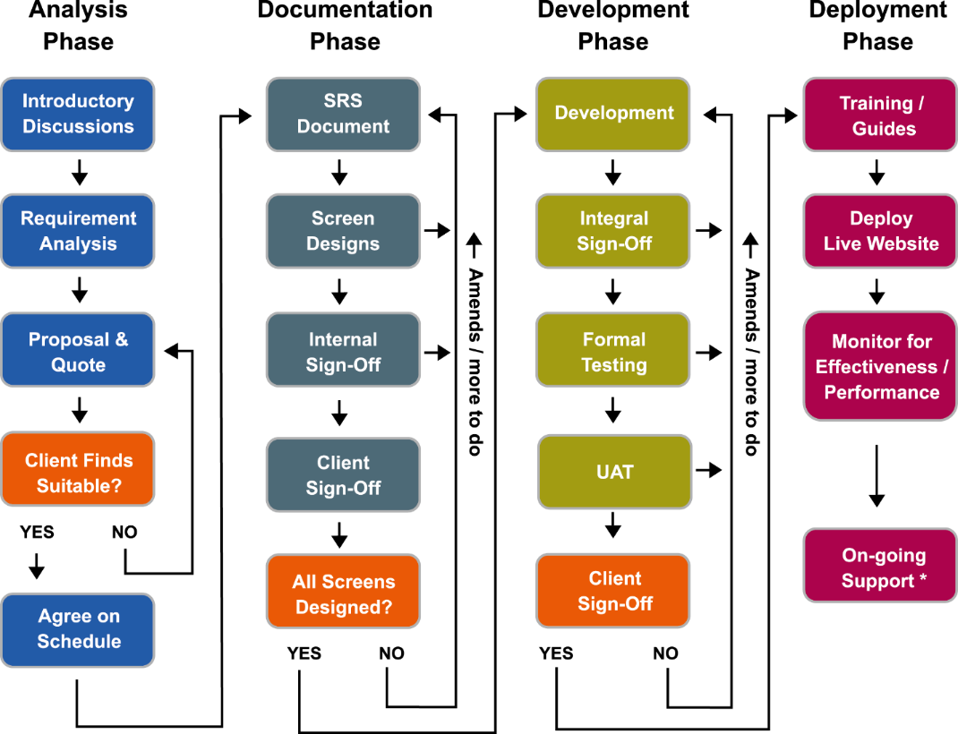

Project Schedule

- We estimate the project will take approximately _ weeks
- The timeline given is tentative based on the High level requirements specified by client. After confirming the SRS, will share the project plan & Timeline

