**Adapting to climate change in small-scale fisheries: a regional study of Pacific North America**

Chapter 2: Impacts of climate change on catch potential and species diversity of Pacific North America’s small-scale fisheries

2.1 Introduction

Climate change will have significant implications for global marine ecosystems and fisheries with multiple studies depicting shifts in species abundance, distributions and catch potentials (Doney et al. 2012; Cheung et al. 2010; Perry et al. 2014). While there is a tendency to take an aggregated approach in studying the effects of climate change on fisheries, the importance of understanding these climate-induced impacts on each sector is essential as small-scale fisheries (SSF) and large-scale fisheries (LSF) have distinctive characteristics, implications and adaptive capacities. Comprehensive understanding of these fisheries sectors under climate change will contribute positively to resource management, and consequently, help inform policies on fisheries, livelihoods and food security.

SSF, encompassing the artisanal and subsistence sectors, account for 90% of employment in the global fishing industry and composes 90% of global fishing vessels (Béné 2006; Chuenpagdee et al. 2006). Studies have demonstrated that SSF have greater positive implications for society and economic viability than its large-scale fisheries (LSF) counterparts (Schuhbauer and Sumaila 2016). Yet, research and policies on SSF are often marginalized by efforts that largely focus on industrial operations (Pauly 2006; Jacquet and Pauly 2008). Therefore, taking a comparative approach in analyzing each sector will illuminate any potential differences in patterns that might otherwise be masked in a cumulative study.

Pacific North America (PNA) is selected as the study region because of its biological and socio-economic importance — it is identified as one of the fourteen ecological significant regions by the Commission for Environmental Cooperation (Morgan et al. 2005). Further, as climate change is known to have a more profound effect across latitudes and as species migrate across national borders, the three countries in the PNA (United States, Canada and Mexico) have an inherently linked ecosystem and hence, an integrated regional focus is necessary to assess overarching trends and effects. Within the PNA region, the definition of SSF are highly varied as these countries and their fisheries have different fishing grounds, historical developments and exploited species. Currently, there is no established global definition for small-scale fisheries, therefore what constitutes SSF in one country could be classified as LSF in another. While there are ongoing efforts towards identifying and establishing common SSF attributes within and across nations (Gibson 2017, FAO 2014), for the purposes of this research, the definitions as established in the Sea Around Us reconstructed reports (Doherty, Gibson, et al. 2015; Ainsworth 2015; Doherty, Harguth, et al. 2015; Cisneros-Montemayor et al. 2013) were used (see Methods).

By taking a species distribution modelling approach, this chapter seeks to quantitatively understand the projected impacts of climate change on the catch potential and species diversity of small-scale fisheries compared to large-scale fisheries in the PNA region. The climate change scenarios applied are based on the Intergovernmental Panel on Climate Change (IPCC)’s representative concentration pathways (RCP) 8.5 and 2.6 – representing a high and low carbon emission scenario respectively (Moss et al. 2010). Such comparative approach can illuminate otherwise hidden trends of projected shifts in catch potential and species diversity from SSF. The results will allow for a more comprehensive understanding of climate change impacts to SSF in the region and inform management decisions.

2.2 Materials and methods

2.2.1 Defining study area of interest and sectors

The study area, Pacific North America, includes four different Exclusive Economic Zones (EEZs): Alaska Sub-Arctic, Canada Pacific, United States Pacific and Mexico Pacific (Figure 1). The EEZs extend up to 200 nautical miles from the territorial sea baseline (CITE) and encompasses an area of X km2. Majority of biomass production occurs in the inshore areas (CITE) and hence, majority of the fishing operations are shown to occur in the EEZs, which is the area of focus in this study.

Small-scale fisheries constitute the artisanal and subsistence sectors, while large-scale sector composes of the industrial sector. As the study captures catch potential, by-catch and discards, where available, were included in the study, however they were accumulated and analyzed alongside landings data. This includes catches of marine finfish and invertebrates.

2.2.2 Historical catch data from the Sea Around Us

Historical marine fisheries catch data for 1990-2010 by sectors were obtained for the 4 EEZs in the PNA region from the Sea Around Us (SAU) databases (www.seaaroundus.org). As globally reported fisheries catch to the Food and Agricultural Organization (FAO) does not account for illegal, unreported catches and discards, Sea Around Us reconstructed catches were utilized for a more comprehensive source of marine fisheries catches. The methodology for the reconstruction of this fisheries data can be accessed in the following reports; (Doherty, Gibson, et al. 2015; Ainsworth 2015; Doherty, Harguth, et al. 2015; Cisneros-Montemayor et al. 2013)

We recognize that small-scale fisheries in different regions of the world may constitute a variety of vessel types and capacities, Sea Around Us methodology states that each countries’ definition is used where possible. When a country’s definition is unavailable, the reports used the Sea Around Us definition of operations in domestic waters, within an Exclusive Economic Zone (EEZ) with a maximum of 50 km off the coast or 200 m depth (whichever comes first) (Zeller et al. 2016). More specifically, the distinction and approaches used to disaggregate SSF and LSF catches for each EEZ in the PNA region is summarized in Table 1.

**Table 1**: Definition of SSF in each EEZ within PNA as identified by SAU reconstruction reports by Doherty et al. (2015), Ainsworth (2015), Doherty et al. (2015b) and Cisneros-Montemayor et al. (2015).

|  |  |
| --- | --- |
| Alaska | SSF are defined by gear type, with small-scale fisheries having non-towed gear, while large-scale fisheries using towed gear. |
| Canada Pacific | SSF are defined by species according to data reported by DFO |
| USA West Coast | Within SSF, subsistence is defined by National Marine Fisheries Services (NMFS) and Washington Department of Fish and Wildlife (WDFW) data and artisanal is split from large-scale commercial catches based on the Sea Around Us definition of a maximum of 50km from the coast or 20m depth. Data is calculated separately by state. |
| Mexico Pacific | Within SSF, subsistence is defined as catch kept for consumption in the household. Artisanal is defined as open deck, outboard or no engine while industrial have covered deck and inboard engines. |

2.2.3 Disaggregation of catch to species level

The fisheries data from the Sea Around Us are reported with taxonomic grouping. Certain catches were already reported to species level (n = 109), however there are classifications that are often reported at higher levels such as at family or genus level. For example, a large portion of the catch is reported as “Miscellaneous marine fishes” or “Perciformes.” These larger classifications are refined to species level using information from literature and databases such as FishBase and SeaLifeBase. This disaggregation was done separately for each EEZ and sector as catch composition and species exploited can vary between countries. For each EEZ, local sources were prioritized and FishBase or SeaLifeBase were used to confirm commercial or subsistence exploitation. Subsequently, catches in higher taxonomic groupings were disaggregated equally between species.

After disaggregation, there were 417 unique species present in the Pacific North America region. For the purposes of this study, the species composing the top 70% of catches in each EEZ and sector were selected for subsequent analysis. These 313 species – comprising of marine fin fishes and invertebrates are summarized in Appendix A1. This analysis is not intended to be complete account of all species exploited by the large-scale and small-scale fisheries in the region, instead a summary of key exploited species in the region to illustrate regional and temporal trends.

2.2.4 Current distributions of species

Knowledge of current species distributions are required to project future changes. Of the 313 species to analyze, 115 species had known distribution ranges previously developed with the detailed algorithm in (Close et al. 2006). The remaining 198 species were modelled following the same methodology in SharpDevelop (Version 3.2). The species and habitat parameters for input into the model are summarized in Appendix A2 with input parameters including species depth, latitudinal range limits and habitat association factors. Based on these input, the SDM created a distribution map for each species. Data for these filters were obtained primarily from FishBase, SeaLifeBase, Encyclopedia of Life and OBIS. For species with limited available parameters, data from other species within the same family group or genus were substituted. The distributions were calculated by applying a set of filters: 1. FAO area; 2. Latitude range; 3. Range-limiting polygons; 4. depth range; 5. Habitat preferences; 6. Equatorial submergence. Range-limiting polygons were drawn in QGIS (version 2.18.9) based on habitat information and ranges from IUCN Red List of Threatened Species (IUCN 2018).

2.2.5 Future distributions using the Dynamic Bio-climate Envelope Model

The Dynamic Bioclimate Envelope Model (DBEM) is used to project future changes in catch potential and spatial distributions for the 313 studied species. The detailed algorithm and methodology can be found in (Cheung, Lam, and Pauly 2008b; Cheung et al. 2009). The model driven by environmental inputs from coupled atmospheric-ocean models (as discussed below), interacting processes (reproduction, survival, migration) and species parameters such as affinity to habitats, depth and latitude ranges (Appendix A2) projects changes for each species on a 0.5 latitudinal and 0.5 longitudinal grid cell (Cheung, Lam, and Pauly 2008a).

2.2.5.2 Representative Concentration Pathways

The DBEM was modelled under the two Representative Concentration Pathways (RCP) scenarios; 8.5 (high emission scenario) and 2.6 (low emission scenario). These RCP scenarios represent the range of projected carbon emission scenarios from (Moss et al. 2010), thus encompassing a range of potential climate change scenarios.

2.2.5.3 Climate Data from Earth System Models

In order to assess the sensitivity of the model to the analysis, two different Earth System Models (ESM) were incorporated. These models represent variations in responses to climate forcing factors, such as aerosols, solar irradiance and mixing of gases (Randall et al. 2007). Therefore, multiple models were applied to improve projections and counter the uncertainty associated with variations in the climate data. One model developed at Geophysical Fluid Dynamics Laboratory (GFDL; (Dunne et al. 2014)) and the other at Institut Pierre Simon Laplace (IPSL; (Dufresne et al. 2013)).

2.2.6 Projections to species’ catch potentials and distributions

2.2.6.1 Processing data for analyses

The disaggregated species-level Sea Around Us catch (from 2.2.3) is applied to the projected changes in catch potential from DBEM (2.2.5) for years 2000 to 2097. The analyses, performed in R (version 1.0.136), were done separately for each type of fishery (large-scale and small-scale), climate models (GFDL and IPSL) and RCP scenarios (8.5 and 2.6), resulting in a spatial projections of future catch potential and species distributions. To account for possible inter-annual and decadal variability (Mantua and Hare 2002; Chavez et al. 2018), a 20-year moving span was averaged, resulting in a time period ranging from 2000 (1991-2010) to 2087 (2080-2097).

2.2.6.2 Changes in species’ catch potential

Using the above processed catch potentials, catch potentials in each EEZ, for each RCP scenario, earth system model and LSF/SSF were plotted in a map to visualize the percentage changes in catch potential between year 2087 and 2000. The top 10 exploited species were also isolated and analyzed separately to observe catch trends.

2.2.6.3 Changes in species’ distributions (richness and turnover)

Subsequently, species diversity (richness) is analyzed for the PNA region. On an individual species basis, the spatial results from above were modified to reflect presence of species (‘1’) and absence of species (‘0’). The difference between future and present can be taken to illustrate the changes in species occurrence in each 0.5 x 0.5 cell. The results can be summed for all species to show the absolute changes within the PNA region.

While species richness shows the change in the absolute number of species in a region, it can fail to capture the turnover of specific species. Species turnover is implemented…

2.3 Results

PNA region

Changes in catch potentials

Overall in the PNA region for the time period 1990-2087, the catch potential for LSF are projected to decline (RCP 2.6: -7.16%; RCP 8.5: -10.7%). Contrastingly, the catch potential for SSF are projected to increase in the same time period (RCP 2.6: +1.65%; RCP 8.5: +16.65%) (Figure 2).

While LSF experiences an overall reduction in its catch potential, on an individual species basis, a majority of LSF species (65.1%) are projected to exhibit increases in its catch potential (RCP 2.6: n = 185; RCP 8.5, n = 173). Likewise, the majority (54.8%) of exploited species by the SSF are projected to increase in its catch potential between 2000 and 2087 (RCP 2.6: n = 134; RCP 8.5, n = 152).

Despite these general increases in catch potentials observed across the majority of exploited species in the PNA region, it is important to note that the results are largely dominated by a few key species in both sectors that constitutes a high proportion of the catch. Figure 3a and 3b illustrates the species composition and aggregated catch potentials between 2000 and 2087 for the top 50% of SSF and LSF catches in the PNA region respectively, with the highlighted bars indicating species unique to that sector. The SSF sector is largely dominated by catches of California market squid (*Loligo opalescens*; 22.1% of catch), Pacific cod (*Gadus macrocephalus*; 19.7%) and Pink salmon (*Oncorhynchus gorbuscha*; 11.9%), while the LSF species are mainly composed of Alaska pollock (*Theragra chalcogramma*; 49.2%), North Pacific hake (*Merluccius productus*; 11.7%) and Pacific cod (*Gadus macrocephalus*; 4.6%).

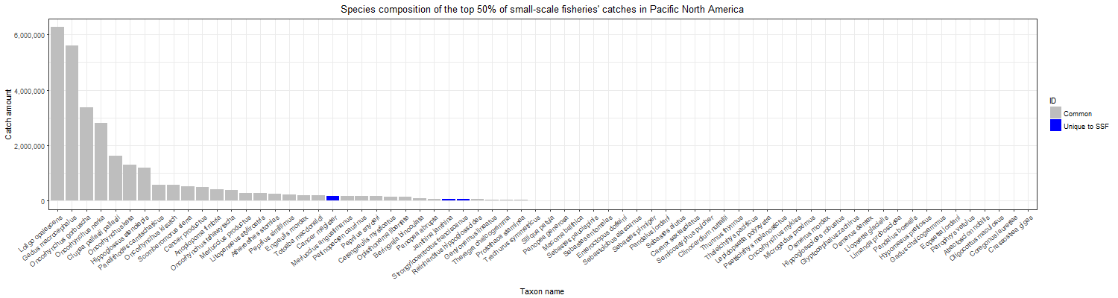

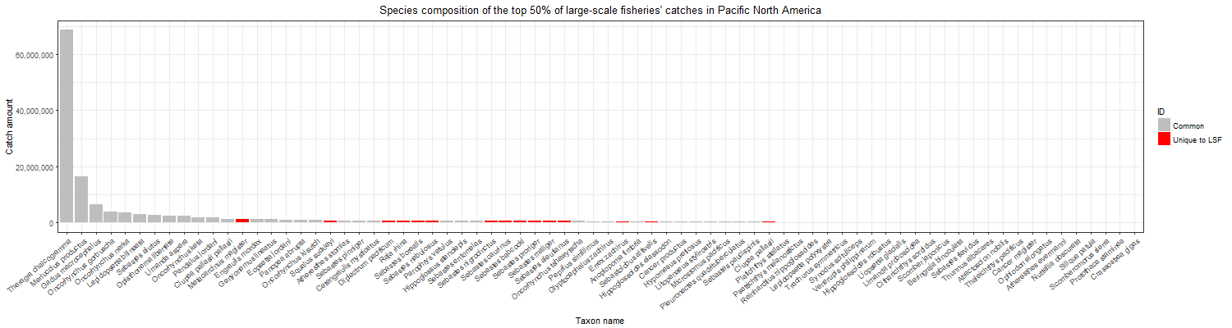

Figure 3. Aggregated top 50% of the catch within the years 2087 and 2000 of the top species exploited in Pacific North America’s EEZ by (a) small-scale fisheries and (b) large-scale fisheries, with blue bars indicating species unique to SSF and red bars indicating species that are unique to the LSF.

Changes in catch potentials for top exploited species

Within these top exploited species, majority in both SSF and LSF in the PNA will also experience increases in catch potential between 2087 and 2000. Only two of the top 10 exploited species by the SSF have projected declines: Pacific cod (*Gadus macrocephalus*) have projected declines in catch potential by -17.6% (RCP 2.6 = -14.3%; RCP 8.5 = -21.0%) and sockeye salmon by X % (RCPXXXXX). The accumulated increase observed in catch potential for the SSF is attributed to the positive changes in catch potential for the other eight top species, such as Pink salmon (*Oncorhynchus gorbuscha*) by 3.47% (RCP 2.6 = -3.57%, RCP 8.5 = 10.5) and California market squid by 52.5% (RCP 2.6 = 21.7%, RCP 8.5 = 83.3%). Similarly, among the top 10 LSF exploited species, all species except for Pacific cod (*Gadus macrocephalus*) by -12.1% (RCP 8.5 = -14.3%, RCP 2.6 = -9.80%) and sockeye salmon by -12.1% (RCP 8.5 = -14.3%, RCP 2.6 = -9.80%) are projected to experience a gain in catch potential between 2000 and 2087. While Pacific thread herring is expected to increase by 15.5% (RCP 2.6 = 18.4%, RCP 8.5 = 12.6%), the top following LSF species will decline as follows: Alaska pollock (*Theragra chalcogramma*) by -2.98% (RCP 8.5 = -5.45%; RCP 2.6 = -0.51%), North Pacific hake (*Merluccius productus*) by -5.76% (RCP 8.5 = -8.15%; RCP 2.6 = -3.36%) and (Figure 4).

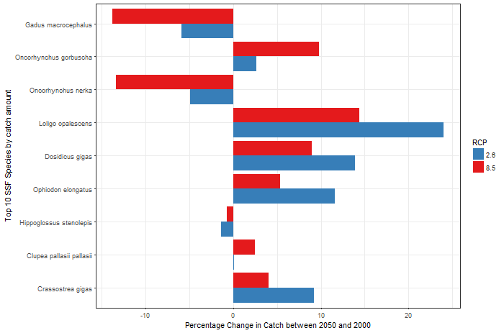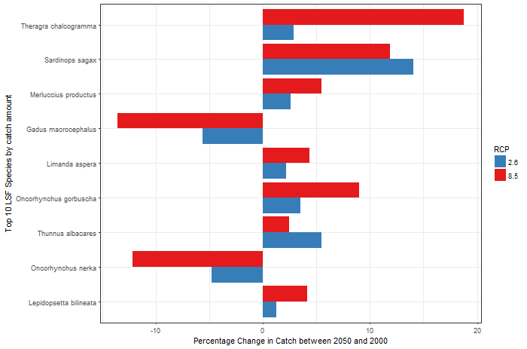

Figure 4. Percentage change in the catch potential of top exploited species in PNA’s EEZ between 2087 and 2000 by (a) small-scale fisheries and (b) large-scale fisheries. Species ranked in order of their catch amount with the species composing the majority of the catch at the top.

It is important to note that there is high overlap (Z species; Z% of total exploited species) in species composition between LSF and SSF in the PNA region as both fisheries operate within the same fishing area. Overall in the PNA region, LSF have 17 unique species composing 0.76% of the total LSF catch, while SSF have 24 unique species composing 1.35% of the total SSF catch. Therefore, the resulting differences we observed in catch potentials between SSF and LSF is attributed to the varying catch amount of exploited species in each sector rather than differences in species composition. As illustrated in Figure 3a and 3b, the top unique species to each sector comprise of a small proportion to the overall catch. For example, in the SSF, top unique species include Common violet snail (*Janthina janthina*; 0.24% of catch), Red sea urchin (*Strongylocentrotus franciscanus*; 0.21% of catch) and Giant Pacific octopus (*Enteroctopus dofleini*; 0.054% of catch) and the top unique species to LSF are the Inshore sand perch (*Diplectrum pacificum*; 0.52%), Shorthead lizardfish (*Synodus scituliceps*; 0.12%) and Green spiny lobster (*Panulirus gracilis*; 0.022%).

Alaska Sub-arctic

Catch Potential

The catch potential in Alaska is strongly correlated with the climate change emission scenario (Figure 5), with the high emission (RCP 8.5) scenario resulting in a strong positive change in catch potential, while the low emission (RCP 2.6) scenario results in a loss of catch potential.

Sectoral comparison reveals that LSF tend to show slight positive changes (RCP 2.6: -0.62%; RCP 8.5: 17.1%) in catch potential over SSF (RCP 2.6: -9.11%; RCP 8.5: 6.69%).

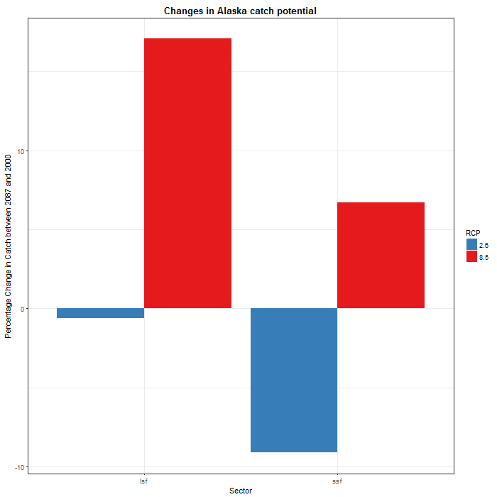

Figure 5. Percentage change in Alaska’s catch potential between 2087 and 2000 for LSF and SSF under Representative Concentration Pathways 2.6 and 8.5.

Analysis on an individual species basis illustrates that the majority of LSF species (76.4%) in Alaska’ EEZ will increase in catch potential (RCP 2.6: n = 185; RCP 8.5, n = 97). Likewise, catch potential will increase for the majority (54.8%) of SSF species (RCP 2.6: n = 134; RCP 8.5, n = 152). These is a distinct variation between RCP scenarios, with notably more species displaying increased catch potentials at RCP 8.5 compared to RCP 2.6.

Catches in the SSF and LSF within Alaska’s EEZ are dominated by a select few species as shown in Figure 6a and 6b respectively. The top exploited SSF species are Alaska pollock (*Theragra chalcogramma*; 66.9% of catch), Pacific cod (*Gadus macrocephalus*; 5.84%) and Sockeye salmon (*Oncorhynchus nerka*; 3.78%) and the top LSF are Alaska pollock (*Theragra chalcogramma*; 67.9%), Pacific cod (*Gadus macrocephalus*; 5.93%) and Sockeye salmon (*Oncorhynchus nerka*; 3.84%).

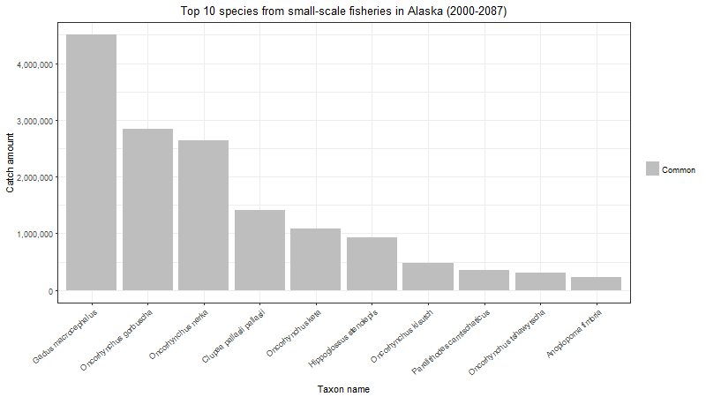

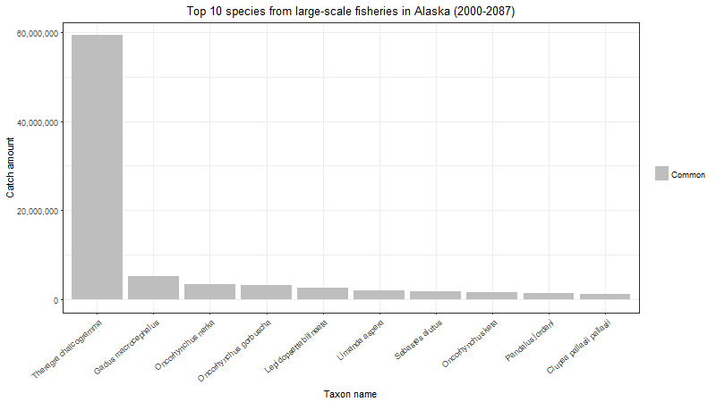

Figure 6. Aggregated catch within the years of 2087 and 2000 of the top species exploited in Alaska’s EEZ by (a) small-scale fisheries and (b) large-scale fisheries.

Further analysis of these top species exploited in Alaska’s EEZ reveals the following projected changes in catch potential for these top 10 species between 2087 and 2000 (Figure 7). Within the SSF, the top exploited species of Pacific cod will decrease (RCP 2.6: -15.0%; RCP 8.5: -22.5%), Pink salmon will increase (RCP 2.6: -1.02%; RCP 8.5: 12.7%) and Sockeye salmon will decrease (RCP 2.6: -9.16%; RCP 8.5: -8.33%). Within the LSF, Alaska Pollock will increase (RCP 2.6: 1.51%; RCP 8.5: 18.7%), Pacific cod will decrease (RCP 2.6: -10.5%; RCP 8.5: -18.7%) and Sockeye salmon will decrease (RCP 2.6: -4.33%; RCP 8.5: -3.77%).

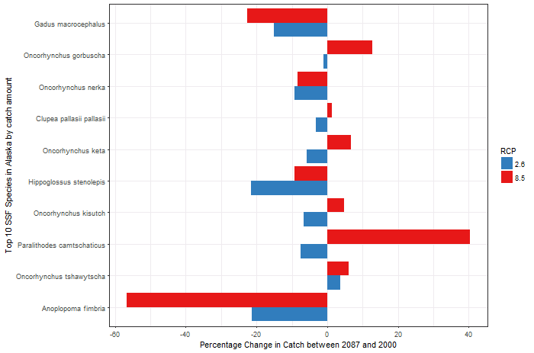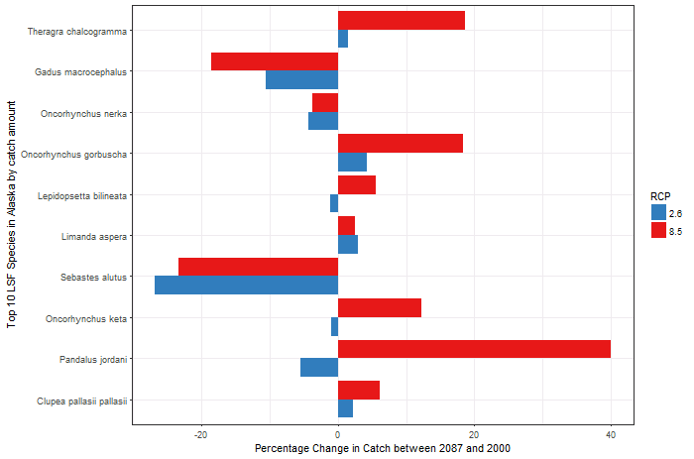

Figure 7. Percentage change in the catch potential of top exploited species in Alaska’s EEZ between 2087 and 2000 by (a) small-scale fisheries and (b) large-scale fisheries. Species displayed in descending order with top exploited species at the top.

Species composition

Similar to species composition at the regional level, there is high overlap (78 species; 99% of total exploited species) in species composition between LSF and SSF in Alaska’s EEZ. The top 10 exploited species in SSF and LSF exclusively consist of common species found in the catch portfolio of both sectors. LSF have 4 uniquely LSF species composing 0.027% of the total LSF catch, while SSF have 5 unique species to the SSF composing 1.49% of the total SSF catch. The top unique species to the SSF are Pink salmon (*Pandalus jordani*; 1.47% of catch), Red sea urchin (*Strongylocentrotus franciscanus*; 0.00164% of catch) and Giant Pacific octopus (*Enteroctopus dofleini*; 0.000431% of catch) and top unique species to LSF are Giant Pacific octopus (*Enteroctopus dofleini*; 0.000437%), Snow crab (*Chionoecetes opilio*; 0.000245%) and Wahoo (*Acanthocybium solandri*; 0.0000000%).

Canada Pacific

Within Canada’s EEZ, overall increases in catch potentials are observed for both sectors, with SSF projected to have a significant increase of 114.9% (RCP 2.6: +31.82%; RCP 8.5: 198%) and LSF with a slightly increase of 0.81% (RCP 2.6: -3.41%; RCP 8.5: 5.02%) (Figure 8).

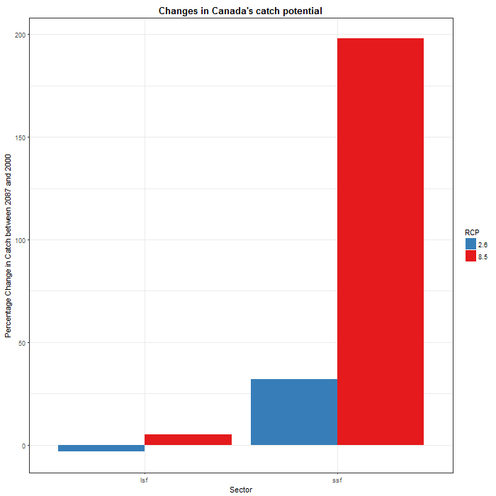

Figure 8. Percentage change in Canada’s catch potential between 2087 and 2000 for LSF and SSF under Representative Concentration Pathways 2.6 and 8.5.

Concurringly, the majority of species in the SSF (54.8%; RCP 2.6: n = 134; RCP 8.5, n = 152) and LSF (65.1%; RCP 2.6: n = 185; RCP 8.5, n = 173) have positive catch potentials.

Catches are dominated by a few selected species, with Figure 9a and 9b illustrating the species composition for the top 50% of catches for SSF and LSF in the PNA region respectively. Notably, the top SSF species are California market squid (*Loligo opalescens*; 41.6% of catch), Pacific cod (*Gadus macrocephalus*; 13.6%) and Pink salmon (*Oncorhynchus gorbuscha*; 7.85%) and the top LSF are Alaska pollock (*Theragra chalcogramma*; 62.3%), Pacific cod (*Gadus macrocephalus*; 5.44%) and Sockeye salmon (*Oncorhynchus nerka*; 3.53%).

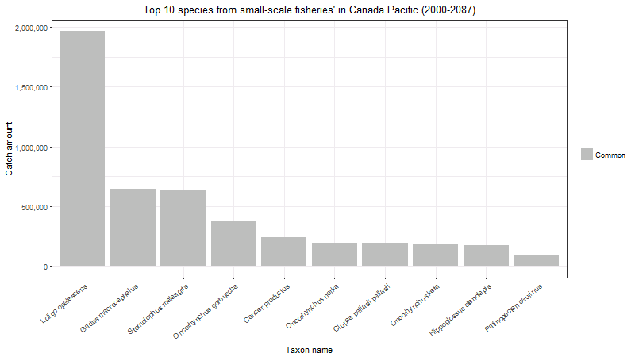

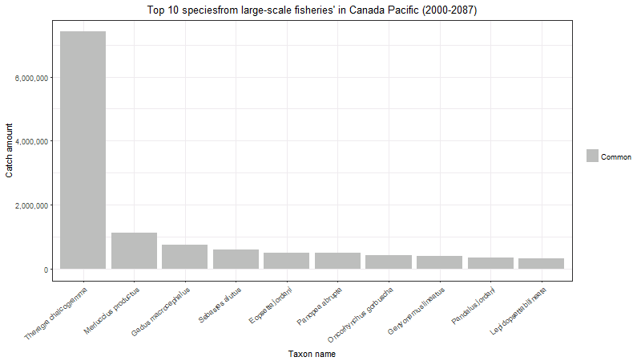

Figure 9. Aggregated catch within the years of 2087 and 2000 of the top species exploited in Canada’s EEZ by (a) small-scale fisheries and (b) large-scale fisheries.

In Canada’s EEZ, there is a projected increase in catch potential of the top exploited species between 2087 and 2000, mainly attributed to the significant growth in catch potential of a selected few species. In the SSF, such species includes the California market squid (RCP 2.6: 160%; RCP 8.5: 794%) and Cannonball jellyfish that both exhibit drastic increases (RCP 2.6: 347%; RCP 8.5: 1652%) in catch potential (Figure 10a). In the LSF, the top species, Alaska pollock will decrease (RCP 2.6: -14.4%; RCP 8.5: -11.1%), North Pacific hake will increase (RCP 2.6: 3.28%; RCP 8.5: 9.61%) and Pacific cod will decrease (RCP 2.6: -12.0%; RCP 8.5: -15.3%) (Figure 10b).

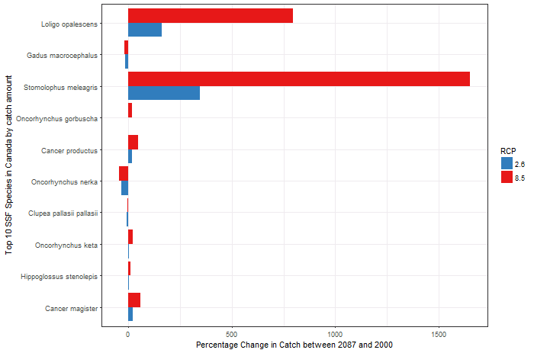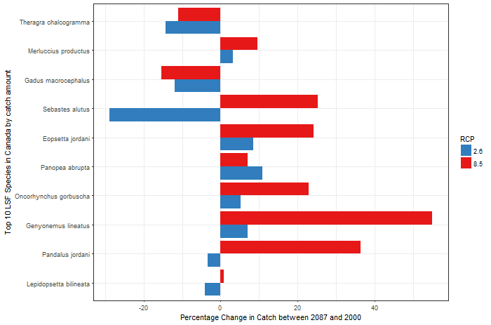

Figure 10. Percentage change in the catch potential of top exploited species in Canada’s EEZ between 2087 and 2000 by (a) small-scale fisheries and (b) large-scale fisheries. Species displayed in descending order with top exploited species at the top.

Similar to regional trends, there is high overlap (90 species; 99% of total exploited species) in species composition between LSF and SSF in Canada’s EEZ. LSF have 6 uniquely LSF species composing 0.21% of the total LSF catch, while SSF have 21 unique species to the SSF composing 2.42% of the total SSF catch. The top unique species compose a small proportion to the overall catches. The top unique species to the SSF are Red sea urchin (*Strongylocentrotus franciscanus*; 0.236% of catch), Pink salmon (*Pandalus jordani*; 0.0495% of catch) and Giant Pacific octopus (*Enteroctopus dofleini*; 0.0446% of catch) and top unique species to LSF are Sebastes borealis 0.518, Sebastes nigrocinctus 0.5119, Sebastes nebulosus 0.501,

USA West Coast

USA

Changes in projected catch potentials in USA West Coast’s EEZ is strongly correlated with fisheries sector (Figure 11). Particularly, LSF will largely experience a decline in catch potential of -9.23% (RCP 2.6: -6.25%; RCP 8.5: -12.2%) while SSF will increase by 9.69% (RCP 2.6: +9.11%; RCP 8.5: +10.26%).

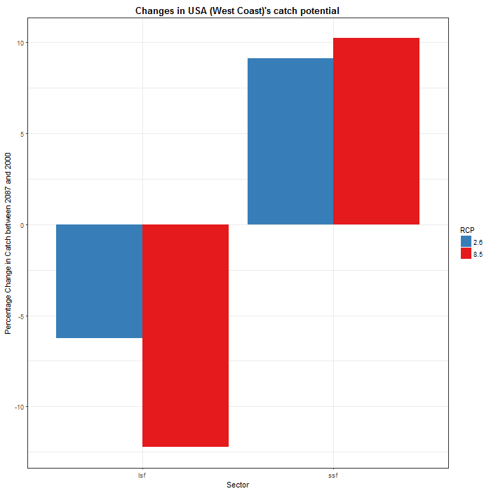

Figure 11. Percentage change in USA’s catch potential between 2087 and 2000 for LSF and SSF under Representative Concentration Pathways 2.6 and 8.5.

While LSF experiences an overall decrease in catch potential, on an individual species basis, a majority of LSF species (58.5%) will increase in catch potential (RCP 2.6: n = 134; RCP 8.5, n = 135). SSF catch potential will decrease for the majority (55.7%) of species (decreases in RCP 2.6: n = 117; RCP 8.5, n = 123).

The increase we observe in SSF is attributed to the positive catch potentials for a few key species exploited in high amounts, as discussed later in this section. These comprises of California market squid (*Loligo opalescens*; 65.3% of catch), Pacific cod (*Gadus macrocephalus*; 9.74%) and Pink salmon (*Oncorhynchus gorbuscha*; 3.63%) (Figure 12a). Figure 12b illustrates the species composition for the top 10 species exploited by the LSF in the PNA region respectively, with the highlighted bars indicating species unique to that sector. These top LSF includes North Pacific hake (*Merluccius productus*; 45.8%), Alaska pollock (*Theragra chalcogramma*; 23.7%) and California anchovy (*Engraulis mordax*; 4.54%).

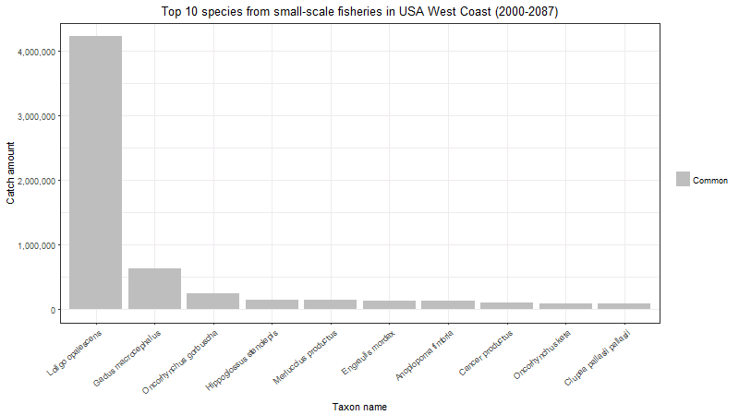

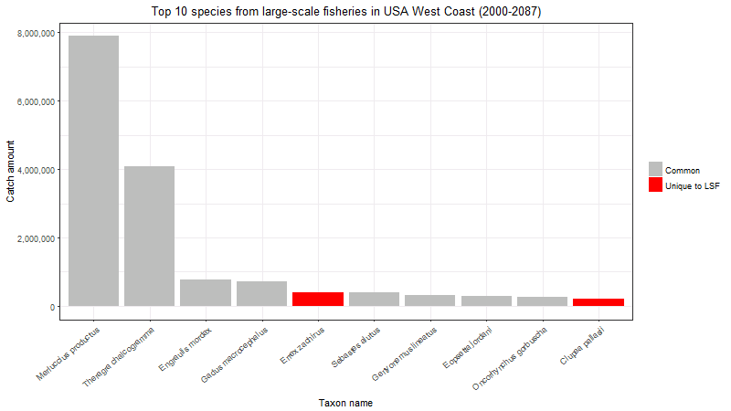

Figure 12. Aggregated catch within the years of 2087 and 2000 of the top species exploited in USA’s EEZ by (a) small-scale fisheries and (b) large-scale fisheries, with red bars indicating species that are unique to the LSF.

Within USA West Coast’s EEZ, top exploited species display varying effects in catch potentials (Figure 13). In the SSF, California market squid exhibit strong increases (RCP 2.6: 20.2%; RCP 8.5: 28.0%) in catch potentials while Pacific cod (RCP 2.6: -7.53%; RCP 8.5: -10.6%) and Sockeye salmon (RCP 2.6: -26.4%; RCP 8.5: -12.0%) have projected declines. In the LSF, top exploited species tend to exhibit declining trends in catch potentials, with North Pacific hake (RCP 2.6: -20.7%; RCP 8.5: -21.5%), Alaska Pollock (RCP 2.6: -6.21%; RCP 8.5: -6.64%) and Californian anchovy (RCP 2.6: 5.80%; RCP 8.5: -9.72%) declining overall.

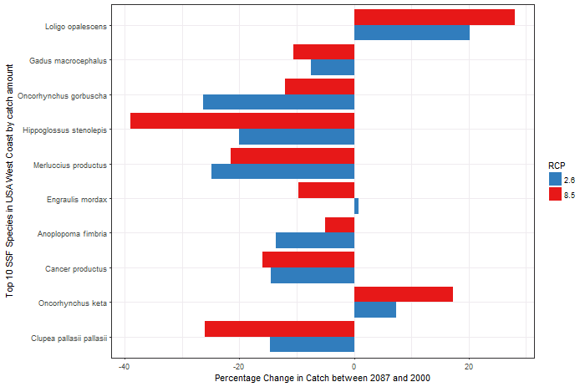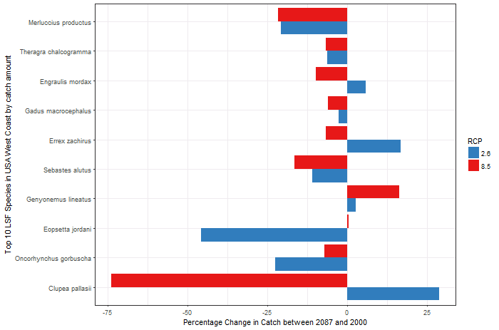

Figure 13. Percentage change in the catch potential of top exploited species in USA’s EEZ between 2087 and 2000 by (a) small-scale fisheries and (b) large-scale fisheries. Species displayed in descending order with top exploited species at the top.

There is high overlap (110 species; 98% of total exploited species) in species composition between LSF and SSF in the Alaska EEZ. LSF have 14 uniquely LSF species composing 1.40% of the total LSF catch, while SSF have 21 unique species to the SSF composing 1.97% of the total SSF catch. The top unique species to the SSF are Common violet-snail (*Janthina janthina*; 1.05% of catch), Red sea urchin (*Strongylocentrotus franciscanus*; 0.0950% of catch) and Shortspine thornyhead (*Sebastolobus alascanus*; 0.0410% of catch) and top unique species to LSF are Curlfin sole (*Pleuronichthys decurrens*; 0.0265%), Bluefin shark (*Prionace glauca*; 0.0137%) and Pronghorn spiny lobster (*Panulirus penicillatus*; 0.00898%).

Mexico Pacific

Mexico

While on average, the catch potential of SSF is projected at a slight negative value of -1.16% (RCP 2.6: 8.85%; RCP 8.5: -11.16%) and LSF at a -0.01% (RCP 2.6: 10.58%; RCP 8.5: -10.6, changes in LSF and SSF’s catch potentials are strongly dependent on the carbon emission scenario (Figure 14). RCP 2.6 projects positive catch potentials in both SSF and LSF, where else RCP 8.5 produces declines.

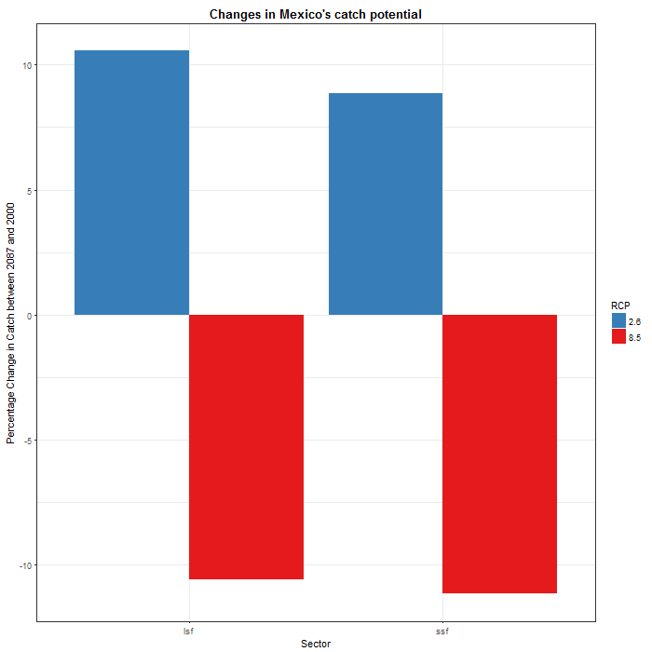

Figure 14. Percentage change in Mexico’s catch potential between 2087 and 2000 for LSF and SSF under Representative Concentration Pathways 2.6 and 8.5.

Furthermore, changes in catch potential of individual species are largely dependent on the RCP scenarios. In the high emission scenario (RCP 8.5) for both SSF and LSF, we observe that majority of species will decline (by 56.8% in SSF; n = 121 and by 52.2% in LSF; n = 117). Contrastingly, in the low emission scenario (RCP 2.6), there are projected increases in the majority of exploited species in both sectors (by 53.3% in SSF; n = 112 and by 65.8% in LSF; n = 146).

Figure 15a and 15b illustrates the species composition for the top 10 of catches for SSF and LSF in Mexico’s EEZ respectively, with the highlighted bars indicating species unique to that sector. The top SSF species are California market squid (*Loligo opalescens*; 26.5% of catch), Pacific sierra (*Scomberomorus sierra*; 17.5%) and Blue shrimp (*Litopenaeus stylirostris*; 8.83%) and the top LSF species are North Pacific hake (*Merluccius productus*; 59.2%), Pacific thread herring (*Opisthonema libertate*; 17.7%) and Pacific anchoveta (*Cetengraulis mysticetus*; 4.91%).

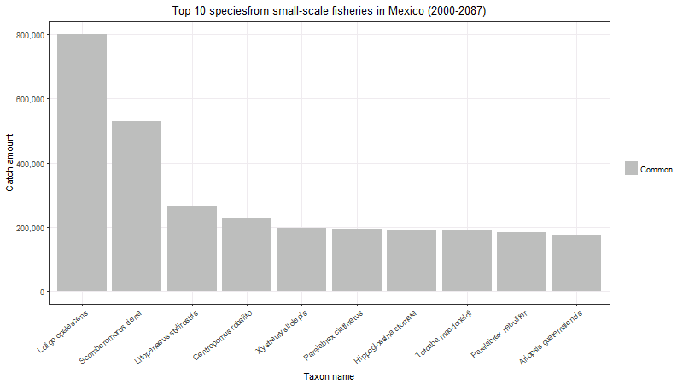

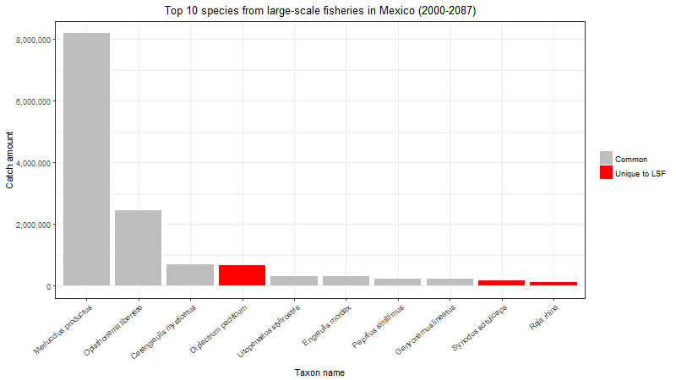

Figure 15. Aggregated catch within the years of 2087 and 2000 of the top species exploited in Mexico’s EEZ by (a) small-scale fisheries and (b) large-scale fisheries, with red bars indicating species that are unique to the LSF.

Within Mexico’s EEZ, the top exploited species exhibit the following changes in catch potential (Figure 16). In SSF, California market squid show declines (RCP 2.6: -17.8%; RCP 8.5: -70.7%) while Pacific sierra (RCP 2.6: 28.9%; RCP 8.5: 20.8%) and Blue shrimp (RCP 2.6: 25.5%; RCP 8.5: 10.5%) show increases. In the LSF, North Pacific hake exhibits changes based on RCP scenarios (RCP 2.6: 7.36%; RCP 8.5: -12.5%), while Pacific thread herring (RCP 2.6: 18.4%; RCP 8.5: 1.73%) and Pacific anchoveta (RCP 2.6: 17.6%; RCP 8.5: 1.98%) show increases in catch potentials.

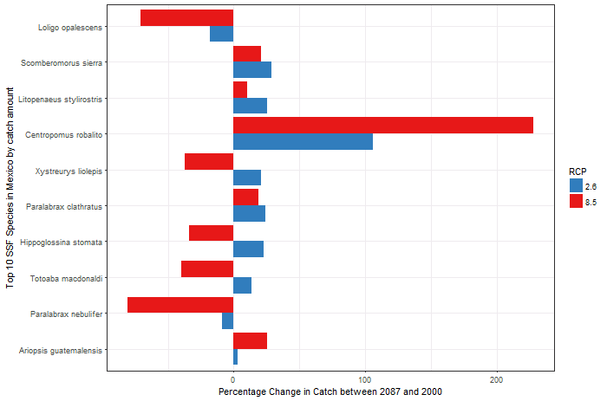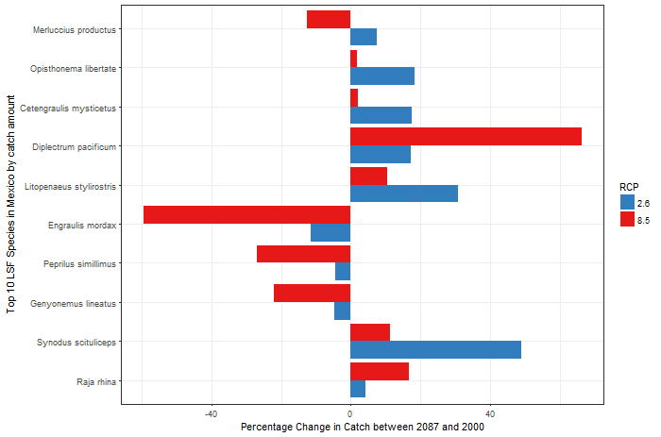

Figure 16. Percentage change in the catch potential of top exploited species in Mexico’s EEZ between 2087 and 2000 by (a) small-scale fisheries and (b) large-scale fisheries. Species displayed in descending order with top exploited species at the top.

A 98% overlap (92 species) in exploited species is observed between LSF and SSF in Mexico’s EEZ. LSF have 16 uniquely LSF species composing 6.5% of the total LSF catch, while SSF have 7 unique species to the SSF composing 0.56% of the total SSF catch. Top unique species to the SSF are Bigeye scad (*Selar crumenophthalmus*; 11.7% of catch), Giant Pacific octopus (*Enteroctopus dofleini*; 11.2% of catch) and Pacific calico scallop (*Argopecten ventricosus*; 0.0693% of catch) and top unique species to LSF are Inshore sand perch (*Diplectrum pacificum*; 4.74%), Shorthead lizardfish (*Synodus scituliceps*; 1.14%) and Longnose skate (*Raja rhina*; 0.83%).

Changes in catch potential by RCP scenario

On a regional level, comparisons between RCP scenarios in both LSF and SSF suggest that RCP 8.5 experiences a greater degree of change (27% change = -11% to +16% change) while RCP 2.6 results in less variability in effects (9% change = -7% to +2% change). Furthermore, analysis on an annual basis reveals that while RCP 2.6 show overall increases in catch potential at the beginning of the time period (2000-2030/2070), ultimately RCP 8.5 produces greater positive percentage changes towards the end of the time period (2030/2070-2089) (Figure 17).

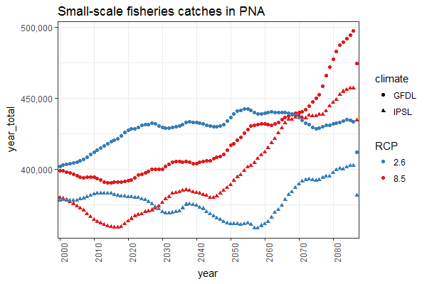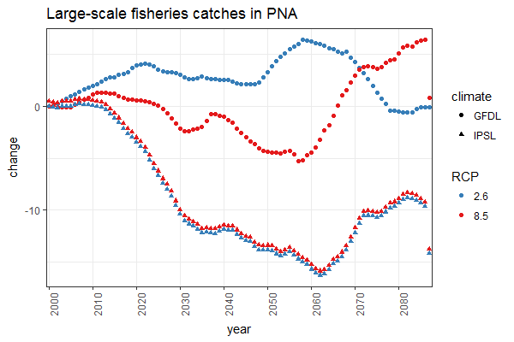

Figure 17. Time series plot illustrating changes (%) in catch potential relative to 2000 for PNA region under low (RCP 2.6) and high (RCP 8.5) climate change scenario under two earth system models (GFDL and IPSL) for (a) small-scale fisheries and (b) large-scale fisheries.

Changes in catch potential by latitude

There is a strong positive correlation between catch potential and latitudes for both SSF and LSF in the high emission scenario, RCP 8.5. The relationship is less apparent in the low emission scenario of RCP 2.6 (Figure 18).

* Changes in lat of top exploited spp (in species distr section)

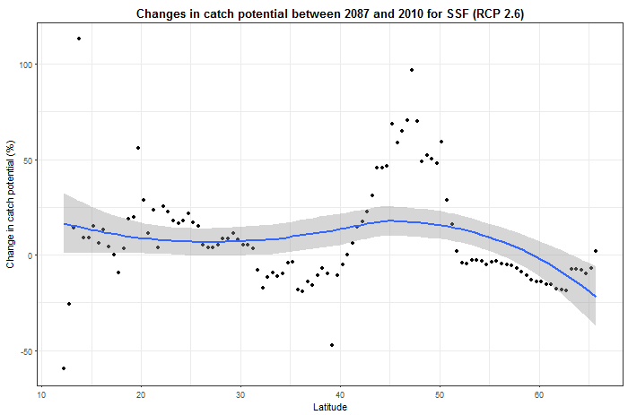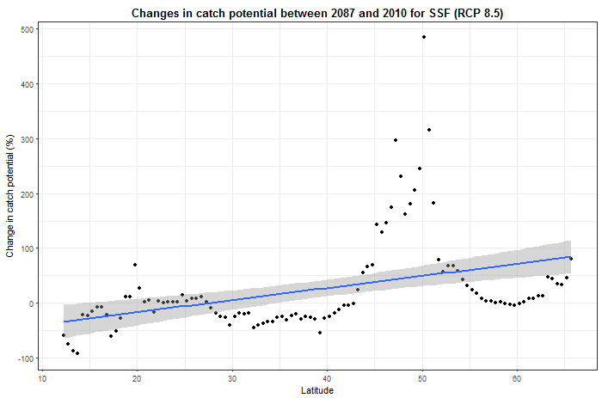

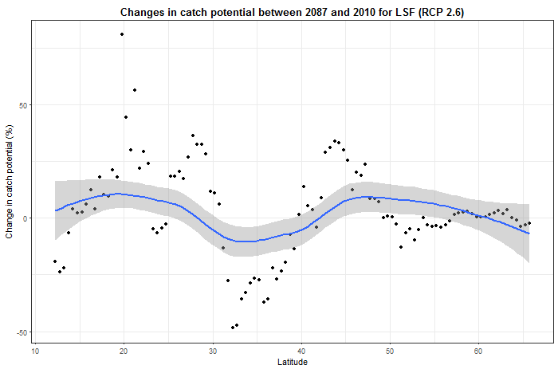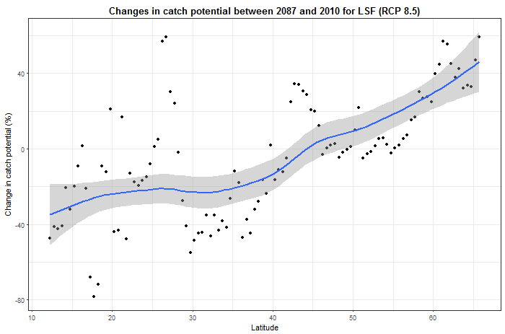

Figure 18. Relationship between changes in catch potential (%) in PNA between 2087 and 2000 and latitudes for (a) small-scale fisheries under low (RCP 2.6) emission scenario, (b) small-scale fisheries under high (RCP 8.5) emission scenario, (c) large-scale fisheries under low (RCP 2.6) emission scenario, (d) large-scale fisheries under high (RCP 8.5) emission scenario. High emission scenario exhibiting a positive correlation while low emission scenario has variable effects.

Changes in catch potential by Earth System Model

IPSL tend to yield catch potentials on the lower end/more negative while GFDL produced results with higher magnitude of catch potential (Figure 19).

2.3.2 Impacts to species richness and diversity

PNA

Overall, the comparison of 2087 to 2000, reveals that there is a projected decline in species richness across the PNA region (Figure 20). This equates to a -3.5% decrease in LSF at RCP 2.6 and a larger decline of -4% in LSF at RCP 8.5. Contrastingly in SSF, a greater decline (-4%) in species richness is seen at RCP 2.6 compared to a -2.5% reduction at RCP 8.5. While there is a general loss of species across the PNA region, further analysis within each EEZ can reveal additional insights.

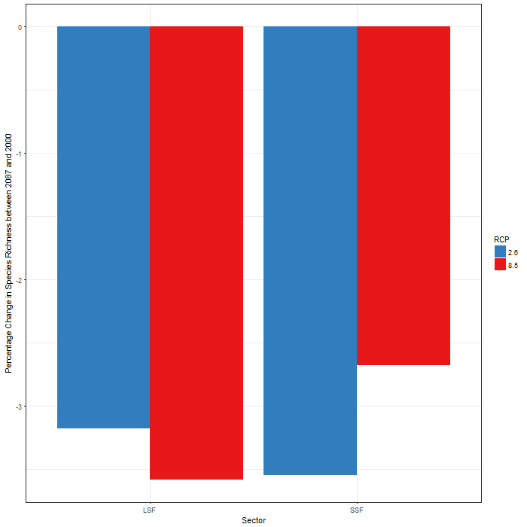

Figure 20. Projected changes (%) in species richness between 2087 and 2000 for LSF and SSF in PNA for lower (RCP 2.6) and upper (RCP 8.5) climate change scenarios.

For example, increase in species richness is observed in Canada (RCP XXXX) and Alaska (RCP XXXXXXX)’s EEZs. Although

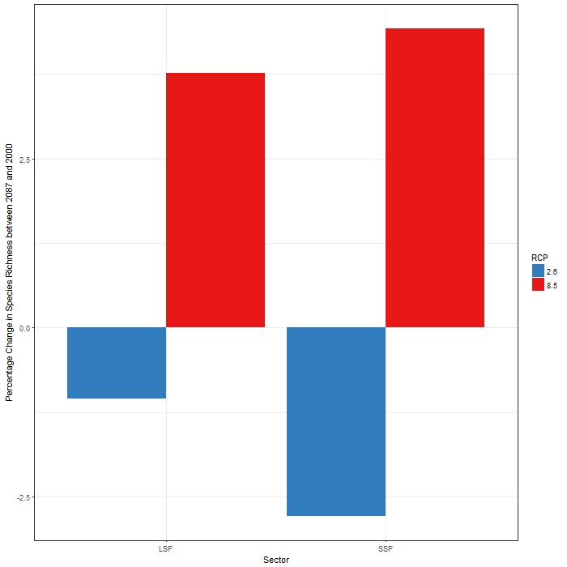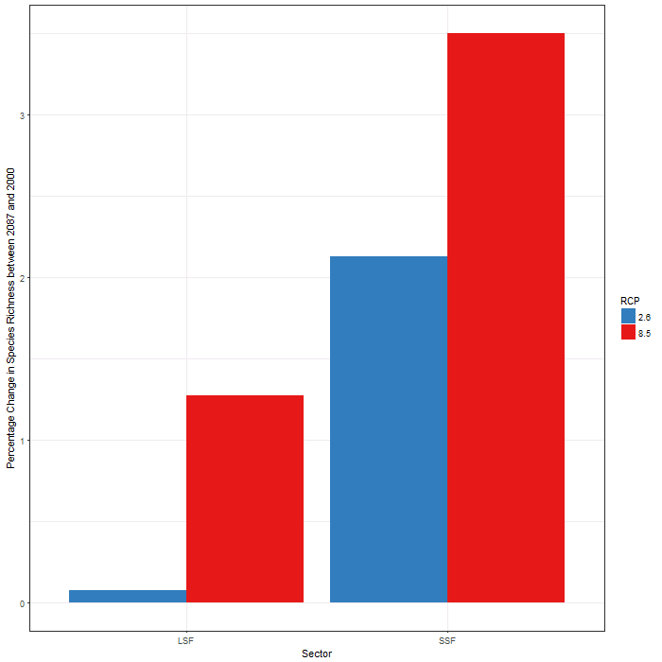

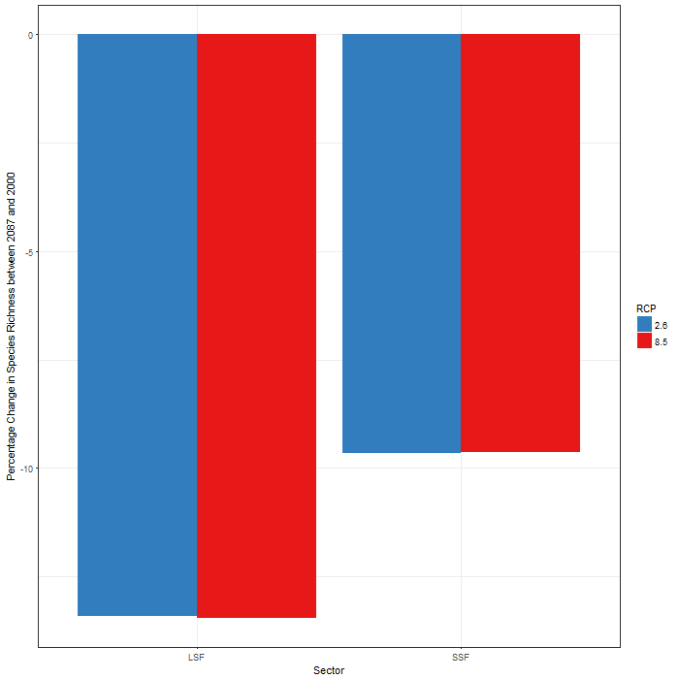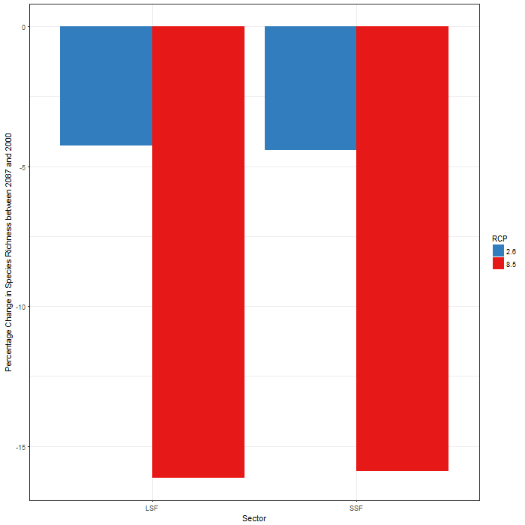

Figure 21. Projected changes (%) in species richness between 2087 and 2000 for LSF and SSF under lower (RCP 2.6) and upper (RCP 8.5) climate change scenarios for the EEZs of (a) Alaska, (b) Canada, (c) USA and (d) Mexico.

Figure 22 presents the spatial changes in species richness across the PNA region for both SSF and LSF. Taken cumulatively, spatial projections of the changes in species richness illustrate significant losses in Mexico’s EEZ and complementary gains in Alaska’s EEZ in the RCP 8.5 scenario compared to the RCP 2.6 scenario. While less apparent visually, SSF (Figure 22; top) tend to have more positive changes in species richness in Canada’s EEZ than LSF (Figure 22; bottom), as indicated in blue.

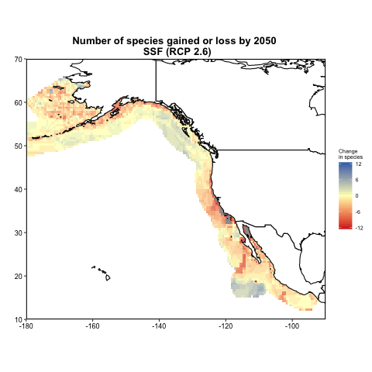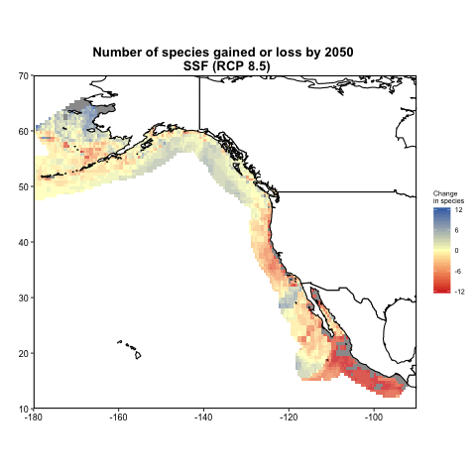

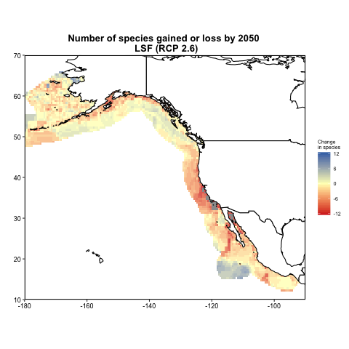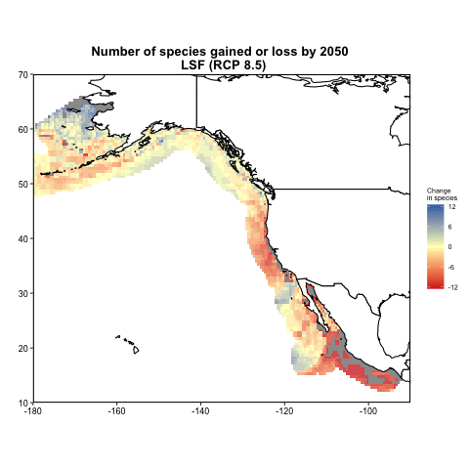

Figure 22. Maps of PNA region illustrating changes in number of species from 2087 relative to 2000 for (a) small-scale fisheries under low (RCP 2.6) emission scenario, (b) small-scale fisheries under high (RCP 8.5) emission scenario, (c) large-scale fisheries under low (RCP 2.6) emission scenario, (d) large-scale fisheries under high (RCP 8.5) emission scenario. High emission scenario exhibiting greater loss at lower latitudes and gains at higher latitudes compared to the low emission scenario.

3. Discussion

3.1 Implications to PNA fisheries

Results from this study projects declining relative catch potential for LSF and increased catch potentials for SSF in the PNA region. This trend is more evident in the high emission scenario (RCP 8.5) compared to the low emission scenario (RCP 2.6), potentially as environmental conditions are more exacerbated in RCP 8.5. There is extensive similarity in exploited species between SSF and LSF across the region, therefore this variation in the impacts of climate change is largely attributed to the degree in which exploited species are caught in each sector. Evidently, compared to LSF in the PNA region, SSF are exploiting more species with a higher degree of positive changes in catch potentials, and at greater relative amounts, such as California market squid. Arguably, LSF do have the capacity to catch these highly positive catch potential species at greater catch volumes, as they are presently already exploiting these species. Future studies exploring the impacts of the continued and extended exploitation of these specific highly positive catch potential species by the SSF and the increasing exploitation of these species by the LSF would be informative in climate change adaptation strategies. There is also an overall decreasing species richness across the PNA region. The results summarized above are overarching regional patterns, however there are varying effects within EEZs. In some EEZs, the predominant difference in results is attributed to sectoral variations (Alaska, Canada, USA). While in other EEZs sector differences are slight, but produce drastically different results based on RCP scenario (Alaska, Mexico).

Aggregation of catches in Alaska’s EEZ depicts LSF to generate more positive catch potentials than SSF. Further comparison of the top 10 exploited species reveals significant overlap in species between SSF and LSF, except for the high exploitation of Alaska Pollock in LSF which does not occur in significant amounts in SSF. Alaska Pollock, projected to increase drastically under both climate change scenarios, is a key species in the region with multiple interactions and predator-prey relationships. Drastic increase in the catch potential of this species is the attributing factor in the projected gains of LSF. It is a key prey of marine mammal and sea birds and consequently has been demonstrated to fluctuate with its population. As it consumes prey and crustaceans, dramatic increases in Alaska Pollock can directly compete with other fisheries in the region (A’mar, Punt, and Dorn 2018). Studies have documented that certain climate induced changes such as higher precipitation in the Gulf of Alaska can cause more eddies which have positive implications for the survival of juveniles Pollock (Bailey et al. 2005). Furthermore, the RCP 8.5 scenario results in higher catch potentials compared to RCP 2.6. This could be attributed to higher species richness in the RCP 8.5. Perhaps the higher emission scenario creates more extreme environmental conditions which opens new and otherwise previously inaccessible habitats for adaptable exploited species.

In Canada’s EEZ, the key differences lie within the sectors, with SSF projected to outperform LSF in catch potentials in the future. The success of SSF in Canada can be directly attributed to two species: California market squid and Cannonball jellyfish, with the other top species ranking around a neutral or slight negative catch potential. At present, California market squid is a significant fishery in the United States, composing one of the three-fold Monterrey Bay shifting wetfish fishery, shifting between the exploitation of the market squid, Pacific sardine (*Sardinops sagax*) and northern anchovy (*Engraulis mordax*) (Aguilera et al. 2015). Market squid populations are particularly sensitive to environment changes, with dramatic documented fluctuations in population size (Koslow and Allen 2011). Thus, deeming this to be a relatively unreliable fishery which should be considered with caution. Despite this, in the 1990s, the market squid became the largest fishery in California by revenues and landings (Koslow and Allen 2011). While Canada’s SSF does not presently exploited squid in such high amounts, the potential for expansion and development of this fishery as an adaptation strategy may be possible, especially with the notably declines that are projected for other currently exploited top species such as Pacific herring and salmon species. This warrants further analysis and community based research, especially as these species have cultural significance and provide ecosystem services. The results are in line with other climate change and species distributions studies in the region, that projects decline for Pacific herring, eulachon and salmon species in Canada (Weatherdon et al. 2016). However, these significant fisheries to First Nations communities in British Columbia, tend to be masked by larger exploitations of species in the region.

Likewise, increases in catch potentials in Cannonball jellyfish is also documented in Canada’s EEZ. Largely catered towards an Asian market, its range has been noted to expand towards North American waters, generating almost 3.5 million US$ in revenue and holds potential for expansion (Agencias 2013) (Girón-Nava, López-Sagástegui, and Aburto-Oropeza 2015). Furthermore, in the case of SSF, RCP 8.5 appears to create significantly higher catch potential compared to RCP 2.6; attributing to the differences in catch potential of market squid and cannonball jellyfish between the two scenario. The lack of growth in catch potentials of LSF is attributed to declines in Alaska Pollock. While it appears that Alaska Pollock has positive catch potential implications for Alaska, its appears to decline in Canadian waters, an indication of shifting ranges. Other top exploited species of LSF have documented increases such as North Pacific hake and Pink salmon, therefore, diverting catch portfolio away from Alaska Pollock and towards these species could be explored as a strategy. Finally, projections of LSF’s catch potential appears to only vary slightly between RCP scenarios, owing to a minimal variation in catch potentials among top exploited species.

Similar to Canada’s EEZ, delving into USA’s EEZ reveals future projection of SSF that outperform LSF, in terms of catch potentials. However, the impacts are more exacerbated in USA (compared to Canada), with its LSF producing accumulated negative values in catch potentials under both RCP scenarios. Closer analysis reveals that the majority of top exploited species in both sectors to be declining in catch potential, however this is overshadowed in the SSF by the immense growth in market squid. This seems to suggest that potentially diverting target species towards market squid. This may eventually reduce the diversity of SSF’s exploited species and focus its target on market squid, which could in itself be a challenge as market squid has been documented to be an unreliable and highly fluctuating species (as previously mentioned; (Koslow and Allen 2011)). Top LSF species such as North Pacific hake is noted to decline in USA’s waters but increase in neighbouring Canada’s EEZ. Taken together with observed declines in species richness suggests the movement of species towards higher latitudes.

Lastly in Mexico’s EEZ, LSF slightly outperforms SSF. However, the predominant variation in this EEZ is associated with the RCP scenarios, with RCP 2.6 deriving more positive catch potentials compared to RCP 8.5. Potentially, as RCP 8.5 is a more extreme emission scenario, ocean conditions in lower latitudes, such as in Mexico, could prove to be beyond a species thermal preferences or tolerances, prompting their movement towards higher latitudes to seek refuge.

3.2 Uncertainties and assumptions

3.2.1 Fisheries data

As this study applies fisheries data from previous research studies, it is important to be aware of methodology and assumptions from the original studies. In this case, the underlying assumptions of the distinguishing characteristics between SSF and LSF in each EEZ (Table X) would have a drastic effect on the initial input data for SSF and LSF and hence, would alter its subsequent projections on catch potentials and species richness. In majority of the EEZs, the disaggregation of SSF and LSF from a cumulated data source is based on fisheries characteristics (gear type, vessel type or fishing area) rather than an individual species approach and this would reflect the quality of the initial dataset.

The study encompasses the top 70% of fisheries catches in the PNA region including top commercially exploited species. The results, taken collectively, provides insights into the general trends and projected patterns in the region. However, there is a level of uncertainty associated with any individual species-level forecasts, especially as the method of the species disaggregation of higher taxonomic groupings to species level is performed on an equal proportion assumption. However, substantial efforts were undertaken to overcome this uncertainty by including as comprehensive list of species as possible through referencing with literature and database sources like FishBase and SeaLifeBase.

As the inclusion of species in the study is based on their relative catch amounts, it is important to recognize that the analysis may overlook culturally important or socially relevant species when they are not exploited in significant numbers. For instance, in (Weatherdon et al. 2016), eulachon (*Thaleichthys pacificus*), a species of importance to First Nation fisheries, was shown to decline considerably. While the projections in this study concur, the impacts to these culturally important species, like eulachon, are masked by more heavily exploited species. Therefore, this study does not attempt to comment on any specific community or provide a complete account, rather it should be viewed as a quantitative approach towards analyzing the general effects of climate change on fisheries in the region.

3.1.2. Species distribution model

The study is based on the assumption that historical fishing data from the SAU is an indication of the species’ current distributions and it represents an equilibrium of the species with the environment such that its current occurrences reflects the species’ environmental preferences and tolerance. If the current distributions are conservation and well within a species thresholds, then the results may be an overestimation of the effects (Cheung, Lam, and Pauly 2008a). Further, historical fishing data is used as an indication of catch potentials, therefore the assumption is that the current fishing pressure and level remains consistent into the future. Given that SAU data commences in 1950 and captures a 60 year time period, any fluctuations in fishing pressures and trends can arguably be said to have standardized in this study. Further, the initial SAU data encompassed discards and by-catch in order to account for the total catch potentials. Therefore, our results may be an over-estimation of the fisheries resources exploited and landed by fisheries.

To best provide a detailed account of exploited species through the species distribution models, assumptions were made to estimate parameters for species where data was unavailable. For instance, parameters from a closely related species within the same family or genus, and preferably one that occupied a similar range, was applied. This obstacle of the lack of available information predominately arose in species that were under-studied and generally not heavily exploited; often in species that compose a small proportion of the fisheries catch. Given this, the overall trends should be unaffected, although precaution should be taken when examining the less ubiquitous and sparsely exploited species.

Finally, a multi-model ensemble, encompassing other SDMs like Maxent and AquaMaps, could be introduced in future studies to enhance the robustness of the results and account for variation between SDMs (Jones and Cheung 2015).

DBEM

* Species interactions, and shifting of envelope.. if predator envelope shifts but prey does not etc.
* Factors that are not included in the model are biotic interactions, evolutionary change and dispersal ability (Pearson and Dawson 2003, Guisan and Thuiller 2005, Cheung et al. 2009). These limitations should be considered and results interpreted with these limitations in mind. Predictions can agree with observations in bioclimate models (Araujo et al. 2005). Such models can be the first approximation and a tool towards understanding the potential impacts of climate change (Pearson and Dawson 2003).

Literature cited

A’mar, Z.T., A.E. Punt, and M.W. Dorn. 2018. “The Evaluation of Two Management Strategies for the Gulf of Alaska Walleye Pollock Fishery under Climate Change.” *ICES Journal of Marine Science* 66 (January): 1614–32.

Aguilera, Stacy E., Jennifer Cole, Elena M. Finkbeiner, Elodie Le Cornu, Natalie C. Ban, Mark H. Carr, Joshua E. Cinner, et al. 2015. “Managing Small-Scale Commercial Fisheries for Adaptive Capacity: Insights from Dynamic Social-Ecological Drivers of Change in Monterey Bay.” *PLoS ONE* 10 (3): 1–22. doi:10.1371/journal.pone.0118992.

Ainsworth, Cameron. 2015. “British Columbia Marine Fisheries Catch Reconstruction: 1873 to 2010.” Fisheries Centre Working Paper #2015 - 62.

Béné, Christophe. 2006. “Small-Scale Fisheries : Assessing Their Contribution To Rural.” *FAO Fisheries Circular No. 1008* 1008 (1008): 57.

Chavez, Francisco P, John Ryan, Salvador E Lluch-cota, and Miguel Ñiquen C. 2018. “From Anchovies to Sardines and Back : Multidecadal Change in the Pacific Ocean Published by : American Association for the Advancement of Science Stable URL : http://www.jstor.org/stable/3833328” 299 (5604): 217–21.

Cheung, William W L, V W Y Lam, and D Pauly. 2008a. “Modelling Present and Climate-Shifted Distribution of Marine Fishes and Invertebrates” 16 (3).

Cheung, William W L, Vicky W Y Lam, and Daniel Pauly. 2008b. “Dynamic Bioclimate Envelope Model to Predict Climate-Induced Changes in Distribution of Marine Fishes and Invertebrates.” In *Modelling Present and Climate-Shifted Distributions of Marine Fishes and Invertebrates. Fisheries Centre Research Reports 16(3)*, edited by WWL Cheung, VWY Lam, and D Pauly, 16:5–50. University of British Columbia, Vancouver.

Cheung, William W L, Vicky W Y Lam, Jorge L. Sarmiento, Kelly Kearney, Reg Watson, and Daniel Pauly. 2009. “Projecting Global Marine Biodiversity Impacts under Climate Change Scenarios.” *Fish and Fisheries* 10 (3): 235–51. doi:10.1111/j.1467-2979.2008.00315.x.

Cheung, William W L, Vicky W Y Lam, Jorge L. Sarmiento, Kelly Kearney, Reg Watson, Dirk Zeller, and Daniel Pauly. 2010. “Large-Scale Redistribution of Maximum Fisheries Catch Potential in the Global Ocean under Climate Change.” *Global Change Biology* 16 (1): 24–35. doi:10.1111/j.1365-2486.2009.01995.x.

Chuenpagdee, Ratana, Lisa Liguori, Maria L.D. Palomares, and Daniel Pauly. 2006. “Bottom-Up, Global Estimates of Small-Scale Marine Fisheries Catches.” *Fisheries Centre Research Reports* 14 (8): 105. doi:10.14288/1.0074761.

Cisneros-Montemayor, M, Miguel A Cisneros-Mata, Sarah Harper, and Daniel Pauly. 2013. “Extent and Implications of IUU Catch in Mexico’s Marine Fisheries.” *Marine Policy* 39: 283–88. doi:10.1016/j.marpol.2012.12.003.

Close, Chris, William Cheung, Sally Hodgson, Vicky Lam, Reg Watson, and Daniel Pauly. 2006. “Distribution Ranges of Commercial Fishes and Invertebrates.” In *Fishes in Database and Ecosystems. Fisheries Centre Research Reports 14(4)*, edited by M.L.D. Palomares, K.I. Stergiou, and D. Pauly, 27–37.

Doherty, Beau, Darah Gibson, Yunlei Zhai, Ashley Mccrea-strub, Kyrstn Zylich, Dirk Zeller, and Daniel Pauly. 2015. “Reconstruction of Marine Fisheries Catches for Subarctic Alaska, 1950-2010.” Fisheries Centre Working Paper #2015 - 82.

Doherty, Beau, Haley Harguth, Ashley Mccrea Strub, Lekelia D Jenkins, and Will Figueira. 2015. “Reconstructing Catches along Highway 101: Historic Catch Estimates for Marine Fisheries in California, Oregon and Washington from 1950-2010.” Fisheries Centre Working Paper #2015 - 81.

Doney, S.C., M. Ruckelshaus, J. Emmett Duffy, J.P. Barry, F. Chan, C.A. English, H.M. Galindo, et al. 2012. “Climate Change Impacts on Marine Ecosystems.” *Annual Review of Marine Science* 4 (1): 11–37. doi:10.1146/annurev-marine-041911-111611.

Dufresne, J, S Denvil, A Caubel, O Marti, O Aumont, Y Balkanski, S Bekki, et al. 2013. “Climate Change Projections Using the IPSL-CM5 Earth System Model : From CMIP3 to CMIP5.” *Climate Dynamics* 40 (9–10): 2123–65. doi:10.1007/s00382-012-1636-1.

Dunne, John P., Jasmin G. John, Alistair J. Adcroft, Stephen M. Griffies, Robert W. Hallberg, Elena Shevliakova, Ronald J. Stouffer, et al. 2014. “GFDL’s ESM2 Global Coupled Climate–Carbon Earth System Models. Part I: Physical Formulation and Baseline Simulation Characteristics.” *Journal of Climate* 25: 6646–65. doi:10.1175/JCLI-D-11-00560.1.

Girón-Nava, A, C López-Sagástegui, and O Aburto-Oropeza. 2015. “On the Conditions of the 2012 Cannonball Jelly Fish (Stomolophus Meleagris) Bloom in Golfo de Santa Clara : A Fishery Opportunity?” *Fisheries Management and Ecology* 22: 261–64. doi:10.1111/fme.12115.

IUCN. 2018. “IUCN.” http://www.iucnredlist.org/.

Jacquet, Jennifer, and Daniel Pauly. 2008. “Funding Priorities : Big Barriers to Small-Scale Fisheries” 22 (4): 832–35. doi:10.1111/j.1523-1739.2008.00978.x.

Jones, Miranda C, and William W L Cheung. 2015. “Multi-Model Ensemble Projections of Climate Change Effects on Global Marine Biodiversity.” *ICES Journal of Marine Science* 72 (January): 741–52.

Koslow, J Anthony, and Caitlin Allen. 2011. “The Influence of the Ocean Environment on the Abundance of Market Squid, Doryteuthis (Loligo) Opalescens, Paralarvae in the Southern California Bight.” In *California Cooperative Oceanic Fisheries Investigations*, edited by J.N. Heine, 52:205–13. La Jolla, California.

Mantua, N, and S.R. Hare. 2002. “The Pacific Decadal Oscillation.” *Journal of Oceanography* 58: 35–44.

Morgan, Lance, Sara Maxwell, Fan Tsao, Tara AC Wilkinson, and P Etnoyer. 2005. “Marine Priority Conservation Areas: Baja California to the Bering Sea.” Montreal,.

Moss, Richard H, Jae A Edmonds, Kathy A Hibbard, Martin R Manning, Steven K Rose, Detlef P van Vuuren, Timothy R Carter, et al. 2010. “The next Generation of Scenarios for Climate Change Research and Assessment.” *Nature* 463 (November): 747+. http://go.galegroup.com.ezproxy.library.ubc.ca/ps/i.do?p=HRCA&sw=w&u=ubcolumbia&v=2.1&it=r&id=GALE%7CA219074976&sid=summon&asid=c64babfa7039915db3532d143898efd0.

Pauly, Daniel. 2006. “Major Trends in Small-Scale Marine Fisheries, with Emphasis on Developing Countries, and Some Implications for the Social Sciences.” *Maritime Studies* 4 (Pauly 1997): 7–22. http://sustsci.aaas.org/content.html?contentid=2248.

Perry, Allison L., Paula J. Low, Jim R. Ellis, and John D. Reynolds. 2014. “Climate Change and Distribution Shifts in Marine Fishes.” *Science* 308 (5730): 1912–15. doi:10.1126/science.1111322.

Randall, DA, RA Wood, S. Bony, R. Colman, T. Fichefet, J. Fyfe, V. Kattsov, et al. 2007. “Climate Models and Their Evaluation.” In *Climate Change 2007: The Physical Science Basis*.

Schuhbauer, Anna, and U Rashid Sumaila. 2016. “Economic Viability and Small-Scale Fi Sheries — A Review.” *Ecological Economics* 124. Elsevier B.V.: 69–75. doi:10.1016/j.ecolecon.2016.01.018.

Weatherdon, Lauren V, Yoshitaka Ota, Miranda C Jones, David A Close, and William W L Cheung. 2016. “Projected Scenarios for Coastal First Nations’ Fisheries Catch Potential under Climate Change: Management Challenges and Opportunities.” *PLoS ONE* 11 (1): 1–28. doi:10.1371/journal.pone.0145285.

Zeller, D, M L D Palomares, A Tavakolie, M Ang, D Belhabib, W W L Cheung, V W Y Lam, et al. 2016. “Still Catching Attention: Sea Around Us Reconstructed Global Catch Data, Their Spatial Expression and Public Accessibility.” *Marine Policy* 70: 145–52. doi:http://dx.doi.org/10.1016/j.marpol.2016.04.046.

Appendix A1. The 313 modelled species, representing the top 70% of the catches in PNA

|  |  |  |
| --- | --- | --- |
| *Acanthocybium solandri* | *Hypomesus pretiosus* | *Sardinops caeruleus* |
| *Alopias superciliosus* | *Hypomesus pretiosus* | *Sardinops sagax* |
| *Alopias vulpinus* | *Hyporthodus acanthistius* | *Scomber japonicus* |
| *Alosa sapidissima* | *Isopsetta isolepis* | *Scomberomorus concolor* |
| *Anadara tuberculosa* | *Istiophorus platypterus* | *Scomberomorus sierra* |
| *Anarrhichthys ocellatus* | *Isurus oxyrinchus* | *Scorpaena guttata* |
| *Anoplopoma fimbria* | *Janthina janthina* | *Scorpaenichthys marmoratus* |
| *Argopecten ventricosus* | *Katsuwonus pelamis* | *Sebastes aleutianus* |
| *Ariopsis guatemalensis* | *Kyphosus analogus* | *Sebastes alutus* |
| *Arothron meleagris* | *Kyphosus azureus* | *Sebastes atrovirens* |
| *Atheresthes evermanni* | *Kyphosus elegans* | *Sebastes auriculatus* |
| *Atheresthes stomias* | *Lagocephalus lagocephalus* | *Sebastes aurora* |
| *Atractoscion nobilis* | *Lepidopsetta bilineata* | *Sebastes babcocki* |
| *Auxis thazard* | *Lepidopsetta polyxystra* | *Sebastes borealis* |
| *Bagre panamensis* | *Leukoma staminea* | *Sebastes carnatus* |
| *Bagre pinnimaculatus* | *Limanda aspera* | *Sebastes caurinus* |
| *Balistes polylepis* | *Limanda proboscidea* | *Sebastes chrysomelas* |
| *Bathyraja abyssicola* | *Liopsetta glacialis* | *Sebastes constellatus* |
| *Bathyraja aleutica* | *Lithodes aequispinus* | *Sebastes crameri* |
| *Bathyraja interrupta* | *Lithodes couesi* | *Sebastes diploproa* |
| *Beringraja binoculata* | *Litopenaeus stylirostris* | *Sebastes elongatus* |
| *Boreogadus saida* | *Litopenaeus vannamei* | *Sebastes ensifer* |
| *Callinectes arcuatus* | *Loligo opalescens* | *Sebastes entomelas* |
| *Callinectes bellicosus* | *Lutjanus aratus* | *Sebastes eos* |
| *Cancer magister* | *Lutjanus argentiventris* | *Sebastes flavidus* |
| *Cancer productus* | *Lutjanus colorado* | *Sebastes gilli* |
| *Canthigaster punctatissima* | *Lutjanus novemfasciatus* | *Sebastes goodei* |
| *Caranx caballus* | *Lutjanus viridis* | *Sebastes hopkinsi* |
| *Caranx sexfasciatus* | *Lyopsetta exilis* | *Sebastes jordani* |
| *Caranx vinctus* | *Macoma balthica* | *Sebastes maliger* |
| *Carcharhinus brachyurus* | *Makaira indica* | *Sebastes melanops* |
| *Carcharhinus falciformis* | *Mallotus villosus* | *Sebastes melanostomus* |
| *Carcharhinus limbatus* | *Menticirrhus undulatus* | *Sebastes miniatus* |
| *Carcharhinus longimanus* | *Merluccius angustimanus* | *Sebastes mystinus* |
| *Carcharhinus obscurus* | *Merluccius productus* | *Sebastes nebulosus* |
| *Carcharodon carcharias* | *Metacarcinus magister* | *Sebastes nigrocinctus* |
| *Centropomus medius* | *Microgadus proximus* | *Sebastes ovalis* |
| *Centropomus nigrescens* | *Microstomus pacificus* | *Sebastes paucispinis* |
| *Centropomus robalito* | *Mugil cephalus* | *Sebastes pinniger* |
| *Centropomus viridis* | *Mustelus californicus* | *Sebastes proriger* |
| *Cetengraulis mysticetus* | *Mustelus henlei* | *Sebastes rastrelliger* |
| *Cetorhinus maximus* | *Mustelus lunulatus* | *Sebastes rosaceus* |
| *Chaenomugil proboscideus* | *Mya arenaria* | *Sebastes rosenblatti* |
| *Cheilotrema saturnum* | *Myliobatis longirostris* | *Sebastes ruberrimus* |
| *Chione californiensis* | *Myoxocephalus polyacanthocephalus* | *Sebastes rubrivinctus* |
| *Chionoecetes angulatus* | *Nasolamia velox* | *Sebastes rufus* |
| *Chionoecetes bairdi* | *Nezumia convergens* | *Sebastes saxicola* |
| *Chionoecetes opilio* | *Nezumia liolepis* | *Sebastes serranoides* |
| *Chionoecetes tanneri* | *Nezumia stelgidolepis* | *Sebastes serriceps* |
| *Citharichthys sordidus* | *Nodipecten subnodosus* | *Sebastes simulator* |
| *Citharichthys stigmaeus* | *Nuttallia obscurata* | *Sebastes umbrosus* |
| *Citharichthys fragilis* | *Oligocottus maculosus* | *Sebastolobus alascanus* |
| *Clinocardium nuttallii* | *Oncorhynchus gorbuscha* | *Sebastolobus altivelis* |
| *Clupea pallasii* | *Oncorhynchus keta* | *Selar crumenophthalmus* |
| *Clupea pallasii pallasii* | *Oncorhynchus kisutch* | *Selar crumenophthalmus* |
| *Coregonus laurettae* | *Oncorhynchus mykiss* | *Selene peruviana* |
| *Coregonus nasus* | *Oncorhynchus nerka* | *Semicossyphus pulcher* |
| *Coregonus pidschian* | *Oncorhynchus tshawytscha* | *Seriola lalandi* |
| *Coregonus sardinella* | *Ophichthus triserialis* | *Seriphus politus* |
| *Coryphaena hippurus* | *Ophichthus zophochir* | *Serrivomer samoensis* |
| *Crassostrea gigas* | *Ophiodon elongatus* | *Sicyonia ingentis* |
| *Cynoscion albus* | *Opisthonema bulleri* | *Siliqua patula* |
| *Cynoscion parvipinnis* | *Opisthonema libertate* | *Sphoeroides annulatus* |
| *Cynoscion xanthulus* | *Opisthonema medirastre* | *Sphoeroides lobatus* |
| *Dasyatis brevis* | *Osmerus dentex* | *Sphoeroides sechurae* |
| *Diplectrum pacificum* | *Osmerus mordax* | *Sphyraena argentea* |
| *Doryteuthis opalescens* | *Ostrea lurida* | *Sphyraena barracuda* |
| *Dosidicus gigas* | *Pandalus borealis* | *Sphyrna lewini* |
| *Echinorhinus cookei* | *Pandalus jordani* | *Sphyrna media* |
| *Eleginus gracilis* | *Pandalus platyceros* | *Sphyrna zygaena* |
| *Embassichthys bathybius* | *Panopea abrupta* | *Spirinchus starksi* |
| *Engraulis mordax* | *Panopea generosa* | *Squalus suckleyi* |
| *Enteroctopus dofleini* | *Panulirus gracilis* | *Squatina californica* |
| *Eopsetta jordani* | *Panulirus inflatus* | *Stereolepis gigas* |
| *Epinephelus analogus* | *Panulirus interruptus* | *Stomolophus meleagris* |
| *Erimacrus isenbeckii* | *Panulirus penicillatus* | *Strongylocentrotus franciscanus* |
| *Errex zachirus* | *Paralabrax clathratus* | *Strongylocentrotus purpuratus* |
| *Euphausia pacifica* | *Paralabrax nebulifer* | *Sufflamen verres* |
| *Euthynnus lineatus* | *Paralichthys californicus* | *Synodus lacertinus* |
| *Euvola vogdesi* | *Paralithodes californiensis* | *Synodus scituliceps* |
| *Farfantepenaeus brevirostris* | *Paralithodes camtschaticus* | *Tagelus californianus* |
| *Farfantepenaeus californiensis* | *Paralithodes platypus* | *Tetrapturus angustirostris* |
| *Gadus chalcogrammus* | *Parophrys vetulus* | *Thaleichthys pacificus* |
| *Gadus macrocephalus* | *Patinopecten caurinus* | *Theragra chalcogramma* |
| *Galeocerdo cuvier* | *Peprilus medius* | *Thunnus alalunga* |
| *Galeorhinus galeus* | *Peprilus ovatus* | *Thunnus albacares* |
| *Genyonemus lineatus* | *Peprilus simillimus* | *Thunnus obesus* |
| *Glyptocephalus zachirus* | *Peprilus snyderi* | *Thunnus orientalis* |
| *Gnathophis cinctus* | *Physiculus talarae* | *Thunnus thynnus* |
| *Gymnothorax mordax* | *Platichthys stellatus* | *Thysanoessa inspinata* |
| *Haliotis corrugata* | *Platyrhinoidis triseriata* | *Thysanoessa longipes* |
| *Haliotis cracherodii* | *Pleuronectes quadrituberculatus* | *Thysanoessa spinifera* |
| *Haliotis fulgens* | *Pleuronichthys coenosus* | *Tivela stultorum* |
| *Haliotis kamtschatkana* | *Pleuronichthys decurrens* | *Totoaba macdonaldi* |
| *Haliotis rufescens* | *Porichthys notatus* | *Trachurus symmetricus* |
| *Haliotis sorenseni* | *Prionace glauca* | *Tresus nuttallii* |
| *Hemilepidotus jordani* | *Protothaca staminea* | *Trichiurus lepturus* |
| *Hexagrammos decagrammus* | *Psettichthys melanostictus* | *Umbrina roncador* |
| *Hexanchus griseus* | *Raja rhina* | *Upogebia pugettensis* |
| *Hippoglossina stomata* | *Raja stellulata* | *Venerupis philippinarum* |
| *Hippoglossoides elassodon* | *Reinhardtius hippoglossoides* | *Xiphias gladius* |
| *Hippoglossoides robustus* | *Rhinobatos spinosus* | *Xystreurys liolepis* |
| *Hippoglossus stenolepis* | *Rhizoprionodon longurio* | *Zapteryx exasperata* |
| *Hydrolagus colliei* | *Roncador stearnsii* | *Zapteryx xyster* |
|  | *Salvelinus malma malma* |

Appendix A2. Parameters required by species distribution models

|  |  |
| --- | --- |
| Demersal-Pelagic |  |
| Depth |  |
| Diffusion Coefficient |  |
| Intrinsic R |  |
| Linf |  |
| Von Bon K |  |
| LwA |  |
| LwB |  |
| ArrHCoef0 |  |
| Habitat Association (Salinity, Coral, Upwelling) |  |
| Inshore/Offshore |  |
| Shelf/Offshore |  |
| Trophic Level |  |
| Max Length |  |
| Standard length maximum |  |
| Latitude North/South |  |