CHAPTER ONE

INTRODUCTION

1.1 Background to the Study
Information Technology (IT) has become an important part of modern society and plays a major role in many areas, including education, business, communication, healthcare, banking, finance, government, transportation, and entertainment. The continuous growth of digital technologies has changed the way organizations operate and how people communicate, access information, and perform their daily activities. As businesses and institutions increasingly depend on computer systems, software applications, networks, databases, artificial intelligence, and other digital technologies, there is a growing demand for individuals who have the appropriate technical knowledge and practical skills to work with these technologies effectively.
The development of the IT industry has also influenced the way students are educated and prepared for future careers. Students studying computer science, information technology, software engineering, cybersecurity, information systems, and other related disciplines are expected to acquire more than theoretical knowledge from the classroom. Although classroom education provides students with fundamental concepts, principles, and technical knowledge, it may not always provide enough opportunity to understand how these concepts are applied in real-world situations. Students therefore need opportunities to practice their knowledge, work with actual technologies, interact with professionals, and understand how organizations use IT to solve practical problems.
Internship and industrial training programmes provide an important opportunity for students to gain this practical experience. Through internship programmes, students can spend a period of time working within an organization where they are exposed to real workplace activities and responsibilities. This experience allows students to connect the knowledge gained in the classroom with practical tasks. For example, an IT student may have the opportunity to participate in software development, database management, networking, technical support, web development, cybersecurity activities, data analysis, or other technology-related tasks. Such experiences can help students understand the expectations of employers and develop skills that may not be fully acquired through classroom learning alone.
Work-integrated learning (WIL) is one approach that helps to connect academic learning with workplace experience. It includes internships, industrial placements, cooperative education, work experience, and other activities that allow students to learn within real or simulated work environments. WIL provides students with opportunities to develop technical abilities as well as important workplace skills such as communication, teamwork, problem-solving, time management, adaptability, and professional responsibility. These skills are valuable because employers often look for graduates who can combine academic knowledge with the ability to perform effectively in practical work environments. Research has recognized work-integrated learning as an important approach to improving students' employability and preparing them for the transition from education to employment (Jackson, 2015; Jackson & Dean, 2023).
Despite the benefits of internship programmes, finding and allocating suitable internship placements can be challenging. Students may have different academic backgrounds, technical skills, career interests, preferred locations, and personal preferences. At the same time, organizations offering internship positions may have specific requirements concerning the skills, academic background, or areas of specialization expected from students. When these factors are not properly considered, students may be assigned to organizations that do not closely match their areas of study or career interests. This can reduce the practical value of the internship and may prevent students from gaining experience in areas that are relevant to their future careers.
The process of internship allocation can become even more difficult when it is handled manually. Internship coordinators may need to collect and manage information about a large number of students and organizations. They may also have to review student records, identify available internship positions, communicate with organizations, and assign students to placements. When these activities are performed using paper records, spreadsheets, emails, or other disconnected methods, the process can become slow and difficult to monitor. Errors may occur when student information is entered incorrectly, records are duplicated, or available internship positions are not updated on time. These challenges can create unnecessary delays and make the allocation process less efficient.
A well-designed IT internship allocation system can help address some of these challenges by providing a centralized platform for managing internship placements. Such a system can allow students to create profiles containing information about their academic background, technical skills, interests, and preferred internship locations. Organizations can also provide information about available internship positions and the skills or qualifications they require. Internship coordinators can then use the system to manage student records, monitor available opportunities, and oversee the allocation process.
The use of smart matching techniques can further improve the allocation process. Instead of simply assigning students based on availability, a smart system can consider several factors when recommending or allocating internship opportunities. These factors may include the student's field of study, technical skills, academic performance, interests, preferred location, and the requirements of the organization. By considering these factors, the system can identify placements that are more closely related to the student's abilities and career goals. This can make the internship experience more meaningful and help students gain practical knowledge that supports their future employment.
Therefore, the development of a Smart IT Internship Allocation System is relevant because it can provide a more organized and efficient approach to managing student internship placements. The system can reduce the amount of manual work required by internship coordinators, improve the management of student and organization information, and support better matching between students and available internship opportunities. Ultimately, such a system can help students obtain more suitable workplace experiences while helping educational institutions and organizations manage the internship allocation process more effectively.
IT internships are particularly important because the field of information technology is highly practical and constantly changing. Students may learn programming, database management, networking, cybersecurity, web development, software engineering, and other technical subjects in the classroom, but an internship allows them to experience how these skills are used in professional environments. During industrial training, students can work with experienced professionals, participate in real projects, improve their problem-solving abilities, develop communication and teamwork skills, and gain a better understanding of workplace expectations. Research on IT work-integrated learning indicates that IT internship opportunities can expose students to both technical and general competencies, although the specific skills developed may vary depending on the internship organization and the nature of the placement (Smith et al., 2017).
Beyond technical knowledge, internship experience can contribute to students' employability and preparedness for future careers. Work-integrated learning provides students with opportunities to develop professional skills such as communication, teamwork, adaptability, confidence, and workplace problem-solving. Jackson (2015) noted that work-integrated learning can contribute significantly to the development of employability skills, while more recent research has continued to associate work-integrated learning with improved perceptions of employability and preparedness for employment (Jackson & Dean, 2023). In addition, research involving students in Nigeria found that work-integrated learning had a positive relationship with graduate employability and that digital literacy could contribute to this relationship (2024). Therefore, ensuring that students are placed in appropriate internship environments is important because the quality and relevance of the placement can influence the knowledge and experience students gain.
Despite the importance of internships, the process of allocating students to suitable organizations can be challenging when it is performed manually. In many educational institutions, internship placement may involve collecting student information, identifying available organizations, communicating with companies, reviewing student preferences, and assigning students to available positions. When these activities are handled using paper records, spreadsheets, emails, or other disconnected methods, the process can become time-consuming and difficult to manage. Manual allocation may also make it difficult for administrators to compare a student's skills and interests with the requirements of available internship positions. As the number of students and participating organizations increases, managing these activities manually can become even more complicated.
Students may also experience difficulties during the internship placement process. Some students may struggle to identify organizations that offer opportunities related to their areas of specialization or personal interests. Others may be assigned to organizations that do not closely match their technical skills, career goals, academic background, or preferred location. This can reduce the relevance of the internship experience and make it more difficult for students to gain the practical knowledge they need. Studies on work-integrated learning have also identified issues involving access, equity, partner engagement, resources, and the quality of placement experiences (Jackson, 2024). Consequently, internship allocation should go beyond simply assigning students to organizations with available vacancies; it should attempt to identify placements that provide a reasonable match between students and available opportunities.
Organizations providing internship opportunities can also face challenges. Companies may receive applications from students with different academic backgrounds and skill levels, making it difficult to identify students who are appropriate for specific roles. An organization looking for students with skills in areas such as web development, database administration, networking, software development, or cybersecurity may need to manually review several student profiles before identifying suitable candidates. At the institutional level, internship coordinators may also have difficulty keeping accurate records of available organizations, student applications, placement decisions, and internship status. Poor coordination among students, institutions, and organizations can therefore lead to delays, inappropriate placements, duplicated records, and difficulty monitoring internship activities.
The challenges associated with internship placement create a need for technology-based approaches that can make the process more organized, efficient, and data-driven. A smart internship allocation system can provide a centralized platform through which students can create profiles, provide information about their academic background and skills, indicate areas of interest, select preferred locations, and view available internship opportunities. Organizations can similarly provide information about their internship positions, required skills, preferred qualifications, available slots, and location. Administrators can then use the system to manage student records, organizations, internship opportunities, applications, and final allocations.
A major advantage of a smart system is the ability to introduce a matching mechanism into the allocation process. Instead of allocating students solely on a first-come, first-served basis or through manual judgment, the proposed system can compare relevant student information with the requirements of available internship opportunities. Factors such as technical skills, area of specialization, academic performance, career interests, preferred location, and internship requirements can be considered when generating suitable matches. The system can rank or recommend available opportunities according to the degree of compatibility between a student and an organization. Such an approach is consistent with the broader use of data-driven and technology-supported approaches to improve decision-making and personalize opportunities.
The development of a Smart IT Internship Allocation System can therefore provide a more systematic approach to managing internship placements. Students can receive recommendations that are more closely related to their skills and interests, while organizations can more easily identify students who meet their requirements. Internship coordinators can also benefit from centralized records, automated matching, allocation tracking, and reporting features. Furthermore, the system can help improve transparency by allowing students and administrators to monitor the progress of applications and placements.
The proposed system is particularly relevant in an environment where higher institutions are expected to provide students with meaningful practical experiences while also managing an increasing number of students seeking internship placements. As the number of students and organizations involved in internship programmes continues to grow, managing the placement process manually can become more difficult for internship coordinators and other responsible staff. Students may have different areas of interest, technical skills, academic backgrounds, and career goals, while organizations also have different requirements for the interns they are willing to accept. When these differences are not properly considered during allocation, students may be placed in organizations that do not provide suitable opportunities for them to develop their skills. Since work-based learning can contribute to the development of students' skills and their perception of employability, improving the way students access suitable placements can support the wider objectives of higher education (Jackson & Dean, 2023).
IT internships provide an important connection between academic learning and professional practice. Although students gain theoretical knowledge from lectures, assignments, and practical classes, the workplace provides an opportunity to apply this knowledge to real problems and situations. Through internship programmes, students can become familiar with professional environments, workplace responsibilities, organizational procedures, and current technologies. They can also gain experience working with other people and learn how to communicate effectively in a professional setting. For this reason, ensuring that students are placed in appropriate organizations is an important part of making internship programmes more useful and productive.
Despite these benefits, traditional methods of internship allocation can be inefficient and difficult to manage. In a manual process, coordinators may need to collect student information, review available organizations, compare requirements, assign placements, and maintain records using paper documents or separate files. As the number of students increases, this can create a significant workload and increase the possibility of errors. Information may also become outdated, misplaced, or difficult to retrieve when needed. Students may experience delays in receiving placement information, while coordinators may struggle to determine which organizations still have available spaces. These challenges can make the allocation process stressful for both students and administrators.
Another challenge is that traditional allocation methods may not adequately consider the individual characteristics of students. Students do not have the same technical abilities, interests, academic performance, or career goals. Similarly, organizations differ in the skills and qualifications they expect from interns. If allocation is based mainly on availability rather than suitability, there is a possibility that students will be assigned to placements that do not meet their expectations or help them develop relevant skills. This can reduce student satisfaction and may limit the practical value they gain from the internship programme.
A smart IT internship allocation system can help address these challenges by centralizing internship information and applying clearly defined matching criteria when recommending or allocating placements. The system can compare information provided by students with the requirements provided by organizations and identify opportunities that are more closely related to each student's profile. Factors such as technical skills, academic programme, academic performance, areas of interest, preferred location, and organizational requirements can be considered during the matching process. This approach can reduce the amount of manual work required from internship coordinators while also giving students a better chance of finding placements that are relevant to their abilities and career interests.
The proposed system can also improve transparency in the allocation process. Students can have access to relevant internship opportunities and information about their placement status, while administrators can monitor the allocation process from a central platform. Organizations can also provide details about available positions and the type of skills they require. This can create a more organized relationship between students, institutions, and participating organizations. In addition, maintaining digital records can make it easier to retrieve student placement information, monitor internship activities, and generate reports when required.
Furthermore, the system can support better decision-making by making relevant information available to internship coordinators. Instead of reviewing every student and organization manually, the system can help identify potential matches based on the criteria defined by the institution. This does not necessarily remove the role of the coordinator; rather, it provides a tool that can assist the coordinator in making more informed placement decisions. The final allocation can still be reviewed where necessary to ensure that special circumstances or additional requirements are properly considered.
The development of a Smart IT Internship Allocation System has the potential to improve the way internship placements are managed. By bringing students, internship opportunities, and organizations together on a single platform, the system can reduce delays, minimize errors, improve record management, and support better student-organization matching. More importantly, it can help students gain access to internship opportunities that are more closely related to their skills, interests, and career goals. The proposed system therefore provides a practical approach to improving the efficiency, transparency, and effectiveness of IT internship allocation while supporting the broader goal of preparing students for the demands of the professional workplace.

1.2 Statement of the Problem
The process of allocating students to IT internship placements is still carried out manually in many institutions. This process can be stressful, time-consuming, and difficult to manage, especially when there are many students looking for internship opportunities at the same time. Students are often required to search for organizations on their own, contact different companies, and try to find placements that are suitable for their area of study. In some cases, students may end up choosing organizations that do not provide enough practical experience or do not match their skills and interests.
Internship coordinators also face challenges when trying to manage and assign students to available organizations. They may have to work with large amounts of student information, organization details, internship requirements, and placement records. Managing these records manually can lead to mistakes, delays, missing information, or assigning students to organizations that are not well suited to their academic background and skills. It can also make it difficult for coordinators to keep track of which students have been placed, which organizations still have available positions, and which students are yet to secure placements.
Another major problem is the lack of a proper system for matching students with suitable internship opportunities. Factors such as a student's skills, field of study, interests, preferred location, academic performance, and the requirements of an organization may not always be considered during manual allocation. As a result, some students may receive placements that do not closely relate to their career goals or areas of interest. This can reduce the value of the internship experience and make it more difficult for students to gain relevant practical knowledge.
The absence of a centralized platform also makes communication and information sharing between students, internship coordinators, and organizations more difficult. Students may not have easy access to updated internship opportunities, while organizations may have limited ways of identifying students whose skills meet their requirements. These challenges can contribute to delays in placement and make the entire internship allocation process less effective.
Therefore, there is a need for a Smart IT Internship Allocation System that can simplify and improve the internship placement process. The proposed system will provide a centralized platform where student information and available internship opportunities can be managed effectively. It will also use relevant factors such as students' skills, academic background, interests, and preferences to help identify suitable internship placements. By reducing manual work and improving the matching process, the system is expected to make IT internship allocation faster, more accurate, transparent, and convenient for students, institutions, and participating organizations.

1.3 Aim and Objectives
The aim of this Project work is to design and implement a Smart IT Internship Allocation System
The objectives can include:
- To examine the existing process of IT internship allocation.
- To identify the challenges associated with manual internship placement.
- To design a centralized system for managing students, organizations, and internship opportunities.
- To develop a smart matching mechanism for allocating students to suitable internship placements.
- To enable administrators to manage and monitor internship allocations efficiently.

1.4 Significance of the Study
The study is important because it will make the process of allocating IT internships easier, faster, and more organized. The proposed Smart IT Internship Allocation System will help students find internship opportunities that match their skills, interests, academic background, and preferences. This can reduce the difficulty students face when searching for suitable organizations.
The system will also help internship coordinators and school administrators manage student placements more effectively. Instead of relying mainly on manual records, they can use the system to store student information, manage available internship positions, and monitor allocations. This will help reduce errors, save time, and make the allocation process more efficient.
Organizations offering internship opportunities will also benefit from the system because they can provide information about available positions and the skills they require. The system can then help identify students who are suitable for those opportunities. Overall, the study will improve communication between students, institutions, and organizations and provide a more organized approach to IT internship allocation.

1.5 Scope of the Study
This study focuses on the design and development of a Smart IT Internship Allocation System for managing and assigning students to suitable IT internship opportunities. The system will allow students to create accounts, provide their academic and skill information, view available internship opportunities, and apply for suitable placements. It will also allow organizations to provide information about available internship positions and their requirements.
The system will help administrators manage student records, organization details, internship opportunities, and student placements. It will use information such as students' skills, interests, academic background, and internship requirements to suggest suitable placements. The study will also cover tracking the status of internship applications and generating basic reports. However, the system will not cover salary or payment management, employee recruitment, or the physical supervision of students during their internship.

1.6 Limitation of the Study
The study may be limited by the availability and accuracy of information provided by students and internship organizations. The system depends on correct student details, skills, interests, and internship requirements to make suitable allocations. Limited internet access may also affect the use of the system, especially when users have poor or unstable network connections. In addition, the number of internship organizations available in the system may be limited, which could reduce the number of placement options for students.
Another limitation is that the smart allocation process may not always produce a perfect match because students and organizations may have different needs and preferences. The study may also be affected by limited time, financial resources, and technical resources available for developing and testing the system. Despite these limitations, the proposed system is expected to improve the speed, organization, and efficiency of IT internship allocation.

1.7 Definition of Terms
- Internship: A period during which a student gains practical work experience in an organization.
- IT Internship: Practical training related to information technology and computing.
- Allocation: The process of assigning a student to an appropriate internship organization.
- Smart System: A computerized system capable of using defined rules or intelligent techniques to support decision-making.
- Matching: The process of comparing student characteristics with internship requirements to identify suitable placements.
- Internship Opportunity: An available position provided by an organization for students to gain practical experience.
- Administrator: An authorized person responsible for managing the internship allocation system.
- Student Profile: Information about a student, including academic background, skills, interests, and preferences.
- Recommendation: A suggested internship opportunity generated by the system based on matching criteria.
- Organization: A company or institution that provides internship opportunities.

CHAPTER TWO

LITERATURE REVIEW

2.1 Introduction
Industrial training and internship programmes constitute an important component of higher education because they provide students with opportunities to apply theoretical knowledge to real-world work environments. In Information Technology (IT), internships are particularly important because the rapid evolution of software development, cybersecurity, networking, artificial intelligence, database management, cloud computing, and other digital technologies requires students to acquire practical competencies that may not be fully developed through classroom instruction alone. Work-integrated learning (WIL) therefore provides a mechanism through which academic knowledge and workplace experience can be integrated to improve students' employability and professional development.
Despite the importance of internships, allocating students to appropriate organizations remains a significant challenge in many higher education institutions. Traditional allocation approaches may rely on manual applications, students independently searching for organizations, administrative decisions, or first-come-first-served processes. Such approaches may fail to adequately consider students' academic disciplines, technical skills, career interests, geographical preferences, organizational requirements, and available internship positions. Research on Nigerian SIWES has similarly identified difficulties in obtaining appropriate placements and cases where students are placed in organizations or departments that are poorly related to their academic programmes (Ogbuanya et al., 2018).
A Smart IT Internship Allocation System can address these challenges by using computerized matching and recommendation techniques to identify suitable internship opportunities for students. Such a system can incorporate student profiles, skills, academic programmes, employer requirements, location, available positions, student preferences, and organizational preferences to produce more appropriate placement decisions. The literature reviewed in this chapter therefore focuses on internship and work-integrated learning, IT internships, internship placement challenges, intelligent recommendation systems, matching and allocation mechanisms, and the Nigerian SIWES environment.

2.2 Concept of Internship and Work-Integrated Learning
Internship can be understood as a structured period of practical workplace experience through which students apply academic knowledge and develop professional competencies. Within the broader concept of work-integrated learning, internships connect formal education with authentic workplace activities. Dollinger and Brown (2019) explain that work-based placements constitute one of several forms of WIL used by higher education institutions to strengthen graduate employability.
The importance of internship extends beyond the acquisition of technical skills. Students can develop communication, teamwork, problem-solving, professionalism, interpersonal skills, and an understanding of organizational culture. For example, research examining IT internship postings found that employers expected students to develop both technical and general competencies, although technical competencies received considerably greater emphasis in many postings (Bennett et al., 2017).
Internships can consequently be viewed as a bridge between academic learning and professional employment. Evidence from transnational education indicates that internship experiences can contribute to graduates' transition into employment and can function as transformational learning experiences rather than merely as a mechanism for obtaining jobs (Tran & Soejatminah, 2019).
The quality of an internship, however, is influenced by the quality and relevance of the placement. A student placed in an organization that provides little opportunity to practice the competencies associated with the student's academic programme may receive substantially less benefit than a student placed in a relevant organization. This observation provides an important justification for intelligent internship allocation systems: the objective should not simply be to assign students to available organizations but to identify appropriate student-organization matches.

2.3 Information Technology Internship
IT internships have particular characteristics because the industry requires a combination of theoretical knowledge, practical technical competencies, and soft skills. Students may possess competencies in programming, web development, database systems, networking, cybersecurity, artificial intelligence, data analytics, software engineering, or systems administration. Organizations, on the other hand, may require specific combinations of these skills.
Bennett et al. (2017) investigated 86 IT internship advertisements and compared the competencies demanded by employers with professional standards for four-year IT programmes. Their findings indicated that internship opportunities exposed students to technical and general competencies, although technical skills were more strongly emphasized than general competencies.
This finding has implications for internship allocation. A basic placement system that considers only a student's department may produce weak matches. For instance, two Computer Science students may have substantially different competencies: one may specialize in artificial intelligence while another specializes in web development. Similarly, two companies seeking "IT interns" may have very different requirements. One organization may need a Python developer, while another may require a network administration trainee.
Consequently, an effective Smart IT Internship Allocation System should incorporate skill-based matching rather than relying exclusively on academic department or programme. Relevant variables could include:
- academic programme;
- technical skills;
- skill proficiency;
- career interests;
- preferred internship area;
- previous experience;
- academic performance;
- geographical preference;
- internship duration;
- employer requirements;
- available internship positions; and
- employer preferences.
This approach would enable the system to move from simple placement toward competency-oriented matching.

2.4 Internship Placement Challenges
Internship placement represents a major operational challenge for higher education institutions. Jackson et al. (2017), in a study involving employers across Western Australian universities, found that although employers generally recognized the value of work placements, several factors constrained their participation. This included difficulty identifying appropriate student projects and tasks, sourcing suitable students, concerns about student performance, and the capacity of organizations to provide supervision.
These findings demonstrate that internship placement is inherently a two-sided problem. Students are searching for organizations that meet their interests and career objectives, while organizations are simultaneously searching for students who meet their requirements. Therefore, an allocation system that considers only students' preferences may not produce optimal outcomes.
A similar problem has been identified in Nigeria. Ogbuanya et al. (2018) reported that students participating in SIWES may experience difficulties securing appropriate industrial placements. In some circumstances, students accept organizations that lack appropriate equipment or facilities, or placements that are not sufficiently related to their academic fields.
Research on Nigerian higher education has also identified structural and administrative problems surrounding SIWES. Omonijo et al. (2020), for example, found considerable variation in the organizational structures and administrative resources available for managing SIWES across tertiary institutions in Ogun State.
These challenges suggest that an effective allocation platform should centralize relevant information about students and employers and automate important stages of the placement process.

2.5 Students Industrial Work Experience Scheme (SIWES) in Nigeria
The Nigerian context provides a particularly important justification for research into smart internship allocation. The Students Industrial Work Experience Scheme (SIWES) was established to expose students in tertiary institutions to practical industrial experience and help bridge the gap between theoretical education and workplace requirements.
The official Industrial Training Fund (ITF) SIWES platform describes the scheme as a mechanism for developing industrial skills, providing practical knowledge, preparing students for industrial work, and strengthening relationships between educational institutions and employers. The platform also provides functionality for students and employers to request and search for internship placements.
However, the existence of an online platform does not necessarily eliminate the underlying matching problem. Research on Nigerian SIWES has identified placement as an important challenge. Ogbuanya et al. (2018) specifically observed that students can experience difficulty securing appropriate industrial attachment and may eventually accept placements that do not provide sufficient exposure to relevant equipment or activities.
More recently, research involving Nigerian built-environment students identified timely placement in relevant organizations, simplified registration and documentation, stakeholder engagement, and better coordination as areas requiring improvement in SIWES.
These findings demonstrate the relevance of an automated system capable of considering relevance, preferences, availability, location, and organizational requirements when allocating students.

2.6 Internship Placement Recommendation Systems
One of the closest studies to the proposed Smart IT Internship Allocation System is the work of Segun and Blessing (2016), who developed a mobile-based SIWES placement recommendation system for Nigerian universities. The researchers identified the recurring difficulty students face in finding suitable placements and proposed a mobile system capable of recommending organizations according to students' disciplines and location preferences.
The study is particularly relevant because it demonstrates that internship placement can be treated as a recommendation problem rather than solely as an administrative process. Instead of requiring students to manually search through organizations, a computerized system can use information stored in a database to identify organizations that are potentially suitable.
However, a recommendation system and an allocation system are not necessarily identical. A recommendation system may provide a student with a list of suitable organizations, while an allocation system must ultimately decide which student is assigned to which available position while considering organizational capacity and potentially competing preferences.
Therefore, a Smart IT Internship Allocation System can extend the recommendation approach by incorporating:
- student profiling;
- employer profiling;
- internship vacancy management;
- skill matching;
- preference matching;
- geographical matching;
- capacity constraints;
- automated ranking;
- allocation optimization; and
- monitoring and feedback.
This represents an important progression from "recommend suitable organizations" to "determine the most appropriate available allocation."

2.7 Matching Theory and Internship Allocation
The allocation of students to internship organizations can be conceptualized as a two-sided matching problem. On one side are students who have preferences concerning organizations; on the other side are organizations that have requirements and preferences concerning students.
The classical stable matching model introduced by Gale and Shapley (1962) provides an important theoretical foundation for such problems. In a stable matching, there should be no unmatched student–organization pair that would mutually prefer each other to their assigned matches. The concept has subsequently been applied to numerous allocation problems involving students, institutions, workers, and organizations.
The relevance of stable matching to internship allocation has been demonstrated empirically. Aziz et al. (2024) developed a two-sided stable matching model specifically for summer internship allocation and considered distributional constraints associated with internship matching.
Similarly, Mahdavi et al. (2015) applied stable matching to the assignment of trainees to software project requirements. Their study is especially relevant to an IT internship allocation system because trainees had preferences concerning project requirements while projects had requirements concerning trainee capabilities. The researchers found that stable matching improved trainee and project satisfaction compared with alternative allocation approaches and reduced unstable assignments.
This literature provides a strong theoretical basis for implementing a matching algorithm within a Smart IT Internship Allocation System.

2.8 Stable Matching in IT Training and Workforce Allocation
The application of matching algorithms is particularly relevant to IT because technology organizations frequently allocate employees or trainees to projects according to skills, preferences, location, and project requirements.
Mahdavi et al. (2015) demonstrated that unstable assignments can negatively affect both trainees and project requirements. Their approach used utility theory to predict preferences and then applied stable matching to improve the allocation process. The results indicated that stable matching could achieve better average satisfaction for both sides of the allocation problem.
More recent research further demonstrates the relevance of preference-based matching to organizational allocation. Cowgill et al. (2024), in Management Science, examined stable matching within internal talent markets and compared centralized and preference-based allocation. Their findings demonstrate that different matching mechanisms can produce different trade-offs between organizational productivity, worker satisfaction, and skill development.
For an internship system, this suggests that the allocation objective should be explicitly defined. A system could, for example, maximize a weighted matching score based on:
where:
- overall suitability of student for organization ;
- skill compatibility;
- preference compatibility;
- location compatibility;
- career/discipline compatibility;
- availability compatibility; and
- weights assigned to the criteria.
Such a model could subsequently be combined with a stable matching or optimization algorithm to generate the final allocation.

2.9 Preference-Based Matching
An important feature of a Smart IT Internship Allocation System is the incorporation of preferences from both students and organizations. Students may prefer organizations based on location, industry, specialization, company reputation, learning opportunities, or career objectives. Employers may prefer students according to technical skills, academic performance, experience, discipline, or other eligibility criteria.
Ackermann et al. (2022) studied a university IT "speed dating" event in which students interacted with companies to identify suitable internship opportunities. Their study demonstrates the importance of facilitating interactions between students and companies before internship placement and shows how matching and scheduling can be treated as an operations-research problem.
A digital allocation system can formalize this process. Rather than depending entirely on physical career fairs or manual interaction, the system can collect preferences digitally and use them to calculate compatibility.
The advantage is that the system can consider both student utility and employer utility, rather than simply assigning students to organizations with available vacancies.

2.10 Recommendation Systems and Intelligent Matching
Recommendation systems are widely used in areas such as e-commerce, entertainment, employment, and education. Their fundamental purpose is to identify items, opportunities, or services that are likely to be relevant to users based on available information.
In the context of internships, a recommendation algorithm could calculate similarity between a student's profile and an organization's internship requirements. For example, a student whose profile indicates Python, machine learning, Flask, SQL, and data analysis skills could receive higher recommendations for organizations seeking those competencies.
A content-based recommendation approach could represent students and organizations as feature vectors and calculate similarity using methods such as cosine similarity. Alternatively, a machine-learning model could learn from historical placement data to predict the likelihood that a particular student–organization combination would result in a successful internship.
However, a purely recommendation-based approach may not adequately address capacity constraints. If ten students are recommended to the same company but the company has only two internship positions, recommendation alone cannot solve the allocation problem. This is where optimization and stable matching become particularly important.
Therefore, the proposed Smart IT Internship Allocation System can integrate recommendation and allocation:
Recommendation identifies suitable opportunities; allocation determines the final feasible matches. This distinction provides a strong conceptual foundation for the proposed system.

2.11 Relevance and Quality of Internship Placement
The success of an internship programme depends not merely on whether a student receives a placement but also on whether the placement provides meaningful learning opportunities. Research on WIL emphasizes the importance of meaningful interaction, appropriate learning objectives, supervision, and workplace conditions.
Hansen et al. (2022) reported that effective internship programmes involve multiple stages, including student preparation, identification of industry targets, student placement, monitoring, debriefing, reporting, and assessment. They also emphasize collaboration among students, academic staff, and workplace supervisors.
Similarly, Jackson et al. (2017) identified employer concerns about their capacity to supervise students and provide appropriate tasks.
Therefore, an intelligent allocation system should not treat the availability of a vacancy as sufficient evidence that a placement is appropriate. It should also consider whether the organization's internship activities correspond to the student's learning objectives and discipline.
This suggests that the system could maintain an organization quality profile, incorporating factors such as:
- available technical facilities;
- internship specialization;
- previous student evaluations;
- supervisor availability;
- organization–student ratio;
- historical internship performance;
- relevance to academic programmes; and
- employer reliability.
Such information can improve the quality of allocation decisions.

2.12 Internship and Graduate Employability
One of the principal objectives of internship programmes is to improve employability. Work-integrated learning provides students with opportunities to acquire practical skills, understand workplace expectations, develop professional networks, and demonstrate competencies to potential employers.
Evidence indicates that internship experiences can contribute positively to students' transition from education to employment. Tran and Soejatminah (2019) found that internships contributed to graduate employment transitions and were perceived by participants as transformative learning experiences.
Research on work placements has also found evidence of positive effects on students' academic outcomes, even after accounting for self-selection into placement programmes (Jones et al., 2017).
Consequently, the quality of the initial allocation decision can have implications beyond the internship period. A student who is appropriately matched with an organization may have greater opportunities to develop relevant technical skills, establish professional networks, and understand the expectations of the IT industry.

2.13 Employer-University Collaboration
Successful internship systems require cooperation among students, universities, and employers. Jackson et al. (2017) found that employers' understanding of WIL and their ability to provide suitable projects and supervision affect their participation in work placements.
A Smart IT Internship Allocation System can facilitate this collaboration by providing separate interfaces for different stakeholders.
Students can:
- create profiles;
- upload CVs;
- list technical skills;
- select career interests;
- specify preferred locations;
- view recommended internships;
- rank preferred organizations; and
- monitor allocation status.
Organizations can:
- register their companies;
- create internship vacancies;
- specify required skills;
- define eligibility requirements;
- indicate the number of available positions;
- review recommended students; and
- provide performance feedback.
Institutional administrators can:
- verify organizations;
- approve internship vacancies;
- monitor allocations;
- manage students;
- resolve allocation conflicts;
- track internship progress; and
- generate reports.
Such an architecture would transform internship management from a predominantly administrative process into a coordinated digital ecosystem.

2.14 Existing Systems and Research Gap
Existing literature reveals several approaches to internship placement. The first involves traditional manual placement, where students independently seek organizations or university administrators allocate students. The second involves digital recommendation, where systems recommend organizations according to factors such as discipline and location. The third involves matching and optimization, where algorithms consider preferences, requirements, and allocation constraints.
The Nigerian context already provides evidence of a need for digital intervention. Segun and Blessing (2016) proposed a mobile SIWES placement recommendation system that recommends organizations according to students' discipline and location preferences. However, this approach primarily focuses on recommendation rather than a comprehensive two-sided allocation mechanism.
Meanwhile, international research has demonstrated the feasibility of stable matching for internship allocation. Aziz et al. (2024) specifically modeled summer internship allocation as a two-sided matching problem, while Mahdavi et al. (2015) demonstrated the usefulness of stable matching for assigning trainees to software project requirements.
The literature therefore reveals a significant opportunity for a system that combines these ideas into an integrated Smart IT Internship Allocation System. Such a system could move beyond simple organization recommendation by incorporating:
- student skill profiling;
- employer requirement profiling;
- student preferences;
- employer preferences;
- location compatibility;
- internship capacity;
- academic discipline;
- skill-to-requirement matching;
- stable matching or optimization;
- organization quality assessment;
- automated allocation;
- internship monitoring; and
- feedback-based improvement.
The research gap can therefore be expressed as follows:
Although existing studies have investigated internship recommendation, work-integrated learning, and stable matching, relatively limited research has integrated skill-based recommendation, two-sided preference matching, organizational capacity, and internship-quality factors into a unified intelligent allocation system specifically for IT students within the Nigerian higher-education/SIWES environment.
This gap provides a strong justification for the development of the proposed system.

2.15 Theoretical Framework

2.15.1 Stable Matching Theory
The principal theoretical foundation for the proposed system is Stable Matching Theory, originating from the work of Gale and Shapley (1962). The theory addresses situations in which two groups of participants have preferences over members of the opposite group.
Applied to internship allocation:
- students constitute one side of the market;
- organizations constitute the other side;
- students rank internship opportunities;
- organizations rank or evaluate students;
- the system attempts to produce stable assignments.
An assignment is considered stable when there is no student-organization pair that would both prefer to be matched with each other rather than their current assignments.
This theory is particularly appropriate because internship allocation is fundamentally a two-sided matching problem.

2.15.2 Utility Theory
Utility theory can complement stable matching by providing a quantitative measure of how suitable a student is for a particular organization. Mahdavi et al. (2015) used utility-based preference prediction in their stable matching approach for trainee-software-project allocation.
For the proposed system, utility may be calculated from:
- skill similarity;
- academic discipline;
- career interest;
- location;
- employer requirements;
- academic performance;
- student preference; and
- employer preference.
The resulting utility score can be used to rank possible student–organization combinations before the final allocation.

2.16 Conceptual Framework of the Proposed System
The framework assumes that the quality of the final allocation depends on the quality of the information supplied to the system and the effectiveness of the matching algorithm.
A major advantage of this framework is that it separates recommendation from allocation. A recommendation engine can identify potentially suitable organizations, while the allocation engine ensures that the final placements satisfy organizational capacity and other constraints.

2.17 Summary of Literature Review
The literature reviewed establishes that internships and work-integrated learning play an important role in connecting academic knowledge with workplace competencies and improving graduate employability. Research on IT internships demonstrates that organizations require students to possess both technical and general professional competencies. However, internship placement is affected by challenges including inadequate matching, limited organizational capacity, difficulty identifying suitable students, inadequate supervision, and poor alignment between students' academic fields and their placement activities.
The Nigerian SIWES literature further demonstrates the relevance of these challenges to the local educational environment. Studies have reported difficulties associated with securing relevant placements, inadequate facilities, administrative limitations, and the need for improved placement processes. Existing digital approaches, including mobile SIWES recommendation systems, demonstrate the potential of technology to improve internship placement, but there remains room for more comprehensive systems.
Research on stable matching and allocation provides a strong theoretical and computational foundation for solving the student–organization matching problem. Stable matching has been applied to trainee–project allocation and internship markets, demonstrating its potential to improve satisfaction and reduce unstable assignments. The literature consequently supports the development of a Smart IT Internship Allocation System that integrates student profiling, employer requirements, recommendation techniques, preference-based matching, capacity constraints, and stable allocation.
The proposed system therefore addresses a practical and research gap by seeking to automate and improve the process of matching IT students with suitable internship organizations. Rather than merely finding available internship positions, the system can seek to identify the most appropriate placement for each student while simultaneously considering the requirements and preferences of participating organizations.

CHAPTER THREE

METHODOLOGY

3.1 Introduction
This chapter presents the methodology adopted for the design and development of the proposed Smart IT Internship Allocation System. It describes the systematic procedures and techniques employed to investigate the existing internship allocation process, identify its limitations, determine the requirements of the proposed system, and develop an intelligent approach for matching students with suitable internship organizations. The methodology provides a structured framework for ensuring that the proposed system addresses the identified challenges and satisfies the needs of students, internship coordinators, and participating organizations.
The chapter covers the analysis of the existing system, feasibility study, functional and non-functional requirements, and the design of the proposed system. It also presents the matching and allocation model used to determine the suitability of students for available internship opportunities based on factors such as academic programme, technical skills, career interests, location, preferences, and organizational requirements. In addition, the chapter discusses the system architecture, database design, development technologies, implementation procedures, security measures, testing methods, and evaluation criteria. These methodological procedures provide the foundation for developing a reliable and efficient system capable of improving the accuracy, transparency, and effectiveness of IT internship allocation.

3.2 Research Methodology
This study adopts a Design and Development Research Methodology for the development of the proposed Smart IT Internship Allocation System. The methodology is considered appropriate because the study is focused not only on investigating the challenges associated with existing internship placement practices but also on designing, developing, and evaluating a computerized solution to address those challenges. The methodology provides a systematic approach for identifying user and system requirements, designing the proposed solution, implementing the system, and assessing its effectiveness.
The study begins with an analysis of the existing internship allocation process to identify challenges such as manual placement procedures, difficulty in matching students with relevant organizations, limited consideration of students' technical skills and preferences, organizational capacity constraints, and delays in placement decisions. Information obtained from the analysis is used to establish the requirements of the proposed system.
A mixed-method approach is adopted for gathering and analyzing information required for the system. Quantitative information may be obtained through questionnaires administered to students and other relevant stakeholders, while qualitative information may be obtained through interviews and discussions with internship/SIWES coordinators and participating organizations. The combination of these approaches provides both measurable information about the existing placement process and detailed insights into the experiences and requirements of the stakeholders.
For the system development process, an Agile software development approach is adopted. Agile is suitable because the proposed system consists of several interconnected modules, including student registration, organization registration, internship vacancy management, student skill profiling, preference management, internship recommendation, matching and allocation, notification, and feedback. The system can therefore be developed incrementally, allowing individual modules to be implemented and tested before being integrated into the complete system.
A major component of the methodology is the development of the intelligent matching and allocation mechanism. Student profiles and organizational internship requirements are analyzed according to predefined criteria such as academic programme, technical skills, career interests, location, student preferences, employer requirements, and available internship capacity. A compatibility score is calculated for potential student–organization pairs, after which an appropriate matching or allocation algorithm is applied to determine suitable placements. The use of matching techniques is consistent with previous research that has modeled internship and trainee placement as two-sided matching problems involving the preferences and requirements of both students/trainees and organizations.
The completed system will subsequently be evaluated through functional and user-oriented testing. Functional testing will determine whether the system performs its specified operations correctly, while user acceptance testing will assess whether the system satisfies the practical requirements of students, internship administrators, and participating organizations. The performance of the allocation component will also be evaluated using criteria such as successful placement rate, skill compatibility, preference satisfaction, allocation time, and the proportion of students successfully matched with available internship positions.
Overall, the methodology provides a structured process for moving from problem identification and requirements analysis to system design, development, intelligent allocation, testing, and evaluation. This approach ensures that the proposed Smart IT Internship Allocation System is developed based on identified stakeholder needs and evaluated according to measurable criteria rather than being implemented solely as a conventional internship management platform.

3.3 Method of Data Collection
Data collection for this study was carried out to obtain relevant information required for the analysis, design, and development of the proposed Smart IT Internship Allocation System. The researcher adopted both primary and secondary methods of data collection to ensure that sufficient information was obtained from the major stakeholders involved in the internship placement process. The major stakeholders considered were students, internship/SIWES coordinators, and organizations that provide IT internship opportunities.
Primary data were collected through questionnaires, interviews, and direct observation. Questionnaires were administered to students who had participated or were preparing to participate in industrial training or internship programmes. The questionnaire collected information relating to students' academic programmes, technical skills, preferred areas of specialization, preferred internship locations, previous internship experiences, challenges encountered during placement, and factors they considered important when selecting an organization.
Interviews were also conducted with internship/SIWES coordinators and selected representatives of organizations that accept IT interns. The interviews were used to obtain detailed information about the existing internship placement procedure, the criteria used by organizations when selecting interns, the challenges associated with student placement, the number of internship positions available, and the difficulties encountered in manually coordinating students and organizations. The information obtained from these interviews was useful in identifying the functional requirements of the proposed system.
Direct observation was used to examine the existing internship placement process. The researcher observed how students search for internship organizations, how placement information is exchanged, how organizations communicate their requirements, and how internship records are managed. This method enabled the researcher to identify practical limitations that might not have been completely captured through questionnaires or interviews.
Secondary data were obtained from relevant academic journals, conference publications, textbooks, institutional documents, SIWES-related materials, and existing literature on internship placement, work-integrated learning, recommendation systems, and matching algorithms. These sources provided the theoretical and empirical foundation for the study and assisted the researcher in identifying appropriate criteria for matching students with suitable IT organizations.
The information collected from these sources was analyzed and used to identify the major parameters required by the proposed system. These parameters included academic discipline, technical skills, career interests, preferred location, student preferences, organizational requirements, internship duration, and available internship capacity. The parameters formed the basis for developing the matching and allocation mechanism of the proposed system.
The combination of questionnaires, interviews, observation, and secondary sources provided a comprehensive understanding of the existing internship allocation process and ensured that the proposed Smart IT Internship Allocation System was designed based on the actual needs of its intended users.

3.4 Analysis of the Existing System
The existing IT internship allocation process in many tertiary institutions is largely characterized by manual and semi-automated procedures. Students are often required to search for suitable organizations independently, contact organizations to determine internship availability, submit relevant documents, and subsequently obtain approval from the institution or internship coordinator. In some cases, internship coordinators may maintain lists of organizations and manually assign students based on available opportunities. Although this approach can facilitate internship placement, it becomes increasingly difficult to manage as the number of students and participating organizations increases.
The existing process also provides limited mechanisms for systematically comparing students' skills and interests with the requirements of organizations. For IT students, this limitation is significant because internship opportunities may require specific competencies such as programming, database management, networking, cybersecurity, web development, artificial intelligence, or data analysis. A placement based mainly on academic programme or availability may therefore result in a mismatch between the student's competencies and the activities provided by the host organization. Previous studies on work-integrated learning and IT trainee allocation have similarly emphasized the importance of aligning students' competencies and preferences with organizational or project requirements.
Furthermore, the existing approach may require students to visit or communicate with several organizations before obtaining a suitable placement. This can be time-consuming and may create unequal opportunities for students who have limited access to information about available organizations. From the institutional perspective, manually reviewing applications, verifying organizations, tracking placement status, and resolving allocation conflicts can place a considerable administrative burden on internship coordinators.
Another limitation is the absence of an intelligent allocation mechanism. In a conventional process, there may be no systematic method for determining which student is most suitable for a particular organization when several students apply for the same position. Similarly, an organization may not have an automated means of identifying students whose skills best satisfy its internship requirements. This makes the process highly dependent on human judgement and available information.
Therefore, the existing system can be described as a manual or partially automated internship placement process in which students, organizations, and institutional coordinators perform most activities independently. While the approach can achieve basic internship placement, it does not adequately address intelligent student–organization matching, preference management, vacancy constraints, automated allocation, and real-time monitoring. These limitations provide the justification for developing the proposed Smart IT Internship Allocation System, which seeks to automate and improve the placement process through structured student and organization profiles, skill-based matching, preference analysis, and an allocation algorithm.

3.5 Problems of the Existing System
The existing IT internship allocation process is largely manual and faces several challenges. These include:
- Time-consuming allocation: Manual processing of student and organization information increases administrative workload.
- Poor student-organization matching: Students may be placed in organizations that do not adequately align with their skills or academic discipline.
- Human errors and bias: Manual allocation can result in incorrect assignments, omissions, and subjective decisions.
- Limited monitoring and feedback: Existing processes may provide inadequate mechanisms for tracking placements and evaluating internship experiences.
- Lack of intelligent matching: There is often no automated algorithm for calculating compatibility between students and available internship opportunities.
These challenges indicate the need for a Smart IT Internship Allocation System capable of automatically matching students with suitable organizations based on skills, academic discipline, preferences, requirements, location, and available internship capacity.

3.6 Analysis of the Proposed System
The proposed Smart IT Internship Allocation System is designed to address the limitations associated with conventional internship placement processes by providing an automated, centralized, and intelligent platform for matching students with suitable IT internship organizations. Unlike a traditional system that may depend primarily on manual applications, personal contacts, first-come-first-served procedures, or administrative judgment, the proposed system considers multiple factors, including students' academic programmes, technical skills, career interests, preferred locations, and internship preferences, as well as organizations' requirements and available internship capacity.
The system will provide three major categories of users: students, internship organizations, and administrators. Students will create personal profiles containing their academic information, technical skills, areas of interest, preferred internship locations, and other relevant information. Organizations will create profiles describing their business activities, internship opportunities, required skills, eligibility conditions, preferred student qualifications, and available internship positions. The administrator will be responsible for managing users, verifying organizations, monitoring internship vacancies, supervising the allocation process, and generating reports.
The major intelligent component of the proposed system is the student-organization matching and allocation module. After collecting information from both students and organizations, the system will evaluate the compatibility between each student and available internship opportunities. For example, a student with competencies in Python, machine learning, database management, and web development will receive higher compatibility scores for organizations requiring these skills. Similarly, factors such as academic discipline, career interest, location preference, and employer requirements will contribute to the final matching score.
The proposed system can employ a weighted matching model to determine the suitability of a student for a particular organization. The general matching score can be represented as:

MSij​=Ws​Sij​+Wa​Aij​+Wc​Cij​+Wl​Lij​+Wp​Pij​
Where:
- MSij​ = overall matching score between student i and organization j;
- Sij​ = technical skill compatibility;
- Aij​ = academic programme compatibility;
- Cij​ = career-interest compatibility;
- Lij​ = location compatibility;
- Pij​ = preference compatibility; and
- Ws​,Wa​,Wc​,Wl​,Wp​ = weights assigned to the respective criteria.
After calculating the compatibility scores, the system can rank suitable internship opportunities for each student. Where multiple students compete for limited positions, the allocation component can apply a matching strategy, such as a stable matching approach, while respecting the capacity of each organization. This approach is appropriate because internship allocation involves two groups with potentially different preferences: students seek suitable organizations, while organizations seek students with suitable qualifications and skills. Previous research has demonstrated the applicability of stable matching to trainee-software-project allocation and internship matching.

3.6.1 Advantages of the Proposed System
The proposed system is expected to provide several improvements over conventional internship allocation methods. First, it will reduce the time required for placement by automating the identification of suitable organizations. Second, it will improve placement relevance by considering students' skills and academic programmes rather than merely assigning students to available organizations. Third, it will improve transparency because allocation decisions can be based on predefined and measurable criteria.
The system will also reduce administrative workload by centralizing student, organization, vacancy, and allocation information. Furthermore, the availability of historical placement and feedback data will enable administrators to identify organizations that consistently provide relevant internship experiences.
Overall, the proposed Smart IT Internship Allocation System changes internship placement from a predominantly manual placement process into a data-driven matching and allocation process. Its primary objective is not simply to provide students with internship positions, but to increase the likelihood that each student is placed in an organization where the internship requirements, technical skills, academic background, career interests, and available opportunities are appropriately aligned. This approach is consistent with existing research showing that effective work-integrated learning depends on appropriate student-organization relationships and that matching mechanisms can improve the quality and stability of allocation decisions.

3.6.2 Functional Requirements
Functional requirements describe the specific operations and services that the Smart IT Internship Allocation System must provide to its users. The proposed system will support three major categories of users: students, internship organizations, and administrators
Table 3.1 Functional Requirement Table
S/N | Functional Requirement | Description
1 | Student Registration | The system shall allow students to create an account by providing required personal and academic information.
2 | Student Authentication | The system shall allow registered students to securely log in and log out of their accounts.
3 | Student Profile Management | Students shall be able to create, view, and update their profiles, including academic programme, skills, interests, and preferred internship location.
4 | Skill Management | Students shall be able to add and update their technical and professional skills and indicate their proficiency levels.
5 | Internship Search | The system shall allow students to search and view available IT internship opportunities based on relevant criteria.
6 | Internship Recommendation | The system shall recommend suitable internship opportunities to students based on their academic background, skills, interests, preferences, and other matching criteria.
7 | Internship Application | Students shall be able to apply for suitable internship opportunities through the system.
8 | Organization Registration | IT organizations shall be able to register and create organizational profiles on the platform.
9 | Organization Authentication | Registered organizations shall be able to securely log in and manage their accounts.
10 | Vacancy Management | Organizations shall be able to create, modify, and close internship vacancies.

3.6.3 Non-Functional Requirements
Non-functional requirements specify the quality attributes and operational characteristics that the Smart IT Internship Allocation System should possess. They determine how effectively, securely, reliably, and conveniently the system performs its functions.
Table 3.2 Non-Functional Requirement
S/N | Non-Functional Requirement | Description
1 | Security | The system shall protect user information and prevent unauthorized access to student, organization, and administrative data.
2 | Authentication | The system shall require users to provide valid credentials before accessing protected functions.
3 | Authorization | The system shall restrict users to functions appropriate to their roles, such as student, organization, or administrator.
4 | Data Privacy | Personal, academic, and organizational information shall be handled confidentially and made accessible only to authorized users.
5 | Performance | The system should process user requests and matching operations within an acceptable response time.
6 | Reliability | The system should perform its required functions consistently without frequent failures or unexpected interruptions.
7 | Availability | The system should be available to authorized users whenever internship registration, application, and allocation activities are taking place.
8 | Usability | The system should provide a simple, clear, and user-friendly interface that can be used without extensive technical knowledge.
9 | Scalability | The system should be capable of supporting an increasing number of students, organizations, internship vacancies, and transactions.
10 | Maintainability | The system should be structured in a way that allows developers to easily identify, correct, and modify software components.

3.7 Matching and Allocation Model
The proposed Smart IT Internship Allocation System is based on a two-sided matching model in which students and internship organizations represent two distinct but interacting groups. Students seek internship opportunities that are relevant to their academic background, technical skills, career interests, and personal preferences, while organizations seek students whose qualifications and competencies satisfy their internship requirements. Therefore, the allocation problem is not simply a matter of assigning an available internship position to an available student; rather, it involves determining the most suitable relationship between the two parties.
This approach is supported by existing research on IT trainee allocation. Gharote et al. (2015) demonstrated that trainee allocation can be modeled as a stable matching problem in which both trainees and project requirements have preferences. Their study found that stable matching reduced unstable assignments and improved average satisfaction compared with conventional allocation approaches. Similarly, research on summer internship matching has treated internship allocation as a two-sided matching problem with capacity and fairness constraints.
In the proposed system, each student will have a profile containing relevant attributes, while each organization will provide information about its available internship positions and requirements. The system will compare these attributes to determine the compatibility between a student and an organization.

3.7.1 Student Attributes
The following attributes will be considered when determining a student's suitability for an internship:
Table 3.3 Student Attribute Table
Attribute | Description
Student ID | Unique identifier assigned to each student.
Academic Programme | The student's course or field of study.
Academic Level | Current level/year of study.
Technical Skills | Programming, database, networking, cybersecurity, AI, web development, etc.
Skill Proficiency | Student's level of competence in each identified skill.
Career Interest | Area of IT in which the student intends to develop professionally.
Preferred Location | Location where the student would prefer to undertake the internship.
Internship Preference | Student's ranking or preference for available organizations.
Previous Experience | Relevant practical or professional experience.
Academic Performance | Academic performance where required as an eligibility criterion.

3.7.2 Organization Attributes
Organizations participating in the system will provide information that enables the system to determine suitable candidates.
Table 3.4 Organization Attributes
Attribute | Description
Organization ID | Unique identifier of the organization.
Organization Name | Name of the participating organization.
Industry/IT Area | Area of operation, such as software development, networking, cybersecurity, or data science.
Required Skills | Technical competencies expected from interns.
Academic Requirements | Programmes or disciplines accepted by the organization.
Internship Location | Physical location of the internship.
Available Positions | Number of students the organization can accommodate.
Internship Duration | Expected duration of the internship.
Eligibility Criteria | Additional conditions students must satisfy.
Student Preference/Ranking | Organization's preference for qualified student candidates.

3.7.3 Matching Criteria
The proposed system will calculate a compatibility score for each eligible student–organization pair. The matching criteria and their proposed weights are presented below.
Criterion | Weight | Description
Technical Skill Compatibility | 35% | Measures how closely the student's skills correspond to the organization's required skills.
Academic Programme Compatibility | 20% | Determines whether the student's academic discipline is relevant to the internship.
Career Interest Compatibility | 15% | Measures the relationship between the student's career interests and the organization's area of operation.
Location Compatibility | 10% | Determines whether the internship location agrees with the student's preferred location.
Student Preference | 10% | Considers the student's ranking or preference for the organization.
Employer Preference/Eligibility | 10% | Considers the organization's preferred qualifications and candidate requirements.
Total | 100%

The weights can be modified by the system administrator depending on the requirements of the institution. Technical skill compatibility is assigned the highest weight because an IT internship should provide students with opportunities that correspond to their technical competencies and professional development objectives. Research on software trainee allocation similarly identified technological skills, project type, location, and project domain as relevant factors in preference formation.

3.7.4 Matching Score
For each student–organization pair, the system will calculate a matching score using a weighted scoring model:
MSij​=0.35Sij​+0.20Aij​+0.15Cij​+0.10Lij​+0.10Pij​+0.10Eij​
Where:
- MSij​ = matching score between student i and organization j;
- Sij​ = technical skill compatibility;
- Aij​ = academic programme compatibility;
- Cij​ = career-interest compatibility;
- Lij​ = location compatibility;
- Pij​ = student preference score; and
- Eij​ = employer preference/eligibility score.
Each component can be normalized to a scale of 0–100. The resulting matching score will also fall between 0 and 100.
For example, if a student's skills closely correspond to the requirements of an organization, the skill compatibility score will be high. If the organization is also located in the student's preferred location and the internship aligns with the student's career interest, the overall matching score will increase.
The system can establish a minimum eligibility threshold, such as 60%, below which a student–organization pair will not be considered for final allocation. This threshold can be configured according to institutional requirements.

3.7.5 Allocation Constraints
The matching model will operate subject to several constraints:
- A student should not be allocated to more than one internship position.
- An organization should not receive more students than its available internship capacity.
- A student must satisfy the minimum eligibility requirements of the organization.
- The student's academic programme should be relevant to the internship where such a requirement exists.
- The organization must have an active and approved internship vacancy.
- Students should be considered according to their preferences where feasible.
- Organizations should receive students who meet their specified requirements.
- Allocations should avoid unstable student–organization pairs where both parties would prefer one another over their assigned matches.
Capacity is particularly important because internship positions are not unlimited. Research on stable project allocation and internship matching shows that capacity constraints and stability are important components of real-world allocation problems.

3.8 Matching Algorithm
The proposed system will employ a stable matching-based allocation algorithm, supported by the calculated compatibility scores. The choice of stable matching is appropriate because the proposed system involves two parties with potentially different preferences: students prefer certain organizations, while organizations prefer certain students.
The classical Gale-Shapley deferred acceptance algorithm provides the theoretical foundation for stable matching. Its central principle is that proposals are made progressively and organizations temporarily retain their preferred candidates while rejecting less-preferred candidates. The process continues until no further beneficial proposals can be made. The resulting allocation is stable, meaning that there is no student-organization pair that would both prefer to be matched with each other rather than their assigned partners.
Gharote et al. (2015) applied this concept specifically to IT trainee allocation and found that stable matching could improve trainee and project requirement satisfaction while reducing unstable assignments.

3.8.1 Pseudocode for the Proposed Algorithm

BEGIN

1. Register all eligible students.
2. Register all approved organizations and internship vacancies.
3. For each student:
Obtain academic programme, skills, career interest,
location and preferences.

4. For each organization:
Obtain required skills, academic requirements,
location, preferences and vacancy capacity.

5. FOR each student-organizaton pair:
IF student satisfies organization eligibility THEN
Calculate matching score.
ELSE
Mark pair as ineligible.
END IF
END FOR

6. Generate preference lists for students.
7. Generate preference lists for organizations.

8. WHILE there is an unmatched student with an
untried organization DO

Student proposes to highest-ranked available organization.

IF organization has available capacity THEN
Temporarily accept student.
ELSE
Compare student with currently accepted candidates.

IF student is preferred over the lowest-ranked
accepted candidate THEN
Accept new student.
Reject lowest-ranked candidate.
ELSE
Reject new student.
END IF
END IF

9. END WHILE

10. Confirm all temporary matches.
11. Store final allocations in the database.
12. Notify students and organizations.
13. Generate allocation report.

END

3.9 System Design
The system design describes the architectural structure, components, processes, data flow, and interactions that will constitute the proposed Smart IT Internship Allocation System. The design translates the functional and non-functional requirements identified in the preceding sections into a technical structure that can be implemented and evaluated. The proposed system adopts a modular web-based architecture consisting of a presentation layer, application layer, database layer, and intelligent matching and allocation component.
The system is designed to support three principal categories of users: students, internship organizations, and system administrators. Students will provide their academic, technical, career, and preference information; organizations will provide internship opportunities and required qualifications; while administrators will manage and monitor the overall system.
The major components of the proposed system are illustrated conceptually as follows:
Users → Web Interface → Application Server → Matching & Allocation Engine → Database
The architecture ensures separation of concerns, making the system easier to maintain, test, secure, and extend.

3.9.1 System Architecture
The proposed Smart IT Internship Allocation System will employ a three-tier web-based architecture, extended with a dedicated intelligent matching component.
Presentation Layer: The presentation layer provides the interface through which students, organizations, and administrators interact with the system. It will contain registration forms, login pages, dashboards, internship listings, student profiles, organization profiles, application interfaces, allocation results, notifications, and administrative pages.
Application Layer: The application layer contains the main business logic of the system. It will process user requests, authenticate users, validate data, manage internship applications, calculate matching scores, execute the allocation algorithm, manage notifications, and generate reports.
Matching and Allocation Layer: This layer represents the intelligent component of the proposed system. It will receive student and organization information from the application layer, calculate compatibility scores, generate preference rankings, and execute the selected stable matching algorithm to produce suitable allocations.
Database Layer: The database layer will store and manage persistent system information, including student records, organization information, skills, internship vacancies, applications, preferences, matching scores, allocations, feedback, and system users.
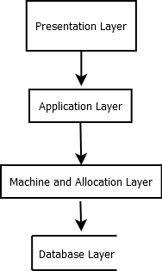
Figure 3.1 proposed system architecture

3.9.2 Use Case Diagram
The Use Case Diagram identifies the major actors that interact with the proposed system and the functions available to each actor.
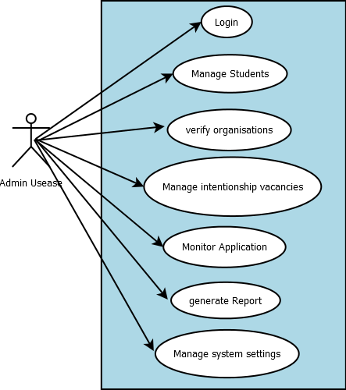
Figure 3.2 Admin Use case
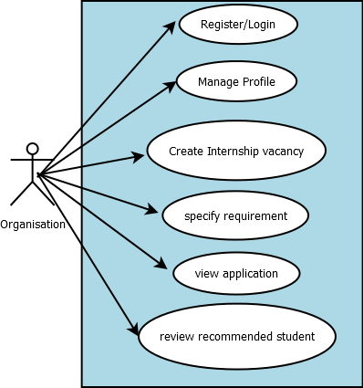
Figure 3.3 Organization Use case
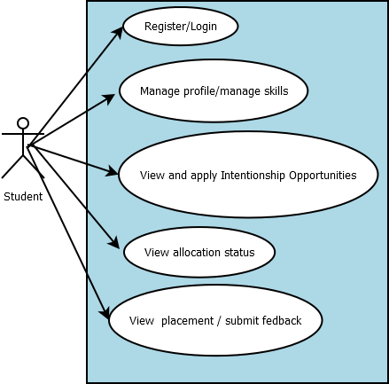
Figure 3.4 Student Use Case
The diagrams shows that the three major actors have different responsibilities. Students primarily interact with the system to manage their profiles, identify suitable internships, and monitor their placements. Organizations manage internship opportunities and participate in candidate selection and evaluation. Administrators maintain control over system operations, verification, allocation, monitoring, and reporting.
3.9.3 Activity Diagram
The activity diagram describes the sequence of activities involved in the proposed internship allocation process.
The process begins when students and organizations register on the platform. After authentication, students complete their profiles and organizations provide their internship requirements. The system validates the information before generating compatibility scores. Eligible student–organization pairs are then ranked and processed by the allocation algorithm.
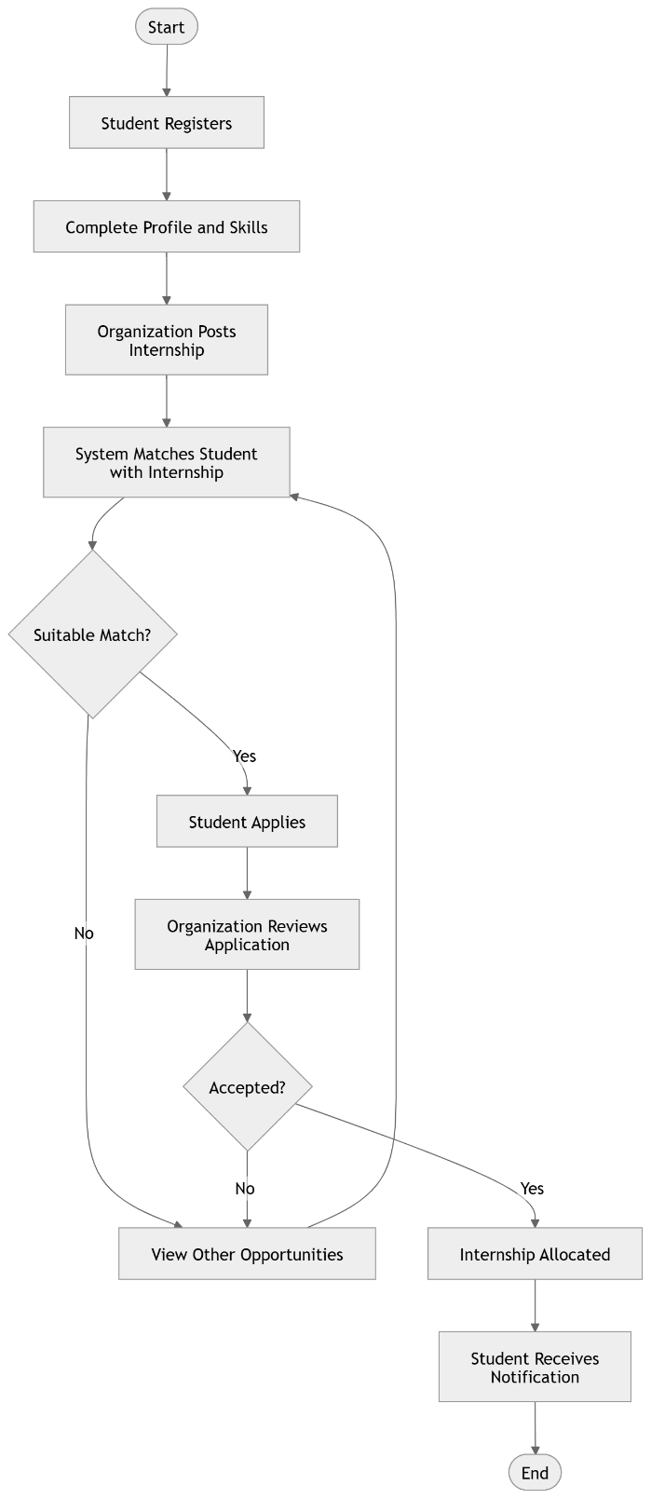
Figure 3.5 Activity Diagram

3.9.4 Data Flow Diagram
The Data Flow Diagram illustrates how information moves between external entities, system processes, and data stores. The three primary external entities are Student, Organization, and Administrator.
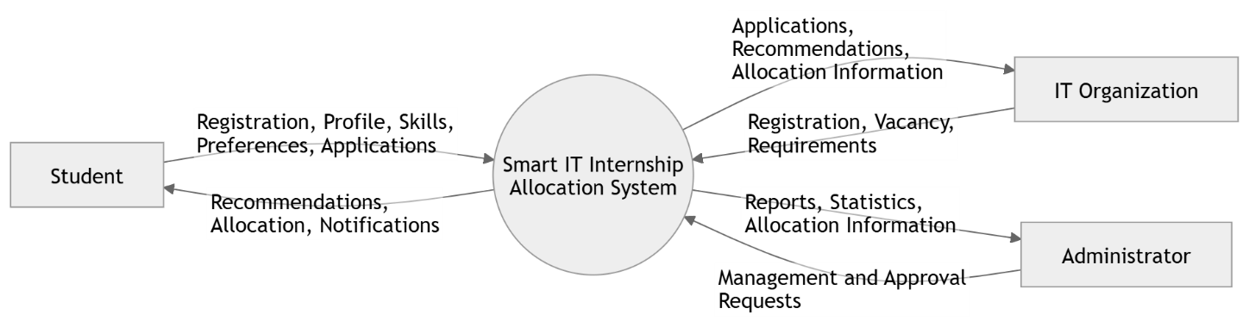
Figure 3.6 Data Flow Diagram

3.9.5 Class Diagram
The Class Diagram presents the major objects of the system and their relationships. The central classes include Student, Organization, Internship, Skill, Application, Preference, Allocation, Feedback, and Administrator.
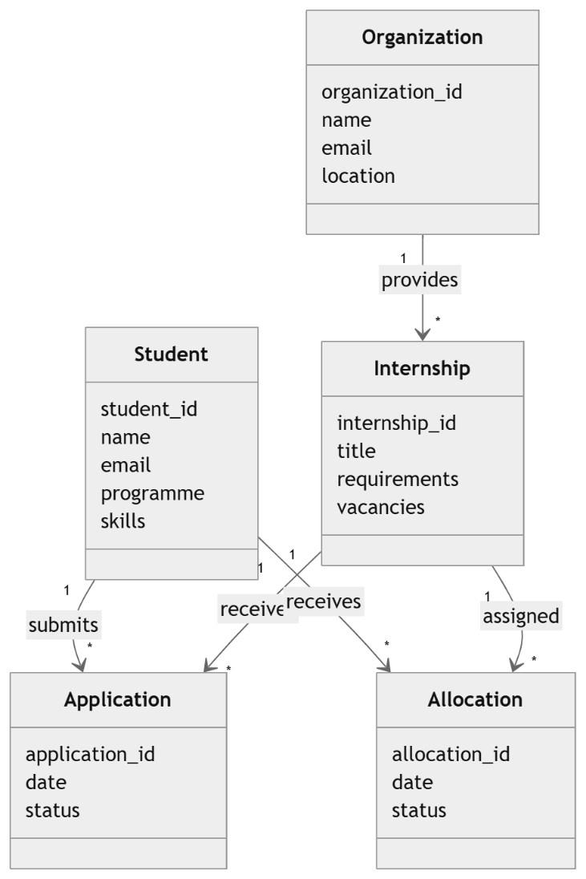
Figure 3.7 Class diagram
3.9.6 Entity Relationship Diagram
The Entity Relationship Diagram (ERD) represents the logical structure of the proposed database and the relationships among the major entities.
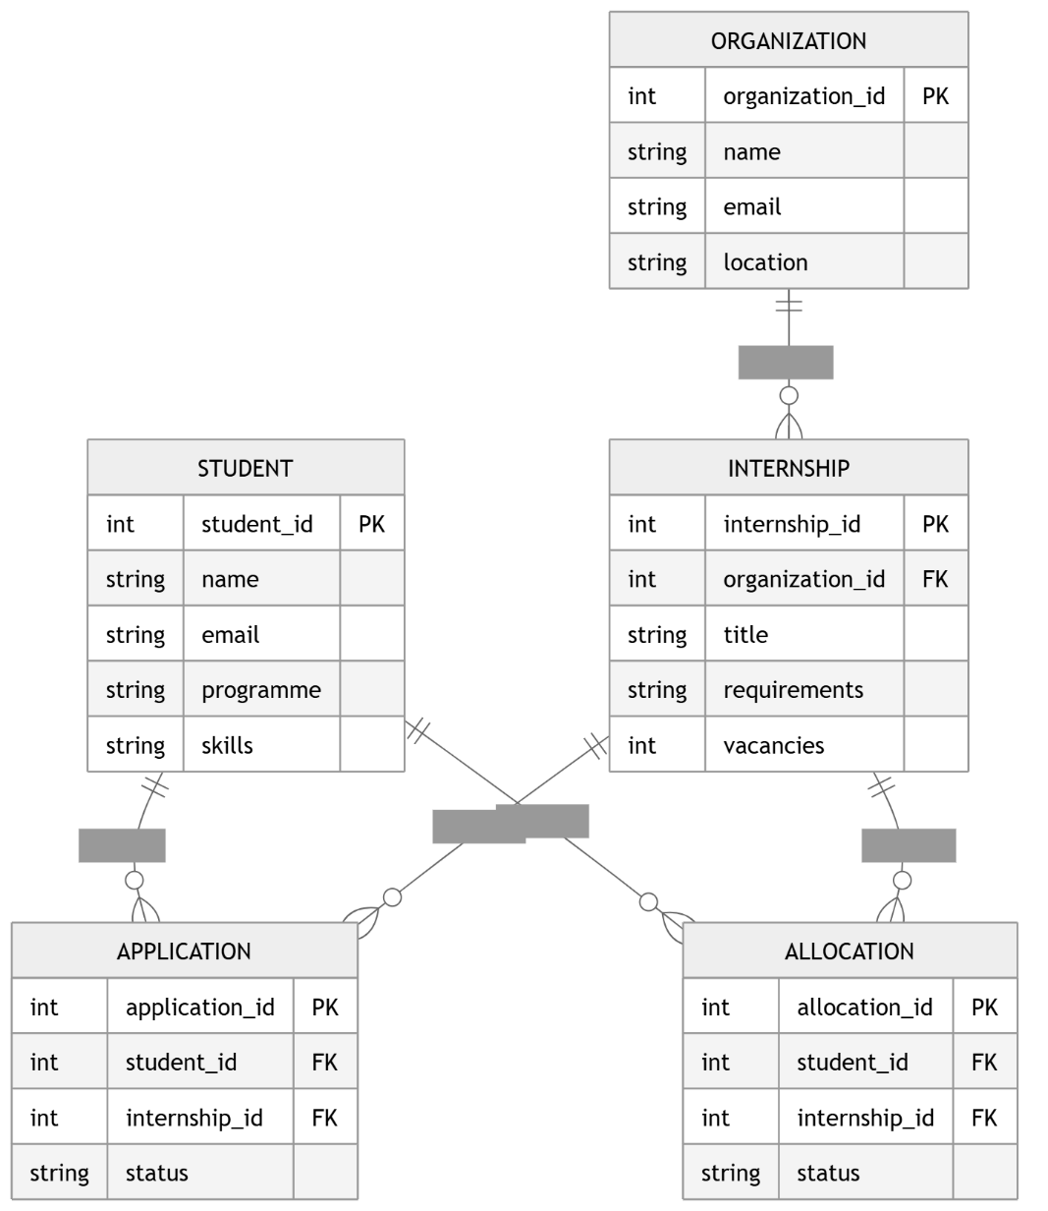
Figure 3.8 Entity Relationship diagram
The ERD consists of five major entities: Student, Organization, Internship, Application, and Allocation. The Student entity stores information about students seeking internship opportunities, while the Organization entity stores information about participating companies. An organization can provide multiple Internship opportunities. Students can submit Applications for available internships. After the system performs the matching and allocation process, the successful placement is recorded in the Allocation entity. This simplified database structure captures the essential data relationships required for the proposed Smart IT Internship Allocation System while keeping the design easy to understand and implement.
3.9.7 Database Design
The proposed database will use a relational structure in which related information is stored in separate tables. This approach reduces unnecessary duplication and improves data integrity.
The major database tables are summarized below:
Table 3.5 Database design Table
Table | Primary Key | Main Purpose
students | student_id | Stores student information.
organizations | organization_id | Stores organization information.
skills | skill_id | Stores available technical skills.
student_skills | student_skill_id | Associates students with their skills.
internships | internship_id | Stores available internship vacancies.
applications | application_id | Stores student internship applications.
preferences | preference_id | Stores student and/or organization preferences.
matching_scores | score_id | Stores calculated compatibility scores.
allocations | allocation_id | Stores final internship placements.
feedback | feedback_id | Stores student and organization feedback.
administrators | admin_id | Stores authorized administrator accounts.

The proposed Smart IT Internship Allocation System is designed as a modular web-based system consisting of user interfaces, application services, a matching and allocation engine, and a relational database. The design supports three principal actors students, organizations, and administrators and provides dedicated functionality for each.
The major innovation of the proposed design is the integration of a matching and allocation engine into the internship management process. Instead of simply listing available internship opportunities, the system processes student and organizational information, calculates compatibility scores, generates preference rankings, and applies an allocation algorithm to identify suitable placements. The proposed architecture, use case model, activity flow, data flow, class structure, and ERD collectively provide the technical blueprint for implementing the system in the subsequent development and implementation stages.

3.10 Summary
This chapter presented the methodology and system design adopted for the development of the Smart IT Internship Allocation System. The chapter began with an analysis of the proposed system and identified the major requirements needed to improve the existing internship placement process. The functional requirements described the major operations of the system, including student registration, organization registration, internship management, application processing, student–organization matching, allocation, notification, and feedback. The non-functional requirements addressed important quality attributes such as security, usability, reliability, performance, scalability, and data privacy.
The chapter also presented the proposed matching and allocation model, which considers factors such as technical skills, academic programme, career interests, location, student preferences, and organizational requirements. A stable matching approach was proposed to improve the suitability and fairness of internship allocations while considering the available capacity of participating organizations.
Furthermore, the system design was presented through the system architecture, use case diagram, activity diagram, class diagram, and entity relationship diagram. The design identified students, organizations, internships, applications, and allocations as the core components of the system. The chapter also discussed the proposed database structure and user interfaces for students, organizations, and administrators. Overall, the methodology and design presented in this chapter provide the technical foundation for the implementation and testing of the proposed Smart IT Internship Allocation System.

CHAPTER FOUR

IMPLEMENTATION AND DISCUSSION

4.1 Introduction
This chapter presents the implementation, testing, and evaluation of the Smart IT Internship Allocation System developed based on the requirements and design specifications presented in Chapter Three. The chapter describes how the proposed system was translated into a functional application capable of supporting student registration, organization registration, internship vacancy management, internship applications, intelligent student–organization matching, and automated internship allocation.
The chapter also presents the major interfaces of the developed system and explains the operation of the matching and allocation module. The implemented system is tested to determine whether its functional and non-functional requirements are adequately satisfied. The results obtained from the system testing and evaluation are presented and discussed, with particular attention given to the effectiveness of the matching process, allocation outcomes, usability, and overall system performance. The chapter concludes by highlighting the major findings and limitations identified during the implementation and evaluation of the proposed system.

4.2 System Implementation
The implementation of the Smart IT Internship Allocation System involved translating the system requirements and design specifications presented in Chapter Three into a functional web-based application. The implementation focused on providing an accessible platform through which students can create profiles, provide their academic and technical information, search and apply for internship opportunities, and receive suitable internship recommendations. Internship organizations can also manage their profiles, publish available internship positions, and specify the requirements for prospective interns. The system further incorporates an automated matching and allocation component that evaluates student information against internship requirements to support suitable placement decisions.
The system was implemented using Next.js as the primary web application framework, Firebase for backend services and data management, and Dropbox for file storage. These technologies were selected based on their suitability for developing a responsive web application, managing application data, authenticating users, and storing documents associated with internship applications. The combination provides a practical architecture in which the Next.js application serves as the user-facing layer, Firebase provides backend and database services, while Dropbox provides external storage for uploaded files such as students' CVs and supporting documents.

4.2.1 Development Environment
The development environment refers to the hardware and software resources used to design, develop, test, and deploy the Smart IT Internship Allocation System. The development process was conducted using a modern computer system capable of supporting web application development and testing.
The application was developed using Next.js, a React-based framework for building web applications. The development environment provided the necessary tools for creating the user interfaces, implementing application logic, connecting the application to Firebase services, and testing the different system modules.

4.2.2 System Development Technologies
The Smart IT Internship Allocation System was implemented using a combination of modern web development and cloud-based technologies. The major technologies used were Next.js, Firebase, and Dropbox.

4.2.2.1 Next.js
Next.js was used as the primary framework for developing the web application. It provides a structured environment for building React-based applications and was used to implement the presentation layer and application functionality of the proposed system. The framework was used to create pages and components for student registration, authentication, student profiles, internship listings, applications, organization management, administrator functions, and allocation results.
The use of Next.js also facilitated the development of a responsive interface that can be accessed through modern web browsers. Its component-based development approach allowed commonly used interface elements such as navigation menus, forms, cards, tables, dashboards, and notification components to be reused across different sections of the application.

4.2.2.2 Firebase
Firebase was used as the major backend service for the application. It provides cloud-based services that reduce the need to develop and maintain a conventional server infrastructure. In the proposed system, Firebase was used primarily for user authentication and database management.
Firebase Authentication was used to manage user accounts and authentication. It supports the registration and login processes for the different categories of system users. Appropriate access restrictions can be applied so that students, organizations, and administrators access only the functions relevant to their respective roles.
Cloud Firestore was used as the database for storing structured system information. The database stores records relating to students, organizations, internship opportunities, applications, matching information, allocations, and other relevant system data. The use of Firestore allows the application to retrieve and update records as users interact with the system.

4.2.2.3 Dropbox
Dropbox was incorporated into the system as an external file-storage service. It was used to store documents that may be submitted during the internship application process, particularly student CVs and other supporting documents.
Rather than storing large documents directly within the application's structured database, the system can store the files in Dropbox and retain the corresponding file reference or link within Firebase. This separation helps distinguish between structured application data and uploaded documents.
The architecture allows Next.js to provide the user interface and application functionality, Firebase to manage authentication and structured system data, and Dropbox to manage uploaded documents.

4.2.3 Database Implementation
The database component of the Smart IT Internship Allocation System was implemented using Firebase Cloud Firestore. Firestore is a cloud-based NoSQL database that stores information in collections and documents. It was selected for the proposed system because it integrates effectively with web applications and provides flexible storage and retrieval of application data.
The database was structured around the major entities identified during the system design stage. These include students, organizations, internships, applications, and allocations. Additional records relating to skills, preferences, matching results, and feedback can also be maintained where required.

4.2.3.1 Database Relationship Structure
Although Firestore is a NoSQL database and does not use conventional relational tables in the same manner as MySQL, logical relationships are maintained through document identifiers and references.
For example, an internship document contains an organization ID that identifies the organization providing the internship. Similarly, an application contains both a student ID and an internship ID, allowing the system to determine which student applied for which internship.
The Matching Scores collection stores the results generated when the system compares student attributes with internship requirements. These scores are subsequently used by the allocation component to rank potential matches.

4.2.3.2 Document Storage Implementation
Because internship applications may contain supporting documents, Dropbox was used for file storage. When a student uploads a CV or other required document, the file is stored in Dropbox, while the relevant file reference is associated with the student's application record in Firestore.
The resulting process can be summarized as:
This implementation separates structured database information from document storage, thereby providing a clearer organization of the application's data and uploaded files.
The implementation of the Smart IT Internship Allocation System therefore combines Next.js, Firebase, and Dropbox to provide the required functionality. Next.js forms the main application and presentation framework, Firebase provides authentication and Firestore database services, while Dropbox provides external storage for uploaded internship-related documents. The technologies work together to provide the foundation for student management, organization management, internship management, application processing, matching, allocation, and document handling within the proposed system.

4.3 System Modules
The Smart IT Internship Allocation System was implemented as a web-based platform that provides students with a centralized environment for discovering and applying for IT internship opportunities. The implemented system, referred to as Pathway, provides functionality for searching placements, receiving recommendations based on a student's profile, managing applications, saving opportunities, and viewing placement information. The system also emphasizes verified internship opportunities to improve users' confidence in the available placements. (simpl-azure.vercel.app)
The major modules implemented in the system are described below.

4.3.1 Student Module
The student module provides students with the primary interface for interacting with the internship allocation system. Students can access available IT placement opportunities and search for positions based on roles, skills, or companies. The system also provides a workspace where students can view recommended opportunities and manage their internship activities. (simpl-azure.vercel.app)
The module supports profile-based recommendations by using information associated with the student's Information Technology profile. This allows the system to present opportunities that are considered relevant to the student's course, skills, and career goals.

4.3.2 Internship Search Module
The internship search module enables students to discover available IT placement opportunities. The implemented interface provides a search field where users can search using roles, skills, or company names. The system also provides a location-based search option, allowing users to use their location when searching for suitable placements. (simpl-azure.vercel.app)
This module reduces the need for students to manually search through numerous organizations or rely exclusively on personal contacts when looking for internship opportunities.

4.3.3 Recommendation and Matching Module
The recommendation and matching module represents the intelligent component of the proposed system. It uses information contained in the student's profile to identify internship opportunities that are potentially suitable for the student.
The system displays a profile match percentage to indicate the degree of compatibility between the student's profile and available opportunities. For example, the implemented interface displays a profile match value of 92% for a recommended placement. (simpl-azure.vercel.app)
The matching process considers information such as the student's academic profile, skills, and career interests. This allows the system to move beyond a basic internship listing platform toward a more personalized placement recommendation system.

4.3.4 Application Management Module
The application management module enables students to monitor internship applications submitted through the platform. The student's workspace contains an Applications section where application-related information can be accessed. The implemented system displays the number of applications and their current status, including applications awaiting responses. (simpl-azure.vercel.app)
This functionality provides students with a centralized method of tracking their internship applications rather than relying on separate records or manual follow-up.

4.3.5 Saved Opportunities Module
The system provides a Saved section within the student's workspace. This enables students to retain internship opportunities that they consider relevant for later review or application. (simpl-azure.vercel.app)
The feature is particularly useful when a student identifies several suitable opportunities but is not immediately ready to apply for all of them.

4.3.6 Verified Opportunities Module
The system incorporates verification of internship opportunities as part of its placement discovery process. The implemented interface states that opportunities are verified and that companies are reviewed before being presented to users. (simpl-azure.vercel.app)
This feature is important because it helps improve the reliability of internship opportunities available through the platform and provides students with greater confidence when considering organizations.

4.3.7 Administrator/Database Management
The backend services of the system support the storage and retrieval of placement, profile, and application information. The system updates information from its database and uses stored student profile information to generate recommendations. The implemented interface explicitly indicates that placement information is updated from the database. (simpl-azure.vercel.app)
Administrative and backend management therefore provide the foundation for maintaining internship records, student information, application information, and other system data required for the matching process.

4.4 Presentation of the Developed System
This section presents the major interfaces of the implemented Smart IT Internship Allocation System, developed as the Pathway IT Placements platform. The implemented system provides students with access to verified IT internship opportunities, profile-based recommendations, internship searching, application tracking, and saved opportunities. The system also provides a profile-match indicator to show the compatibility between a student's profile and available placements. (simpl-azure.vercel.app)

4.4.1 Home Page
The home page serves as the entry point to the system. It introduces the purpose of the platform and provides users with a search interface for finding IT placement opportunities. Users can search for opportunities using roles, skills, or company names and can also use their location when searching for placements.

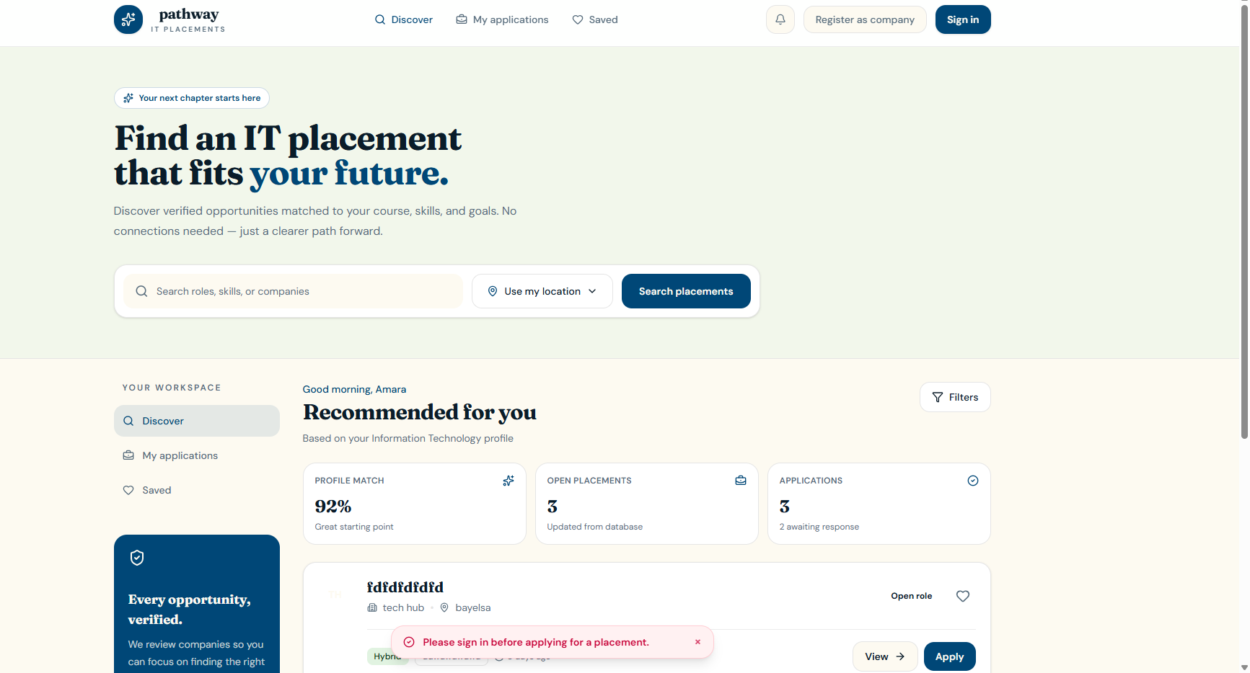
Figure 4.1: Home Page of the Smart IT Internship Allocation System
The interface provides a simple starting point for students seeking internship opportunities. The system emphasizes verified opportunities matched to the student's course, skills, and career goals. (simpl-azure.vercel.app)

4.4.2 Placement Search Interface
The placement search interface enables students to search for available IT internship opportunities. The search functionality allows users to enter relevant roles, skills, or company names, while the location option can be used to identify opportunities based on geographical preferences. (simpl-azure.vercel.app)

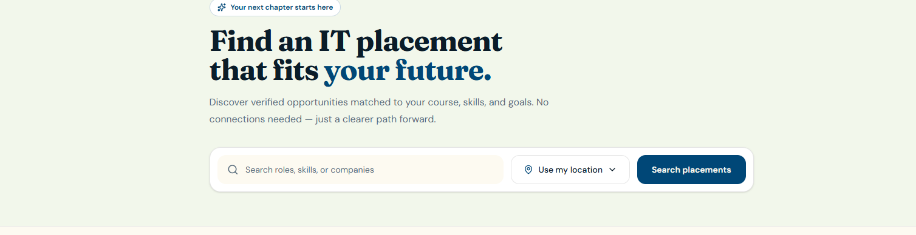
Figure 4.2: Placement Search Interface
This feature simplifies the process of identifying relevant internship opportunities and reduces the dependence on manual searches.

4.4.3 Student Workspace
The student workspace provides a centralized area for managing internship-related activities. The implemented system provides sections for Discover, My Applications, and Saved opportunities.
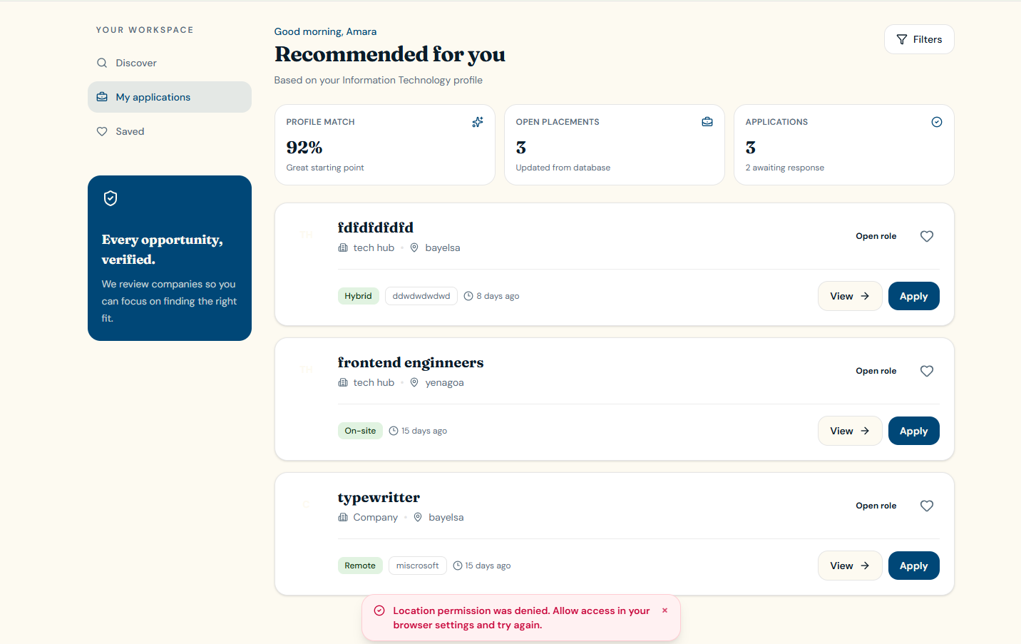
Figure 4.3: Student Workspace
The workspace enables students to move between internship discovery, application tracking, and saved opportunities from a single interface.
4.5 System Requirement
4.5.1 Software Requirements
The development and operation of the Smart IT Internship Allocation System require a modern web development environment. Next.js is used as the primary framework, with JavaScript/TypeScript for programming. Firebase and Cloud Firestore provide authentication and database services, while Dropbox is used for storing uploaded documents such as students' CVs. Visual Studio Code is used for source-code development, Git for version control, and a modern web browser such as Google Chrome for testing and accessing the system.
4.5.2 Hardware Requirements
The system requires a standard computer or laptop with at least an Intel Core i3 processor or equivalent, 4 GB of RAM, and 128 GB of storage, although higher specifications are recommended for smoother development and testing. A standard monitor, keyboard, and mouse are also required. Since the application uses cloud-based services such as Firebase and Dropbox, a stable internet connection is required for development, testing, data storage, authentication, and system deployment.

4.6 Summary
This chapter presented the implementation and evaluation of the Smart IT Internship Allocation System. It discussed the development environment, technologies used, database implementation, and major system modules. The chapter also presented the key interfaces of the developed system, including internship search, student workspace, recommended placements, profile matching, application management, and saved opportunities. Furthermore, system testing and evaluation were discussed to determine whether the developed system met its specified requirements. The results demonstrate that the system provides a centralized and efficient platform for discovering and managing IT internship opportunities.

CHAPTER FIVE

SUMMARY, CONCLUSION AND RECOMMENDATION

5.1 Summary
This project focused on the design and implementation of a Smart IT Internship Allocation System developed to improve the process of connecting students with suitable Information Technology internship opportunities. The study was motivated by the challenges associated with traditional internship placement processes, where students may have to search for organizations independently while internship coordinators manage student information, organization details, applications, and placement records manually. Such processes can be time-consuming, difficult to monitor, and may result in placements that do not adequately correspond with students' skills, academic backgrounds, interests, or preferred locations. The study therefore proposed a centralized and technology-driven solution capable of supporting a more organized and efficient internship placement process.
The study examined the existing internship allocation process and identified major problems including time-consuming allocation procedures, poor student-organization matching, human errors and bias, limited monitoring and feedback, and the absence of an intelligent mechanism for determining compatibility between students and internship opportunities. To address these challenges, the proposed system was designed around three major categories of users: students, internship organizations, and administrators. Students are provided with facilities for creating profiles, managing their skills and interests, searching for internship opportunities, applying for placements, and monitoring their applications. Organizations can provide information about their internship opportunities and requirements, while administrators can manage and monitor the activities of the system.
The study also incorporated a matching approach in which student information is compared with internship requirements. Factors considered in the proposed matching model include technical skills, academic programme, career interests, location, and preferences. The system uses compatibility information to rank suitable opportunities, thereby moving the internship placement process beyond simple availability-based allocation. The project also considered the application of stable matching principles because internship allocation involves two sides: students seeking suitable opportunities and organizations seeking students with appropriate qualifications and skills.
The system was implemented as a web-based application using Next.js, Firebase, and Dropbox. Next.js was used for the development of the web application and user interfaces, Firebase was used for authentication and database services, while Dropbox was incorporated for storing uploaded documents such as students' CVs and supporting files. This combination provided the technical foundation for managing student profiles, internship opportunities, applications, matching information, allocations, and documents.
The implementation produced several important system modules, including the student module, internship search module, recommendation and matching module, application management module, saved opportunities module, verified opportunities module, and administrative/database management functions. The recommendation and matching module is particularly important because it uses information from a student's profile to identify potentially suitable internship opportunities and displays a profile-match percentage to indicate the level of compatibility. The application management feature also allows students to monitor their applications and their current status from a centralized workspace.
The developed system was also presented and evaluated based on its ability to provide a centralized environment for discovering and managing IT internship opportunities. The implementation included internship searching, profile-based recommendations, application tracking, saved opportunities, verified opportunities, and profile matching. Overall, the findings presented in the document indicate that the developed system provides a more organized and efficient platform for managing IT internship opportunities and reduces dependence on manual searches and disconnected methods of managing internship information.

5.2 Conclusion
The study concludes that the development of a Smart IT Internship Allocation System provides a practical technological approach to improving the management and allocation of IT internship opportunities. The investigation of the existing process showed that manual and partially automated methods can create delays, increase administrative workload, make information difficult to manage, and provide limited support for matching students with organizations according to their skills and interests. The developed system addresses these challenges by providing a centralized platform through which internship-related information can be managed and accessed more conveniently.
The system demonstrates that internship placement can be improved when relevant student and organization information is brought together in one platform. By allowing students to create profiles containing their academic and professional information and by using these details to recommend relevant internship opportunities, the system provides a more personalized approach to internship discovery. The profile matching feature further supports this process by indicating the compatibility between students and available opportunities. This represents an improvement over traditional approaches that may depend largely on manual searching, personal contacts, or simple availability of internship positions.
The project also demonstrates the usefulness of modern web and cloud technologies in developing an internship management platform. The integration of Next.js, Firebase, and Dropbox provides a practical structure for user interface development, authentication, database management, and document storage. The system is therefore capable of supporting the major activities involved in internship discovery and application management while maintaining information in a centralized digital environment.
In conclusion, the Smart IT Internship Allocation System achieves the main purpose of the project by providing a centralized and intelligent platform for discovering and managing IT internship opportunities. It has the potential to reduce the difficulties associated with manual internship searches, improve the relevance of recommended placements, support better management of applications, and provide students with easier access to internship opportunities. Although the quality of the recommendations depends on the accuracy and completeness of information supplied by students and organizations, the developed system provides a strong foundation for improving IT internship placement and management.

5.3 Recommendation
Based on the outcome of the study, it is recommended that educational institutions and internship coordinators consider adopting digital systems such as the Smart IT Internship Allocation System for managing internship placement activities. Moving from predominantly manual processes to a centralized digital platform can make it easier to manage student information, internship opportunities, applications, and placement-related activities. The system can also reduce the administrative burden associated with manually reviewing large numbers of students and internship opportunities.
It is recommended that students provide complete and accurate information when creating their profiles. Since the recommendation and matching process depends on information such as academic background, technical skills, interests, and preferences, inaccurate or incomplete profiles may affect the relevance of the opportunities presented by the system. Students should therefore regularly update their profiles and skills so that the recommendations generated by the system remain relevant to their current abilities and career interests.
Internship organizations are also recommended to provide accurate and detailed information about their available internship positions. Organizations should clearly specify the technical skills, academic requirements, areas of specialization, location, available positions, and other relevant requirements for each internship opportunity. Providing reliable information will improve the system's ability to identify suitable candidates and will contribute to better student-organization matching.
It is further recommended that internship administrators regularly verify organizations and internship opportunities before they are made available to students. The developed system already emphasizes verified opportunities, which can improve users' confidence in the available placements. Continuous verification can help ensure that students are directed toward genuine organizations that can provide relevant practical experience.
The matching mechanism should also be continuously improved as more internship and application data become available. Future versions of the system can incorporate additional factors such as previous internship performance, organization quality, supervisor availability, student feedback, previous placement outcomes, and employer feedback. These additional factors can make the matching process more comprehensive and potentially improve the quality of internship recommendations and allocations.
Finally, future researchers and developers are encouraged to extend the system with more advanced intelligent matching and allocation techniques. The existing study provides a foundation for profile-based recommendation and matching, while future work can investigate machine-learning-based recommendation, more advanced optimization techniques, real-time notifications, mobile application support, automated feedback analysis, and improved monitoring of students during their internship period. Such improvements can further transform the system from an internship opportunity and recommendation platform into a comprehensive intelligent internship allocation and monitoring system.

REFERENCE
Ackermann, C., Hahne, F., & Rieck, J. (2022). Matching and scheduling of student-company-talks for a university IT-speed dating event. Operations Research Forum, 3, Article 42.
Aziz, H., Baychkov, A., & Biró, P. (2024). Cutoff stability under distributional constraints with an application to summer internship matching. Mathematical Programming, 203, 247-269.
Bennett, D., Richardson, S., & MacKinnon, P. (2017). Work-integrated learning (WIL) in information technology. Higher Education, Skills and Work-Based Learning, 7(4), 394-407.
Cowgill, B., Davis, J., Montagnes, B. P., & Perkowski, P. (2024). Stable matching on the job? Theory and evidence on internal talent markets. Management Science.
Dollinger, M., & Brown, J. (2019). An institutional framework to guide the comparison of work-integrated learning. Journal of Teaching and Learning for Graduate Employability, 10(1).
Emeasoba, N. C. (2022). Business educators' appraisal of relevance of Students Industrial Work Experience Scheme (SIWES) to business education programme in universities in South East, Nigeria. Journal of Sustainable Development in Education, 2(1).
Gale, D., & Shapley, L. S. (1962). College admissions and the stability of marriage. The American Mathematical Monthly, 69(1), 9–15.
Hansen, S., Rostiyanti, S. F., Setiawan, M. I., & Koesalamwardi, A. H. (2022). Developing a work-integrated learning model adjusting to Construction 4.0 aspects of internship evaluation. International Journal of Work-Integrated Learning, 23(1), 65-80.
Jackson, D. (2015). Employability skill development in work-integrated learning: Barriers and best practice. Studies in Higher Education, 40(2), 350–367.
Jackson, D. (2024). Work-integrated learning: Opportunities and challenges in Australia. Higher Education Research & Development, 43(3), 767-773.
Jackson, D., & Dean, B. A. (2023). The contribution of different types of work-integrated learning to graduate employability. Higher Education Research & Development, 42(1), 93–110.
Jackson, D., Rowbottom, D., Ferns, S., & McLaren, D. (2017). Employer understanding of work-integrated learning and the challenges of engaging in work placement opportunities. Studies in Continuing Education, 39(1), 35-51.
Jones, M., Green, J. P., & Higson, H. E. (2017). Do work placements improve final year academic performance or do high-calibre students choose to do work placements? Studies in Higher Education, 42(6), 1038–1055.
Mahdavi, M., Ghasemian, M., & Shadrokh, S. (2015). Assignment of trainees to software project requirements: A stable matching based approach. Computers & Industrial Engineering, 87, 228–237.
Ogbuanya, T. C., Njoku, C. A., Kemi, P. O., & Ogunkelu, M. O. (2018). Evaluating the effectiveness of Students Industrial Work Experience Scheme (SIWES) programme to ensure quality of technical, vocational education and training in technical colleges in Lagos State. International Journal of Vocational and Technical Education, 10(7), 61-69.
Omonijo, D. O., Anyaegbunam, M. C., Ejoh, S. I., & Ogechukwu, J.-A. C. (2020). Qualitative analysis of the Student Industrial Work Experience Scheme (SIWES) in tertiary institutions in Ogun State, Nigeria. Journal of Educational and Social Research, 10(4), 187.
Segun, O., & Blessing, K. (2016). Mobile-based SIWES placement recommendation system: A case study of Nigerian universities. International Journal of Computer Applications, 152(9), 1-6.
Smith, C., Worsfold, K., & others. (2017). Work-integrated learning (WIL) in information technology. Higher Education, Skills and Work-Based Learning, 7(4), 394-407.
Tran, L. T., & Soejatminah, S. (2019). Work integrated learning internships in transnational education. Education + Training, 61(3), 359-373.

