|  |  |
| --- | --- |
| **`WRITTEN ASSESSMENT** | **Uncontrolled when printed**  **16/12/2014**  **FM02_21a** |

|  |  |  |  |  |  |  |  |  |  |  |
| --- | --- | --- | --- | --- | --- | --- | --- | --- | --- | --- |
| **Student Name:** | | | **ANGELO PALAZZOLO** | | | **Student Number:** | | | **3150704699** | |
| **Unit Code/s & Name/s:** | | | **ICAICT503A Validate Quality and Completeness of System Design Specifications** | | | | | | | |
| **Assessment Type:** | | | **Exam/Test  Assignment  Other** | | | | | | | |
| **Assessment Description:** | | | **P1 - Validate Quality and Completeness of System Design Specifications** | | | | | | | |
| **Assessment Due Date:** | | |  | | **Assessment Received Date:** | | | | |  |
| **Student Declaration:** I declare that this assessment is my own work. Any ideas and comments made by other people have been acknowledged as references. I understand that if this statement is found to be false, it will be regarded as misconduct and will be subject to disciplinary action as outlined in the TAFE Queensland Student Rules. I understand that emailing or submitting this assessment electronically confirms my assent to this declaration in lieu of written signature. | | | | | | | | | | |
| **Student Signature:** | |  | | | | | **Date: / /** | | | |
| **Assessor Feedback:**  0  **Student provided with feedback** | | | | | | | | | | |
| **Attempt 1 Satisfactory  Not Satisfactory  Date:      /     /** | | | | | | | | | | |
| **Attempt 2 Satisfactory  Not Satisfactory  Date:      /     /** | | | | | | | | | | |
| **Assessor Name:** | D. Batchelor | | | **Assessor Signature:** | | | |  | | |
| **Note to assessor: Please record any adjustment below that has occurred to this assessment e.g. written assessment given orally.** | | | | | | | | | | |
|  | | | | | | | | | | |
| **Disclaimer:** TAFE Queensland North (TQN) is collecting the information on this form for assessment purposes. Only authorised Departmental officers have access to this information. Your personal information will not be disclosed to any other third party without your consent, unless authorised or required by law, in accordance with the Information Privacy Act 2009. | | | | | | | | | | |

**This section must be completed by the student when the student either posts or hands a completed assessment/assignment to customer service centres. a receipt is only issued for face to face assessments when requested by the student.**

✀ **RECEIPT**

|  |  |  |
| --- | --- | --- |
| STUDENT TO COMPLETE |  | OFFICE USE ONLY |
| Unit of competency code/s:__________________ |  |  |
| Assessment item/No: ______________________ |  | Date received: / / |
| Student’s name: __________________________ |  |  |

|  |  |
| --- | --- |
| **Instructions to Student:** | **Time allowed:** This assessment is to be completed over the semester.  **Materials and equipment to be supplied by the Student:**   * Access to a PC, access to templates,   **General Instructions:**   * You will need access to the folder ‘Docs’, which is in your Student Shared Drive. * You have 9 tasks to complete. * You will need to answer **all** questions correctly * Keep a copy of all assessments as you will be required, to submit them as a zipped file to your teacher.   NOTE: If you are not successful on your first attempt, you will be given comments and a further two weeks to rectify the changes.  You will need to re-submit your corrections for remarking. If you are unsuccessful on your second attempt, you will be required to re-enrol in this unit. ALL SUBMITTED WORK MUST BE YOUR OWNPlagiarism Is An Offence To avoid plagiarism, you must give credit whenever you use:   * Another person’s idea, opinion, or theory * Any facts, statistics, graphs, drawings—any pieces of information— information that is not common knowledge * Quotations of another person’s actual spoken or written * Paraphrasing of another person’s spoken or written words |
| **Instructions to Assessor:** | Please see Instructions to Student above. |
| **Assessment Context and Description: (if required)** | In order to gain competency in **ICAICT503A Validate Quality and Completeness of System Design Specifications,** successful completion is required of the following assessments items:   * Written Assessment |
| **Note to Student:** | An Assessment Matrix is available from your teacher upon request. The matrix shows how the knowledge and skills that you are being asked to demonstrate align to the Elements, Performance Criteria, Critical Aspects, Required Skills and Required Knowledge components of each Unit of Competency. |

*As Online Systems Solutions continues to expand we need to ensure that all our process and procedures are in place to ensure that what we deliver to our clients is of the absolute highest quality. We also need to be able to audit our sites to ensure they match the requirements. Your task is to develop quality assurance testing plans and procedures to be implemented for all websites developed by Online Systems Solutions.*

*Based on your testing plans you will need to develop audit criteria based on the functional and technical requirement and design brief for an existing website. You will then need to conduct an audit on the website and report on your findings. You will use the site developed throughout this stage as your test site for this project.*

*You should ensure that your reports adhere to the Online Systems Solutions style guide.*

*You should create a new folder for this project called '****Quality_assurance****' and save all project files in this folder. You should create sub folders as necessary.*

**Task 1 - Develop quality assurance standards**

***For this task you are required to develop a set of quality assurance standards. You should:***

***From the readings and your research develop a list of standards for Online Systems Solution. The following provides a list of possible items for inclusion:***

|  |  |
| --- | --- |
| Element | Standards |
| Markup validation | * Each page should contain valid HTML 5 markup. * Each page should have its HTML validated using the W3C Markup Validation Service (<http://validator.w3.org>) |
| CSS validation | * All style and formatting is one through the use of Cascading Style Sheets. * Each style sheet should contain valid CSS 3 code. * CSS code should be logically organised – per feature per page * Each style sheet should have its code validated using the W3C Link Checker <http://validator.w3.org>) |
| JavaScript check | * JavaScript programs should be stored in and delivered as .js files. * JavaScript code should not be embedded in HTML files unless the code is specific to a single session. * Each page should have i validated using the W3C CSS Validation Service |
| php script | Here are few guidelines which can be followed while coding in PHP.   * Indenting and Line Length − Use an indent of 4 spaces and don't use any tab because different computers use different setting for tab. It is recommended to keep lines at approximately 75-85 characters long for better code readability. * Control Structures − These include if, for, while, switch, etc. Control statements should have one space between the control keyword and opening parenthesis, to distinguish them from function calls. You are strongly encouraged to always use curly braces even in situations where they are technically optional. * Comments − C style comments (/* */) and standard C++ comments (//) are both fine. Use of Perl/shell style comments (#) is discouraged. * PHP Code Tags − Always use <?php ?> to delimit PHP code, not the <? ?> shorthand. This is required for PHP compliance and is also the most portable way to include PHP code on differing operating systems Variable Names − * Use all lower case letters * Use '_' as the word separator. * Global variables should be prepended with a 'g'. * Global constants should be all caps with '_' separators. * Static variables may be prepended with 's'. * Each section of php code should be validated using the php Code Checker website at: http://phpcodechecker.com/ |
| Link integrity check | * All hyperlinks internal to the website are relative, not absolute * All hyperlinks are tested for broken links * Each page should have its internal and external links validated using the W3C CSS Validation Service (<https://validator.w3.org/checklink>) |
| Content check (text, images, etc.) | All written information should be:   * original in content and semantics; plagiarism is not acceptable * logically organised (or ‘chunked’) within relevant pages and/or headings * accurate and verified my management * correct, in regards to spelling, punctuation, grammar * free of offensive material   The images/graphics on the web site should:   * be relevant, professional, optimized for the web, and legal. * refrain from using clip art or animated GIFs. * make sure you own or have the permission to use any photos for your site. If you are not sure who owns the image or do not have permission to use the image, do not use it. * specify your image size and use the “alt” attribute(the text equivalent) to describe the image in your HTML. * Be resized using image editing software before you upload them. Do not resize images by setting the height and width in your HTML. * not be distort (squish or stretch). All images should maintain their original aspect ratio or be cropped to the desired size.   With respect to the use of multimedia on the web site:   * If including Flash, video, audio or other media on your site, provide text alternatives. (i.e. closed captioning) * Flash and Multimedia elements should be used appropriately and not as a means of delivering the website content. Websites created entirely in Flash are discouraged. * Websites created in Flash must have text alternatives to ensure the content is available to the widest possible audience. * The use of Flash to create navigation is also discouraged; if used, a text alternative is also required. |
| Accessibility check | Some of the elements to include are:   * Alt-text will be provided for all important non-text content such as images * All pre-produced videos will have captions * All websites will be easily navigable for a screen reader, and will be navigable by keyboard * All websites will have high colour contrasts and if any audio plays on the website, then the audio will have adjustable volume and play and pause mechanisms * Users will be able to adjust, pause, and play any timed sequences on websites * Websites will not have elements which flash more than 3 times per second |
| Cross-browser check | The website is compatible with the following base set of browsers:   * Microsoft Internet Explorer 8+ * Mozilla Firefox 3.6.8+ * Apple Safari 5+   Optimise browse functionality   * Use keywords in your page title. Ensure these keywords also appear in your content. Every page title should be unique. * Optimize your robots.txt file. * Use alt attributes for images. * Use descriptive anchor text. Avoid “click here”, “read more”, etc. Keep the anchor text under 55 characters. * Use the title attribute in links. The title or a description of the page you are linking to is an appropriate value for the title attribute. * Use header tag properly. Only one <h1>, and properly nested <h2>, <h3> etc. * Ensure your first paragraph and meta description are representative of the content of your page. * Each page should be validated using Browser Shots (<http://browsershots.org/>) |

***Within the learning resources are the following templates that you should use as part of this project. You should modify them, as necessary, to suit Online Systems Solutions and ensure they adhere to the Online Systems Solutions style guide.***

***"Change Log' template***

***'Change Request Form' template***

***"Test Result' template***

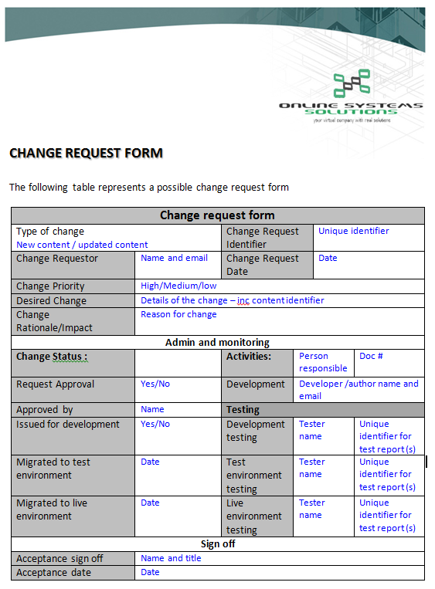

Figure : Modified "Change Request Form" template .

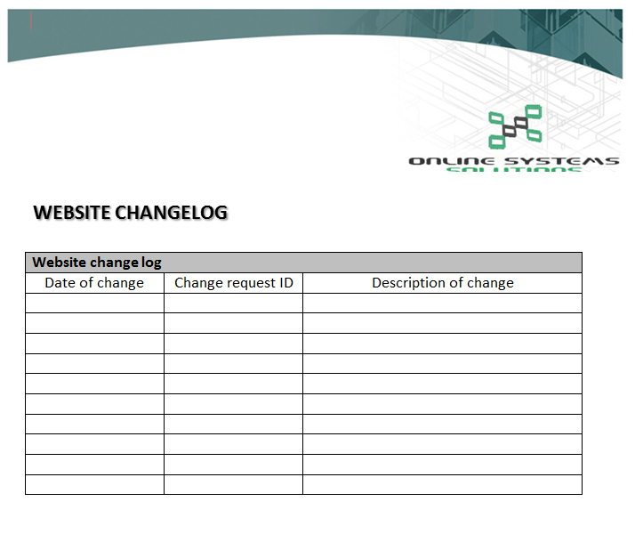

Figure : Modified "Change Log" template.

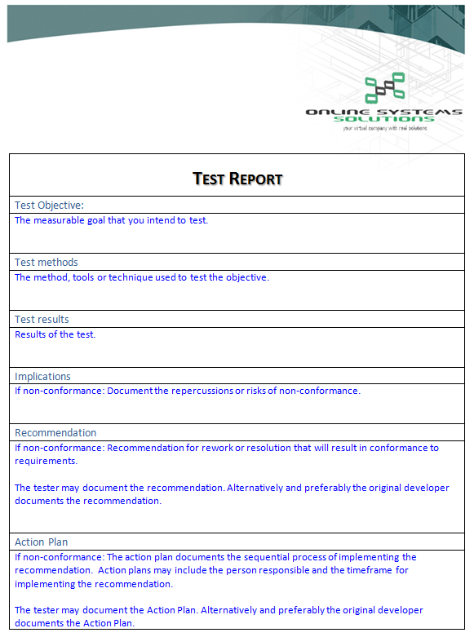

Figure : Modified "Test Report" template, containing the 'Test Results'

**Task 2 - Prepare for the audit and complete an audit preparation report**

***You are required to prepare for an audit of the website and complete a report on these preparations. You should complete the audit preparation report using the*** [***audit preparation template***](http://my.tafe.qld.gov.au/WBI/WBI_Information_Systems/WBI_ICAWEB508A_TQC_A_Stage1/IMS_2012v1/4_Quality/project/resources/audit_prep_template.doc) (Word - 24Kb).

See Appendix A on page 16.

**Task 3 - Develop Quality Assurance schedule**

***You are required to develop a schedule for quality assurance testing. Your schedule should include:***

***what initial testing of the site should be undertaken***

***the ongoing testing of a site that should be undertaken***

***the frequency of testing***

***methods for capturing feedback on quality issues***

|  |  |  |  |  |
| --- | --- | --- | --- | --- |
|  | **Initial Testing to be Undertaken** | **Ongoing Testing to be Undertaken** | **Frequency of Testing** | **Method of Capturing Feedback** |
| **Markup** | * Visual inspection of code  * “Walk-through” website to observe functionality  * Obtain feedback from users of the site (staff/clients) | * All aspect should be tested when changes are made to the content or appearance  * Manual inspection of coding  * Manual testing of all links on page(s) | * Monthly  * As needed | validator.w3.org/ |
| **CSS** | validator.w3.org |
| **Javascript**  **PHP Script** | phpcodechecker.com/ |
| **Link Integrity** | * validator.w3.org/checklink  * Manual inspection of coding  * Manual testing of all links on page(s) |
| **Content** | * As above  * Information and data should be checked for accuracy prior to being sent to the website dept | * As above  * Manual proofreading of content  * Review feedback from staff and clients | * As above | * As above  * Correction and annotations made to information & data  * Surveys and questionnaires  * Analytic software |
| **Accessibility** | * Visual inspection of code  * “Walk-through” site to observe functionality  * Obtain feedback from users of the site (staff/clients) | * All aspect should be tested when changes are made to the content or appearance  * Review feedback from staff and clients | * As above | w3.org/WAI/ER/tools/ wave.webaim.org/ |
| **Cross-Browser Compatibility** | * As above | * As above  * Manual testing of website on popular browsers | * As above | Mozilla Firefox  Internet Explorer/Edge  Google Chrome |

**Task 4 - Develop an audit plan**

***You now need to develop an audit plan. You should:***

***Develop your audit plan using the*** [***audit plan template***](http://my.tafe.qld.gov.au/WBI/WBI_Information_Systems/WBI_ICAWEB508A_TQC_A_Stage1/IMS_2012v1/4_Quality/project/resources/audit_plan_template.doc) ***(Word - 75Kb).***

See Appendix B on page 17

**Task 5 - Develop a test worksheet**

***You now need to develop a test worksheet to identify the way that you will test the audit criteria. The test worksheet will be used to document the tests performed. You should:***

***Develop the test worksheet using the*** [***test worksheet template***](http://my.tafe.qld.gov.au/WBI/WBI_Information_Systems/WBI_ICAWEB508A_TQC_A_Stage1/IMS_2012v1/4_Quality/project/resources/test_worksheet.doc) ***(Word - 35Kb).***

See Appendix C on page 23.

**Task 6 - Undertake Quality Assurance testing**

***You are required to undertake quality assurance testing according to the standards you have defined in Task 1. You will need to record your results as part of your reporting for task 8.***

**HTML Markup**

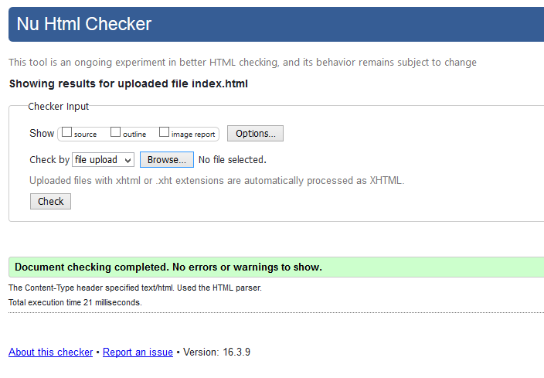

**CSS Code**

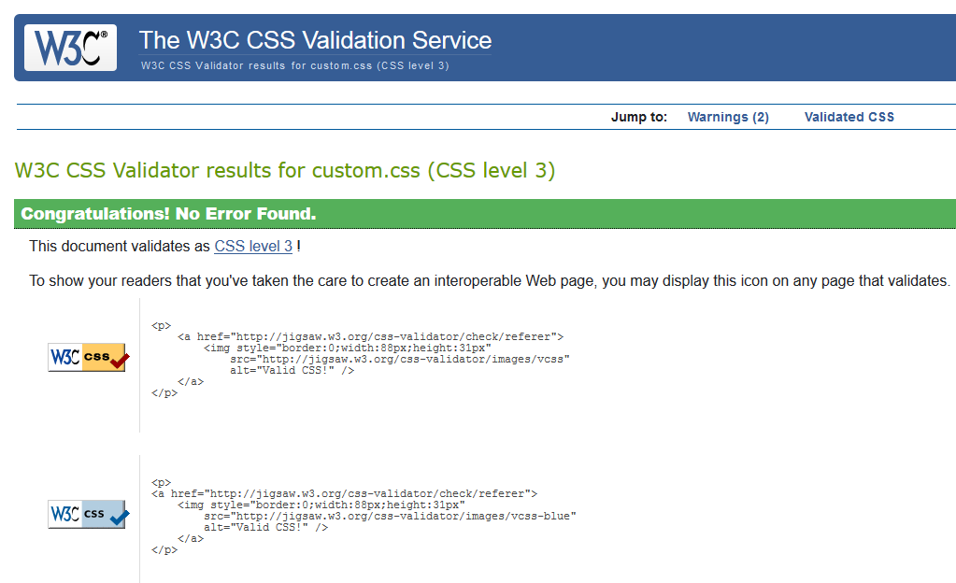

**php Script**

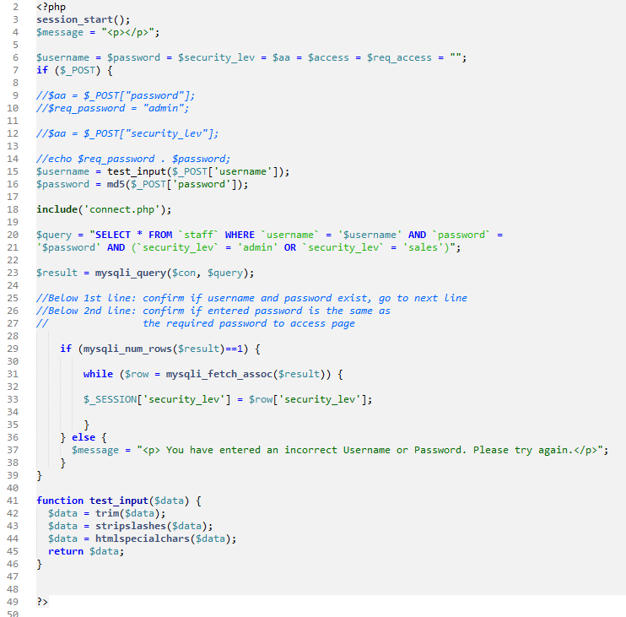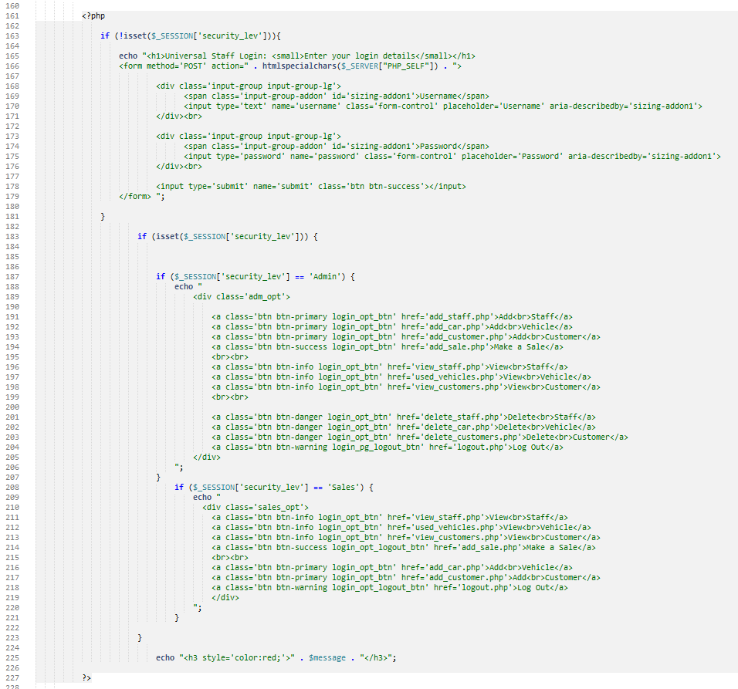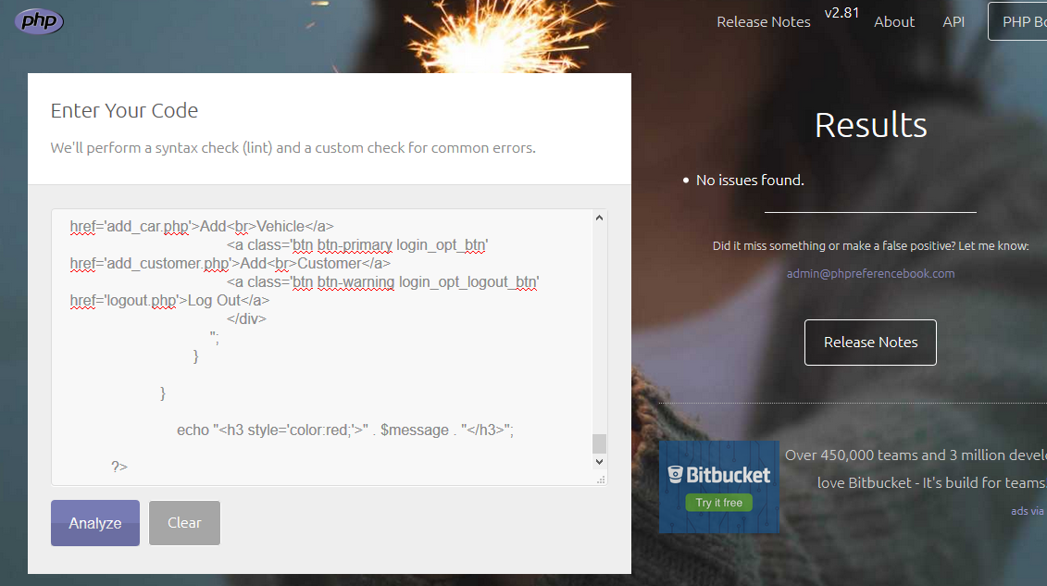

**Javascript**

N/A

**Link Integrity**

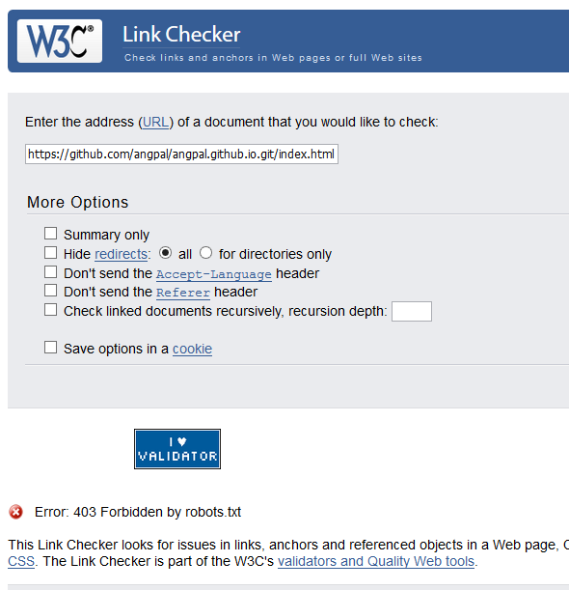 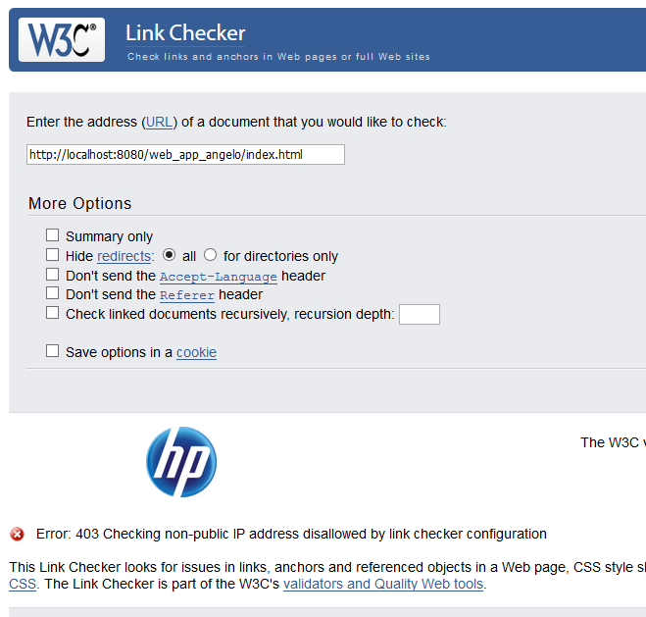

**Content**

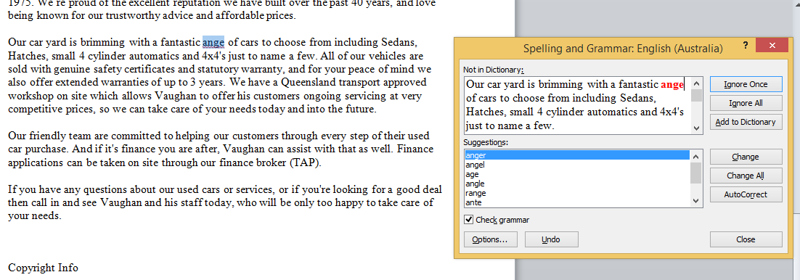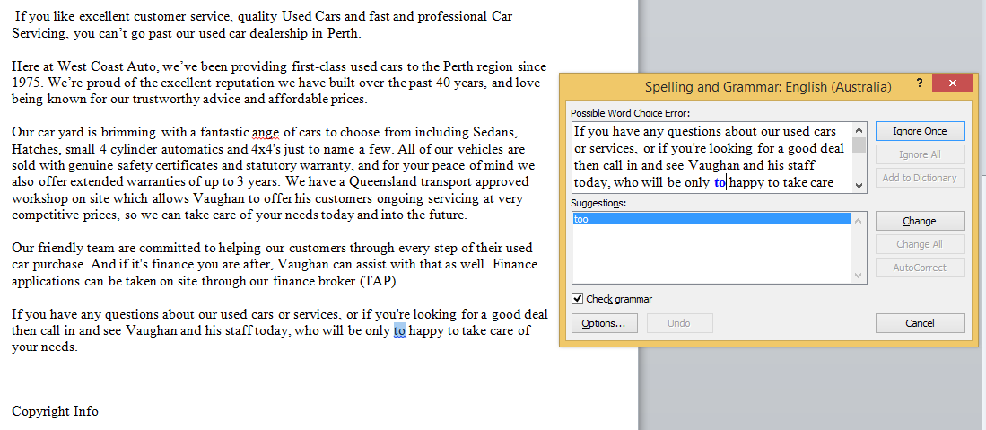

**Accessibility**

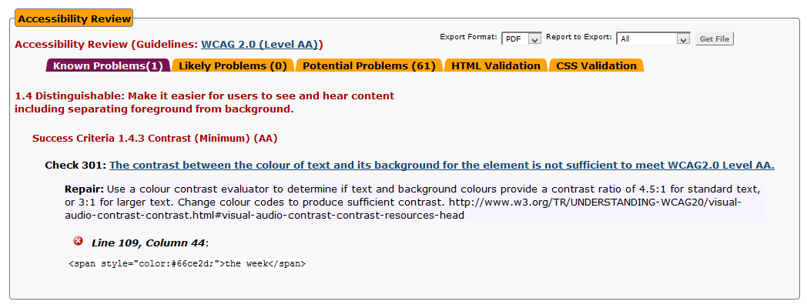 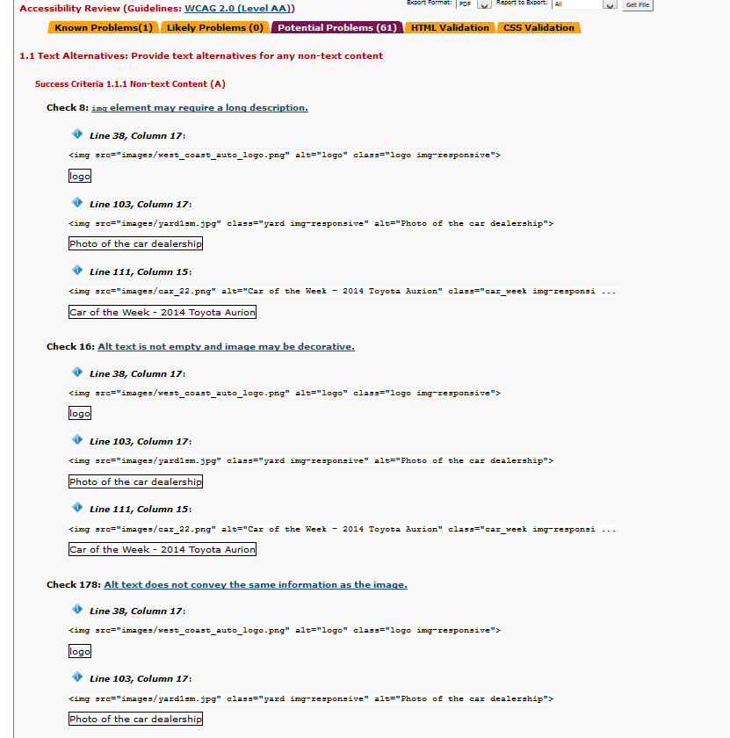

**Cross-browser compatibility**

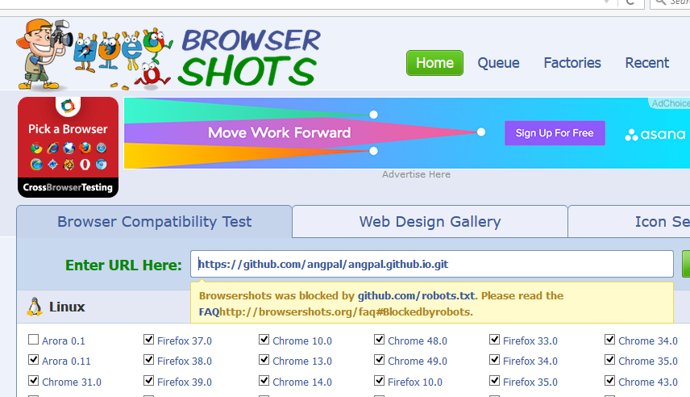 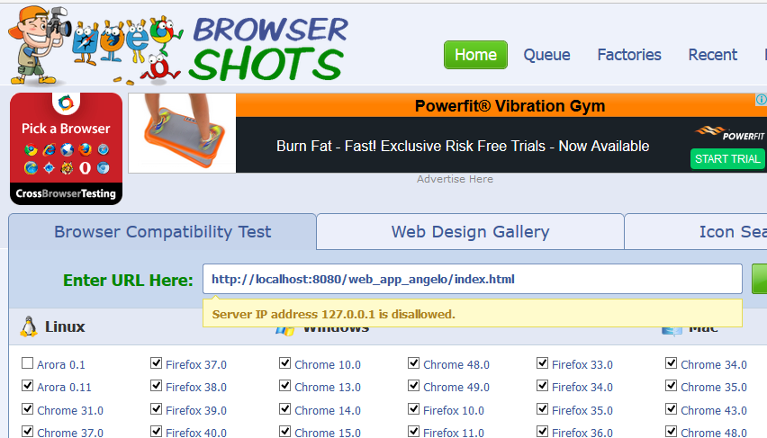

**Task 7 - Perform the audit and summarise results in a test report**

***You are required to perform the audit of the website developed in the previous topics and record the results. You should:***

***Perform the audit***

***Record the test results in the Test Worksheet.***

***Summarise results in the audit test report. Use the*** [***test report template***](http://my.tafe.qld.gov.au/WBI/WBI_Information_Systems/WBI_ICAWEB508A_TQC_A_Stage1/IMS_2012v1/4_Quality/project/resources/audit_test_report.doc) ***(Word - 32Kb). Include any non conformance issues in this report.***

See Appendix D on page 26.

**Task 8 - Develop Quality Assurance report**

***You are required to develop a report recording the results from your quality assurance testing. You will need to refer back to your requirements documents to ensure that they have been correctly met. Your report should:***

***Record the results as either:***

***Conformance (acceptable- or planned to conform at a later stage)***

***Non-conformance (item requires rework)***

***Document new processes and procedures. Where the item being assessed requires rework; identify the causes of non-conformance. Document recommendations for new processes and procedures that may enable you the produce an item that conforms to the quality criteria.***

***Summarise results. Write a short paragraph summarising your analysis.***

***Document any lessons learnt. Include in your report, a paragraph or two on what processes or procedures you would perform differently in your next project.***

The West Coast Auto website was audited for Quality Assurance at the request of the owners/managers.

HTML, CSS, php (and Javascript) were all free of errors, according to the validation tools used.  
The page content was verified as accurate but contained a small number of spelling, punctuation and grammatical errors.

Link Integrity, Accessibility and Cross-browser Compatiblity could not be tested due to a technical (configuration) issue, whereby the virtual server being used was blocking attempts to test

**Task 9 - Prepare the audit report**

You are required to develop an audit report using the [audit report template](http://my.tafe.qld.gov.au/WBI/WBI_Information_Systems/WBI_ICAWEB508A_TQC_A_Stage1/IMS_2012v1/4_Quality/project/resources/audit_report_template.doc) (Word - 46Kb).

See Appendix E on page 28.

You will need to submit

The following should be included in your uploaded zip file (please ensure that there are no additional files):

Quality Assurance Standards (Task 1)

Audit preparation report (Task 2)

Quality Assurance Schedule (Task 3)

Audit plan (Task 4)

Test worksheet (Task 5)

Test report (Task 7)

Quality Assurance report (Task 8)

Audit report (Task 9)

End of Assessment

***­­Appendix A:***

Audit Preparation

**Purpose**

The purpose of this document is to provide an understanding of the system to be audited.

**Opportunity or Problem Statement**

West Coast Auto is a family operated business which was established in 1975. Some time in the past, the business had a website developed. The have now determined that it would be beneficial to the company, to have the website Quality Assured.

**Mandatory *technical* requrements of the Websit**

The website must include the following:

* The website must promote the services offered by West Coast Auto
* The website must display the used vehicles available for purchase
* The website should allow visitors to view the specifications of the vehicles
* The website should include an Frequently Asked Questions (FAQ) page
* The website should include a Testimonials page
* The website should include a downloadable document of West Coast Auto – Privacy Statement and Terms and Conditions.
* The website must provide contact and office information including physical address and map
* The website must be responsive
* The website should have a secure administration login area (for AlllStyle Homes employee/s) to:
  + View and add new clients
  + View and add new staff
  + View and add new vehicles
  + Create a sale
  + The website must act as a User Interface (UI) for the SQL database

**Target Audience**

The target audience of the West Coast Auto website include:

* 18 to 20 year old looking for their first affordable vehicle
* 25 to 25 year old males/females looking to upgrade
* 25 to 35 year olds families looking for a second vehicle
* Over 35 year old males/females looking to upgrade

­­

***Appendix B:***



Audit Plan Template

### Using the Audit Plan Template

This worksheet has been designed as a guide to a website audit. It is not a comprehensive audit checklist, it is an example! You will need to modify the worksheet to suit your own needs.

#### Audit Objective

*To ensure* ***processes and procedures are in place and implemented****, in order to achieve the website functional requirements and technical specifications.*

**Note:** this worksheet focuses on processes and procedures – if your audit focuses purely on the *achievement of functional and technical requirements* without reference to processes and procedures you will need to select different audit criteria.

#### In scope is

##### **Systems Development**

New websites are acquired or developed consistent with management’s intentions.

##### **Specifications**

New websites are implemented appropriately and fulfil the functional requirements and specifications.

##### **Design**

Websites are maintainable and supportable.

#### Audit Criteria

Not all audit criteria for each of the scope statements have been included for testing. This worksheet has been adapted from several audit programs available at http://www.auditnet.org

# Audit Plan

### Audit Objective

*To ensure processes and procedures are in place and implemented, in order to achieve the website functional requirements and technical specifications.*

### Duration of audit

|  |  |
| --- | --- |
| Start date | 04/04/2016 |
| Finish date | 18/04/2016 |

### Resources Required

|  |  |
| --- | --- |
| **Resource** | **Date required** |
| Functional Requirements  The website must include the following:   * The website must promote the services offered by West Coast Auto * The website must display the used vehicles available for purchase * The website should allow visitors to view the specifications of the vehicles * The website should include an Frequently Asked Questions (FAQ) page * The website should include a Testimonials page * The website should include a downloadable document of West Coast Auto – Privacy Statement and Terms and Conditions. * The website must provide contact and office information including physical address and map | 04/04/2016 to 18/04/2016 |
| Technical Specifications   * The website must be responsive * The website should have a secure administration login area (for AlllStyle Homes employee/s) to:   + View and add new clients   + View and add new staff   + View and add new vehicles   + Create a sale   + The website must act as a User Interface (UI) for the SQL database, to add and remove content data | 04/04/2016 to 18/04/2016 |
| <include access to people, systems and tools as required> |  |
| West Coast Auto staff | 04/04/2016 to 18/04/2016 |
| West Coast Auto web server or access to web host | 04/04/2016 to 18/04/2016 |
| W3C website | 04/04/2016 to 18/04/2016 |
| <others> |  |

### Scope of Audit

|  |  |  |
| --- | --- | --- |
| **Areas of audit** | **Scope of Audit** | **Included in scope** |
| WEBSITE IMPLEMENTATION AND MAINTENANCE | Post Implementation The existing websites is appropriately implemented and content and structure is consistent with internationally acceptable standards | <In scope> |

### Audit Criteria

|  |  |  |
| --- | --- | --- |
| **Scope of Audit** | Requirement – Audit Criteria | Testing |
| **Post Implementation** | | |
| The existing websites is appropriately implemented and content and structure is consistent with internationally acceptable standards | ***HTTP Markup***   * Each page should contain valid HTML 5 markup. * Each page should have its HTML validated using the W3C Markup Validation Service (<http://validator.w3.org>) |  |
| ***CSS***   * All style and formatting is one through the use of Cascading Style Sheets. * Each style sheet should contain valid CSS 3 code. * CSS code should be logically organised – per feature per page * Each style sheet should have its code validated using the W3C CSS Validator <http://validator.w3.org>) |  |
|  | ***PHP Script***  Here are few guidelines which can be followed while coding in PHP.   * Indenting and Line Length − Use an indent of 4 spaces and don't use any tab because different computers use different setting for tab. It is recommended to keep lines at approximately 75-85 characters long for better code readability. * Control Structures − These include if, for, while, switch, etc. Control statements should have one space between the control keyword and opening parenthesis, to distinguish them from function calls. You are strongly encouraged to always use curly braces even in situations where they are technically optional. * Comments − C style comments (/* */) and standard C++ comments (//) are both fine. Use of Perl/shell style comments (#) is discouraged. * PHP Code Tags − Always use <?php ?> to delimit PHP code, not the <? ?> shorthand. This is required for PHP compliance and is also the most portable way to include PHP code on differing operating systems * php code should be validated using php Codechecker website at: http://phpcodechecker.com/   ***Javascript***   * JavaScript programs should be stored in and delivered as .js files. * JavaScript code should not be embedded in HTML files unless the code is specific to a single session. * Each page should have it .js files validated using JSLint (<http://www.jslint.com/>) |  |
|  | ***Link Integrity***   * All hyperlinks internal to the website are relative, not absolute * All hyperlinks are tested for broken links * Each page should have its internal and external links validated using the W3C CSS Validation Service (<https://validator.w3.org/checklink>) |  |
|  | ***Content***  All written information should be:   * original in content and semantics; plagiarism is not acceptable * logically organised (or ‘chunked’) within relevant pages and/or headings * accurate and verified my management * correct, in regards to spelling, punctuation, grammar * free of offensive material   The images/graphics on the web site should:   * be relevant, professional, optimized for the web, and legal. * refrain from using clip art or animated GIFs. * make sure you own or have the permission to use any photos for your site. If you are not sure who owns the image or do not have permission to use the image, do not use it. * specify your image size and use the “alt” attribute(the text equivalent) to describe the image in your HTML. * Be resized using image editing software before you upload them. Do not resize images by setting the height and width in your HTML. * not be distort (squish or stretch). All images should maintain their original aspect ratio or be cropped to the desired size.   With respect to the use of multimedia on the web site:   * If including Flash, video, audio or other media on your site, provide text alternatives. (i.e. closed captioning) * Flash and Multimedia elements should be used appropriately and not as a means of delivering the website content. Websites created entirely in Flash are discouraged. * Websites created in Flash must have text alternatives to ensure the content is available to the widest audience. * The use of Flash to create navigation is also discouraged; if used, a text alternative is also required. |  |
|  | ***Accessibility:***  Some of the elements to include are:   * Alt-text will be provided for all important non-text content such as images * All pre-produced videos will have captions * All websites will be easily navigable for a screen reader, and will be navigable by keyboard * All websites will have high colour contrasts and if any audio plays on the website, then the audio will have adjustable volume and play and pause mechanisms * Users will be able to adjust, pause, and play any timed sequences on websites * Websites will not have elements which flash more than 3 times per second |  |
|  | ***Cross-browser Compatibility:***  The website is compatible with the following base set of browsers:   * Microsoft Internet Explorer 8+ * Mozilla Firefox 3.6.8+ * Apple Safari 5+   Optimise browse functionality   * Use keywords in your page title. Ensure these keywords also appear in your content. Every page title should be unique. * Optimize your robots.txt file. * Use alt attributes for images. * Use descriptive anchor text. Avoid “click here”, “read more”, etc. Keep the anchor text under 55 characters. * Use the title attribute in links. The title or a description of the page you are linking to is an appropriate value for the title attribute. * Use header tag properly. Only one <h1>, and properly nested <h2>, <h3> etc. * Ensure your first paragraph and meta description are representative of the content of your page. * Use search engine friendly URLs. The URL should be descriptive. Avoid using URLs like site.edu/p=232323. Instead consider site.edu/topic/help.html * Each page should be validated using Browser Shots (<http://browsershots.org/>) |  |

***Appendix C******:***

**Testing worksheet**

|  |  |  |  |
| --- | --- | --- | --- |
| # | Requirement – Audit Criteria | **Testing performed** | **Result** |
| **Markup** | | | |
|  | Each page should contain valid HTML 5 markup. | W3C Markup Validation Service  (<https://validator.w3.org/>) | Successfully validated. No errors |
| **CSS** | | | |
|  | All style and formatting is one through the use of Cascading Style Sheets. | W3C CSS Validation Service  (<https://jigsaw.w3.org/css-validator/>) | Successfully validated. No errors |
|  | Each style sheet should contain valid CSS 3 code |
|  | CSS code should be logically organised – per feature per page |
| **Javascript** | | | |
|  | JavaScript programs should be stored in and delivered as .js files. | JSLint  (<http://www.jslint.com/>) | N/A |
|  | JavaScript code should not be embedded in HTML files unless the code is specific to a single session. |
|  | **PHP Script** |  |  |
|  | Indenting using an indent of 4 spaces. It is recommended to keep lines at approxi. 75-85 characters long for better code readability. | Php Codechecker website at: phpcodechecker.com/ | Successfully validated. No errors |
|  | Control Structures, including if, for, while, switch, etc. should have one space between the control keyword and opening parenthesis, to distinguish them from function calls. |
|  | CSS comments (/* */) and PHP comments (//) are used.  PHP Code Tags − Always use <?php ?> to delimit PHP code, not the <? ?> shorthand |
| **Link Integrity** | | | |
|  | All hyperlinks internal to the website are relative, not absolute | W3C Link Checker (<https://validator.w3.org/checklink>)  Manual inspection of coding  Manual testing of all links on page(s) | ERROR – Error: 403 Forbidden by robots.txt  Manual inspection proved there were no errors |
|  | All hyperlinks are tested for broken links |
| **Content** | | | |
|  | All written information should be:   * original in content and semantics; plagiarism is not acceptable * logically organised (or ‘chunked’) within relevant pages and/or headings * accurate and verified my management * correct spelling, punctuation, grammar * free of offensive material   The images/graphics on the web site should:   * be relevant, professional, optimized for the web, and legal. * refrain from using clip art or animated GIFs. * make sure you own or have the permission to use any photos for your site. If you are not sure who owns them or do not have permission to use the image, do not use it. * specify your image size and use the “alt” attribute(the text equivalent) to describe the image in your HTML. * Be resized using image editing software before you upload them. Do not resize images by setting the height and width in your HTML. * not be distort (squish or stretch). All images should maintain their original aspect ratio or be cropped to the desired size.   With respect to the use of multimedia:   * If including Flash, video, audio or other media on your site, provide text alternatives. (i.e. closed captioning) * Flash and Multimedia elements should be used appropriately and not as a means of delivering the website content. Websites created entirely in Flash are discouraged. * Websites created in Flash must have text alternatives to ensure the content is available to the widest audience. * The use of Flash to create navigation is also discouraged; if used, a text alternative is also required. | Manual proofreading/ editing & cross-checking  Spelling & Grammar Checkers | Manual proofreading proved there were no errors |
|  |
|  |
|  |
| **Accessibility** | | | |
|  | Some of the elements to include are:   * Alt-text will be provided for all important non-text content such as images * All pre-produced videos will have captions * All websites will be easily navigable for a screen reader, and will be navigable by keyboard * All websites will have high colour contrasts and if any audio plays on the website, then the audio will have adjustable volume and play and pause mechanisms * Users will be able to adjust, pause, and play any timed sequences on websites * Websites will not have elements which flash more than 3 times per second | WAVE Web Accessibility Evaluation Tool  (<http://wave.webaim.org/>)  AChecker  (<http://achecker.ca/checker/index.php>) | ERROR – 1.4 Distinguishable: Make it easier for users to see and hear content including separating foreground from background;  Success Criteria 1.4.3 Contrast (Minimum) (AA); Check 301 |
|  |
|  |
|  |
| **Cross-Browser** | | | |
|  | The website is compatible with the following base set of browsers:   * Microsoft Internet Explorer 8+ * Mozilla Firefox 3.6.8+ * Apple Safari 5+   Optimise browse functionality   * Use keywords in your page title. Ensure these keywords also appear in your content. Every page title should be unique. * Optimize your robots.txt file. * Use alt attributes for images. * Use descriptive anchor text. Avoid “click here”, “read more”, etc. Keep the anchor text under 55 characters. * Use the title attribute in links. The title or a description of the page you are linking to is an appropriate value for the title attribute. * Use header tag properly. Only one <h1>, and properly nested <h2>, <h3> etc. * Ensure your first paragraph and meta description are representative of the content of your page. * Use search engine friendly URLs. The URL should be descriptive. Avoid using URLs like site.edu/p=232323. Instead consider site.edu/topic/help.html | Browser Shots  (<http://browsershots.org/>)  Manual testing of website on popular browsers   * Mozilla Firefox * Internet Explorer/Edge * Google Chrome | ERROR – Browsershots was blocked by github.com/robots.txt.  Manual inspection proved there were no errors |
|  |
|  |
|  |

***Appendix D:***



**TEST REPORT**

|  |  |  |  |  |
| --- | --- | --- | --- | --- |
| **Test Objective:** | | | | |
| To optimise the content and structure of the West Coast Auto website. To achieve this, we will:  1. Validate HTML Markup  2. Validate CSS  3. Validate PHP (and Javascript)  4. Check/Validate Link Integrity  5. Verify the accuracy of the content (Information and Data  6. Validate Accessibility  7. Validate Cross-browser Conformity | | | | |
| **Test Methods** | | | | |
| 1. W3C Markup Validation Service (<https://validator.w3.org/>)  2. W3C CSS Validation Service (<https://jigsaw.w3.org/css-validator/>)  3. php Codechecker website at: (<http://phpcodechecker.com/>)  JSLint (<http://www.jslint.com/>)  4. W3C Link Checker (<https://validator.w3.org/checklink>)  5. Software (such as spell-checker) and staff  6. WAVE Web Accessibility Evaluation Tool (<http://wave.webaim.org/>)  AChecker (<http://achecker.ca/checker/index.php>)  7. Browser Shot (<http://browsershots.org/>) | | | | |
| **Test Results and Implications** | | | | |
| **Objective** | **Test Outcome** | | | **Implication** |
| 1. HTML Markup | Successfully validated. No errors. | | | Nil. |
| 2. CSS | Successfully validated. No errors. | | | Nil |
| 3. php (and Javascript) | Successfully validated. No errors. | | | Nil |
| 4. Link Integrity | ERROR – Error: 403 Forbidden by robots.txt | | | May contain “dead-links” |
| 5. Content (Information and Data) | Successfully validated. No errors. | | | Nil |
| 6. Accessibility | ERROR – 1.4 Distinguishable: …. including separating foreground from background;  Success Criteria 1.4.3 Contrast (Minimum) (AA); Check 301 | | | Disadvantage users with visual impairments/ disability |
| 7. Cross-browser Conformity | ERROR – Browsershots was blocked by github.com/robots.txt. | | | Page/Site may not appear on all browsers |
| Recommendation | | | | |
| **Objective** | | **Recommendation** | | |
| 1. HTML Markup | | Ongoing monitoring and maintenance | | |
| 2. CSS | |
| 3. php (and Javascript) | |
| 4. Link Integrity | |
| 5. Content (Information and Data) | |
| 7. Cross-browser Conform | |
| 6. Accessibility | | Client and developer need to consider different design option | | |
| Action Plan | | | | |
| Objective 6 – Accessibility:   1. Issue lies with the use of green text in a black textbox. 2. Client and developer need to consider different design option. | | | | |
| Test Objective: | | | | |
| **Objective** | | | **Test Method** | |
| 6. Ensure Accessibility conforms to WCAG2.0 | | | AChecker  (<http://achecker.ca/checker/index.php>)  WAVE Web Accessibility Evaluation Tool  (<http://wave.webaim.org/>) | |

# Appendix E: Audit Report

Prepared for: West Coast Auto

Prepared by: Angelo Palazzolo of Online System Solutions

Date: 21 March, 2016

**Introduction**

Online System Solutions has completed a website review of the West Coat Auto website. Agreed action plans and target dates have been obtained in relation to all audit findings, which are detailed in summary form in Appendix 1. Each of the audit findings and the resulting agreed action are documented by the way of an Audit Test Report. Copies of the Audit Test Reports are presented in Appendix D, on page.

The background, objectives and scope of the audit are outlined in Appendix 2

**Overall Grading.**

This audit measured the success of the objective – to optimise the content and structure of the West Coast Auto website for Vaughan and Collette Dennis, managers of West Coast Auto.

A grading system for websites has not been developed and universally agreed within the auditing profession, therefore the grading system applied is loosely based on the Internal Audit Guidelines under which auditees may achieve a grade of good, satisfactory, less than satisfactory or unsatisfactory. The grading system is defined in Appendix 4.

Overall grading: **Satisfactory**

**Executive Summary**

During our review of the objective – to optimise the content and structure of the West Coast Auto website for Vaughan and Collette Dennis, managers of West Coast Auto, it was noted that in general, the website was constructed using sound markup code , however a number of issues were identified during the audit that should be addressed for all web projects in the future.

***The key issues were:***

There is a medium risk that colour contrast will interfere with a user’s accessibility to, or within, the website. This means that users with visual disabilities may encounter difficulty. Therefore accessibility cannot be assured of complying with the audit criteria stated in the audit plan (Appendix D, page ).

### Appendix 1

### Summary of agreed action

|  |  |  |  |
| --- | --- | --- | --- |
| Item | Action taken/to be taken | Officer Responsible | Target Date |
| QA_AR_A | **Issue:**  Ensure Accessibility conforms to WCAG2.0  **Response:**   1. Issue lies with the use of green text in a black textbox. 2. Client and developer need to consider different design option. | Website Developer | 22/03/16 |

### Appendix 2

### Background

Online Systems Solution has been engaged to develop a website for West Coast Auto. Whilst West Coast Auto’ competitors continue to make inroads with their web presence there is evidence that West Coast Auto business will suffer if they do not embark on this marketing tool.

West Coast Auto is a family owned business operated by Vaughan and Collette Dennis. The Dennis family has spent over 40 years in the motor industry and together, with Collette has operated West Coast Auto for the past 25 years with a hands-on approach.

West Coast Auto want to develop a website that will showcase their business and designs to new and existing customers whilst enabling new and returning customers to view their designs and other services they offer which they believe in turn will lead to increased sales.

A well designed website will provide the opportunity for West Coast Auto to reach a broader market, give increased control of their marketing and raise their profile as a contemporary, innovative and modern company.

### Audit Objective:

To optimise the content and structure of the West Coast Auto website.

### Audit Scope

The existing websites is appropriately implemented, and its content and structure is consistent with internationally acceptable standards

### Auditors

Angelo Palazzolo of Online System Solutions

### Appendix 3



**TEST REPORT**

|  |  |  |  |  |
| --- | --- | --- | --- | --- |
| **Test Objective:** | | | | |
| To optimise the content and structure of the West Coast Auto website. To achieve this, we will:  1. Validate HTML Markup  2. Validate CSS  3. Validate PHP (and Javascript)  4. Check/Validate Link Integrity  5. Verify the accuracy of the content (Information and Data  6. Validate Accessibility  7. Validate Cross-browser Conformity | | | | |
| **Test Methods** | | | | |
| 1. W3C Markup Validation Service (<https://validator.w3.org/>)  2. W3C CSS Validation Service (<https://jigsaw.w3.org/css-validator/>)  3. php Codechecker website at: (<http://phpcodechecker.com/>)  JSLint (<http://www.jslint.com/>)  4. W3C Link Checker (<https://validator.w3.org/checklink>)  5. Software (such as spell-checker) and staff  6 . WAVE Web Accessibility Evaluation Tool (<http://wave.webaim.org/>)  AChecker (<http://achecker.ca/checker/index.php>)  7. Browser Shot (<http://browsershots.org/>) | | | | |
| **Test Results and Implications** | | | | |
| **Objective** | **Test Outcome** | | | **Implication** |
| 1. HTML Markup | Successfully validated. No errors. | | | Nil. |
| 2. CSS | Successfully validated. No errors. | | | Nil |
| 3. php (and Javascript) | Successfully validated. No errors. | | | Nil |
| 4. Link Integrity | Successfully validated. No errors. | | | Nil |
| 5. Content (Information and Data) | Successfully validated. No errors. | | | Nil |
| 6. Accessibility | ERROR – 1.4 Distinguishable: …. including separating foreground from background;  Success Criteria 1.4.3 Contrast); Check 301 | | | Disadvantage users with visual impairments/ disability |
| 7. Cross-browser Conformity | Successfully validated. No errors. | | | Nil |
| Recommendation | | | | |
| **Objective** | | **Recommendation** | | |
| 1. HTML Markup | | Ongoing monitoring and maintenance | | |
| 2. CSS | |
| 3. php (and Javascript) | |
| 4. Link Integrity | |
| 5. Content (Information and Data) | |
| 7. Cross-browser Conformity | |
| 6. Accessibility | | Client and developer need to consider different design option. | | |
| Action Plan | | | | |
| Objective 6 – Accessibility:   1. Issue lies with the use of green text in a black textbox. 2. Client and developer need to consider different design option. | | | | |
| Test Objective: | | | | |
| **Objective** | | | **Test Method** | |
| 2. Ensure Accessibility conforms to WCAG2.0 | | | AChecker  (<http://achecker.ca/checker/index.php>)  WAVE Web Accessibility Evaluation Tool  (<http://wave.webaim.org/>) | |