WRITTEN ASSESSMENT

Student Name: |  |  | ANGELO PALAZZOLO |  |  | Student Number: |  |  | 3150704699
Unit Code/s & Name/s: |  |  | ICAWEB508A – Information Architecture
Assessment Type: |  |  | ☐ Exam/Test ☐ Assignment ☐ Other
Assessment Description: |  |  | P1 – ICAWEB508A Web Information Architecture
Assessment Due Date: |  |  |  |  | Assessment Received Date:
Student Declaration: I declare that this assessment is my own work. Any ideas and comments made by other people have been acknowledged as references. I understand that if this statement is found to be false, it will be regarded as misconduct and will be subject to disciplinary action as outlined in the TAFE Queensland Student Rules. I understand that emailing or submitting this assessment electronically confirms my assent to this declaration in lieu of written signature.
Student Signature: |  |  |  |  |  |  | Date: / /
Assessor Feedback:

☐ Student provided with feedback

Attempt 1 Satisfactory ☐ Not Satisfactory ☐ Date: / /
Attempt 2 Satisfactory ☐ Not Satisfactory ☐ Date: / /
Assessor Name: | Daryl Batchelor |  |  | Assessor Signature:
Note to assessor: Please record any adjustment below that has occurred to this assessment e.g. written assessment given orally.
Disclaimer: TAFE Queensland North (TQN) is collecting the information on this form for assessment purposes. Only authorised Departmental officers have access to this information. Your personal information will not be disclosed to any other third party without your consent, unless authorised or required by law, in accordance with the Information Privacy Act 2009.

This section must be completed by the student when the student either posts or hands a completed assessment/assignment to customer service centres. a receipt is only issued for face to face assessments when requested by the student.
• RECEIPT

STUDENT TO COMPLETE |  | OFFICE USE ONLY
Unit of competency code/s:__________________
Assessment item/No: ______________________ |  | Date received: / /
Student’s name: __________________________
Instructions to Student: | Time allowed: This assessment is to be completed over the semester.  Materials and equipment to be supplied by the Student:  - Access to a PC, Web Authoring Tools, templates  - General Instructions:  - You will need access to the folder ‘Web Docs’, which is in your Student Shared Drive.  - You have 6 tasks to complete.  - You will need to answer all questions correctly  - Keep a copy of all assessments as you will be required, to submit them as a zipped file to your teacher.  NOTE: If you are not successful on your first attempt, you will be given comments and a further two weeks to rectify the changes.  You will need to re-submit your corrections for remarking. If you are unsuccessful on your second attempt, you will be required to re-enrol in this unit.  ALL SUBMITTED WORK MUST BE YOUR OWN  Plagiarism Is An Offence  To avoid plagiarism, you must give credit whenever you use:  - Another person’s idea, opinion, or theory  - Any facts, statistics, graphs, drawings—any pieces of information— information that is not common knowledge  - Quotations of another person’s actual spoken or written  - Paraphrasing of another person’s spoken or written words
Instructions to Assessor: | Please see Instructions to Student above.
Assessment Context and Description: (if required) | In order to gain competency in ICAWEB508A Information Architecture successful completion is required of the following assessments items:  - Written Assessment
Note to Student: | An Assessment Matrix is available from your teacher upon request. The matrix shows how the knowledge and skills that you are being asked to demonstrate align to the Elements, Performance Criteria, Critical Aspects, Required Skills and Required Knowledge components of each Unit of Competency.

Contents

Assignment Requirements 5
Task 1 - develop requirements summary 8
Requirements summary 8
Purpose 8
Opportunity or problem statement 8
Mandatory functional requirements 8
Target audience 8
Technical requirements 9
Task 2 – accessibility and usability 9
Task 3 - write a design report/information architecture design 10
Design report 10
Purpose 10
Design metaphor 10
Navigation map 11
Content map 11
Labelling 15
Menu Systems 15
Security Requirements 17
Accessibility and usability 18
Web Content Accessibility Guidelines (WCAG) 2.0 18
Developing Guidelines for the Creation of Accessible Websites 19
Appendix 21
Task 4- create mock-ups of the website 23
Task 5 - create a prototype of the website 23
Task 6 - test prototype 32
Usability Test 32
Response Analysis 34
RECOMMENDATIONS: 35

Assignment Requirements
Online Systems Solutions has been approached by a client to develop a website for them. There is a document describing the technical requirements of this website. The organisation will now need a detailed design of the information architecture before we proceed to implement the website. At the completion of this stage the prototype will be sent to the client for approval before proceeding to implement the project.
Your project is to review the website requirements and develop a detailed design of the information architecture.
You should create a new folder for this project called 'Information_Architecture_Yourname' and save all project files in this folder. You should create sub folders as necessary.

Task 1 - develop requirements summary
You are required to write a brief summary of the requirements for the client website. You should:
- Review the Requirements document from the project resources section of this page.
- Write a brief summary of the website requirements using the requirements summary template (Word - 27Kb).
- Ensure that your summary is correctly formatted according to the Online Systems Solutions Style Guide from the intranet site.

Task 2 – accessibility and usability
From your readings and research on accessibility and usability you should:
- Determine and document the requirements for developing an accessible website
- Develop guidelines for creating a website that is accessible according to these requirements

Task 3 - write a design report/information architecture design
You are required to investigate design alternatives for the website and develop a report explaining the reasons for the choices you have made for the design of the website. You should:
- Investigate what type of metaphor would be appropriate for your website (eg. organisational, functional, or hybrid).
- Write a brief report (half a page) detailing your choice and the reasons for your decision.
Use the resource Information Hierarchy to help, or search the Internet for examples of website metaphors.
- Develop a detailed navigation map based on the metaphor you have chosen for your website.
- The navigation map should show all the pages that you intend to develop on your website. These pages must be numbered.
- An example of a simple navigation map can be found in the resource Information Hierarchy.
- Review the client information and identify the documents that you need for your website. Using these documents "chunk" the content into segments, for use in the web pages. Label each segment. See an example of 'chunking' (PDF - 174 Kb) for help.
- Create a content map to show which content chunks belong to which web page. The web page is identified by the number on the navigation map.
- Develop a list of labels to be used to identify web pages, menu buttons etc. For example "home", "search", "contact". Use the resource on Labelling, or search the Internet. Arrange labels in alphabetical order and check for grammatical inconsistency.
- Investigate different menu systems, Write a brief report describing the advantages and disadvantages of the different menu systems.
- Select the menu system most suitable for the client website. Explain the reasons for your selection.
- Identify the security requirements of the website and detail the system you have implemented to ensure that the website is secure.
- Write a design report based on the information in the design report template (Word - 23KB).
- Ensure that your report is correctly formatted according to the Online Systems Solutions Style Guide from the intranet site.

Task 4- create mock-ups of the website
You are required to create two mock-ups of the client home page. Your mock-ups should:
- Illustrate the look and feel of the website, including navigation system and page layout.
- Investigate alternative navigation systems - you should have at least two alternate navigation systems.

Task 5 - create a prototype of the website
You are required to build a prototype of the client website. You should:
- Select one of your mockups developed in the previous task
- Choose your clickable wireframing software tool (such as Balsamiq https://balsamiq.com/) and create a clickable prototype to test the navigation (menu) system. You will need to create some top level "prototype" pages to test the menu.
- Alternatively you can create a website prototype in HTML/CSS.
- Test to ensure the menu system works correctly and that pages display correctly.

Task 6- test prototype
You are required to test your prototype. You should:
- Develop an evaluation checklist for a usability review, based on the example given in the Test Design page
- Select at least two (2) users to conduct the usability review. This could be a family member or friend.
- Send your prototype and evaluation checklist to your selected users for usability testing.
- Record the results of your usability testing with a screen capture software such as screencast-o-matic https://screencast-o-matic.com/home
- Incorporate any changes required based on the testing feedback
- Sign off prototype

You will need to submit
The following should be included in your uploaded zip file (please ensure that there are no additional files):
- Website requirements summary (Task 1)
- Accessibility Guidelines (Task 2)
- Design report (Task 3)
- Two (2) website mock-ups (Task 4)
- Website prototype (Task 5)
- Evaluation checklist and testing results with video of user testing(Task 6)

How do I submit my project?
- Ensure that your folder is named correctly and contains only the files associated with your project
- Ensure all files are named appropriately
- Upload to GITHUB and fill out the front page of this assessment sheet and hand to your teacher.

Task 1 - develop requirements summary

Requirements summary

Purpose
The purpose of this document is to provide an understanding of the system to be designed.

Opportunity or problem statement
AllStyle Homes want to develop a modern, responsive website to showcase their business that will allow clients to monitor building progress, explain their building process with the end goal of increased sales and better customer interaction.

Mandatory functional requirements
The website must promote the services offered by AllStyle Homes
- The website must be responsive
- The website must have a video introduction by the business owners on the front page
- The website must display an overview of the building process AllStyle Homes follows
- The website should allow visitors to view AllStyle Homes standard home designs
- The website should provide an area/s where potential customers can:
  - view the available appliance range
  - view additional fit out range / options such as tapware, carpets, tiles
  - view additional options such as landscaping, driveways, fencing etc
- The website should include an Frequently Asked Questions (FAQ) page
- The website should include a Testimonials page
- The website should include a downloadable document of AllStyle homes standard terms and conditions
- The website must provide contact and office information including physical address and map
- The website must enable potential customers to contact AllStyle Homes via the website
- The website must have a privacy policy.

Target audience

- Customer, both retail and wholesale
- Medium to high income demographic
- Property Investors and Developers
- Incidental visitor (providing “word-of-mouth” recommendations)

Technical requirements
The following technical specifications should be implemented on the site.

Specification Name | Specification metric or  measurement | Reference
File naming convention | All lowercase alphanumeric up to 20 characters  Three letter file type extensions  No spaces, an underscore for separation | https://lib.stanford.edu/data-management-services/file-naming
Folder naming convention | Folders should be named to represent the contents of the folder eg: images  All lowercase up to 20 characters  No spaces, an underscore for separation | http://w3.unisa.edu.au/wag/construct  /naming.asp  https://msdn.microsoft.com/en-us/library/windows/desktop  /aa365247%28v=vs.85%29.aspx
Browser compatibility | Internet Explorer 8+  Mozilla Firefox 10+  Google Chrome 17+  Safari 4.0+ | http://www.htmlgoodies.com/primers  /jsp/article.php/3624446/Javascript-Basics-Part-13.htm  http://stackoverflow.com/questions  /1242599/css-browser-compatibility-issues
Browser plug-ins | No specific browser plug-ins required at  this stage | https://en.wikipedia.org/wiki/Plug-in_%28computing%29
File format to be used | Image files should be .gif, .jpg or .png as  appropriate  Pages should be .html / .php | https://en.wikipedia.org/wiki  /Image_file_formats
Document formats | All documents should be provided in an  accessible format | https://en.wikipedia.org/wiki  /Document_file_format
Page download times | < 10 secs at 256kbps | http://tool.pingdom.com/fpt/
Default desktop screen resolution | 1024 x 768 pixels
Content accessibility | W3C Content Accessibility Guidelines 2.0  (WCAG 2.0) Level A  W3C Cascading Style Sheets Level 2  Revision 1 (CSS2.1) minimum | www.w3.org/TR/WCAG/  www.w3.org/TR/CSS2/
Target Hardware | Systems able to run the following OS:  Windows XP and above  Apple Mac OS X

Task 2 – accessibility and usability

See Design Report (Task 3) page 16.

Task 3 - write a design report/information architecture design

Design report

Purpose
The purpose of this document is to provide a rationale for the design choices made for the AllStyle Homes website.

Design metaphor
Website structure is the foundation on which you build your website and is the step that precedes building your website. Without it, your website will have no form or order. A well structured website is easy to use. A well-designed structure makes it easy to define a navigation system, and makes designing page layouts and templates very easy. (http://www.webdesignstarter.com/design_lesson5.php)
Three types of metaphor can be applied in the design of web sites. These are organizational, functional, and visual metaphors:
- Organizational metaphors draw on the familiarity users develop with one system's organization to convey quick understanding of a new system's organization. Users have a mental model of how particular sites are organized. Hence they enter a similar site expecting certain elements and organisational structure.
- Functional metaphors relate tasks that you can perform on the website with tasks you can do in another environment. Websites that employ this metaphor in most cases, enable users to actively manipulate elements on the screen to perform a task.
- Visual metaphors are based on familiar graphic elements such as images, icons, and colours to create a connection to the new. For example, an online directory of business addresses and phone numbers might use a yellow background and telephone icons to invoke a connection with the more familiar print-based yellow pages. (http://docstore.mik.ua/orelly/web2/infoarch/ch08_02.htm)
As outlined in the Allstyle Homes Requirements Report, the site must achieve five core outcomes
- the development of a web presence
- showcase their business and designs to new and existing customers whilst enabling new and returning customers to view their designs and other services they offer
- to reach a broader market,
- give increased control of their marketing
- raise their profile as a contemporary, innovative and modern company
To achieve these outcomes, the AllStyle Homes’ website will be presenting descriptions, explanations and visual examples of the products and services they provide. It provide no function (other than presenting information); nor does it provide any visual or graphical element (other than the thumbnail images of house designs). As such, the metaphor which will be most appropriately encapsulate this website would be the Organisational metaphor – whereby a user (client) entering this site would do so with a set of expectations relating to content and layout/structure based on the organisation.

Navigation map
The following diagram shows a detailed navigation map of the AllStyle Homes website.
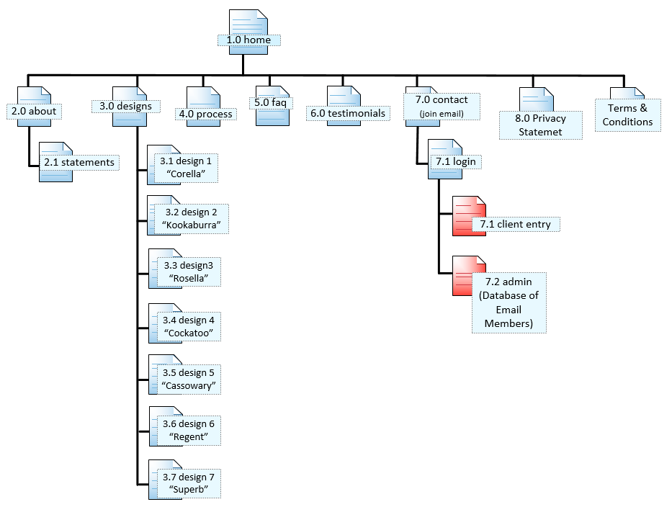
Figure 1: Navigation Map of the AllStyle Homes website

Content map
The content map shows the mapping of content chunks to web pages. The content map is provided below.
AllStyle Homes provided the following documents:
  - The “AllStyle Homes Requirement Document”
  - The AllStyle Homes Prospectus
  - The AllStyle Homes Business Plan (sections of)
  - Customer Brochures and Information Sheets
Unique ID | Description | Original Source Format |  | Expected Format Changes |  | Update Frequency | Information Owner
1.0 home | Contains general introduction to the site and encourages user to move to designs or contact page | PDF –  - AllStyle Homes Requirement Document  - AllStyle Homes Prospectus |  | Modify font family and size  Format paragraph style  Update content if required |  | Monitor monthly.  Update monthly if required & immediately when urgent.  Re-style appearance yearly | AllStyle Homes
2.0 about | Provides historical information & general information about the services the company provides | PDF –  - AllStyle Homes Requirement Document  - AllStyle Homes Prospectus  - Customer Brochures and Info. Sheets |  | Modify font family and size  Format paragraph style  Update content if required |  | Monitor monthly.  Update monthly if required  Re-style appearance yearly. | AllStyle Homes
2.1 statements | Business statements of purpose:  - Mission Statement  - Vision Statement  - Values  - Objectives | PDF –  - AllStyle Homes Requirement Document  - AllStyle Homes Prospectus  - Customer Brochures and Info. Sheets  - AllStyle Homes Business Plan (sections of) |  | Modify font family and size  Format paragraph style  Update content if required |  | Monitor monthly.  Update monthly if required  Re-style appearance yearly. | AllStyle Homes
3.0 designs | Information about the style of buildings. Stresses a commitment to build a home to meet the needs and budget of the customer | PDF –  - AllStyle Homes Requirement Document  - AllStyle Homes Prospectus  - Customer Brochures and Info. Sheets |  | Modify font family and size  Format paragraph style  Update content if required |  | Monitor monthly.  Update monthly if required  Re-style appearance yearly. | AllStyle Homes
3.1 corella | Outlines specifications, details and description of a style/design called “corella” | PDF –  - AllStyle Homes Requirement Document  - Customer Brochures and Info. Sheets |  | Modify font family and size  Format paragraph style  Update content if required |  | Monitor monthly.  Update monthly or as designs are modified  Re-style appearance yearly. | AllStyle Homes
3.2 kookaburra | Outlines specifications, details and description of a style/design called “kookaburra” | PDF –  - AllStyle Homes Requirement Document  - Customer Brochures and Info. Sheets | Modify font family and size  Format paragraph style  Update content if required |  | Monitor monthly.  Update monthly or as designs are modified  Re-style appearance yearly. |  | AllStyle Homes
3.3 rosella | Outlines specifications, details and description of a style/design called “rosella” | PDF –  - AllStyle Homes Requirement Document  - Customer Brochures and Info. Sheets | Modify font family and size  Format paragraph style  Update content if required |  | Monitor monthly.  Update monthly or as designs are modified  Re-style appearance yearly. |  | AllStyle Homes
3.4 cockatoo | Outlines specifications, details and description of a style/design called “cockatoo” | PDF –  - AllStyle Homes Requirement Document  - Customer Brochures and Info. Sheets | Modify font family and size  Format paragraph style  Update content if required |  | Monitor monthly.  Update monthly or as designs are modified  Re-style appearance yearly. |  | AllStyle Homes
3.5 cassowary | Outlines specifications, details and description of a style/design called “cassowary” | PDF –  - AllStyle Homes Requirement Document  - Customer Brochures and Info. Sheets | Modify font family and size  Format paragraph style  Update content if required |  | Monitor monthly.  Update monthly or as designs are modified  Re-style appearance yearly. |  | AllStyle Homes
3.6 regent | Outlines specifications, details and description of a style/design called “regent” | PDF –  - AllStyle Homes Requirement Document  - Customer Brochures and Info. Sheets | Modify font family and size  Format paragraph style  Update content if required |  | Monitor monthly.  Update monthly or as designs are modified  Re-style appearance yearly. |  | AllStyle Homes
3.7 superb | Outlines specifications, details and description of a style/design called “superb” | PDF –  - AllStyle Homes Requirement Document  - Customer Brochures and Info. Sheets | Modify font family and size  Format paragraph style  Update content if required |  | Monitor monthly.  Update monthly or as designs are modified  Re-style appearance yearly. |  | AllStyle Homes
4.0 process | Outlines the stages in the building process , in the construction of your home | PDF –  - AllStyle Homes Requirement Document  - Customer Brochures and Info. Sheets | Modify font family and size  Format paragraph style  Update content if required |  | Monitor monthly.  Update monthly or as designs are modified  Re-style appearance yearly. |  | AllStyle Homes
5.0 faq | Presents the most common or frequently asked question posed by past customers. Also includes the answers to those questions | PDF –  - AllStyle Homes Requirement Document | Modify font family and size  Format paragraph style  Update content if required |  | Monitor monthly.  Update bi-monthly or as new questions become available  Re-style appearance yearly. |  | AllStyle Homes
6.0 testimonials | Presents comments presented to AllStyle Homes in writing, by past customers. | PDF –  - AllStyle Homes Requirement Document  - Customer Brochures and Info. Sheets | Modify font family and size  Format paragraph style  Update content if required |  | Monitor monthly.  Update bi-monthly or as new comments become available  Re-style appearance yearly. |  | AllStyle Homes
7.0 contact | Outlines details on how to contact the company | PDF –  - AllStyle Homes Requirement Document  - Customer Brochures and Info. Sheets | Modify font family and size  Format paragraph style  Update content if required |  | Monitor monthly.  Update bi-monthly or as details change  Re-style appearance yearly. |  | AllStyle Homes
7.1 login | Page in which members &or staff can enter a username & password to gain access to selected pages and features | N/A | N?A |  | Monitor monthly.  Re-style appearance yearly. |  | AllStyle Homes
7.2 Client Entry | Based on the password, entered. Page contains the features, functions and info for which they have permission. | Data must be entered into database software. Data may have been entered manually, or imported in a compatible format, such as CSV or SQL | Format must be compatible with the database software. Fields may be removed or added |  | Data is continually changing from the company’s –perspective, but individual clients may only see periodic changes to their permitted information |  | AllStyle Homes
7.3 Admin.Entry | Based on the password, entered. Page contains the features, functions and info for which they have permission. At this stage, admin./staff are able to view/add database/list of usernames and email addresses | Data must be entered into database software. Data may have been entered manually, or imported in a compatible format, such as CSV or SQL | Format must be compatible with the database software. Fields may be removed or added |  | Data is continually changing as members are being added and deleted. |  | AllStyle Homes

Labelling
The labels intended to be used on the AllStyle Homes website is provided below.

LINKS | Part of Speech
About | Preposition; single word
Back to Top | Adverbial phrase; 3 words; incomplete sentence
Click to Show/Hide | Verb; three words, phrase
Contacts | Noun (plural);single word
Designs | Noun (plural); single word
FAQ | Abbreviation/Acronym; phrase; 3 words
Home | Noun (singular); single word
Login | Noun; single word
Process | Verb (singular); single word
Submit | Verb (singular); single word
Testimonials | Noun (plural); single word
Privacy Statement | Noun; 2 words; recognised term or name
Terms and Conditions | Noun; 3 words; recognised term or name
BUTTONS | Part of Speech
Click to Show/Hide | Verbs; 4 words; phrase or incomplete short sentence
Click To Show/Hide the Labels Covering the Image | Verbs and nouns; 9 words incomplete short sentence
Get Adobe Acrobat Reader | Verb and nouns; 4 word; corporate phrase
Submit | Verb; single word;
Admin. Login | Adjective & noun; 2 words; abbreviated;
Delete | Verb; single word;
Back to Add & Remove | Verbs; 5 words; phrase or improper sentence
Log Out | Verb; 2 words;

There exists a great deal of inconsistency in regards to the labels chosen. There are nouns, verbs adjective and adverbs; single, double and triple words; singular and plural forms; phrases and incomplete sentences; and an abbreviation/acronym. Consistency is essential in helping users navigate easily, especially for people with visual or intellectual disabilities

Menu Systems
As a website grows in complexity, guiding users to that content and functionality shouldn’t be the job of any one menu. While many websites need more than two, most websites have at least two main menus: primary and secondary.
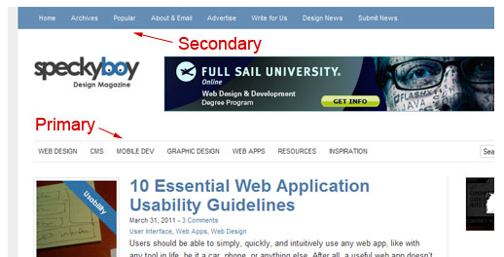
Figure 2: Primary and Secondary menu bar system
Primary navigation stands for the content that most users are interested in and focuses on the specific function of the website.
Secondary navigation is for content that is of secondary interest to the user. Any content that does not serve the primary goal of the website but that users might still want would go here.
For websites where navigation changes based on whether a user is logged in or out, other organizational challenges arise. Some websites may have a simple client area, while others have full-fledged communities. When this kind of interaction is involved, user roles and available content may vary, and owners may want to highlight some content or design it differently.

Figure 3: "Login", "SignUp" and "Submit" can direct user to pages with different features and functions

Styles of website navigation refers to how the navigation system is presented.

Text Links
Text links are words (text) which are surrounded by the anchor set of tags to create clickable text which takes the visitor to another web page within your website, a downloadable document from your website, or to another website on the Internet.

Breadcrumbs
Breadcrumb navigation shows the website visitor the path within your website to the page they are currently on.

Navigation Bar
A navigation bar is the collection of website navigation links all grouped together. A navigation bar can be horizontal or vertical.

Fixed (‘sticky’) or Scrolling
A fixed navigation bar remains stationary (stuck to the screen) while the rest of the page content scrolls; whereas a scrolling bar is part of the content and thus scrolls with it, off the screen

Resizing (‘shrinking’) Bar
Features a dynamic and animated menu that resizes on scroll down. This can be minor shrinkage where the icons disappear but the words remain, or it can shrink to a single icon (eg. “Hamburgers”), or it can go invisible until the user scrolls again

Dropdown Menu
A dropdown menu is a style of website navigation where when the visitor places their mouse over a menu item, another menu is exposed.

Tab Navigation
Tab navigation is where the website navigations links appear as tabs, similar to the tabs you use in a binder to divide the contents into sections.

Sitemap
A sitemap is a page within your website that lists all the sections and web pages (if not too many) that are contained within the website. A traditional sitemap provides a shorter, direct path to the different areas of the website for those who know what exactly they are looking for and a means for the search engines to find all the pages within your website.

Flyout Menu
A flyout menu is constructed similar to the dropdown menu. When the visitor places their mouse over a link, another menu “flys out”, usually to the right, from the link where the mouse is placed.

Named Anchors
Named anchors are the type of links that take you directly to a spot on the current page or on another web page.

Select the menu system most suitable for the client website. Explain the reasons for your selection.
The menu system selected is a horizontal, drop-down menu bar which is fixed to the page (not to the screen), and hence it will scrolls with the rest of the page.
Rationale for the selection:
- A horizontal bar will be thin and therefore discrete/unobtrusive; whereas a vertical bar would be much wider to fit the text width.
- For six items on the primary menu (the login button is separate), the bar will not be too long
- A dropdown menu was chosen, because apart from the design page, there are only a couple of pages/links, nested within the dropdown
- A menu bar; fixed to the page was chosen because most of the pages nop not contain an exhaustive quantity of text/images. Those that do have a “Back to Top” link, giving the user quick access to the menu bar
- Icons were not chosen because any images chosen would be too “cryptic and difficult to decipher/interpret quickly

Security Requirements
The client has stipulated a “login” feature to differentiate between the public, clients and staff. The login button will prevent the public accessing information pertaining to the latter two; it will allow clients to only see information relevant to their home; and will allow staff to see selective information pertaining to clients and company.
Condition outlined in the password policy will enforced and will determine password suitability.

- The website should have a secure client login area where clients can:
  - view a schedule of their build
  - view the current progress of their home
  - view photos of progress
  - request changes
- The website should have a secure administration login area (for AlllStyle Homes employee/s) to update the client area detailed above

Accessibility and usability
Accessible websites are more usable for everybody, regardless of age, ethnicity, disability or literacy level. They create a more socially inclusive environment in which people can perceive, understand, navigate, and interact online.
Web accessibility benefits a wide range of people, including those with:
- visual, auditory, physical, speech, cognitive, and neurological disabilities
- temporary disabilities such as a broken arm
- changing abilities due to aging.
People with a slow internet connection can also benefit.
In its most general sense, accessible web design refers to the philosophy and practice of designing web content so that it can be navigated and read by everyone, regardless of age, ethnicity, location, experience, or the type of computer technology used. Accessible web design is usually discussed in relation to people with a disability, because this group is most likely to be disadvantaged if the principles of accessible web design are not implemented. Failure to follow these principles can make it difficult or impossible for people with a disability to access web content.
Creating accessible web content should be an integral part of the web design cycle, and accessibility features should be incorporated into all aspects of the design process. Planning and testing for accessibility should also be incorporated into all stages of development. Designing for accessibility is therefore as much a strategic issue as a purely technical one.

Web Content Accessibility Guidelines (WCAG) 2.0
http://www.w3.org/TR/WCAG20/

Web Content Accessibility Guidelines (WCAG) 2.0, (See Appendix 1) defines how to make Web content more accessible to people with a wide range of disabilities, including visual, auditory, physical, speech, cognitive, language, learning, and neurological disabilities. Although these guidelines cover a wide range of issues, they are not able to address the needs of people with all types, degrees, and combinations of disability. These guidelines also make Web content more usable by older individuals with changing abilities due to aging and often improve usability for users in general. Accessibility does not require that content be limited to plain text, or that graphics cannot be used. More sophisticated and innovative content can and should also be made accessible. WCAG 2.0 provides many techniques for maintaining visual appeal and dynamic user interaction without sacrificing accessibility.

“In October 2010 the Australian Human Rights Commission (AHRC) updated its World Wide Web Access Advisory Notes to endorse WCAG 2.0 to Level AA. The AHRC advised that all federal government websites were expected to meet Double A conformance by the end of 2014 and all existing non-government websites should comply with WCAG 2.0 to a minimum of Double A conformance by 31 December 2013.” (http://www.visionaustralia.org/business-and-professionals/digital-accessibility-services/resources/legislation-and-guidelines)

Equal access for people with a disability in the area of information and online services is required where it can reasonably be provided. This requirement applies to any individual or organisation developing a website or other web resource in Australia, or placing or maintaining a web resource on an Australian server. This includes web pages and other resources developed or maintained for purposes related to employment; education; provision of services including professional services, banking, insurance or financial services, entertainment or recreation, telecommunications services, public transport services, or government services; sale or rental of real estate; sport; activities of voluntary associations; or administration of Commonwealth laws and programs.

In addition to these specific areas, provision of any other information or other goods, services or facilities through the internet is in itself a service, and as such, discrimination in the provision of this service is covered by the DDA. The DDA applies to services whether provided for payment or not.

Developing Guidelines for the Creation of Accessible Websites
AllStyle Homes, is committed to ensuring access to online materials for people with disabilities. As such we aim to meet the 'Level A' rating as a minimum (and strive toward ‘Level AA’) of the World Wide Web Consortium (W3C) Web Content Accessibility Guidelines 2.0.

The All Style Homes corporate website aims to:
- provide a text equivalent for every non-text element, for images, graphics, animations, etc
- ensure all information conveyed with colour is also available without colour
- use style sheets for layout and presentation
- use tables to mark up tabular information, for example data tables (not for layout purposes)
- ensure pages are accessible when viewed in older browsers, for example a browser that does not recognise style sheets should be rendered so that it is meaningful
- use relative rather than absolute unit sizes so that text in a window can be resized to larger
- ensure that moving, blinking or scrolling text can be paused or stopped
- ensure pages are usable when scripts or objects are turned off or not supported
- provide clear navigation mechanisms
Below is a simple checklist that presents our recommendations for implementing HTML-related principles and techniques for those seeking WCAG 2.0 conformance.
Checkpoint | Checked
Are there any meaningful images?  Is there a text equivalent for these images in the content or elsewhere? | Yes | No | Not applicable
Is there any text boxes or other pictures of text?  Is there a text equivalent for these? | Yes | No | Not applicable
Are there any diagrams or graphs?  Are the key points explained in the text? | Yes | No | Not applicable
Can everything be accessed with a keyboard?  Put away the mouse and double check. | Yes | No | Not applicable
Are there any audio-visuals?  Can the key information be accessed in other ways? | Yes | No | Not applicable
Is the layout consistent throughout the content?  Is it consistent with the organisational style?  Is information properly structured with heading levels, lists and simple data tables? | Yes | No | Not applicable
Are visual cues and images used to complement the text and aid meaning?  Check that they are meaningful to the target audience. | Yes | No | Not applicable
Is colour used to convey meaning?  Check that there is another way to access the meaning.  Is there enough contrast between the text and the background? | Yes | No | Not applicable
What is total size (weight) of the content and any plugins?  Is there any way to reduce this? | Yes | No | Not applicable
Is the content marked up in HTML (XHTML or XML)?  Has a simple accessibility check been completed? | Yes | No | Not applicable
Figure 4: Checklist for accessible online content
http://webaim.org/standards/wcag/checklist (Center for Persons with Disabilities, Utah State University; 2013, Aug 28)
http://www.w3.org/WAI/WCAG20/quickref/

Appendix:
Two mockups were developed, the first was chosen for prototype development.

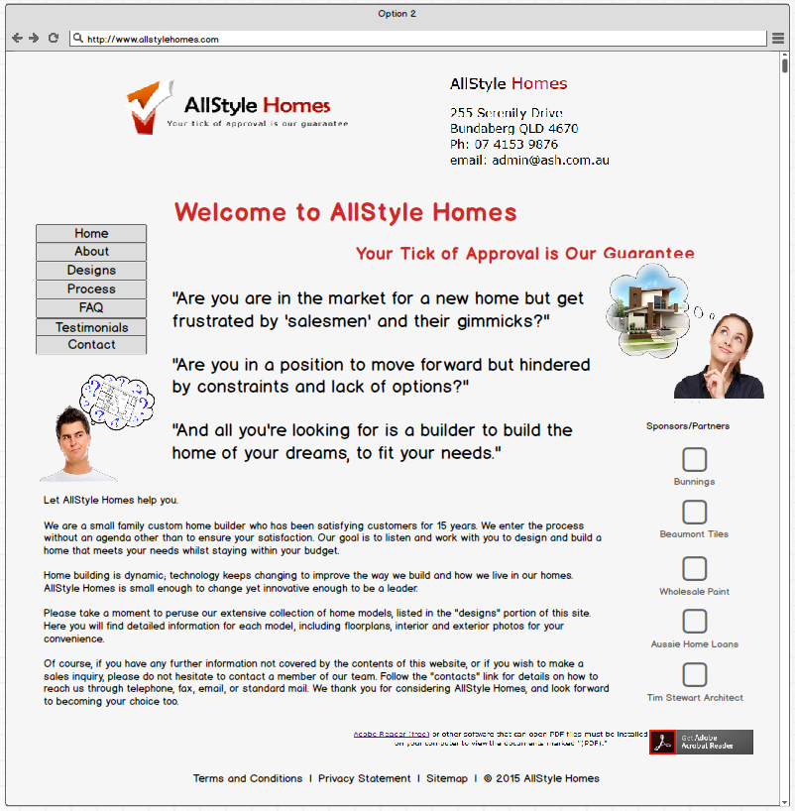
Figure 5: Mockup using vertical menu bars.
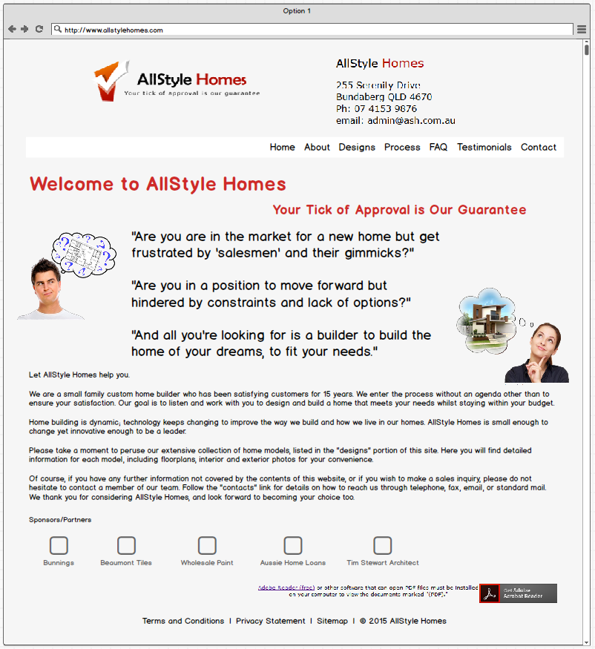
Figure 6: Mockup utilising horizontal menu bar.

The second, of the two mockups (Figure 6), was chosen for prototype development. The reasons for its selection:
- The horizontal navigation bar is less obtrusive than the vertical bar
- The horizontal navigation bar takes up less space, thus allowing more content to be added or greater options for the placement of the content.
- The horizontal navigation bar allows for a dropdown menu that is less obtrusive to the screen content
- The icon links to the supporter/partner site was moved to the bottom of the page to enable AllStyle Home content to take the prominent position at the top of the page

Task 4- create mock-ups of the website

Task 5 - create a prototype of the website
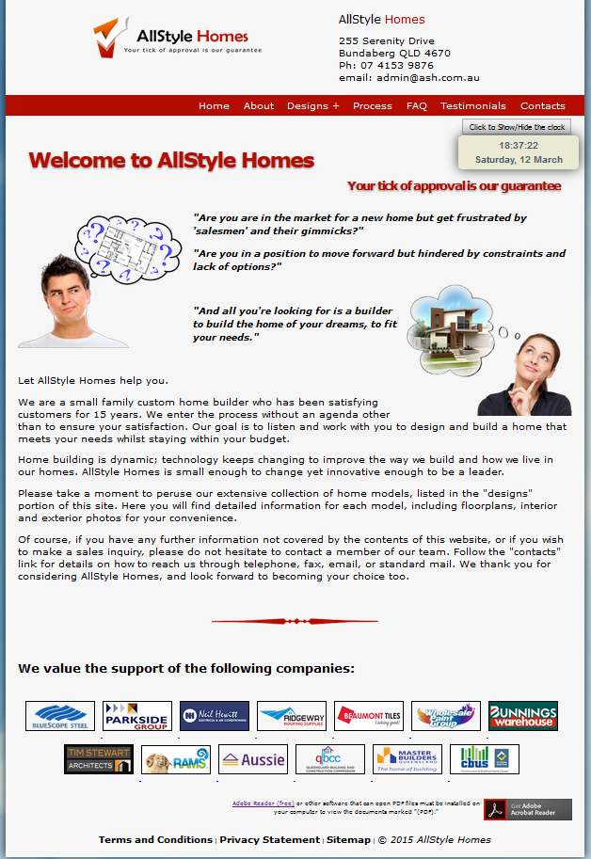

Figure 7: Top-left - mockup of page; bottom-right - prototype of the same page.

Task 6 - test prototype

Usability Test
Today we are asking you to serve as an evaluator of a Web site and to complete a set of tasks. Our goal is to see how easy or difficult you find the site to use.

Test Facilitator’s Role
I am here to observe and record your reactions and comments of the Web site you will view. In addition, your mouse activity and verbal comments will be recorded using screen capture software. Please try not to think of this as you complete the tasks.

During this session, I would like you to think aloud as you work to complete the tasks. I will not be able to offer any suggestions or hints, but from time to time, I may ask you to clarify what you have said or ask you for information on what you were looking for or what you expect to have happen.

Test Participant’s Role
- Today I am going to be asking you to look for some information on the site and tell me how easy or difficult it was to find the information. These activities are all about how easy we have made it for people to use the site.
- There is no right or wrong answer. If you have any questions, comments or areas of confusion while you are working, please let me know.
- If you ever feel that you are lost or cannot complete a task with the information that you have been given, please let me know. I will ask you what you might do in a real-world setting and then either put you on the right track or move you on to the next scenario.
- As you use the site, please do so as you would at home or your office. I would ask that you to try work through the tasks based on what you see on screen, but if you reach a point where you are not sure where or how to find something, please feel free to use ‘Search’.
- We will be recording this session for reference if needed. We are capturing your face, your voice and what you see on the screen. Your name will not be associated or reported with data or findings from this evaluation.
- I may ask you other questions as we go and we will have wrap up questions at the end.

Do you have any questions before we begin?

Sample Questions | Tester’s Comments & Recommendations
Just from looking at this site, what kinds of information do you think you could get from this site? Please be specific.
Who do you think this site is designed for? Why?

Who manages this site?

For these activities, you are a citizen surfing the net.

TASK | Tester’s Comments & Recommendations
You want to make an appointment to discuss options. Find their phone number.

You have decided to discuss a house plan. Find out if they are open for business on a Sunday morning.

You are in the market for a four bedroom house. Determine if this site has anything on offer.

The site has a facility to join a mailing list. Find the page and register your email details.

Locate the AllStyle Homes Privacy Statement. Print yourself a copy.

For these activities, you are a staff member. Your username = “admin” and your password = “admin”

Enter the staff only (admin) area, using the given username and password

Delete the account with the username “fred”

General Comments or Recommendations:

What is your overall impression of the site?
What is your impression of the search capability?
What did you like best about the site?
What did you like least about the site?
If you were the website developer, what would be the first thing you would do to improve the website?
Is there anything that you feel is missing on this site?

Response Analysis

TASK | RESPONSE ANALYSIS
Just from looking at this site, what kinds of information do you think you could get from this site? Please be specific. | P1: House designs  P2: Information
Who do you think this site is designed for? Why? | P1: Enquiries to build a house  P2: Clients/customers looking for house
Who manages this site? | P1: Admin  P2: Allstyle Homes/Angelo/Admin
You want to make an appointment to discuss options. Find their phone number. | P1: Easy to find  P2: Easily seen
You have decided to discuss a house plan. Find out if they are open for business on a Sunday morning. | P1: Contact page shows opening hours  P2: Details are well presented
You are in the market for a four bedroom house. Determine if this site has anything on offer. | P1: Designs page shows designs on offer/Yes  P2: Site offers different house plans which suit  (3 different 4 bdrm options)
The site has a facility to join a mailing list. Find the page and register your email details. | P1: Contact page works and successfully added username and email to list  P2: Easy navigation with the mailing list
Locate the AllStyle Homes Privacy Statement. Print yourself a copy. | P1: Privacy statement located on the footer. Link on contact page not working  P2: Privacy statement must be checked on every page
Enter the staff only (admin) area, using the given username and password | Admin page works fine
Delete the account with the username “fred” | Fred’s account already deleted
Comments:
P1: Well designed; easy to navigate; Didn’t like scrolling on process page

P2: Well presented and can easily operate by any person regardless of age or knowledge of website

What is your overall impression of the site?
P1: Looks good; lots of info; easy to navigate
P2: It is a responsive and well presented site

What is your impression of the search capability?
P1: Sitemap was good; design could be better or more modern
P2: Accessible

What did you like best about the site?
P1: Dynamic hover over house picture in designs page
P2: Presentation of detail and images which captures any user on the first time they click on any page

What did you like least about the site?
P1: Scrolling on process page
P2: On process page the ‘Back to Top’ button was out of place

If you were the website developer, what would be the first thing you would do to improve the website?
P1: No scroll on process page - add dropdown menu; request print page
P2: Not much; just small details previously mentioned

Is there anything that you feel is missing on this site?
P1: No
P2: No

RECOMMENDATIONS:
1. Check and repair all links
2. Check ‘tabbed-text-box’ on process page and rectify “glitch” (requiring excessive scrolling)
3. Position a link to the “Add Email” facility, on the home page.
