**Question 2 [10 marks]:**

Start from vertex e, find a minimum spanning tree of the following graph using Prim’s algorithm:

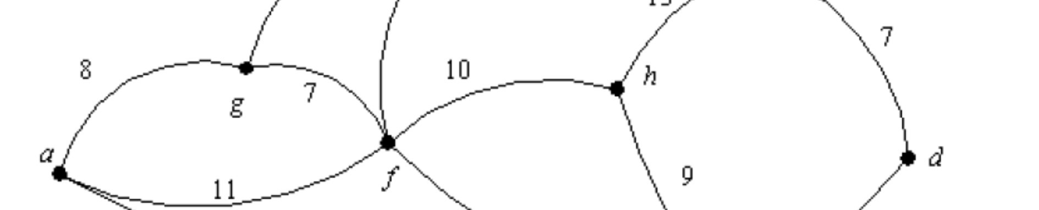

Show the minimum weight and the sequence of edges added.

Starting with vertex e

|  |  |  |
| --- | --- | --- |
| Sequence | Edges | Weight |
| 1 | e,f | 5 |
| 2 | f,b | 6 |
| 3 | f,g | 7 |
| 4 | g,a | 8 |
| 5 | b,c | 9 |
| 6 | c,d | 7 |
| 7 | e,h | 9 |

Minimum weight is 5+6+7+8+9+7+9=51