**Question 7 [10 marks]:**

List the order in which the vertices of the graph shown in Figure 1 are visited when the following methods are applied with the start vertex = a:

* 1. the breath-first-search
  2. depth-first-search

Assume that the vertices are listed in increasing order in each adjacency list.

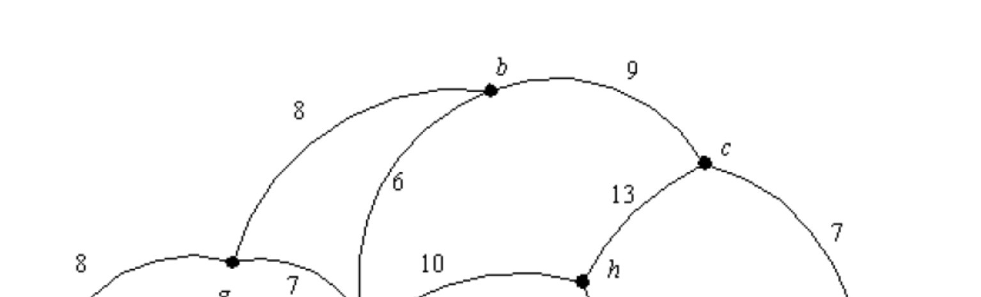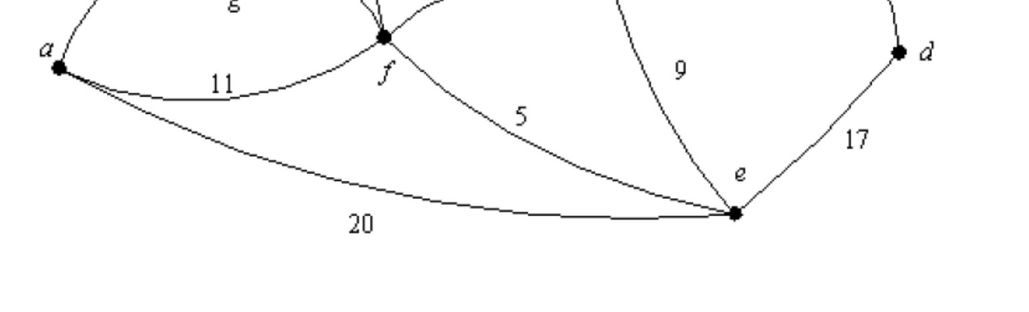

Q7a

BFS = a, e, f, g, d, h, b, c

7b)

DFS = a, e, d, c, b, f, g, h