**DE LA SALLE UNIVERSITY SCIENCE AND TECHNOLOGY COMPLEX**

**Declaration of Original Work**

I, Aileen Benz T. Sabellon, hereby declare that the attached group project, has been researched, undertaken, completed and submitted as required by myself as a collective effort by the group members listed below.

We have honored the principles of academic integrity and have upheld Ryerson University’s Student Code of Academic Conduct in the completion of this work.

**Signed and submitted:**

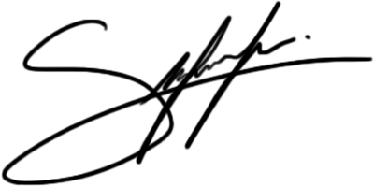

**AILEEN BENZ T. SABELLON**

**Date: April 1, 2016**