**Implement code for**

1. **biggest of Three numbers.**
2. **Grade wise Result by taking Students Marks.**
3. **Calculator.**
4. **Employ Salary hourlyBasis and monthlyBasis.**
5. **Bank Function like Withdraw and Deposite**

**Main.java**

import java.util.Scanner;  
  
class BiggestOfThree {  
 public void findBiggest(int num1, int num2, int num3) {  
 if (num1 > num2 && num1 > num3)  
 System.*out*.println("Num 1 is greater");  
 else if (num2 > num1 && num2 > num3)  
 System.*out*.println("Num 2 is greater");  
 else  
 System.*out*.println("Num 3 is greater");  
 }  
}  
  
class Result {  
 public void calculateResult(Scanner sc) {  
 System.*out*.println("\nEnter the Marks of the subject");  
  
 System.*out*.println("Enter the Marks of DAA subject: ");  
 int DAA = sc.nextInt();  
  
 System.*out*.println("Enter the Marks of DevOps subject: ");  
 int DevOps = sc.nextInt();  
  
 System.*out*.println("Enter the Marks of AJP subject: ");  
 int AJP = sc.nextInt();  
  
 System.*out*.println("Enter the Marks of MP subject: ");  
 int MP = sc.nextInt();  
  
 System.*out*.println("Enter the Marks of PA subject: ");  
 int PA = sc.nextInt();  
  
 System.*out*.println("Enter the Marks of PCS subject: ");  
 int PCS = sc.nextInt();  
  
 System.*out*.println("Enter the Marks of PNS subject: ");  
 int PNS = sc.nextInt();  
  
 int avg = (DAA + DevOps + AJP + MP + PA + PCS + PNS) / 7;  
  
 System.*out*.println("Percentage of the student is: " + avg);  
  
 if (avg >= 90)  
 System.*out*.println("The Student got Grade A+");  
 else if (avg >= 80)  
 System.*out*.println("The Student got Grade A");  
 else if (avg >= 70)  
 System.*out*.println("The Student got Grade B+");  
 else if (avg >= 60)  
 System.*out*.println("The Student got Grade B");  
 else if (avg >= 50)  
 System.*out*.println("The Student got Grade C");  
 else if (avg >= 35)  
 System.*out*.println("The Student got Grade D");  
 else  
 System.*out*.println("The Student got Grade F");  
 }  
}  
  
class Calculator {  
  
 public static void performCalculator(Scanner sc) {  
 int num1, num2, choice;  
  
 System.*out*.println("Enter the value for 1st Number: ");  
 num1 = sc.nextInt();  
  
 System.*out*.println("Enter the value for 2nd Number: ");  
 num2 = sc.nextInt();  
  
 do {  
 System.*out*.println("\nMenu:");  
 System.*out*.println("1. Addition");  
 System.*out*.println("2. Subtraction");  
 System.*out*.println("3. Multiplication");  
 System.*out*.println("4. Division");  
 System.*out*.println("5. ReEnter the Numbers");  
 System.*out*.println("6. Exit");  
  
 System.*out*.print("Enter your choice: ");  
 choice = sc.nextInt();  
  
 if (choice >= 1 && choice <= 4) {  
 *performCalculation*(num1, num2, choice);  
 } else if (choice == 5) {  
 *assignNumbers*(sc);  
 } else if (choice == 6) {  
 System.*out*.println("Exiting the program. Goodbye!");  
 } else {  
 System.*out*.println("Invalid choice! Please try again.");  
 }  
  
 } while (choice != 6);  
 }  
  
 public static void assignNumbers(Scanner sc) {  
 System.*out*.println("Enter the value for 1st Number: ");  
 int num1 = sc.nextInt();  
  
 System.*out*.println("Enter the value for 2nd Number: ");  
 int num2 = sc.nextInt();  
 }  
  
 public static void performCalculation(int a, int b, int choice) {  
 switch (choice) {  
 case 1:  
 *addition*(a, b);  
 break;  
 case 2:  
 *subtraction*(a, b);  
 break;  
 case 3:  
 *multiplication*(a, b);  
 break;  
 case 4:  
 *division*(a, b);  
 break;  
 }  
 }  
  
 public static void addition(int a, int b) {  
 int sum = a + b;  
 System.*out*.println("The result of Addition is: " + sum);  
 }  
  
 public static void subtraction(int a, int b) {  
 int sub = a - b;  
 System.*out*.println("The result of Subtraction is: " + sub);  
 }  
  
 public static void multiplication(int a, int b) {  
 int mul = a * b;  
 System.*out*.println("The result of Multiplication is: " + mul);  
 }  
  
 public static void division(int a, int b) {  
 if (b == 0) {  
 System.*out*.println("Error: Division by zero is not allowed.");  
 } else {  
 float div = (float) a / b;  
 System.*out*.println("The result of Division is: " + div);  
 }  
 }  
}  
  
class employee {  
 private int employeeNumber;  
 private String employeeName;  
 protected int salary;  
  
 public void getData(int empno, String empname) {  
 employeeNumber = empno;  
 employeeName = empname;  
 }  
  
 public void putData() {  
 System.*out*.println("Employee Number: " + employeeNumber);  
 System.*out*.println("Employee Name: " + employeeName);  
 System.*out*.println("Employee Salary: " + salary);  
 }  
}  
  
class hourlyBasis extends employee {  
 private int hours;  
 private int rate;  
  
 public void getHourlyData(int h, int r) {  
 hours = h;  
 rate = r;  
 }  
  
 public void calculate() {  
 salary = hours * rate;  
 }  
}  
  
class monthlyBasis extends employee {  
 private int basic;  
 private int hra;  
 private int da;  
  
 public void getMonthlyData(int b, int h, int d) {  
 basic = b;  
 hra = h;  
 da = d;  
 }  
  
 public void calculate() {  
 salary = basic + (basic * hra / 100) + (basic * da / 100);  
 }  
  
}  
  
  
public class Main {  
 public static void main(String[] args) {  
 Scanner sc = new Scanner(System.*in*);  
  
 // Biggest of Three  
 System.*out*.println("\n*Biggest of Three*");  
 System.*out*.println("Enter value of num 1: ");  
 int num1 = sc.nextInt();  
 System.*out*.println("Enter value of num 2: ");  
 int num2 = sc.nextInt();  
 System.*out*.println("Enter value of num 3: ");  
 int num3 = sc.nextInt();  
  
 BiggestOfThree biggest = new BiggestOfThree();  
 biggest.findBiggest(num1, num2, num3);  
  
 // Result  
 System.*out*.println("\n*Result*");  
 Result result = new Result();  
 result.calculateResult(sc);  
  
 // Calculator  
 System.*out*.println("\n*Calculator*");  
 Calculator.*performCalculator*(sc);  
  
 // Hourly Basis Employee  
 System.*out*.println("\n*Hourly Basis Employee*");  
 hourlyBasis hourlyBasisEmployee = new hourlyBasis();  
 hourlyBasisEmployee.getData(1, "Atharva");  
 hourlyBasisEmployee.getHourlyData(1, 800);  
 hourlyBasisEmployee.calculate();  
 System.*out*.println("Hourly Basis Employee Details:");  
 hourlyBasisEmployee.putData();  
  
 // Monthly Basis Employee  
 System.*out*.println("\n*Monthly Basis Employee*");  
 monthlyBasis monthlyBasisEmployee = new monthlyBasis();  
 monthlyBasisEmployee.getData(2, "Adam");  
 monthlyBasisEmployee.getMonthlyData(15000, 10, 1);  
 monthlyBasisEmployee.calculate();  
 System.*out*.println("\nMonthly Basis Employee Details:");  
 monthlyBasisEmployee.putData();  
 }  
}

**Outputs:**

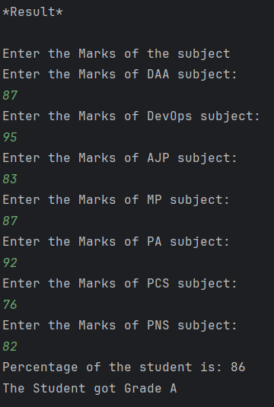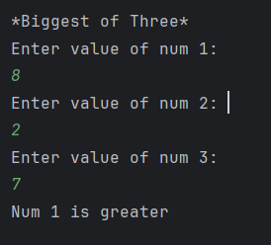

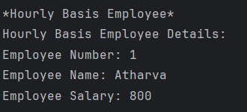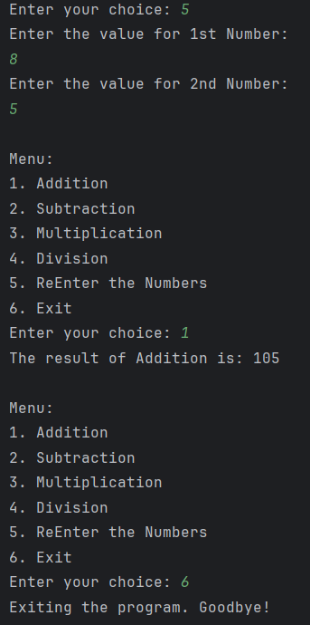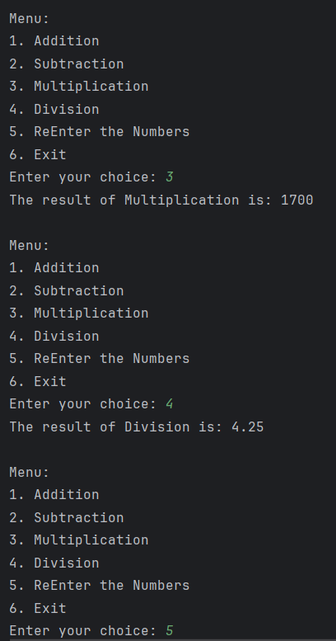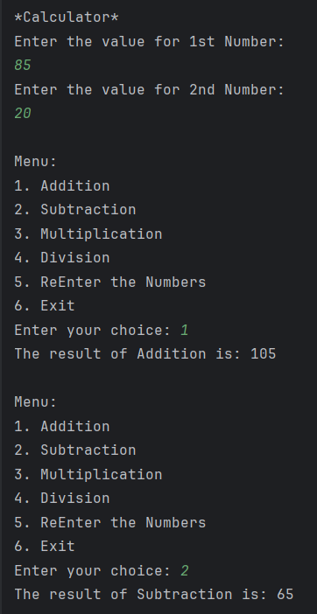 **Bank.java**

import java.util.Scanner;  
  
public class bank {  
 public static void main(String[] args) {  
 Scanner sc = new Scanner(System.*in*);  
  
 Account acc = new Account(1, "Atharva", 1000);  
  
 boolean breakFlow;  
 do {  
 System.*out*.println("\nBank Menu");  
 System.*out*.println("1. Deposit");  
 System.*out*.println("2. Withdraw");  
 System.*out*.println("3. Check Balance");  
 System.*out*.println("4. Exit");  
 System.*out*.print("Enter your choice: ");  
  
 int choice = sc.nextInt();  
 breakFlow = true;  
  
 switch (choice) {  
 case 1:  
 System.*out*.print("Enter amount to deposit: ");  
 double depositAmount = sc.nextDouble();  
 acc.deposit(depositAmount);  
 break;  
 case 2:  
 System.*out*.print("Enter amount to withdraw: ");  
 double withdrawAmount = sc.nextDouble();  
 acc.withdraw(withdrawAmount);  
 break;  
 case 3:  
 acc.checkBalance();  
 break;  
 case 4:  
 System.*out*.println("Thank you for using the bank. Goodbye!");  
 breakFlow = false;  
 break;  
 default:  
 System.*out*.println("Invalid choice. Please enter proper value.");  
 }  
 } while (breakFlow);  
 }  
 static class Account {  
 private int accNumber;  
 private String name;  
 private double balance;  
  
 public Account(int accNumber, String name, double initialBalance) {  
 this.accNumber = accNumber;  
 this.name = name;  
 this.balance = initialBalance;  
 }  
  
 void withdraw(double amount) {  
 if (amount > balance) {  
 System.*out*.println("You have insufficient balance.");  
 } else {  
 balance -= amount;  
 System.*out*.println("Debited " + amount + " from your account.");  
 System.*out*.println("Your current balance is: " + balance);  
 }  
 }  
  
 void deposit(double amount) {  
 balance += amount;  
 System.*out*.println("Credited " + amount + " to your account.");  
 System.*out*.println("Your current balance is: " + balance);  
 }  
  
 void checkBalance() {  
 System.*out*.println("Your current balance is: " + balance);  
 }  
 }  
}

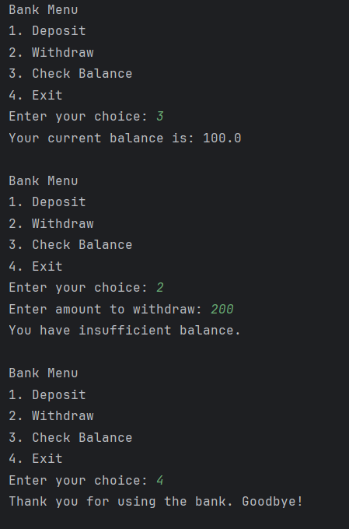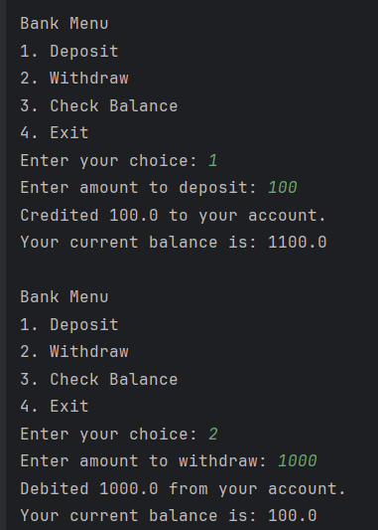**Outputs:**

